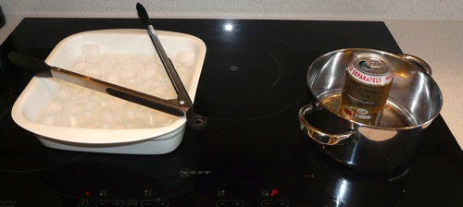
Mystery Island VBS Day 2 Experiment (Can Crushing)

Supplies Needed:
- empty drink can
- shallow tray or dish
- tongs
- ice
- water
- stove or hot plate (and an old saucepan if, like me, you have an induction hob

Instructions:
1. Prepare a tray filled with enough ice to cover its base, and water to cover the ice.
2. Put a small amount of water into the empty can and set it on the stove until the water inside boils.
3. Quickly pick up the can with the tongs and put it upside down into the tray of icy water so that the opening is under water.

Mystery Island VBS Day 2 Craft (Seashell Necklace)
1.Put the shell on the string
2.Put the beads on in any order you like
3.Tie the ends in a knot

Tie in with Lesson:
The beads represent the many chances that God gives us to apologize (repent) for our sins and it is that grace and mercy that makes our relationship with God so beautiful and unique to each and every one of us. No one will have the exact same necklace as you just like no one will have the exact same story as you.

