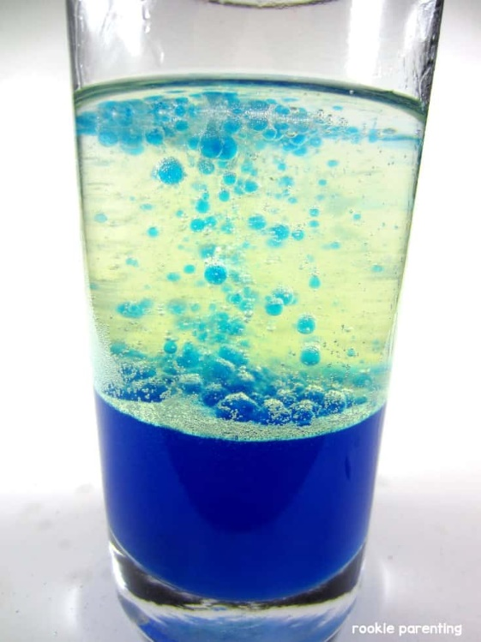
Mystery Island VBS Day 4 Experiment (Lava Lamps)

Supplies Needed:
- Bowl/Cup
- Food coloring
- Vegetable Oil
- Water
- Dropper
- Alka-Seltzer

Instructions:
- Fill the bowl/cup most of the way with vegetable oil.
- Fill the rest of the flask with water. The water will sink to the bottom under the oil and look like little, clear blobs.
- Add a few drops of food coloring; your choice of color. The food coloring is water-based, so it will also sink and color the water that is now at the bottom of the bowl/cup.
- Break an alka-seltzer tablet into a few small pieces, and drop them in the flask one at a time.
- Watch your lava lamp erupt into activity! As the reaction slows down, simply add more alka-seltzer.

Mystery Island VBS Day 4 Craft (Jellyfish Jigglers)
1.Take the paper bowl and color it. You can use: markers, crayons, colored pencils, stickers, glitter, whatever craft supplies you have at home.
2.Glue the googly eyes onto the outside of the bowl
3.Be sure the bowl is upside down, now glue the ribbon you got to the inside of the bowl (the ribbons are the tentacles of the jellyfish)
4.Let dry

Tie in with Lesson:
Look at your Jellyfish Jiggler, you see how the bowl looks like it covers the tentacles? If you set it down on a flat surface it can cover every tentacle, the same goes for Jesus. He covered us all by dying on the cross. That is why He is called our Savior because He protected and saved us from having to pay the price for all the bad choices/mistakes we make.

