Mystery Island VBS Day 5 Experiment (Sink or Float)
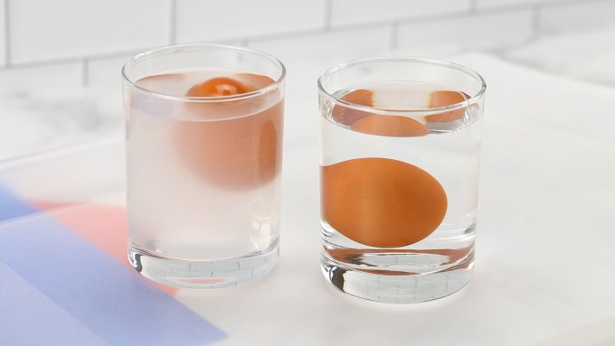
Supplies Needed:
- 2 Bowls/Cups
- Misc. Items around the house
- Salt
- Water

Instructions:
- Fill the bowls/cups with water
- Dump salt into 1 bowl/cup
- Mix saltwater
- Place misc. items in each cup and see what floats and what sinks in regular water vs. salt water

Mystery Island VBS Day 5 Craft (Gods Attribute Rock)
1.Follow instructions on how to use the marker(s) provided. (A little slip of paper is in this bag with marker instructions)
2.Paint/color your rock however you’d like
3.Let it dry for a minute or two
4.Wrap one end of the wire around the rock
5.At the other end of the wire, curl it to create a little slit that you can put your treasure verse in

Tie in with Lesson:
When you think about a rock some things that come to mind are tough, strong, sturdy, and so on, now think about God. God is tough, He can handle anything, God is strong, He can hold each one of us close to His heart and on His shoulders, and God is sturdy, He doesn’t shake or break. This is why you hear people say that God is our rock, because we can always rely on Him to be able to handle all of us, all the time, all at once, and it’s never too much for Him to handle.

