Borrowed Time
By Kelly Abbott

borrowed time: an uncertain postponement of something inevitable—
a person living on borrowed time

How would you spend the last seven days of your life?

LOGLINE:
A decorated ex–Marine leads a two-man unit inside Nova Project, a service that brings people back for seven days—but every resurrection pulls him deeper into a conspiracy where the founder experiments on test subjects to buy immortality.
During the seven days of revival each client fulfills their own agenda—they can use their “borrowed time” to tie up loose ends after they die: make amends with loved ones, tick-off items from a bucket list, plan for their family’s future without them, and enjoy life that one last time or they can rack up debt, make bold decisions, seek revenge on their attacker, right wrongs, and become modern-day vigilantes. The justice system takes time, and when you no longer fear death, you have nothing to lose.

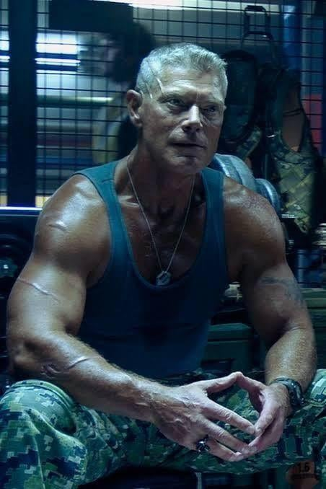
GENRE: Sci-fi action procedural
DURATION: Hour-long episodes

MAIN CHARACTERS:
JAMES TULLY (45) is the lead: controlled, principled, carrying unresolved guilt from war and from the people he couldn’t save.
CARL BREWER (25) is the volatile engine: younger, fearless, morally flexible. He’s great at reading people, breaking rules, and doing what the mission actually requires.

THE HOOK:

A billionaire-funded “second life” agency resurrects the recently dead for a limited window—selling closure, confessions, and miracles—while secretly hunting a rare genetic key that could make resurrection permanent… for the right person.

THEMES
What makes life meaningful? If you died tomorrow, what would you regret? What would be your legacy?
Mortality vs. Control: the wealthy treating death like a solvable problem.

TONE
Grounded yet thought-provoking sci-fi drama with procedural cases-of-the-week, each emotionally punchy and character-driven.

COMPARABLES
Borrowed Time blends the corporate unease and identity erosion of Severance, the ethical dread and unsettling consequence of Black Mirror, and The OA’s fixation on the mysteries and obsession surrounding life and death—grounded with the systemic, profit-driven exploitation lens of Dopesick and the intimate, character-first exploration of grief and family fallout as shown in This Is Us. Each episode has a clear goal, a clock, and an emotional gut-punch.

SERIES OVERVIEW/ SERIES ENGINE
Borrowed Time follows the Nova Project—an elite, secretive agency that temporarily resurrects the recently deceased and extends their lives by seven days. Publicly (the procedural element), the service is sold as mercy: a final goodbye, a last confession, one more chance to resolve loose ends. Privately (the serial element), is something darker—a data-mining operation run by the founder, an unconventional billionaire fixated on immortality, using each resurrection to hunt for a rare DNA sequence with regenerative properties.
Each episode delivers a “borrowed time” case with a clear goal and a ticking clock, while the team uncovers an unsettling truth: Nova isn’t just bringing people back—it’s steering outcomes, cherry-picking clients, and deciding who is worth saving. As the season escalates, the leads discover the serum truly works on only a tiny genetic subset, and over time, Nova begins crossing lines to find it, including planting evidence, manipulating investigations, and engineering deaths to create the perfect test subjects—genetically linked to the founder.

SELECTED EPISODES
- An officer killed in the line of duty, tracks down the perp who took his life and brings him to justice.
- A student enters a school and commits mass murder before turning the gun on himself. He is forced to take responsibility and explain for his actions.
- A couple spend seven days blowing their savings, and having fun, when unexpectedly one person lives beyond the seven days, a rare side-effect of the serum, and end goal for the company.
- A girl’s dream comes true when she plays a piano concert for her parents who struggle to believe that this person is still their daughter.
- An elderly gentleman is given a chance to pursue his high-school sweetheart.
- A mum dies in a car crash only to return home to prepare her unsuspecting family to go on without her.
- A millionaire spends his final moments giving away his entire fortune to help those around him.
- A recently deceased groom, fights his way back to his bride on their wedding day.
- A brave woman comes clean about a dark secret about her dangerous stepfather, as she fears he will become the guardian of her daughter.
- A new mother dies giving birth to her son. Tully and Brewer spend the next seven days driving her across country and arrange care for him, with a long-lost friend.
- A terrorist killed during a shootout is revived with hopes of uncovering a terrorist network.
- A gang member killed by his partner turns stateside and his video testimony uncovers a drug ring
- Brewer struggles to ethically revive a crack-addicted teenager who stole from his family and fled.
- Suicide jumper, Zahid, who is revived and exposes the agency when he is caught jumping to his death.

WHY NOW?

We live in a world where people treat death like a solvable problem—the rich are trying to outspend mortality, and tech companies monetize data, reducing people to assets. Borrowed Time takes our current anxieties—biohacking, consent, surveillance, health inequity—and asks the sharpest question: If death becomes a service, who gets to live… and who gets exploited?

INSPIRATION

My father always told me that the best gift I can give him is my time, and since then I have perceived time as the most valuable currency—limited, fleeting, and meant to be spent wisely. Borrowed Time comes from a fascination with death, grief and unfinished business, and those that try to “fix” death. The series is about what people do with one last chance—how they choose to be remembered—and with time running out, it reveals the kind of person they really are. It also explores what happens when a powerful system decides some lives are worth more than others, all in pursuit of the one thing we all secretly want: immortality.

