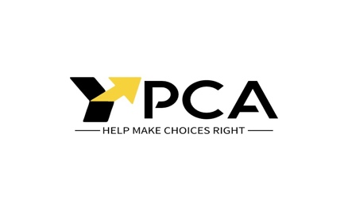
Dear Local Area Coordinator / NDIA representative,
I am writing to formally request that you include Plan Management in my upcoming NDIS plan. I believe that Plan Management will allow me to make the most of my NDIS plan and use my funding in the best way possible.
I require Plan Management because:
- I do not have the capacity to take care of the time-consuming tasks of managing my NDIS plan;
- and/or I need the services of at least one unregistered provider and a Plan Manager to assist me in engaging and paying this provider(s).
This request is based on s.43(2) of the NDIS Act, which states that the “NDIA must give effect to a participant’s plan management request”.
Reference to this legislation is included in the NDIS operational guidelines which can be found at www.ndis.gov.au/operational-guideline/planning/managing-funding-supports.
Thank you in advance for including Plan Management in my NDIS plan.
If you have any questions about my request, please contact YPCA at admin@ypca.com.au.

Yours sincerely,

Name: ____________________________________

Date: ______________________________________

Signature: __________________________________

