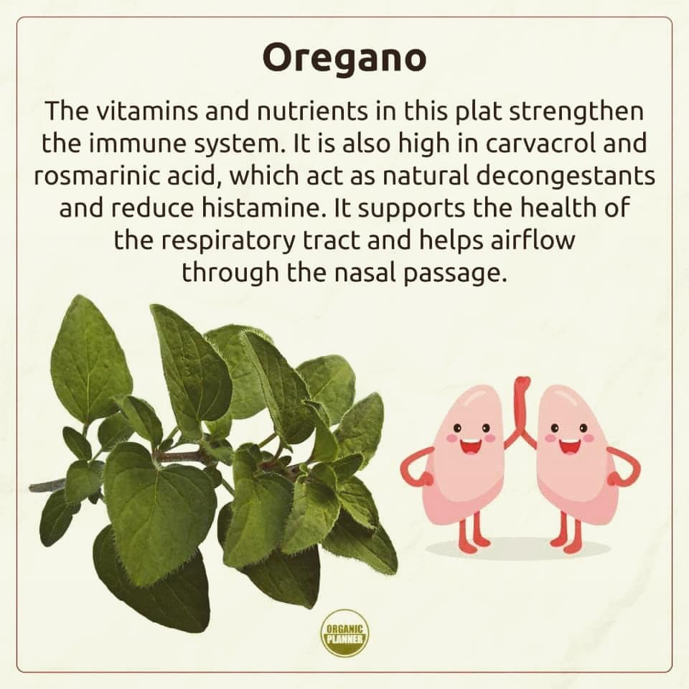
I want share with you power of the oregano leaf. Free radicals are the destructive by-products of cellular metabolism that can cause cancer and other chronic diseases. Thus, adding oregano leaf to your daily routine can improve your immune health and keep your body safe from some of the most dangerous and silent killers. Oregano leaf is rich in antioxidants, which are compounds that help fight damage from harmful free radicals in the body. The buildup of free radicals has been linked to chronic diseases like cancer and heart disease Oregano is especially high in carvacrol and thymol, two antioxidants that can help prevent damage to cells caused by free radicals.

Oregano leaf is a good source of vitamin A, iron, and manganese. Oregano is a rich source of Vitamin K, a vital vitamin that is quite often ignored. Vitamin K is known to promote cardiovascular health and is integral to keeping calcium out of the arteries. It effectively helps in the bone development and promotes proper blood clotting too. Dry oregano leaf, when ingested, acts as a health tonic. Rich in essential oils such as carvacrol, thymol, limonene, pinene, ocimene and caryophyllene, the leaves and flowering stems of oregano have strong antiseptic, anti-spasmodic, carminative, cholagogues (aids in gall bladder secretions), diaphoretic (sweat production), expectorant and stimulant properties.

Oregano leaf improving the functionality of the metabolism, thanks to B-vitamins and its unique organic components present in oregano, the body is rejuvenated and energized. Oregano leaf increases the circulation, due to the presence of iron and increased levels of hemoglobin, helps to fully oxygenate the cells and muscles of the body, thereby increasing energy and strength. It aids in the treatment of colds, mild fevers, influenza, indigestion, stomach upsets and painful menstruation symptoms. Recent research reveals that a gram of oregano Leaf has 42 times more antioxidant properties than apples since it is rich in vitamin A and vitamin C. Hence oregano acts as a protective scavenger against free radicals that play a role in aging and various skin diseases. Rich source of dietary fiber of oregano helps to control cholesterol levels in the blood. Thymol and carvacrol, two active compounds of oregano, increase digestion power. Thymol is also known for its antibacterial and antiseptic activities.

Thymol also soothes the body during sleep. This herb is an excellent source of minerals such as potassium, magnesium, manganese, iron, and calcium. Potassium helps control heart rate and blood pressure caused by high sodium. Magnesium and calcium are important elements for bone metabolism.
Manganese is a potent source of antioxidant and iron helps prevent anemia.
Oregano leaf helps to relieve congestion. Oregano is packed with fiber, so despite its small size, it can have a major impact on your digestive system. Fiber is an essential element of a healthy digestive system, as it can increase the bulk of your stool and stimulate peristaltic motion, which moves food through the digestive tract and excretes it efficiently. Also, fiber helps maintain the health of the gut and increases nutrient feel free to contact Me about this or any other health issues you may be going through.

