Yorkshire Seafoods Ltd – Product List

**2018**

All prices are available on request due to

seasonality and availability.

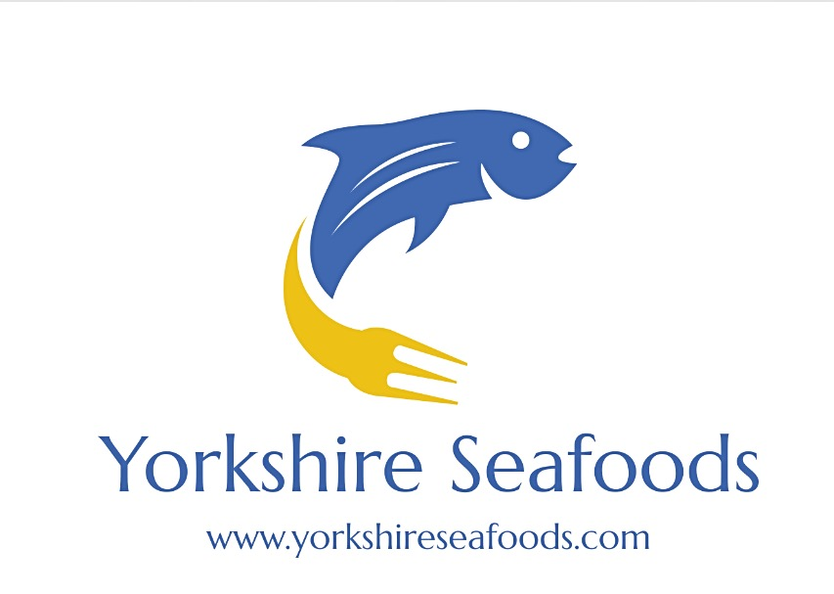

**Fresh Fillets**

Haddock Fillet 5-60z Skinless and Boneless

Haddock Fillet 6-80z Skinless and Boneless

Haddock Fillet 8-10oz Skinless and Boneless

Haddock Fillet 10-12oz Skinless and Boneless

Haddock Fillet Large Skin-on

Cod Fillet 6-8oz Skinless and Boneless

Cod Fillet 8-10oz Skinless and Boneless

Cod Fillet 10-12oz Skinless and Boneless

Cod Loin 8-10oz Skin-on

Salmon Fillet Large

Salmon Portions 6-8oz Skin-on

Sea Bass Fillets 100-140g

Sea Bass Fillets 140-180g

Sea Bream Fillets 100-140g

Sea Bream Fillets 140-180g

Coley Fillet

Hake Fillet

Hake Portions 6-8oz

Halibut Loin

Halibut Portions

Lemon Sole Fillets

Mackeral Fillets

Monkfish Fillets

Plaice Fillets

Pollock Fillets

**Fresh Fillets cont.**

Red Mullet Fillets

Stone Bass Fillets

Turbot Fillet

Whiting Fillet

Swordfish Loin

Tuna Loin

Tuna Portions

Scarborough Woof Fillets

Fresh Fish Pie Mix

Skate Wings

**Frozen Fillets**

Sea Bass Fillets 130-150g

IQF Cod Fillet 7/8

IQF Cod Fillet 8/10

IQF Haddock Fillet 7/8

IQF Haddock Fillet 8/10

F.A.S Haddock Fillet 8/16 Skinless and Boneless

F.A.S Haddock Fillet 5/8 Skinless and Boneless

F.A.S Cod Fillet 8/16 Skinless and Boneless

IQF Lemon Sole Fillet 5/6

IQF Lemon Sole Fillet 6/8

IQF Plaice Fillet 6/8

Monkfish Fillet 4-600g

Salmon Portions 10 x 6-7oz

**Fresh Whole Fish – Wild**

Brill 500g-1kg

Brill 1kg-2kg

Brill 2kg+

Cod 2kg

Cod 2kg+

Conger Eel 3-7kg

Conger Eel 7kg+

Dover Sole

Lemon Sole

Grey Mullet

Sea Bass

Halibut

Herrings

John Dory

Mackeral

Monk Fish

Plaice ¾-1lb

Plaice 1lb+

Sea Trout

Smooth Hound Shark

Sprats

Stone Bass

Turbot

Gurnards

Sardines

**Fresh Whole Fish – Farmed**

Dorade 4-600g

Dorade 6-800g

Rainbow Trout

Salmon

Sea Bass 4-600g

Sea Bass 6-800g

Sea Bass 8-1000g

Turbot 700g-1kg

Turbot 1-2kg

**Other Fresh Items**

Salmon Heads

Cod Heads

Cod Tongues

Monkfish Cheeks

Cod Roe

Cuttlefish

Squid Large

Squid Medium

Octopus

**Fresh Smoked Fish**

Severn & Wye:

Gravalas 200g

Smoked Salmon 200g

Smoked Salmon 400g

Unsliced Salmon 1kg

D-Cut Salmon Side 1kg

Long sliced Salmon Side 1kg

Kiln Smoked Salmon Side

**Natural Smoked**

Haddock

Eel Fillets

Smoked Halibut 200g

Smoked Mackerel

Smoked Peppered Mackerel

Smoked Garlic Mackerel

Smoked Trout Fillets

Kippers

**Live Shellfish**

Crabs

Lobsters

Blue Swimming Crabs

Velvet Crabs

Abalone

Geo Duck

Carpet Clams

Surf Clams

Pallorde Clams

Verace Clams

Razor Clams

King Scallops

Langoustines

Crayfish

Oysters

Sea Urchins

Mussels

Spider Crabs

Whelks

Cockles

**Fresh Shellfish**

Dressed Crabs

Boiled Crabs

Cooked Crab Claws

White Crab Meat

Brown Crab Meat

Dressed Lobsters

Boiled Lobsters

Lobster Meat

Blue Swimmer Claw Meat

Half Shell Scallops

King Scallop Meat

Blue Swimming Crabs

Queen Scallop Meat

**Frozen Shellfish**

Crabmeat 50/50

Dressed Crabs

½ Shell Surf Clams

King Scallop Meat

Queen Scallop Meat

Connemara Mussels – Vac Pack

Rock Lobster Tails

**Exotic Fish - Fresh**

Barracuda

Bombay Duck

Bonito

Doctor Fish

Emperor Fish

Grouper

King Fish

Parrot Fish

Pony Fish

Rabbit Fish

Rascasio

Red Bream

Red Snapper

Yellow Tail Snapper

Ribbon Fish

**Exotic Fish - Frozen**

Escolar Steaks

Golden Thread

Headless Reds

Mahi Mahi Portions

Milkfish

Tilapia – Whole

Tilapia – Fillets

Pomfret

Pengasius Filet

**Exotic Fish – Frozen cont.**

Red Snapper

Ribbon Fish

Trevally

Parrot Fish

Yellow Croaker

**King Prawns - Frozen**

8/12 Peeled & Deveined King Prawn – IQF

13/15 Peeled & Deveined King Prawn - IQF

16/20 Peeled & Deveined King Prawn - IQF

21/25 Peeled & Deveined King Prawn - IQF

26/30 Peeled & Deveined King Prawn - IQF

31/40 Peeled & Deveined King Prawn - IQF

8/12 Head on King Prawn - IQF

16/20 Head on King Prawn – IQF

6/8 Fresh Water King Prawn – IQF

8/12 Fresh Water King Prawn - IQF

16/20 Fresh Water King Prawn - IQF

Argentinean Red Prawn

U5 Fresh Water Block King Prawn

6/8 Fresh Water Block King Prawn

8/12 Fresh Water Block King Prawn

**King Prawns – Refreshed**

10-20 Raw Crevettes

20-30 Raw Crevettes

40-50 Raw Crevettes

80-100 Raw Crevettes

U10 Raw Crevettes

**King Prawns – Cooked**

10-20 Cooked Crevettes

20-30 Cooked Crevettes

30-40 Cooked Crevettes

31-40 Cooked and Peeled Crevettes – Tail on

**Cold Water Prawns**

Royal Greenland 446

Glenmyr U150

Classic – Retail Prawns

**Frozen Seafood**

90/120 Shell-on Prawns

Baby Stuffed Squid

Battered Haddock Fillets

Balnchbait

Brown Shrips

Marinated Butterfly King Prawns – Pacific West

Panko Coated Squid Rings – Pacific West

Salt and Pepper Squid – Pacific West

Prawn Twisters - Pacific West

Seafood Baskets – Pacific West

Chilli & Mango Prawns – Pacific West

Squid Rings

Battered Squid Rings

U5 Squid Tubes

Cockle Meat

Clam Meat

Battered Cod Goujons

Imitation Prawn Tails

Mussel Meat

New Zealand Half Shell Mussels

Cleaned Baby Octopus

Frozen Octopus – 2-3kg

Oyster Meat

Paella Mix

Potted Shrimp

Sardines

**Frozen Seafood cont.**

Whitby Breaded Scampi

Whitby Battered Scampi

Jumbo Plain Scampi

Tuna and Swordfish Kebabs

Soft shell Crabs

Squid Tentacles

6-8oz Sword Supremes

6-8oz Tuna Supremes

Whitebait

**Miscellaneous**

Samphire

Anchovy Fillets in Oil

Caviar

Frogs Legs

Garlic Snails

Keta Salmon Caviar

Crayfish Tails in Brine

King Prawns in Brine

Lobster Bisque

Oyster Knives

Scallops shells

Seafood Salad in Oil

Squid Ink