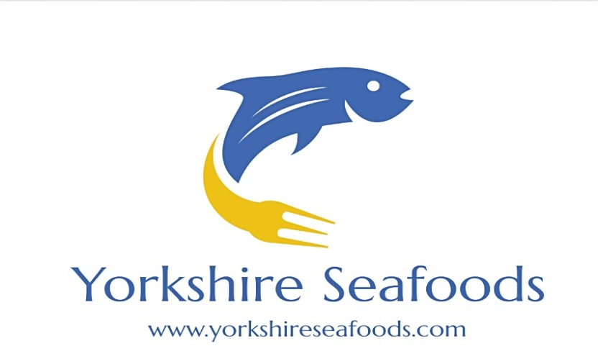

Fresh Fish

Haddock Fillets 5-6oz £15 for 10
Cod Fillets 5-6oz £15 for 10
Salmon Portions 6oz £25 for 10
Cod Loins 6oz £4.50 each
Hake Portions 6oz £4.50 each
Tuna Steaks 7oz £5.50 each
Swordfish Steaks 7oz £3.50 each
Halibut Portions 7oz £5.75 each
Sea Bass Fillets 100-140g £17.50 for 10
Sea Bream Fillets £17.50 for 10

Smoked

Natural Smoked Haddock £11.95kg
D-Cut Smoked Salmon Sides £18.95kg
Kiln Smoked Salmon Sides £19.95kg
Natural Smoked Mackerel £2.95 pack
Peppered Mackerel £2.95 pack
Pale Kippers £2.25 each

Shellfish

Shetland Mussels £3.75kg
Oysters 80p each
Scallop Meat Roe On £26.95kg
Scallop Meat Roe Off £27.95
Palourde Clams £11.95kg
Dressed Crabs £3.95 each
White Crab Meat 85g £4.95
Brown Crab Meat 113g £2.95

Frozen Seafood

16/20 Raw Peeled King Prawns £10.50kg
Paella Mix £7.50kg
U5 Squid Tubes £4.50kg
Plain Squid Rings £4.95kg
Battered Squid Rings £3.50 (500g bag)
Salt & Pepper Squid Chunks £11.95kg
Coldwater Cooked and Peeled Prawns £24.95 (2kg)
Royal Greenland Prawns £29.95 (2kg)
Tuna Steaks 6-8oz £2.95 each
Swordfish Steaks 6-8oz £2.95 each
Halibut Steaks 6-8oz £3.75 each

Plus many more available
Please contact us for more information -
Office 01924 489692 (7am-1pm)
Gary 07872 037287 or Mick 07504 095562

