Beard & Little Johnny Reviews
Episode #16
The Iron Maidens & Paradise Kitty
The Arcada Theater, St. Charles, IL
2-28-25
Welcome friends, fans, and followers to episode #16 of 2025’s new Beard & Little Johnny reviews. Once again, for this one, we are uniting with the best metal site on the internet (Chris Tighes “The Mighty Decibel”), to bring you a review of a unique pair of acts. Iron Maiden all female tribute band The Iron Maidens, and all female Guns & Roses act, Paradise Kitty.
Playing 2-28-25, at the thousand seat Arcada Theater in St. Charles, IL, this was an opportunity for the Beard to examine the question should girls perform as tribute bands of guys? We certainly have some, including “Black Sabbitch” & “Motorbabe,” who have been quite successful at it. Here Little Johnny and I got to check out a couple more. As usual, the Beard was in the balcony while Johnny was at stage front. I would estimate the theater was between 50-75% full for this event.
Paradise Kitty:
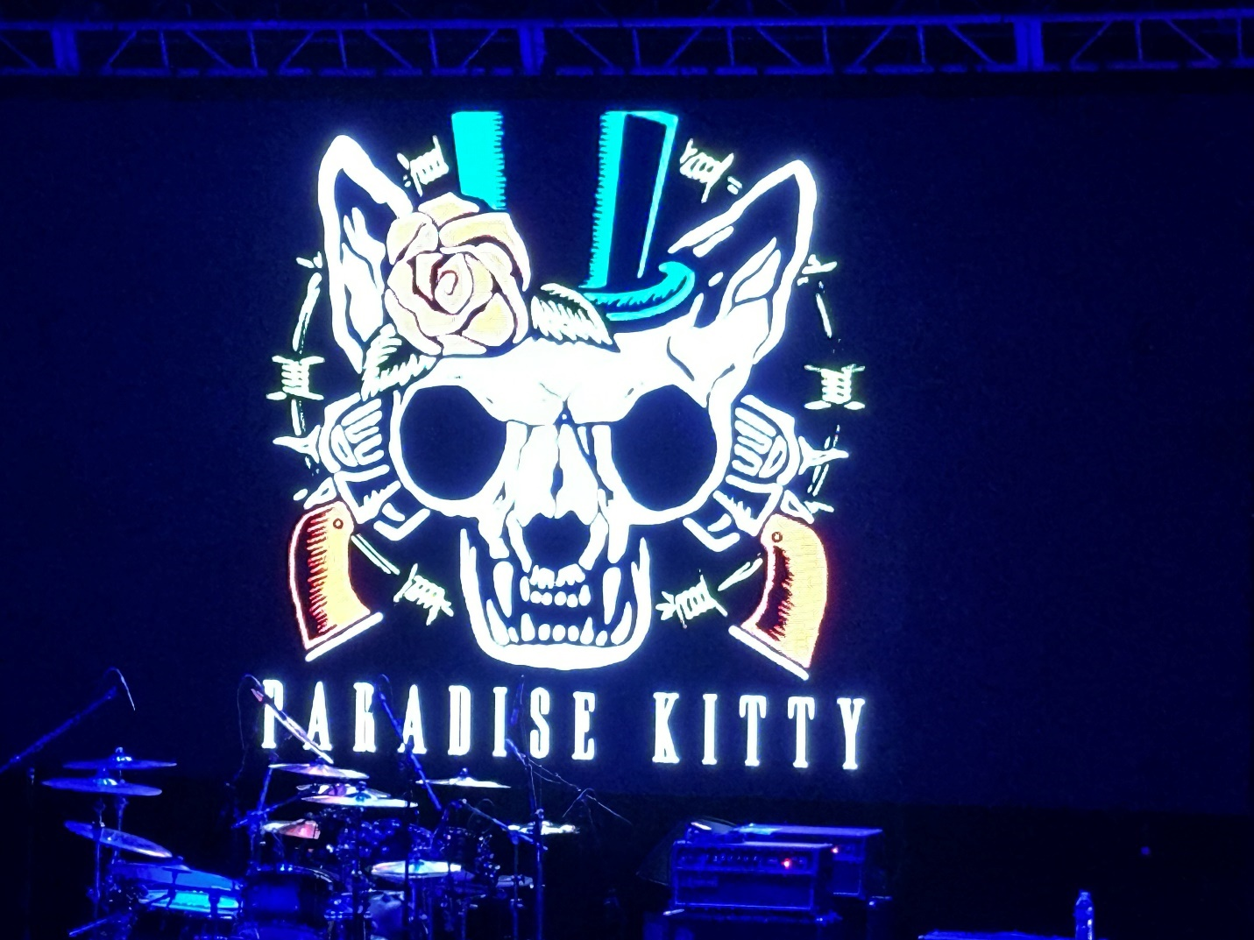
Hailing from the west coast, Paradise Kitty is the long running brainchild of L.A. Drummer Rachael Rine, and frontwoman Jenna Syde. Their site only says a “revolving cast of the best female string players on the L.A. strip.” Currently that included Ariel Bellvalaire, Hisakp Ozawa, and Jessica Fagre.
The ladies hit the stage with “Night Train,” and immediately I noticed two things, one, Rines drums were way too tinny sounding, (which could have been the product of a bad sound check but was distracting with every snare strike.) Second, Syde wasn’t that good of a singer. While she did move like Axel Rose, she sounded like a woman poorly singing Axel Rose.
Follow up songs, “It’s so Easy” & “Rocket Queen” did nothing to alley those impressions. Bellvalaire and Fagre were fine, and Ozawa on guitar was this band’s redeeming feature. While she didn’t nail every note like Slash, more often than not, the solos sounded like they should. Ozawa got high marks.
“Sweet Child of Mine” did get a fan pop, but it had to be on recognition of a song people liked because it was certainly not on how great it was. Again, Ozawa played the solos nicely, but I was already done with Sydes’s voice and singing style.
“Out ta get Me” & “My Michelle” were not songs I was super familiar with so that helped them not sound as bad because I didn’t compare them like I did the bigger hits. “Knocking on Heavens Door” was probably the easiest for Syde to sing and with the guitar solo portions again being good, that may have been the set high point.
Syde told a story about flying into town drunk and getting pulled over by the cops while riding in from the airport, all to introduce “Welcome to the Jungle.” This song, I graded a C- at best, but it was still better than their closer as “Paradise City” was just plain bad. Even the up till then dependable Ozawa wasn’t good on this one. Their encore was “Mama Kin” which was sort of a tribute of a tribute since that song was Aerosmith’s.
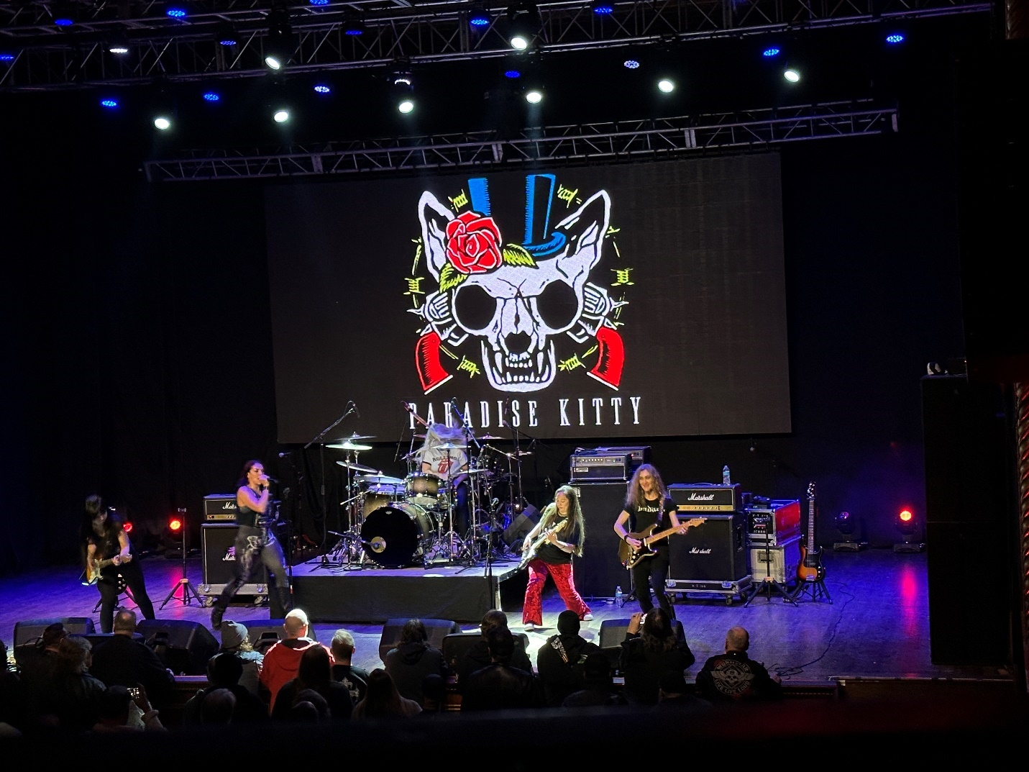
After the set finally ended, I got together with Johnny to see what he thought from his stage front location. “Beard, that wasn’t particularly good. I mean a few of them were hot and stuff and I may try to get that singer’s number but as a performance? I can’t imagine the real Guns & Roses sounded like that.” “I am with you little dude. I know the crowd cheered a lot, but I don’t know at what.” We decided Paradise Kitty got a 70/100 and that was largely thanks to Ozawa’s very good guitar work. Ultimately, there was no paradise in this kitty. Paradise Kitty not recommended.
The Iron Maidens
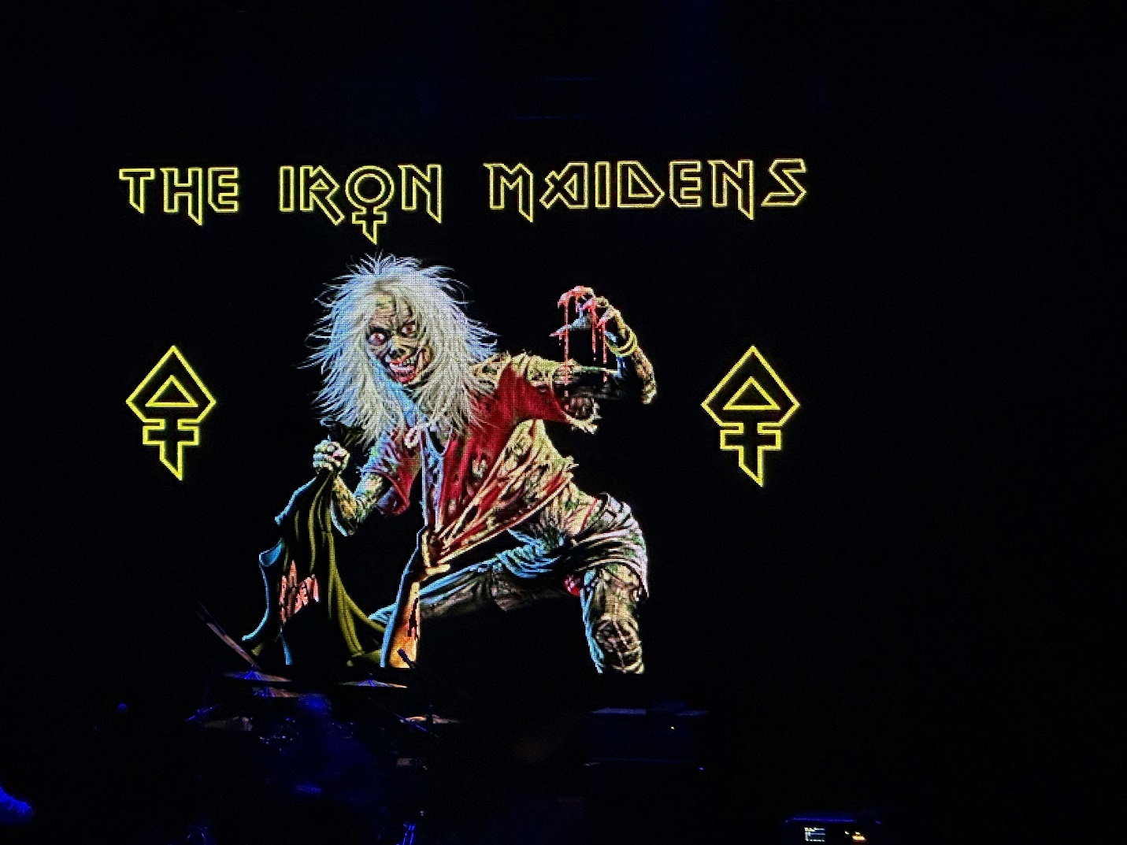
Another L.A. band, the Iron Maidens have been together over twenty years and have had some amazing guitar players come through their ranks including current Alice Cooper guitarist Nita Strauss and Burning Witches axe woman Courtney Cox. (No, not THAT one.)
Currently sporting original members, Linda McDonald (drums), and
Wanda Ortiz (Bass), and flanked by Kirsten Rosenberg (vocalist 2008), Nikki Stringfield (guitars 2012), and Alyssa Day (guitars), the Iron Maidens were a “Beast” of a different color. If Paradise Kitty made me think all girl groups shouldn’t play Metal, the Iron Maidens reassured me that in fact the competent ones should.
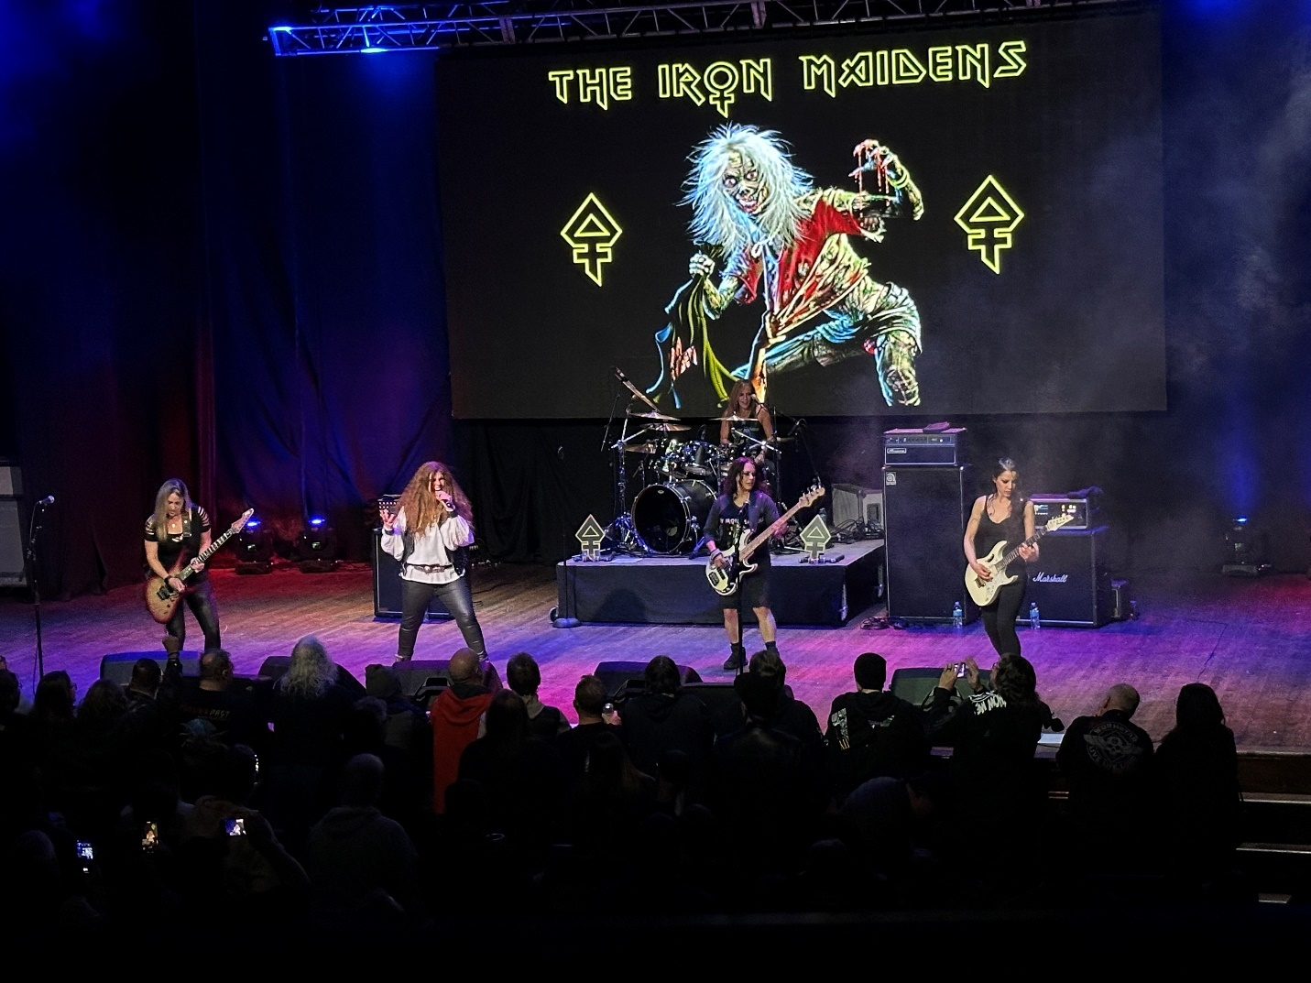
Coming out to “The Ides of March,” right away these ladies set the right tone. Their instrumentation was better tuned, better sounding, and better played. Stringfield was a GREAT Dave Murray, and Day was a good Adrian Smith. With Oritz handling the Steve Harris role, this instrumental indeed made me sit up and think, “Okay, now THIS might BE something.”
When Rosenberg hit the stage for “Wrathchild” I admit I was surprised by how deep her voice was for a lady. Once again, I immediately thought “This band might pull this off.” An accidental technical snafu on “Two Minutes to Midnight” held that song down a bit, and “Killers” although a favorite Maiden song of mine, is really Paul Dianno’s song more than Bruce Dickenson’s so I reserved judgment on that one. “Wasted Years” though had my head nodding along as Rosenberg could do a solid Dickenson, and again the ladies on guitar were solid throughout the song, hitting the solos and doing them well enough that I could suspend disbelief and just enjoy it. (This one generated over a thousand views in less than a few hours on my TikTok page at thebeard0728)
The next three songs were a bit of a lull. “Losfer Words” and “Infinite Dream” I was not familiar with, and “The Trooper” although played very well, I felt Rosenberg struggled some with getting all the lyrics out in Dickenson’s rapid fire staccato delivery.
She redeemed herself all the way though on “Number of the Beast” as the tone of that song’s success starts with that initial scream. If you are trying to do Bruce Dickenson, that needs to be loud, and it needs to hold for anywhere from 10-15 seconds. Rosenberg again surprised me with her lung power, and even if sustain was used to slightly elongate it, (and I am not certain it was), THAT was a damn good scream man or woman. The rest of the song was solid all the way through as Rosenberg spit out the lyrics and the ladies tore up the guitar work.
“The Loneliness of the Long Distance Runner” was another instrumental, but it was the shows high point as the combination of all three guitars held me firmly in a state of thinking “That’s exactly how this ought to sound.” Unlike Paradise Kitty, the Iron Maidens knew how to close a set as Rosenberg, feathered head mask adorned, gave us a great “Powerslave,” before returning for the encore “Hallowed Be Thy Name.”
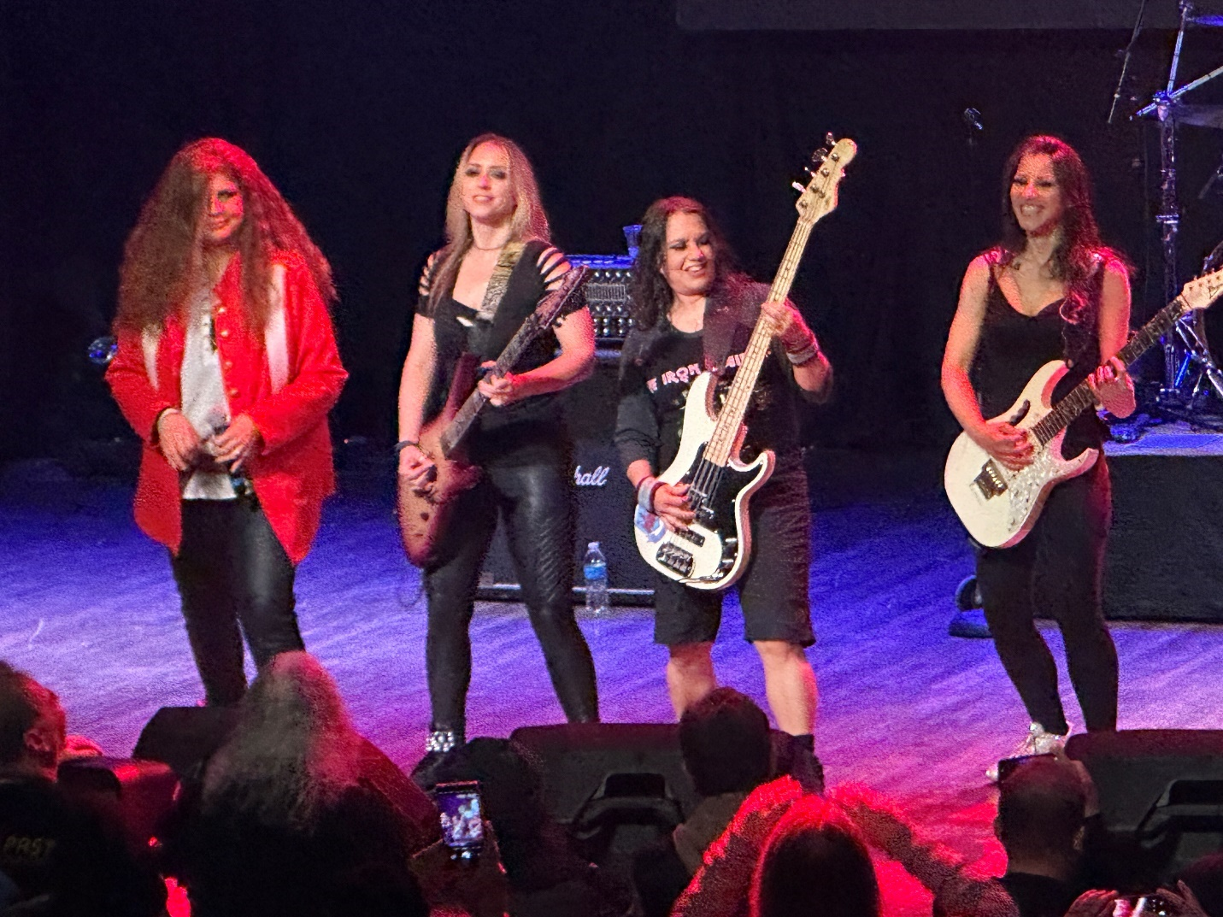
That one is the Beards favorite Maiden song, so I will be generous AND critical here. Generous: Again, the tone is set by just how long one can hold the note of “running lowwwwwwwwwwwwwwwwwwww” then complimenting it with an up-volume scream. Exceedingly difficult to do because you want to hold the initial note as long as possible while still having the wind to then bump up the last part on a single breath. Rosenberg did that about 80% of the way and that was good.
Critical: First, the entire first part lacked the fullness of the bells and crash cymbals and therefore sounded “lacking.” Plus, once again, that one had a lot of lyrics, and they come quickly. Like many Iron Maiden songs, it is made for Bruce Dickenson’s voice and particular vocal talents. Pretty much everyone will fall short of nailing the entirety of it and there were indeed holes and weak sections, but over all it was a good rendition.
In the end, the Iron Maidens earned my respect as a particularly good all ladies tribute of a difficult to emulate superstar level band. Throw in not one, or two, but three appearances of “Eddie” Iron Maidens beloved mascot and you had a good set that was made even better by what preceded it.
The Beard consulted with Little Johnny who agreed, “Beard, that one was fun. They could play great. She sang good, and the monster dude that kept coming out was awesome. I liked em.” “Well said Johnny. Hey, did you get that number from Paradise Kitty’s singer?” “Naw, I struck out Beard, but hey nothing ventured right? Hey, have they given last call yet?”
The Iron Maidens got 90/100 for tackling a difficult act and succeeding far beyond my expectations.
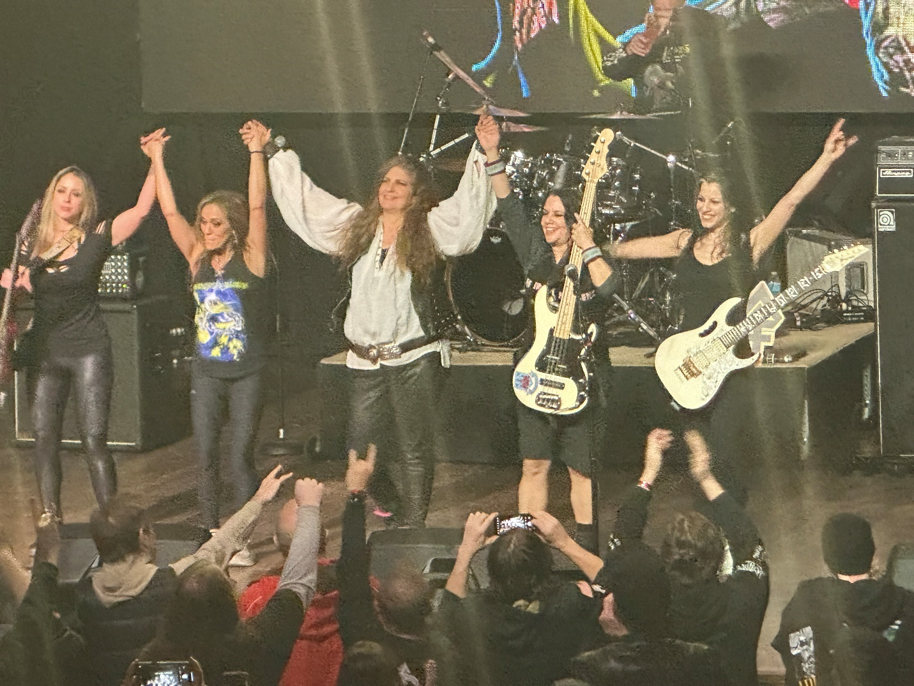
That does it for this episode of Beard & Little Johnnys reviews, but we will be back soon and until then remember to follow along with all our sites:
- Facebook Mark McQueen
- Facebook Beard and Little Johnny
- TikTok the beard0728
- Reviews & Metal content: The Mighty Decibel .com
- Still developing: Beardandlittlejohnnyreviews .com
Until next time, this is the Beard reminding you all to “Live Life” “Stay Heavy” and as always “Horns Up.”

