Beard & Little Johnny Reviews
Episode #22
Hells Heros Metal Festival Official Day One
White Oak Music Hall, Houston, Texas
3-20-25
Greetings friends, fans, and followers and welcome to day two of the Hells Hero’s Metal festival from Houston. Since last night was the pre-party, we will refer to today as Day One of the official Festival. Johnny and I arrived today around 11:30am and headed to the same place VIP ticket holders went inside the last two years.
To explain a bit, the festival itself, for a three-day pass, costs about two hundred dollars. VIP is an add on that costs an additional two hundred dollars. For that upgrade you were supposed to receive:
- Separate entrance line
- Balcony viewing with limited seating.
- Dinner and small bites/snacks throughout the day from the VIP room
- An official festival t-shirt and poster
- Entrance to the pre-show party event the night before
So, since we were paying double the price, there was an expectation that consummate value accompanie that price. In the previous two years, that was borne out. This year however it was sorely tested.
To begin with, for the previous two years, there was a special entrance for VIP pass holders right at the front of the venue allowing immediate access to the upstairs balcony section. In 2023 & 24, VIP pass holders stood in line, got wanded by security, showed our passes, received our wristbands and were inside in minutes. This was a great procedure and contributed to the value of a VIP pass given how long the regular line was to get in.
This year, EVERYONE had to start in the same line until passing security. Then VIPs went to the left and regulars to the right. This hardly shortened the waiting time at all because it is the long line to get everyone inspected by security that takes all the time. This new method hardly saved any time at all for the VIP holders and provided almost no value for the extra two hundred dollars.
Next, we wanted to receive our free fest merchandise. The shirt and poster. So, we went to the merch line and asked, “Where is the line for VIP to pick up their stuff?” We were then directed to the Hells Hero’s festival merch line where we dutifully stood with everyone else only to be told, “Oh, we aren’t doing that here. You have to get that inside.”
So, back inside, where no one seemed to know anything about it. This was like going to the concert version of the DMV. Once again, two hundred extra a ticket for this “upgrade.” Finally, I found a sympathetic lady who made a phone call and after being told by whomever was on the other end that we couldn’t get our stuff until Saturday, (bear in mind it is Thursday right now), incredulously said into the phone, “he is VIP. That is not acceptable. Get an X-large shirt and a poster and bring them here now! GREATEST EMPLOYEE IN THE PLACE!! Whoever you were ma’am; you were my favorite person all weekend. Thank you, thank you, thank you.
So now, t-shirt and poster in hand, we went to the balcony where indeed there were about fifteen chairs. We assumed, like in years past both balconies would be available. How wrong we were. In 2023, & 2024 there were two balconies, each with chairs, and each with a private bar for VIP people. In 2025, there was one balcony and no private bar.
Have I mentioned the two hundred extra dollars we paid for this upgraded treatment?
Finally, there were the bathrooms. Upstairs had a two stall and two urinal set up. On day one, one urinal was already out of order. By day two both urinals were out of order. So, to sum up. They screwed us on the entrance lines, the merch pick up, the balconies, and the bathrooms. General pass holders had to be laughing their asses off at us this year. This did not set a good tone for the event. But finally, we were about to watch a bunch of bands and that is what we were there for. So, let’s get into it.
Band #10 Sanhedrin
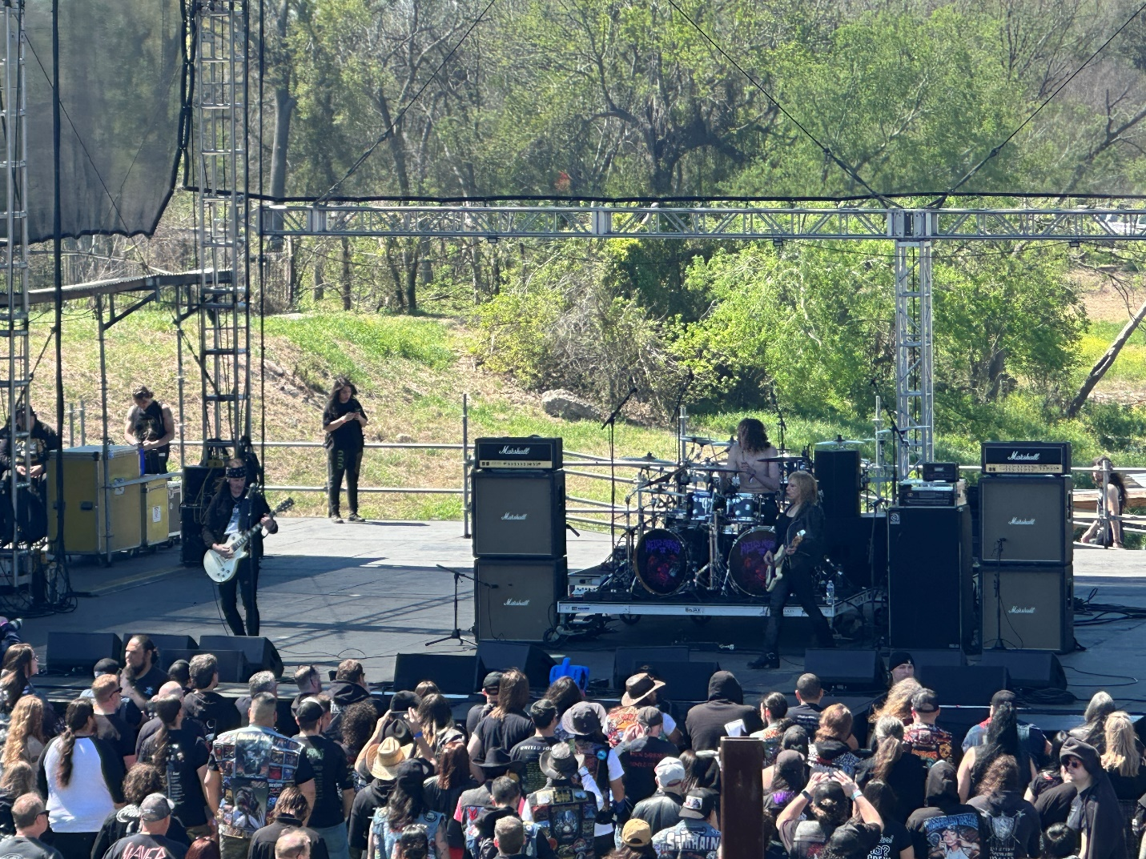
First up was this three-piece doom paced band. Actually, a little faster than straight doom. More like doom meets occult rock. Now, I first saw this group last August and was critical of them then. Frankly, they fixed everything I critiqued so I must have been on to something.
Good opening set. Their female vocalist had a clear voice, and she was more animate with the crowd then last time I saw them. Especially as a fest opener, this was good. People were excited to be there, and Sanhedrin used that to create energy for 30 minutes. Erica Stoltz’s east coast Brooklyn voice kept the grade under 90, and I felt like the sound was a little off but also thought it was just some early fest tweaking. Really, Sanhedrin were a better-than-expected kick off and I was feeling generous early so 86/100.
Band #11 Black Jackal
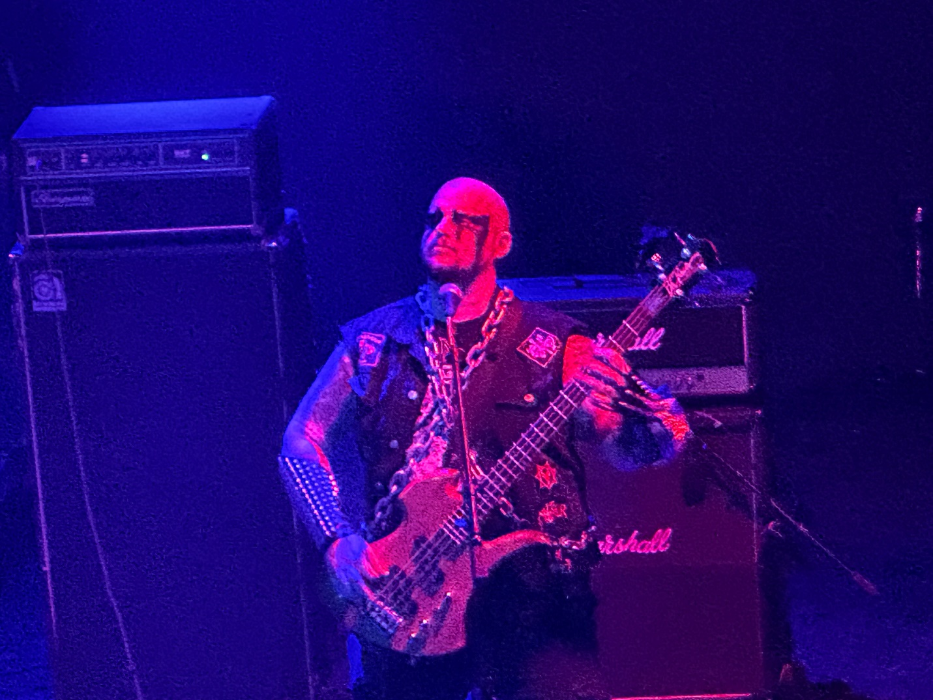
This was a mix of black and speed metal ala Bewitcher or Midnight. Decent sound for that style. The bass player was heavily corpse painted and had the kind of voice where everything sounds evil. He must be fun at the McDonalds drive up.
“I want a quarter pounder with cheese, but no pickles or Satan will rip out your soul!!! Oh yes, and fries please…from the bowels of the Beast!!!! Aaagghh!!”
Still, humor aside, these guys were fun. 85/100 for early effort and good commitment.
Band #12: Satan
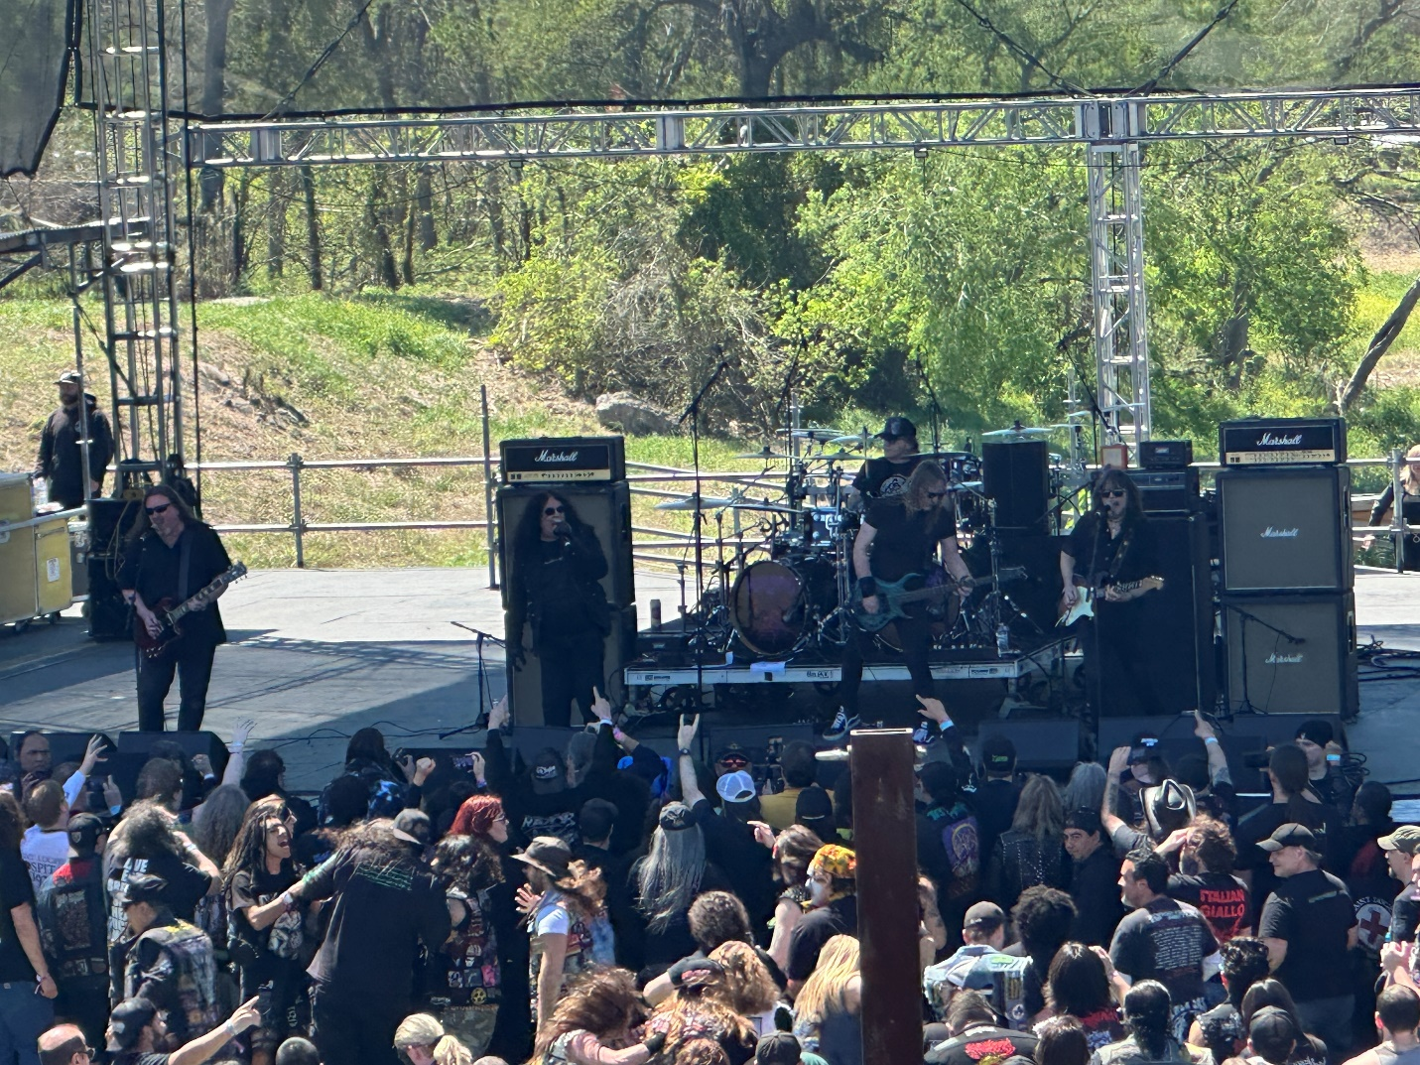
A second set from Satan, this time on the big stage. This set had more old school hits than last nights but otherwise it’s still just Satan. Same old man ranting about crowd surfers as happened at last night’s set. Satan hates crowd surfers which IS funny because when you think of all the things Satan could hate, crowd surfers doesn’t make anyone’s list.. Still, the set was fun and definitely NWOBHM English. 82/100
Band #13: Chamber Mage
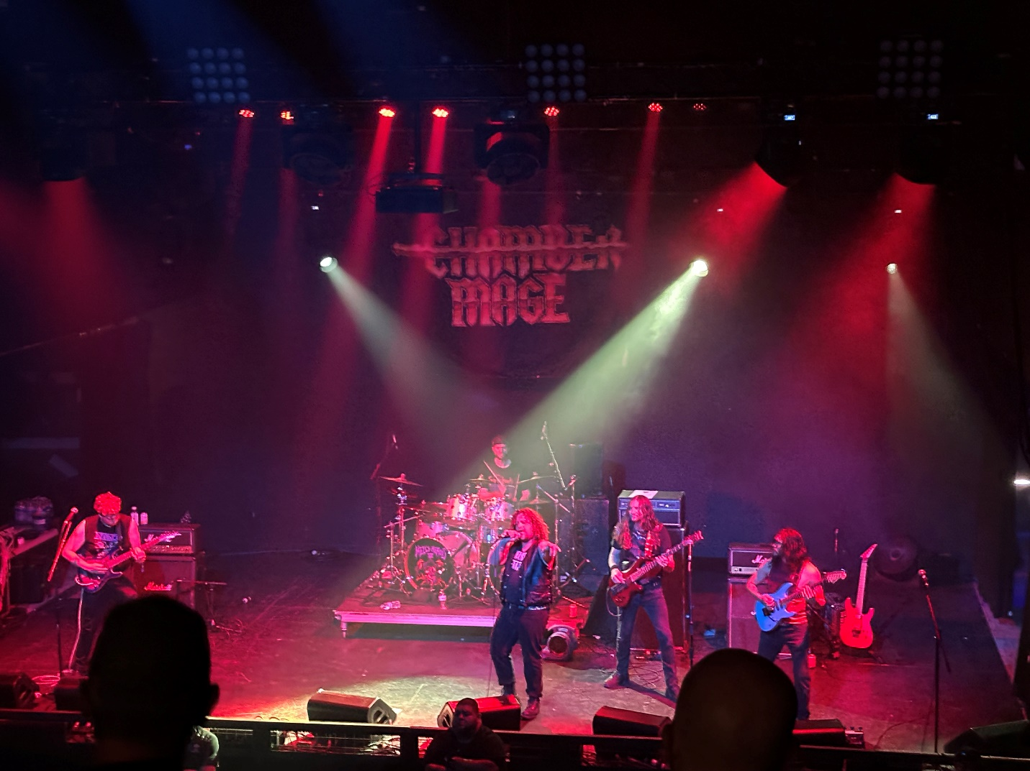
Trad Rock/ Metal. These guys honestly were a miss for me. I didn’t like the vocalist, and the music was just ordinary. I can only go 70/100 on this band. They may have been low for the festival.
Band #14: Fifth Angel
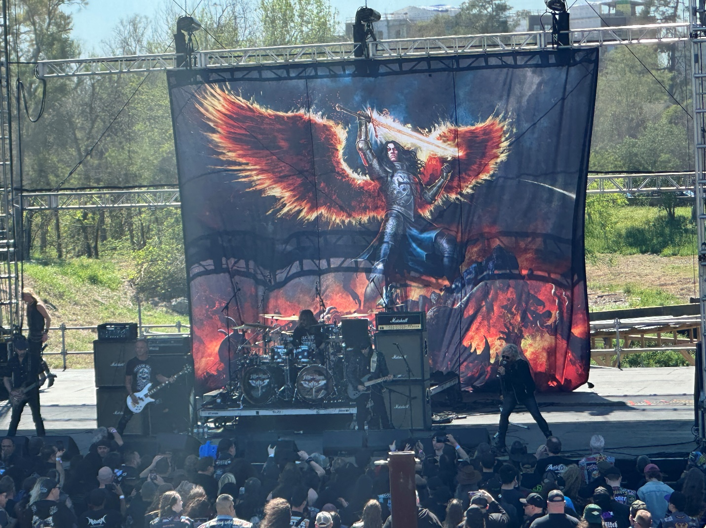
One of my must-see bands today. I had always missed this 1980’s era act, so I was looking forward to finally seeing them live. With two original members and three from 2019 or later it’s a mash up of eras but two original members is still better than Foreigner or REO Speedwagon.
Basically, Fifth Angel was traditional metal. Fairly polished although for the third band in a row, the lawn stage sound was way off. Although there was good lyrical clarity, I wasn’t blown away, but I am not complaining either.
Fifth Angel had a great backdrop. Best so far, and their singer can hold a note. The old era songs sounded far more dated while the newer ones from their 2017 reformation were fuller and probably better songs. I will go 84/100. I just wish the lawn stage sound wasn’t sucking.
I am skipping the BDSM metal of Savage Master since I have seen them so many times, instead I held my spot for Swedish speed metal act Enforcer.
Band #15: Enforcer
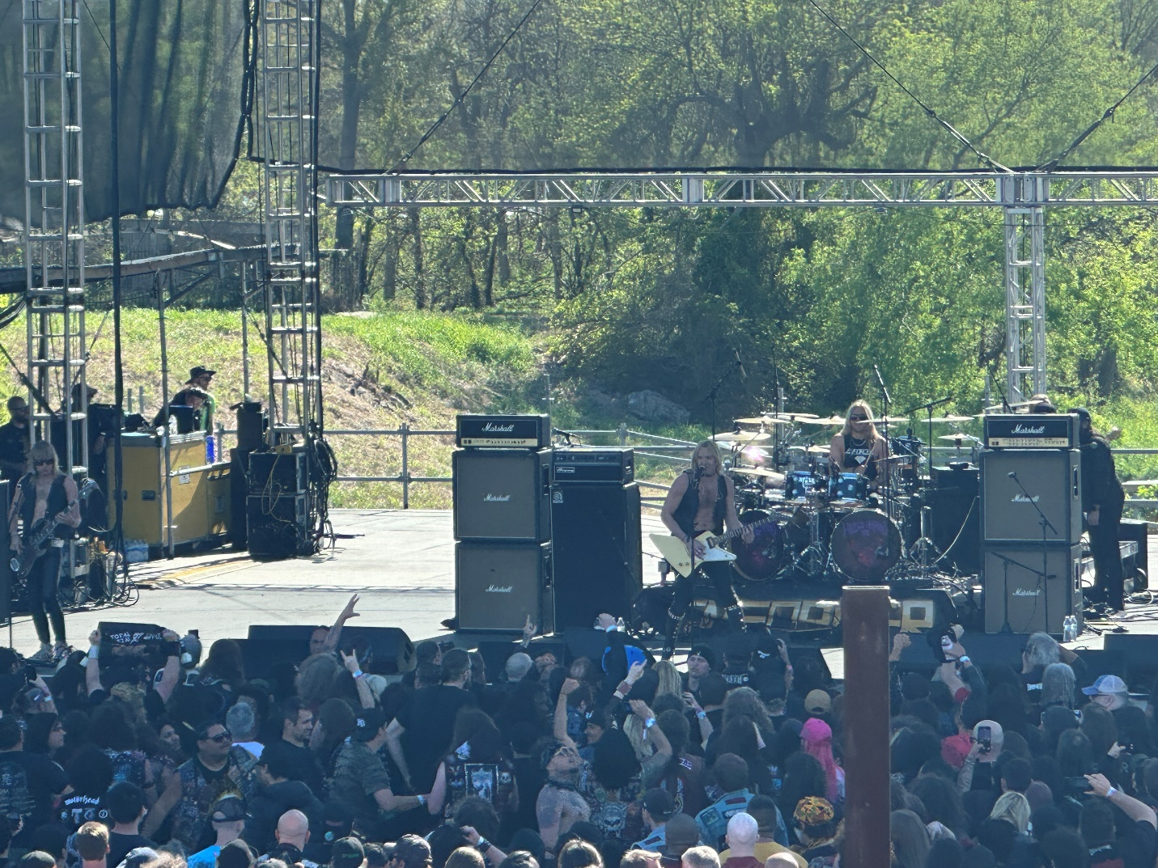
Enforcer got sound fucked. They looked good and moved well but the lawn sound was absolutely horrendous. It was so bad the band apologized and said they were going to play tomorrow to make up for it. I really wanted to enjoy this set, but I had to rate it a 90-band getting a 60 sound. So, 75 and that’s generous. I actually felt sorry for those guys. All the way from Sweden to sound like absolute crap from no fault of theirs.
Band #16: Castle Rat
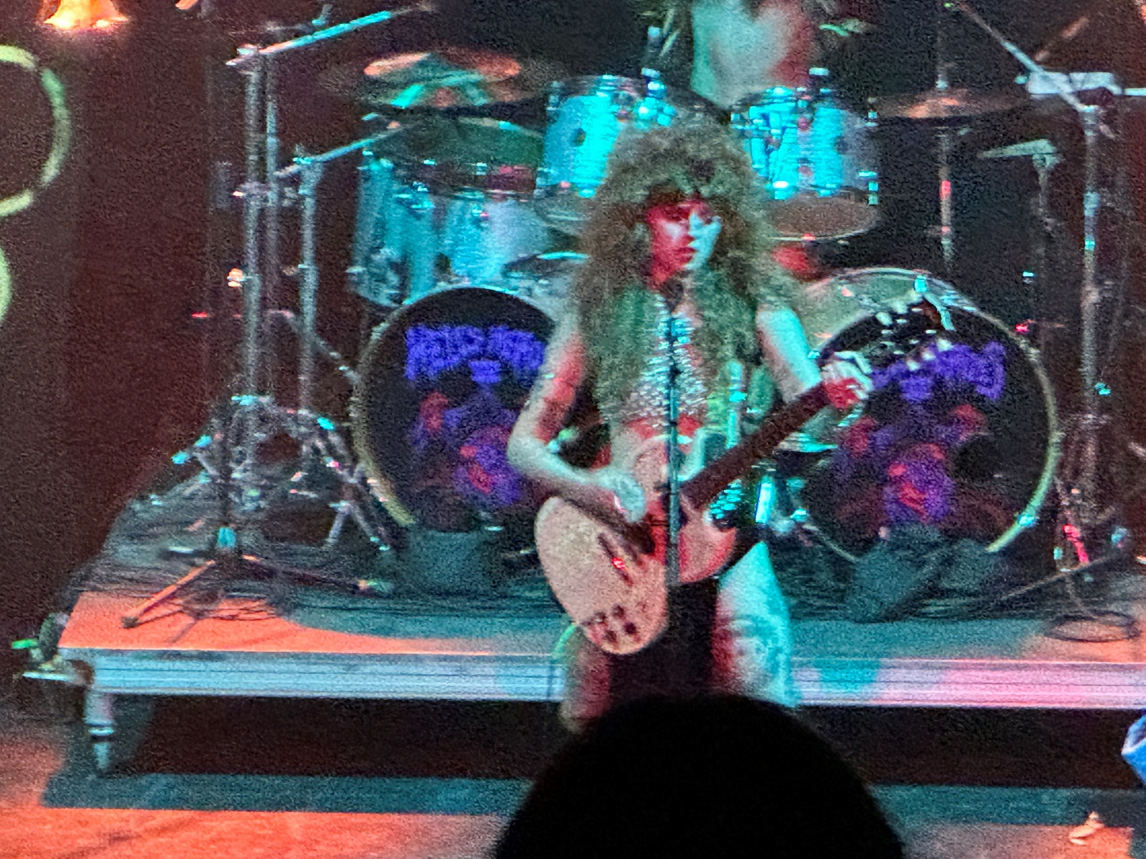
Following the horrible sound Enforcer got, on the second stage even a test pattern would have sounded good. Castle Rat though sounded GREAT!
This was another Occult Rock band with a sexy wild looking female lead singer. Good spooky heavy doomy style act. Very enjoyable. This was both songs AND a story. Musical Theater with a horror tale within the Metal. Castle Rat was the hit of the fest so far. Crack a cold one for the rat. 93/100
Band #17: Hirax
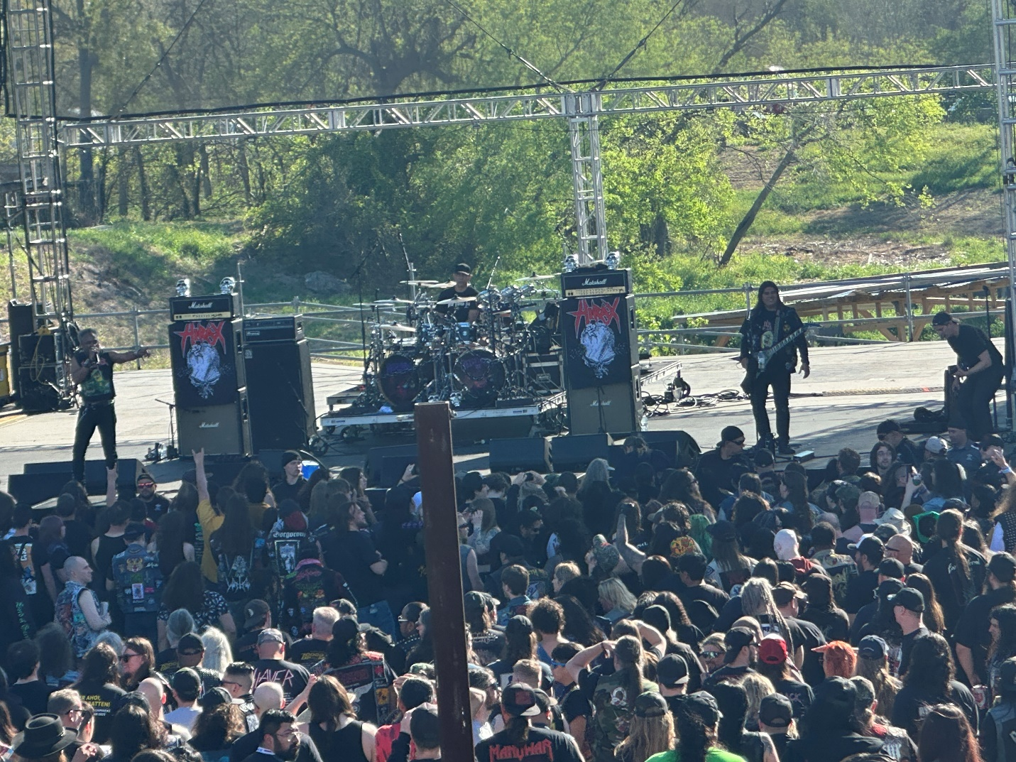
Metal meets Crossover. Kenton De Pena keeps going like some sort of west coast energizer bunny. Little Johnny loved these guys last year and even though sound still sucked up there on the lawn stage, with Hirax it was easier to hide it.
I am awarding an 88/100 and I don’t even own any Hirax. Here though is my reasoning. De Pena is sixty-one. That old man is my senior and The Beard can tell you with all honesty that if I tried to sing two of his songs on stage with THAT much energy, you better bring the paddles of life because I assure you I would pass the #}%> out. De Pena can still throw down for an hour on stage and then throw down for two more backstage, and at the end of the night he will walk out while the rest crawl or get carried.
In Game of Thrones, when you met your “better”, you bent the knee in respect. The Beard and Little Johnny mutually bend the knee to Kenton De Pena and Hirax.
Band #18: DRI
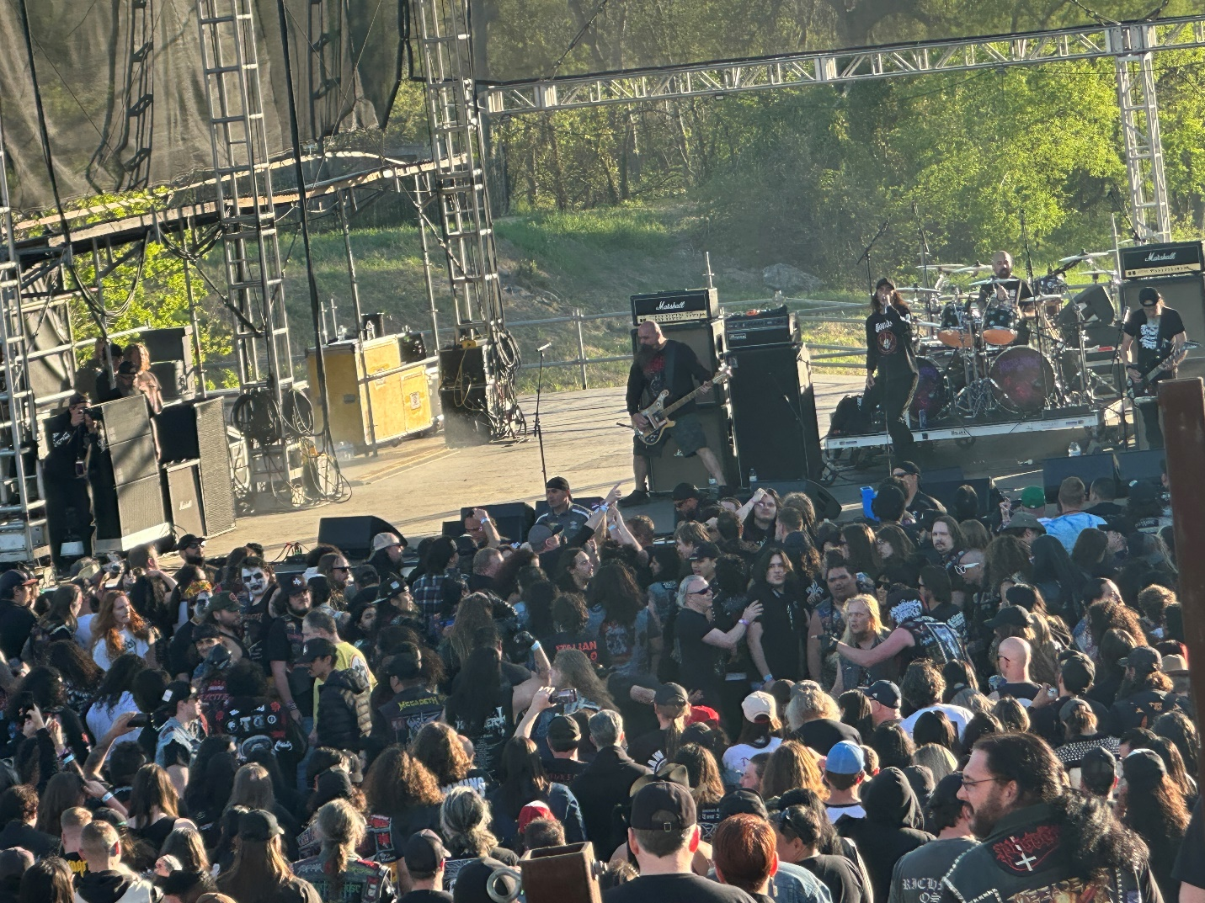
Even after exhausting himself running around and surfing during Hirax, this was Little Johnnys can’t miss band of day one. DRI was hardcore punk metal where being in the Pit meant “try to survive.” I of course was hiding in the VIP balcony for this one, and hoping the lad made it through.
Every song for DRI had to be considered a Pit song but for me that style got old. I prefer a song develop like a relationship rather than like a 14-year-old losing his virginity. I am afraid DRI is only getting a 75/100 for me. Yeah yeah Chris Tighe, I know. I’m fired and Little Johnny is going to end up my boss.
Band #19: Omen
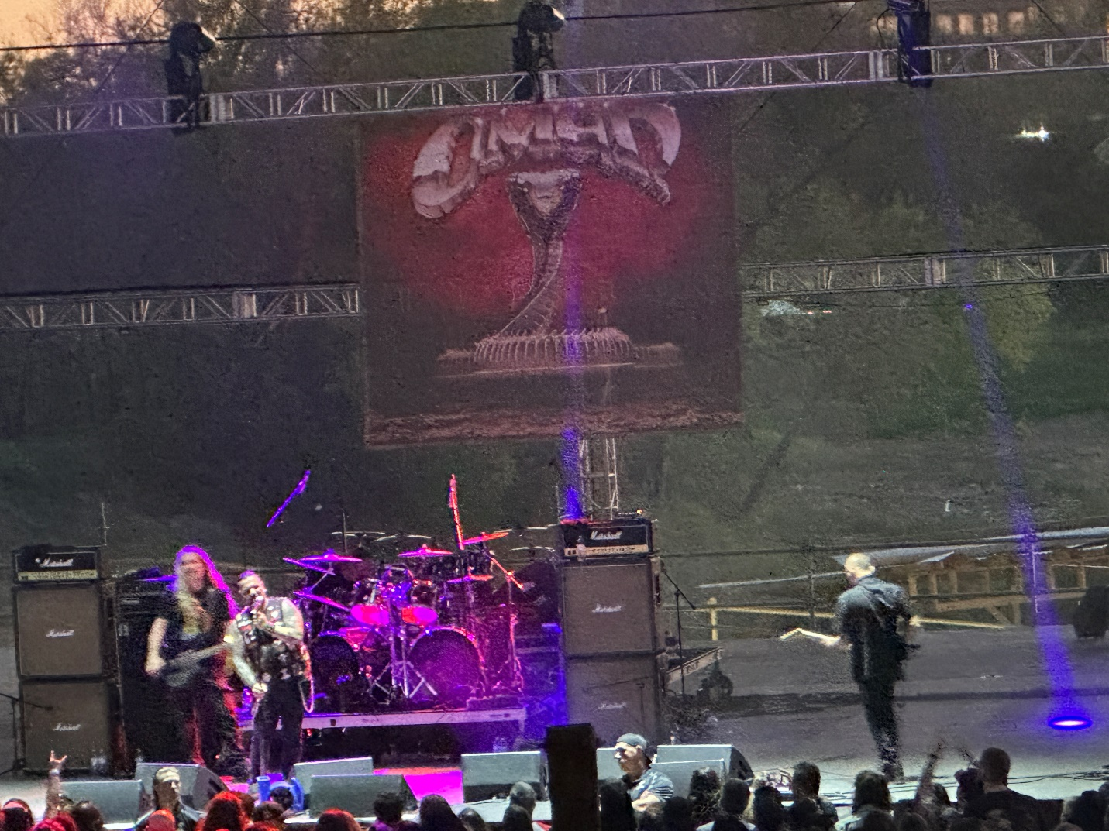
Filling in for fest favorite Warlord (who had visa issues getting here), was power metal act Omen. They have been around for over forty years, but I have never been that taken with them. Still, this was a nice slot with the sun setting and the crowd thickening. The sound was better than what it had been but still never sounded like everything was correct.
Singer Nikos Migus sounded like that early 1970’s band Black Widow. There’s a deep-cut reference for you kids. Omen was billed as 1980’s but only Kenny Powell can truly make that claim. The rest of the band members joined in 2017 or later. Omen was solid but unspectacular. 77/100
Band #20: Abbath
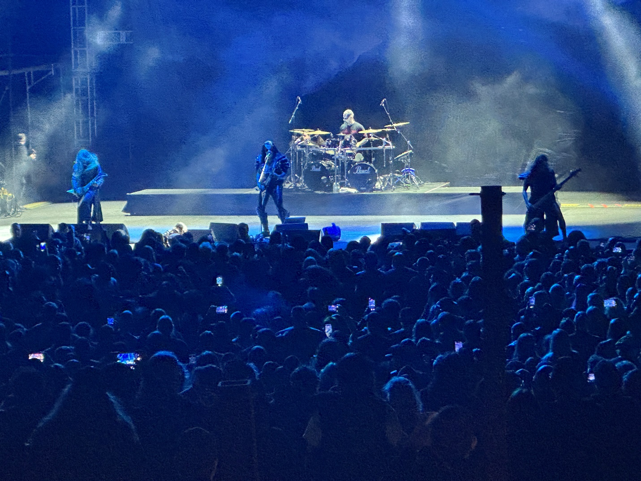
Mixing his “Immortal” roots with his solo material, Abbath is a pretty much “know what you’re going to get” band. If you love his brand of black metal, Abbath is superb, and many in the crowd certainly felt that way. If it isn’t your thing, then Abbath can sound very repetitive. I seem to linger on the edge.
Although I noticed differences between early and later material, it was still water from the same well. I enjoyed both the ambiance and the brutality but in the end Abbath gets 84/100 as night one’s headliner.
So, in the end, day/night one had poor lawn stage sound, poor VIP treatment, and fair bands with one big exception in Castle Rat. Johnny enjoyed the run of Hirax and DRI but this wasn’t any kind of amazing day for me. The eleven bands cumulatively scored a mere 81/100. Very average day for a Hells Hero’s event. Check it out yourself at my TikTok site thebeard0728 or follow Mark McQueen on Facebook.
Hopefully, this trend will improve. Until then, this is the Beard saying Live Life. Stay Heavy. And Horns Up.

