The Beard & Little Johnny Reviews
Episode #21
Hells Heros Metal Festival Pre-Party
White Oak Music Hall, Houston, Texas
3-19-25

Greetings friends, fans, and followers, it is your revealing reviewers the Beard & Little Johnny and today we report from Houston Texas where we journeyed for Hells Heros 2025.

Hells Heros is an indoor/outdoor music festival that brings some of the best local and international Heavy Metal acts to Houston. Now in their seventh year of operation, this will be the Beard & Little Johnnys third year attending.
This review will cover the festival pre-party from Wednesday, March 19th, 2025.
Pre festival show:
After walking the two miles from our downtown apartment we rented to the venue, (with Johnny already grumbling the entire way and muttering “There’s such a thing as Uber ya cheap old man.”, yet never actually offering to pay for said Uber), we arrived at the White Oak Music facility around 4:30pm to find a good-sized crowd waiting for the gates to open.
Right away, the first of what would become a theme for this weekend began to materialize as one of the workers in the line attempted to tell us that our three-day passes didn’t cover the pre-party and that they required a separate fifty-dollar ticket. I knew it was the first day and therefore was polite as I explained the VIP upgrade (which costs two hundred extra), also included “said” pre-party.
Of course I was told no it didn’t. After showing her the email specifically saying it did, she finally said, “Fine. I will quadruple check for you.” The term (quadruple check) was not lost on me and my irritation began to blossom. Sure enough, after a few moments I see her motioning Johnny and I up to the ticket window and sheepishly saying, “You are correct. That does cover it.” No apology of course, but at least we were headed into the show. I smartly decided NOT to ask how she got it wrong on her single, double, and triple checks.
As always, the inside of White Oak Music Halls downstairs stage area was as dark as a well diggers ass at the bottom of a septic tank at midnight. My phone flashlight helped, and I was able to find a good spot upstairs on the balcony for band one.
After explaining to Johnny that in order to access the second stage, we were better off upstairs because then we just had to go down one hallway, he agreed to hang upstairs instead of heading to the stage front downstairs like he usually does.
Since beers here were fourteen dollars plus tax and tip, we did not consume any alcohol on night one. At 5:00pm, right on time, band one began, and the festival was underway.
1. Ice War
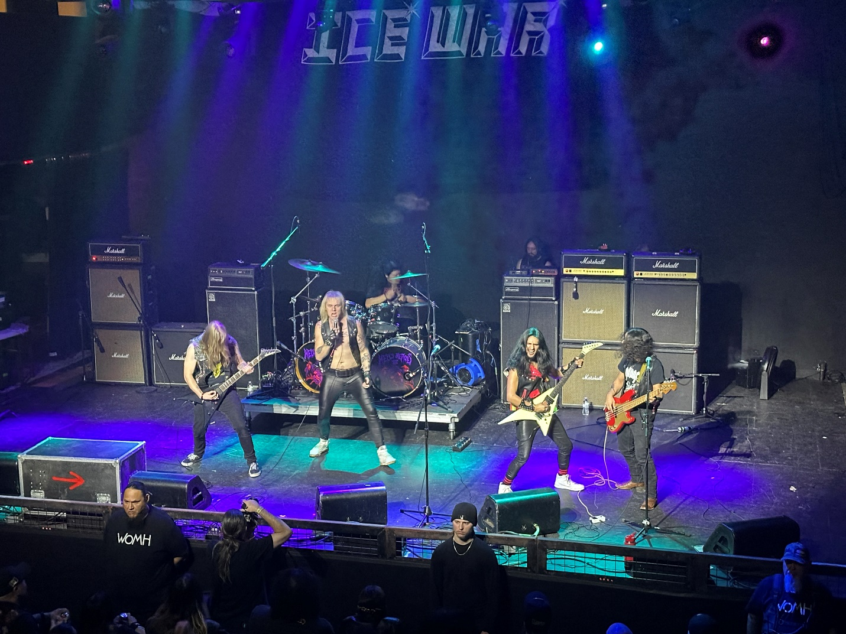
Ice War was a 5-piece mix of power and traditional metal, but all the guys also played in other bands such as Labyrinth and Septic, so this was kind of a one-off type of act opening the festival.
Clear lyrics, with decent leads although the guitarist was far more of a showman than anyone else on the stage. He made bigger moves and struck more “rock poses.” The vocalist had a decent voice, but this was definitely an opening band. 72/100 and we were off to the second room for band number two.
2. Nemesis:
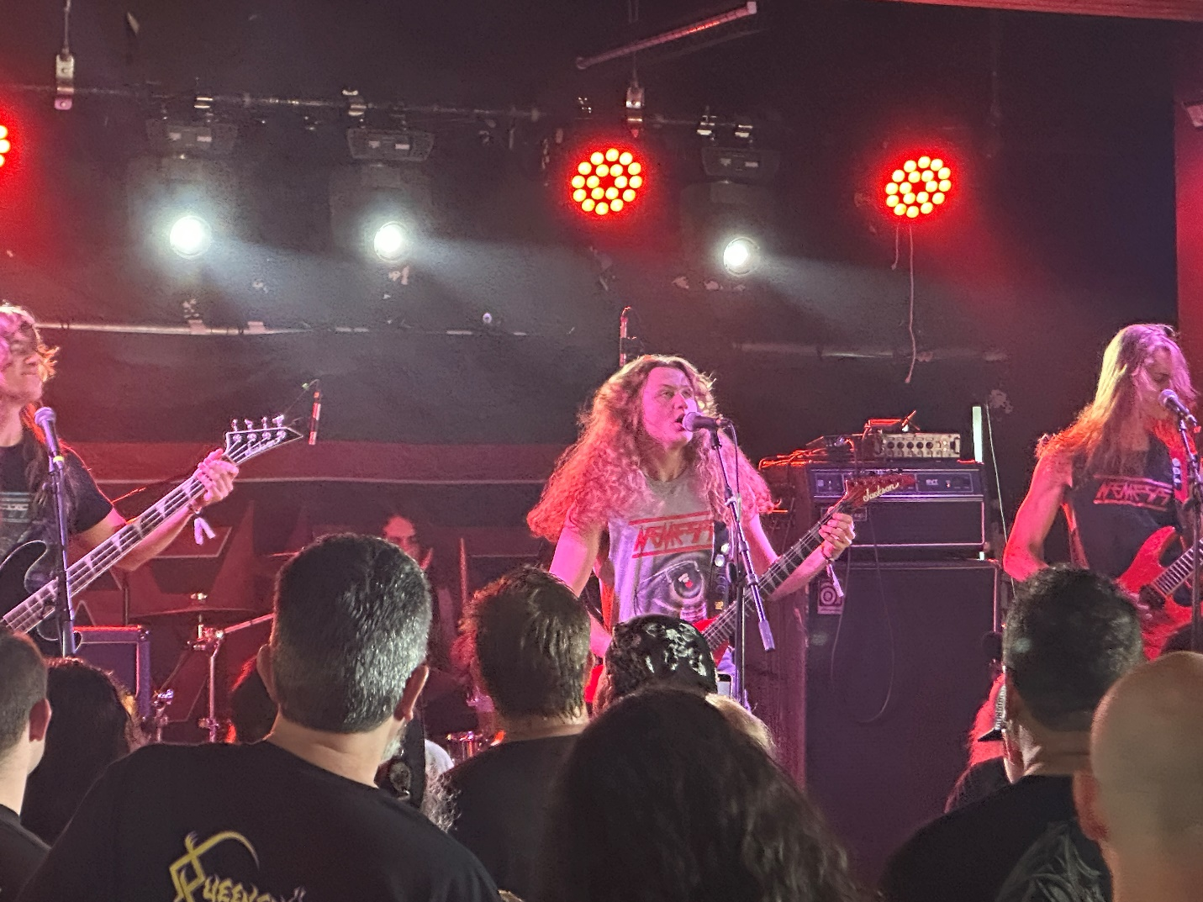
Room number two, (which only had bands at the pre-party and after show events but not the main festival when the lawn stage was in operation), was very small and after a hundred people, it got pretty jam packed in there so Nemesis had a full room crowd at 5:30pm.
Nemesis was thrash. Four piece. Semi clear lyrics. They have only been together since 2023 but have made a decent name for themselves winning a battle of the bands contest on Metal Devastation radio that year and earning an opening slot behind Eyehategod & Goatwhore. Although still very raw, these kids have something that could become a solid touring thrash act in time. 76/100
3 Sentry:
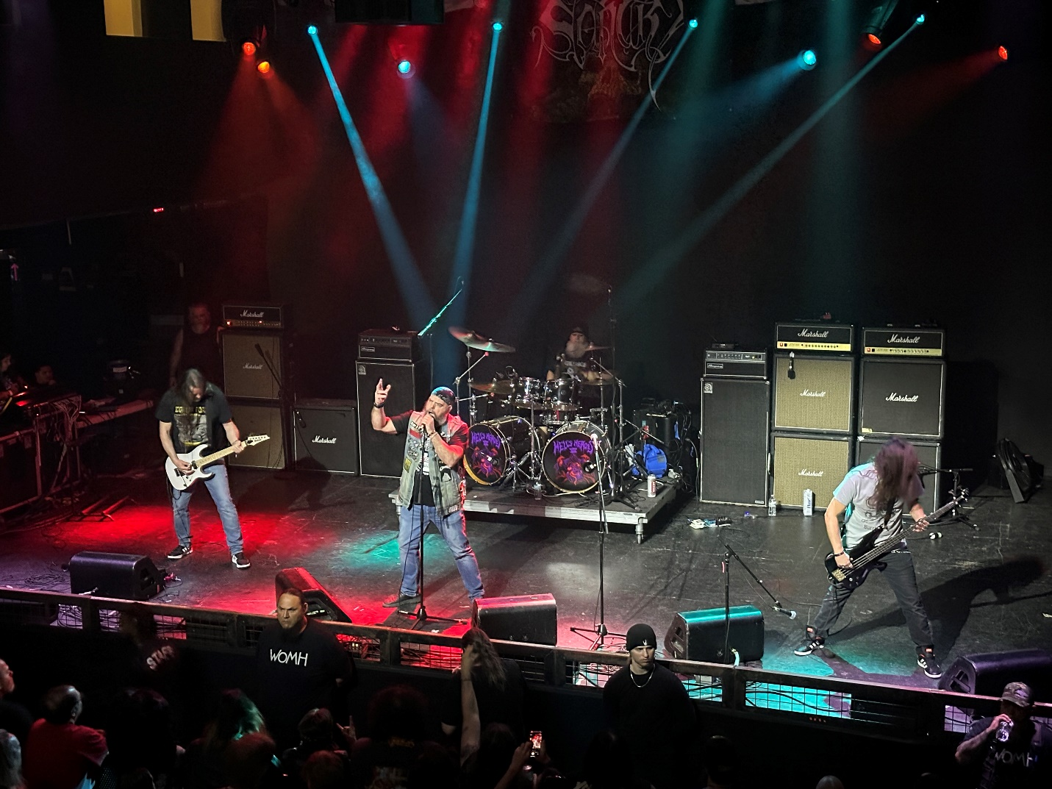
The large rooms second act and third of the evening was Sentry. These guys performed a slower doom-based set with a little power metal. Honestly, these guys looked like a group of bikers who decided to just form a band. Admittedly though, the Beard likes doom metal and therefore I kind of dug this act. Although there was no extraordinary vocal or musical talent, it was a good band and a fun set. Sentry was also the first act of the day to truly fire up the crowd. A very good 84/100 grade.
4. Myth Carver:
By the time we got down the hall, the curse of the small room had already occurred. The room was swamped, and there was just no way to access it as even the hallway was jammed full of fans just trying to hear the band even though they couldn’t see them.
Next year this festival needs a better plan for their second stage. When you sell this many tickets, what do you expect to happen? Simple math says five hundred people can’t fit in a room for one hundred and fifty. No grade for Myth Carver as we just couldn’t get close enough to evaluate.
5. Helstar
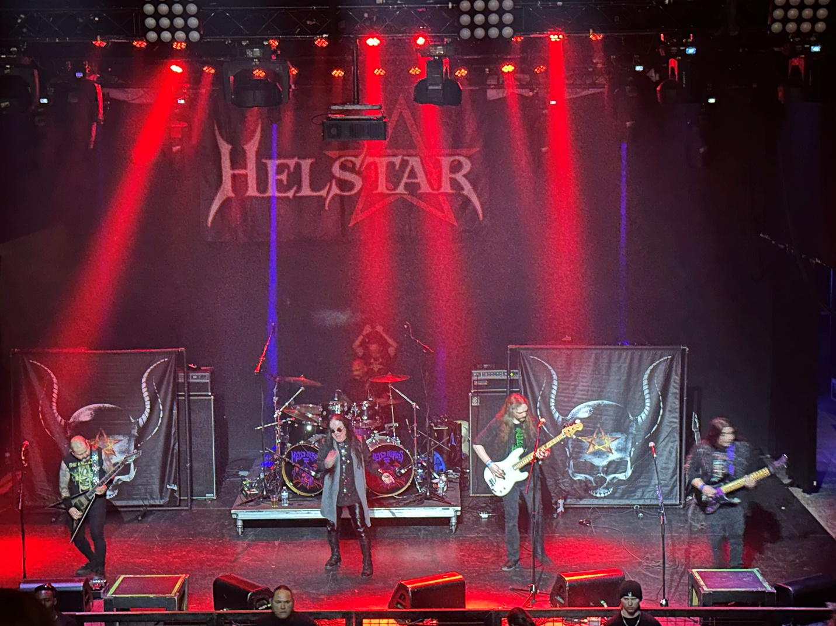
Helstar are perennial Hells Heros participants. Two years ago, they played at the post show party, and last year they did two sets on the main lawn stage. This year they were doing the pre-show party, so I guess they were trying everywhere in the fest.
Helstar is a long tenured Texas band, and with their Ozzy Osbourne doppelgänger vocalist “James Rivera” have released eleven original albums over their forty-year career.
Their music was familiar to me even though specific songs weren’t. Although Rivera has lost a little range on the highest notes, he still has more than most singers, and he knows how to perform and energize a crowd. Helstar was to me the usual forty-five minutes of enjoyment they have been the last two years. 82/100
6. Mean Mistreater:
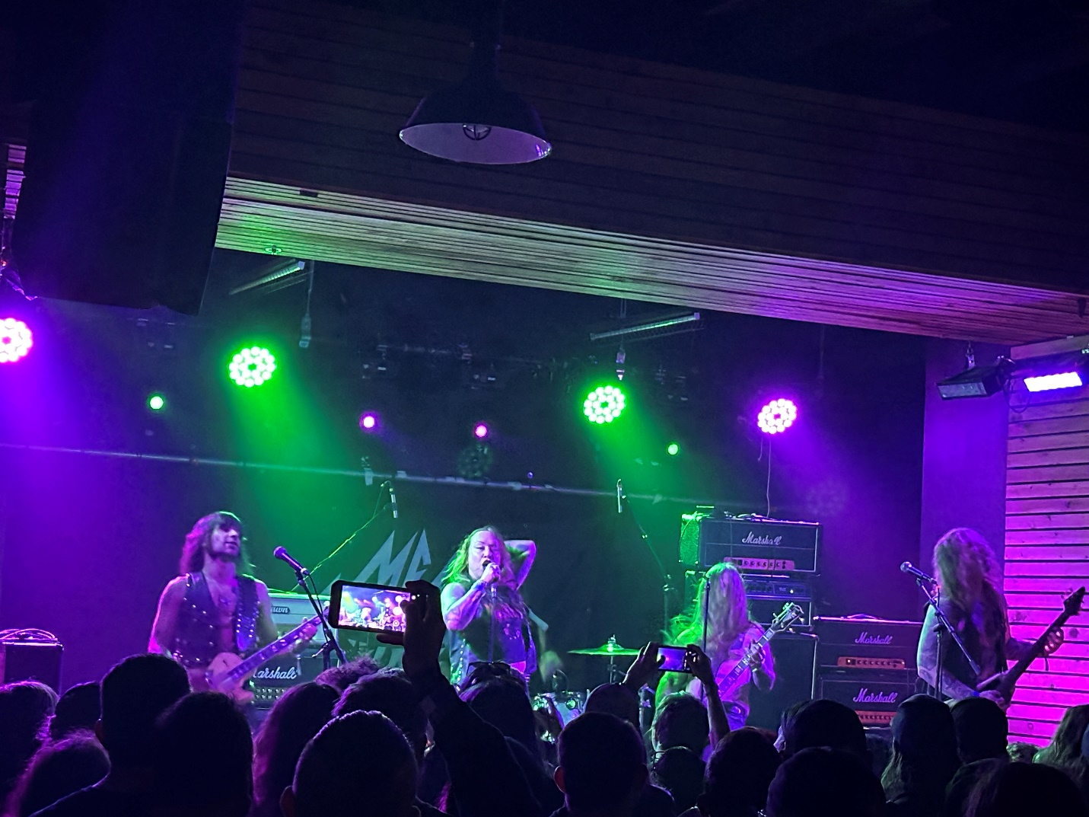
Because we wanted to see this act, Johnny and I exited Helstar early to ensure we were getting a spot in the small room. This effort proved well worth it as Mean Mistreater’s lead singer “Janice Gonzalez” was a dynamo. The rest of the band was also good. This was a high energy act and not a moment was wasted. Mean Mistreater had 30 minutes onstage and gave us 30 minutes of hard speed metal attack. To all the other bands “That” is how you do it. Our first “Crack a cold one” rating and a 90/100.
7. Satan:
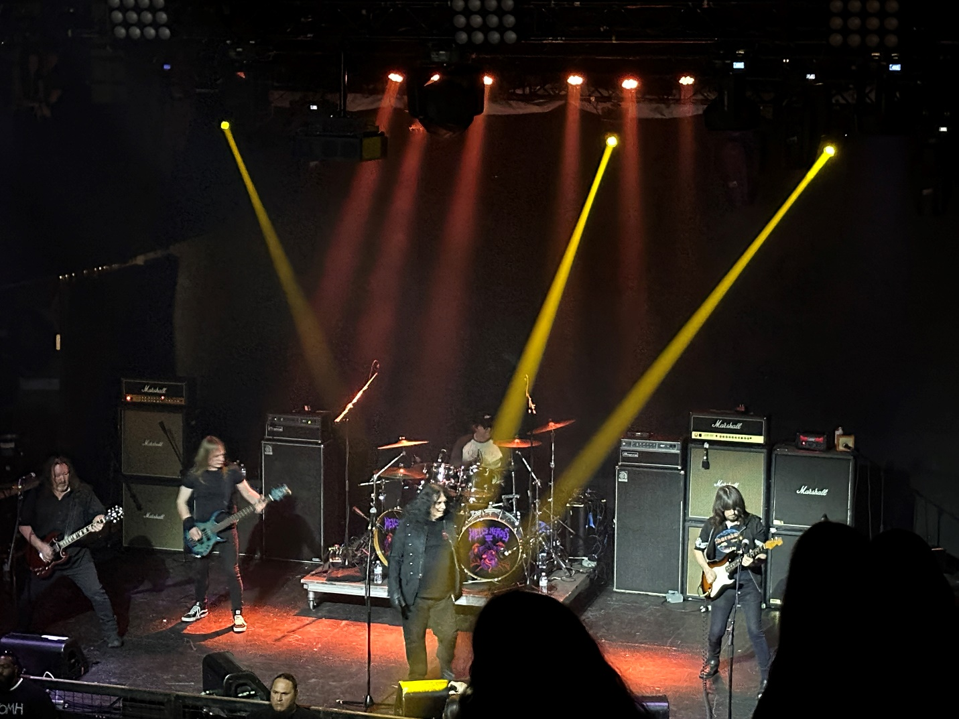
46 years and still going, Satan is the essence of the NWOBHM scene.
Even a brand-new songs like “Sacramental Rights” sounded like it was crafted in that period between 1981-85.
Vocalist “Brian Ross’s” voice remains extremely clear even after all these decades, as does Ross’s continued ranting against crowd surfers. As usual, Ross called them assholes and prats much to the crowd’s delight. With respect to Satan’s new material, I liked it about as much as the classics. There was nothing new under the sun here, but Satan will give you a nice enjoyable set of hard rock. 84/100
8. Dark Meditation
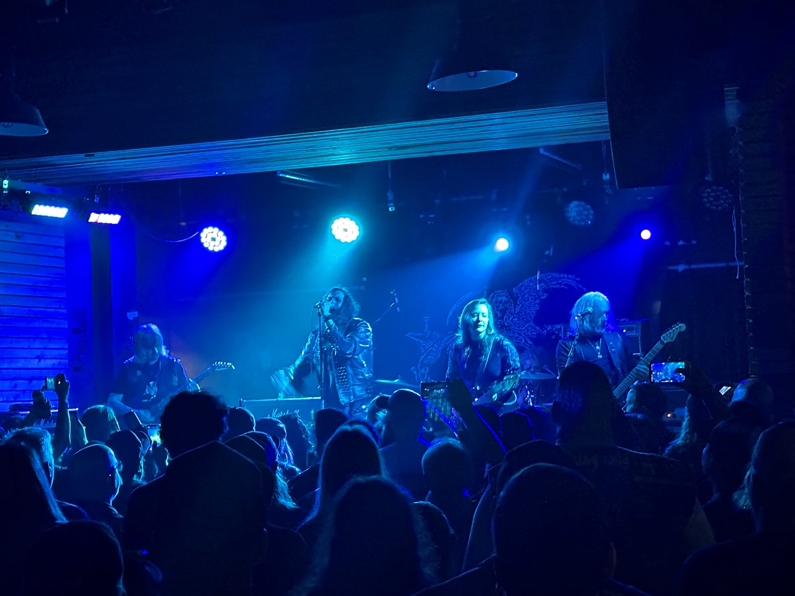
Once again, we bailed early on Satan to ensure a spot in the small room for Dark Meditations take on the Occult Rock sub-genre.
This five-piece act from the west coast was better than I had expected. I enjoyed clear lyrics, some slightly psychedelic guitar work, and songs that were like a cross between Uncle Acid & the Deadbeats & The Witches of God. Going with a surprising 86/100, and I earmarked getting some of their stuff.
9. Liege Lord:
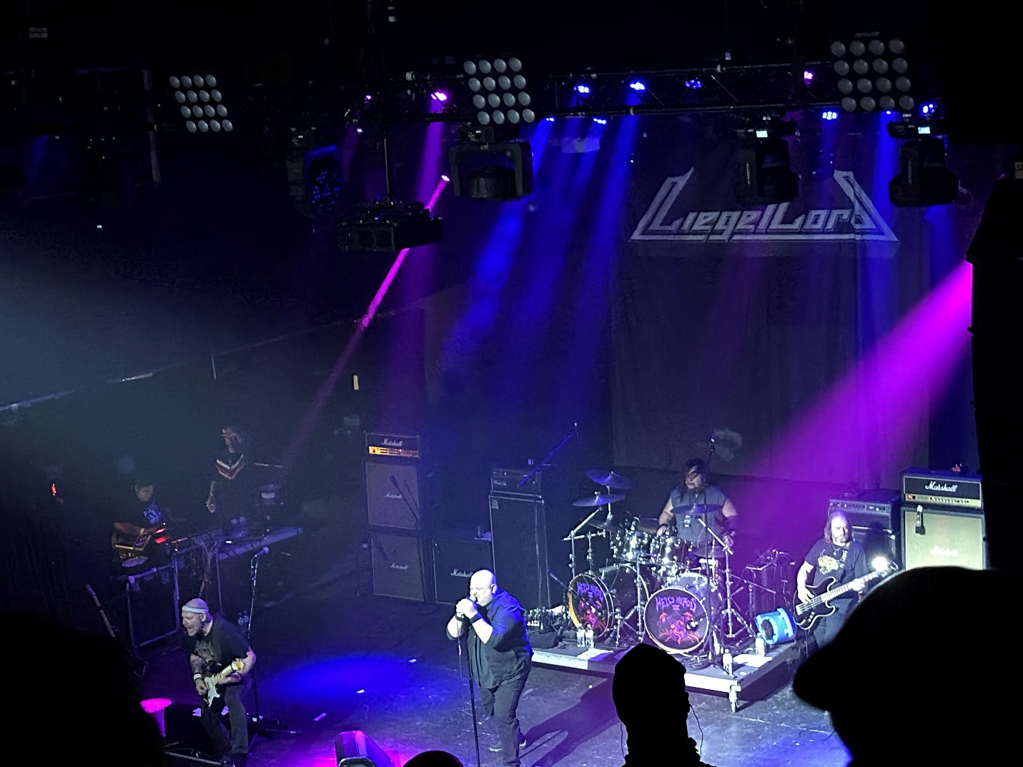
I have seen this 80’s power metal act several times. They kind of do same old same old. It’s not bad and the crowd enjoys it, so I guess that’s what matters, but I can’t rank it that high. They did play a new track “Hypocrisy” so that was something. I respect the talent, but Liege Lord just never does it for me. Going 79/100.
10. Spiter:
Having seen this punk vampire band last year, I did not tackle trying to get in the small room for this one. Little Johnny thought much more of them than I did last time, so we separated, and he made his way there while I remained in the bigger room.
Spiter is not bad, but vocalist guitarist “Richard Spider” is like what would happen if Dee Snider of Twisted Sister and Lillith from Tomb of Dracula had a quickie, and he was the resulting progeny. Spiter is an over-the-top act that I did not feel like fighting to see this time. No grade.
11. Riot:
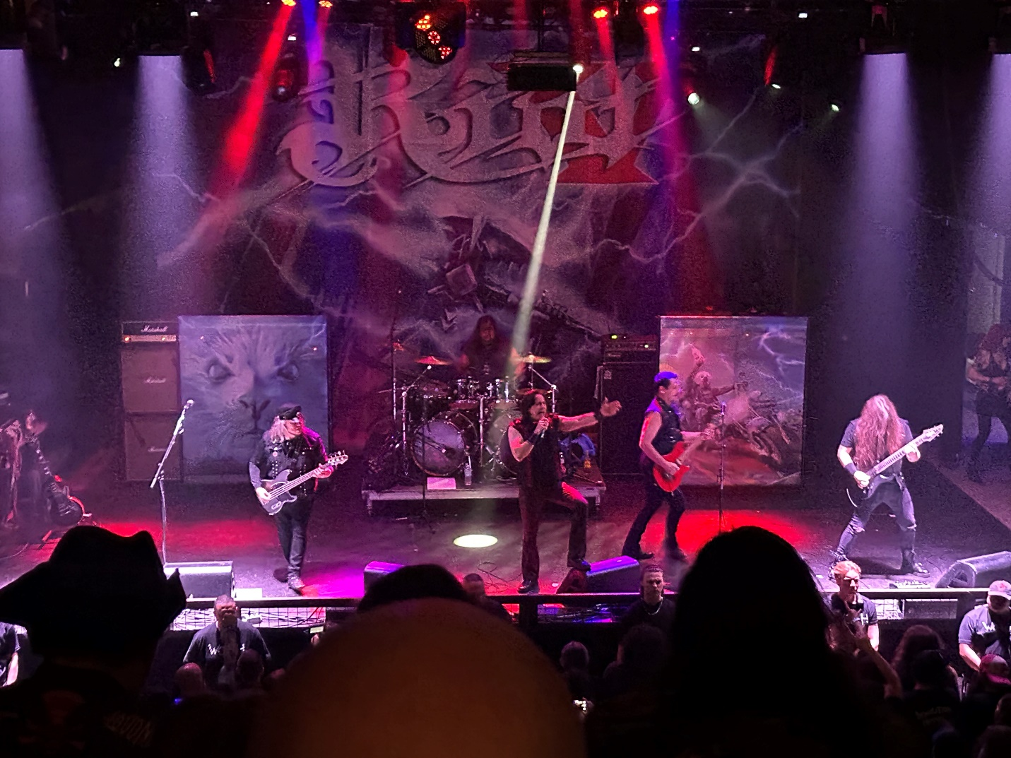
Riot has had a lot of incarnations, and I have seen both touring versions over the last two years. This version, with long time bassist “Don Van Stavern” had the higher voiced vocalist in “Todd Michael Hall” This is a band with about seventeen albums over the years and has proven to be resilient even if they just never really connect big with the mainstream. Watching the set, their fans knew their stuff and several songs generated loud sing-a-longs. An entertaining set and worth an 85/100
That wrapped up night one of Hells Hero’s. As Johnny and I headed back to the apartment after the evening, he mused about the crowds and looked forward to being able to prowl the lawn area again like the last couple of years. This was a good, even if unspectacular, first day and we hope you check out the video footage of all the bands on our TikTok site @thebeard0728. Remember to follow us on Facebook at Mark McQueen and also on the beard and little johnny Facebook page. Finally, check us out on themightydecibel.com and thebeardandlittlejohnnyreviews.com.
Until next time, this is the Beard & Little Johnny saying, “Live Life,” “Stay Heavy” and “Horns Up.”

