Beard Reviews Episode #17
The Rock Orchestra by Candlelight
Coronado Theater, Rockford, IL
3-1-25
Greetings friends, fans, and followers, it is your best loved reviewing duo (The Beard & Little Johnny), and we are popping in for a visit to our favorite heavy metal site, Chris Tighe’s The Mighty Decibel. Tonight, we covered a unique act touring America, The Rock Orchestra by Candlelight.
Performing at the perfect place for a show like this, (the 2300-seat Coronado Theater in Rockford, Illinois), The Beard & Little Johnny had front row balcony seats for this mostly sold-out show. The Coronado is an older theater with breathtaking gothic molding and a sinister “feel” to it, so this act was right at home.
The stage itself was adorned with hundreds of candles and skulls, (including an Easter Island sized one in the center.) Each side of the stage was set up. Stage right had drums, and strings, with stage left having a second set of drums as well as brass instrumentalists.
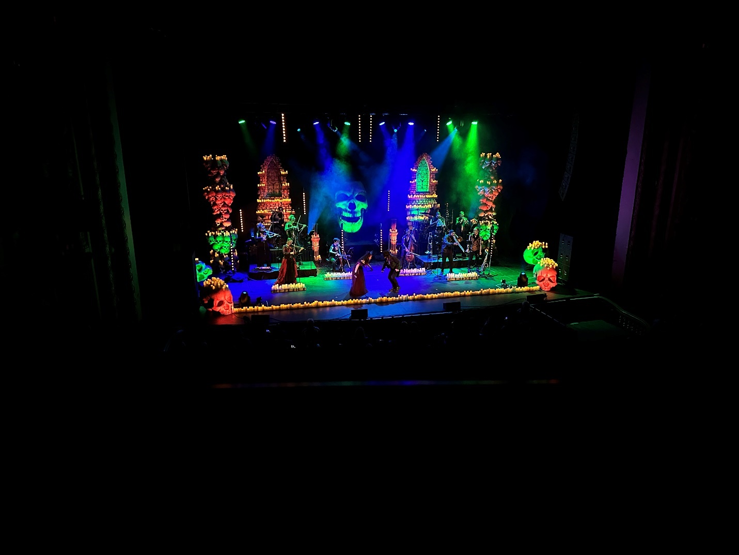
Overall, there were ten band members, including violins, cello, horns, winds, drums etc. There were also two singers, (male & female), and the band leader and lead violinist, so it was a thirteen-piece orchestra. The musicians were dressed (and often masked) as skeletons, zombies, or other gothic horrors. The visual presentation was first rate. The question was would the performance be as well?
Coming out to Vivaldi’s “Storm,” lead violinist Ivana Cetkovic wasted little time showing the audience she was a skilled master of classical music, however after a round of appreciative applause for that number, Cetkovic began playing AC/DC’s “Thunderstruck.” With the backing of her orchestra, the instrumental version of that song ROCKED! I can’t say it any clearer and I advise skeptics to check out my TikTok page at thebeard0728 to hear it for themselves. Even without lyrics, “Thunderstruck” was a fantastic jumping off point.
Following would be “Last Resort” by Papa Roach, which the Beard did not know, however, it allowed me ample opportunity to see that the collection of musicians was an effective and skilled unit working in time and unison. “Sweet Child of Mine” was next, and in my opinion, this orchestra blew away the Paradise Kitty version from last week’s review. (See Beard Reviews episode #16.) This was all instrumental again, but it was played almost perfectly. Once again applause all around from the sold-out crowd.
Next, it was time to unveil one of the vocalists as Erin Fox, in headdress and crimson gown looking like she walked directly out of an Edgar Allen Poe story, added to the orchestral genius by singing Aerosmith’s “Dream On.” Now, for practically anyone who has ever heard about a cover of “Dream On,” the first question is always, “Did they hit the big note?” Answer to that is YES! Fox had the lungs and the voice to break a few beer glasses as she gave her homage to Mr. Steven Tylers fifty-year-old scream for the ages.
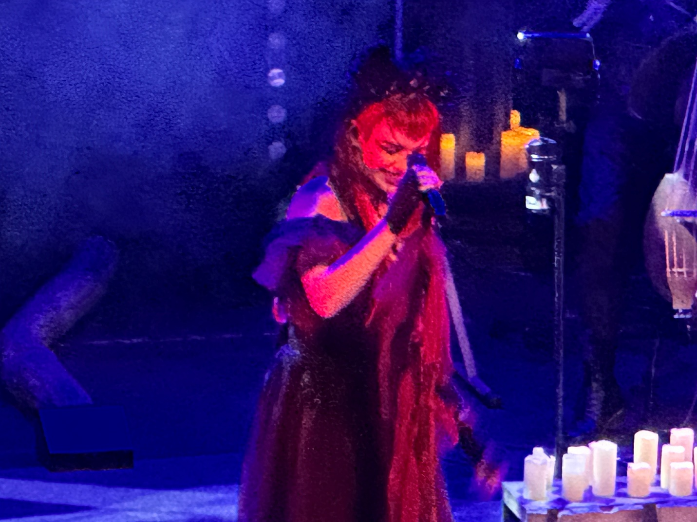
“For gods sake Beard, just because the act was a gothic nod to Shakespeare doesn’t mean you have to write that way. Just say the hot chick hit the scream on Dream On.” “Thank you Johnny but I am writing this review just fine without your help.”
The next three numbers would be instrumental again, as a masterfully rendered “Stairway to Heaven” led the way followed by “No One Knows” from Queens of the Stone Age, and finally the far simpler but well performed “Run to the Hills” from Iron Maiden. At this point, nothing about this set had been even a bit off. It was now time to introduce the second vocalist, Sky Murphy, who looked rather roguish in his black pants, shirt, and hat. Fox joined him and the act went into “Bring Me Back to Life” from Evanescence.
That song requires a strong duet to bring home the vocal prowess of Amy Lee & Paul McCoy. Murphy and Fox not only did so, but Fox hit the concluding note for a show stoppingly long duration. The crowd was already on their feet and applauding before Fox finally took a breath 17.4 seconds after she started that final note. Yes, I recorded and timed it, so check out Mark McQueen on Facebook to both see and hear it for yourself.
An instrumental “Toxicity” from System of a Down would come next as a pallet cleanser before the orchestra ended set one with Beethoven’s “Fur Elise.” During intermission, Little Johnny looked over at me and said, “Beard, because of the combination of syncopated rhythms, tempo changes, and those fast 16th note inclusions, THAT song is really hard to play, and they nailed it.” After I picked up my jaw from the floor, I said, “How in the hell do you know all that little dude?” “Oh, we studied classical music in the orphanage. Beard, I’m not “just” good looking, I’m smart too.” “Okay Johnny, now “I” need a beer. “Cool, get one for me too please.”
After intermission, set two began with an instrumental version of “Welcome to the Black Parade” by My Chemical Romance, which I admit I did not know and had to look up. After that though, Fox retuned to the stage and covered, “Nothing Else Matters” by Metallica. Although I did enjoy her reworked version of the song, I still confess no one has beaten Tarja Turunen’s (of Nightwish) version. Fox’s was good just not the best.
Oddly though, the instrumental version of “Tainted Love” was really really good. Seeing I was into it, Johnny leaned over and said, “Never figured you for a Gloria Jones fan Beard.” “Who are you tonight, and what have you done with Johnny?” Next would come another instrumental as they tackled their second GnR number with “Welcome to the Jungle.” The score now stands Rock Orchestra 2, Paradise Kitty 0 on Guns & Roses covers.
Sky Murphy made his return and put over Lemmy from Motorhead as God, (which is debatable but not completely inconceivable) before he and the orchestra launched into a decent cover of “Ace of Spades.” Again, although good, Abbath’s Motorhead band Bomber does the best Lemmy covers out there. Another good just not great number.
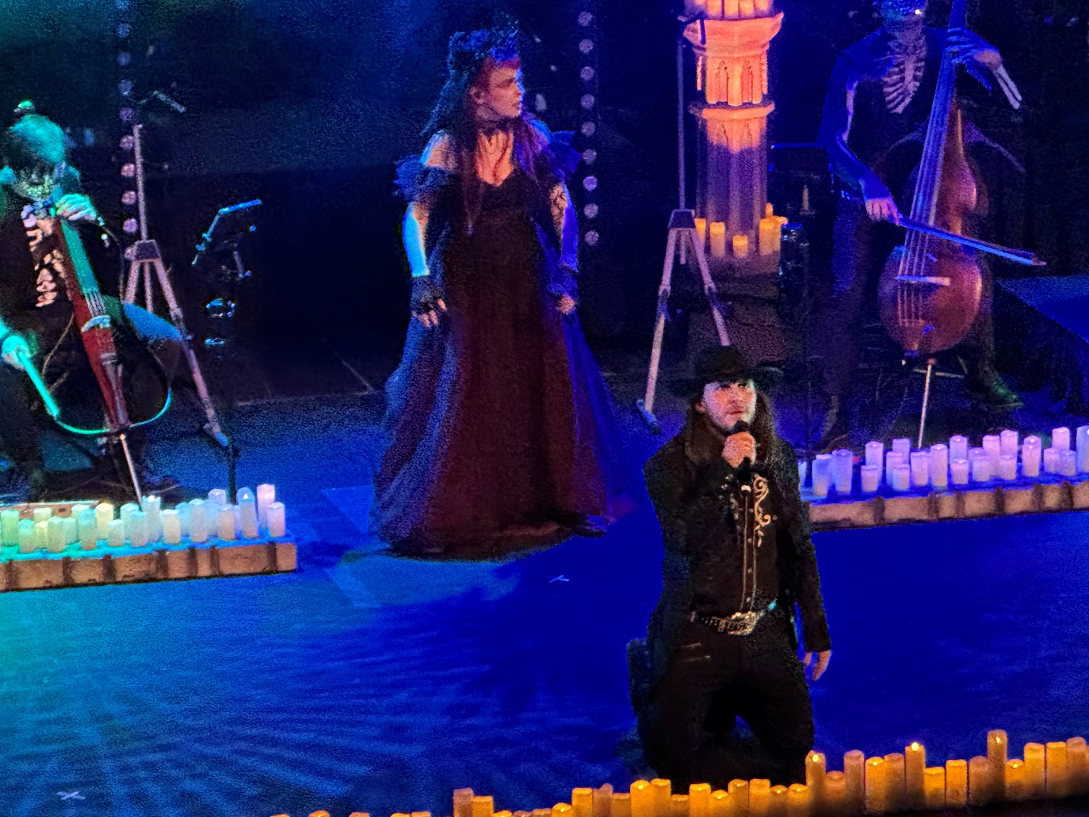
“Chop Suey” from System of a Down was recognizable but not a song that really got me hyped so once more it was good but nothing special. Unfortunately, this act has so impressed me I am starting to need perfection to be stimulated like I was the first set. “That’s how people become addicted to Cocaine Beard.” “What the hell are you talking about?” “Hey, just saying…”
Fox returned and hit one of set twos biggest numbers in terms of crowd support as she powered out “Zombie” from The Cranberries. Admittedly Fox has got one hell of a voice, and she is damned adaptable. Throw in Ivana Cetkovic (who can play metal on violin about as well as anyone I have ever come across) and that song both crooned and thundered in all the right parts.
Honestly, their version of “Killing in the Name of” by Rage Against the Machine was one of their weakest for me. Having just seen Rage two years ago and listened to a 17,000-seat arena go batsh@t crazy on that song, this version was a faucet next to a waterfall by comparison. They tried, but for THIS song I was the wrong audience.
The encore was “Enter Sandman” by Metallica and as would be expected, it got the loudest sing-along of the night. For one thing, Cetkovic played that violin like she wasn’t going to get paid if she didn’t nail it. At one point the fog made it look like her strings were actually smoking. Maybe they were. Vocally Murphy was a poor mans James Hetfield, while Fox, (who had by now ditched the gothic gown and was bounding all over the stage like a member of the Butcher Babies aerobics team), tried to keep the crowd loud throughout. This was an audience number, but for me it fell somewhat short.
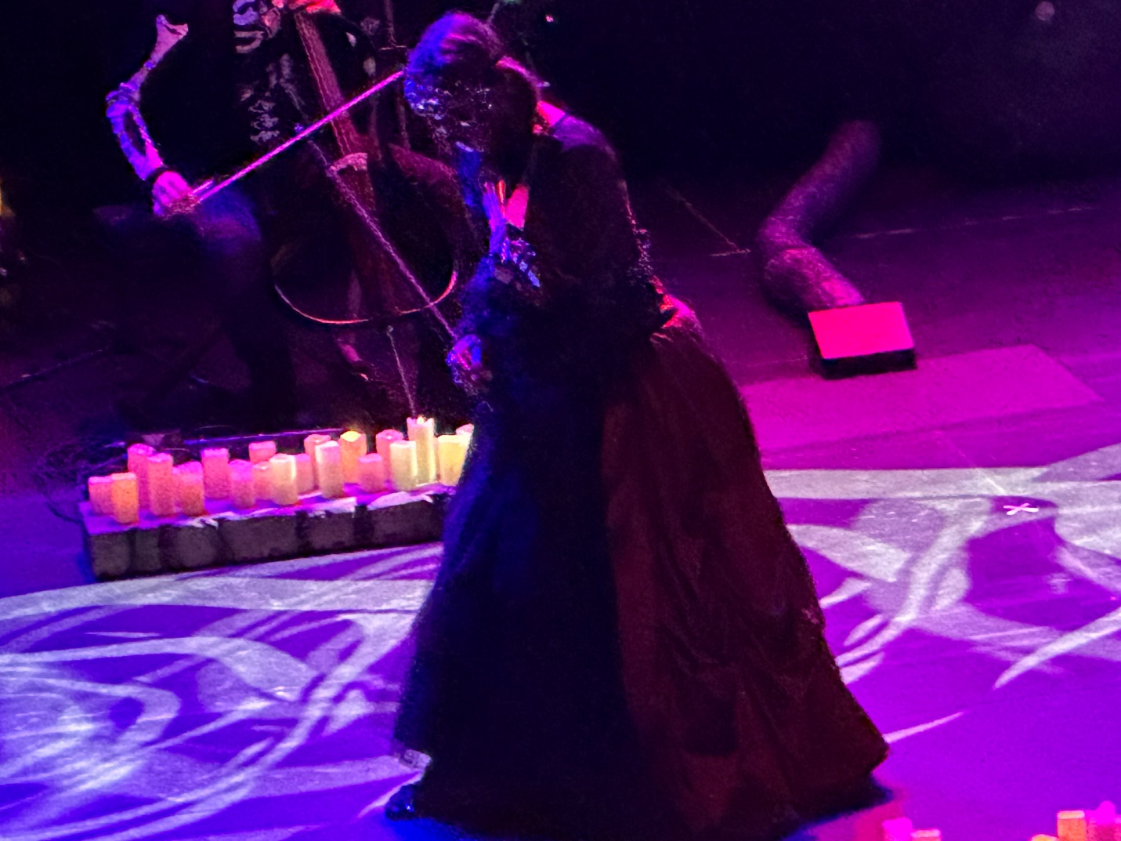
As a whole, set one was far better than anything I had seen this year, but set two was only good. I would award set one a 96/100 but set two only an 86/100. So, I will combine and crack a cold one for Rock Orchestra by Candlelight with a 92/100 score. They had no bad numbers and several great ones, so they deserved 90+ for what they did. Salutes and sips for all thirteen members on the stage, (which means I will need to open a second beer.) It’s a hard job but somebody has to do it right?
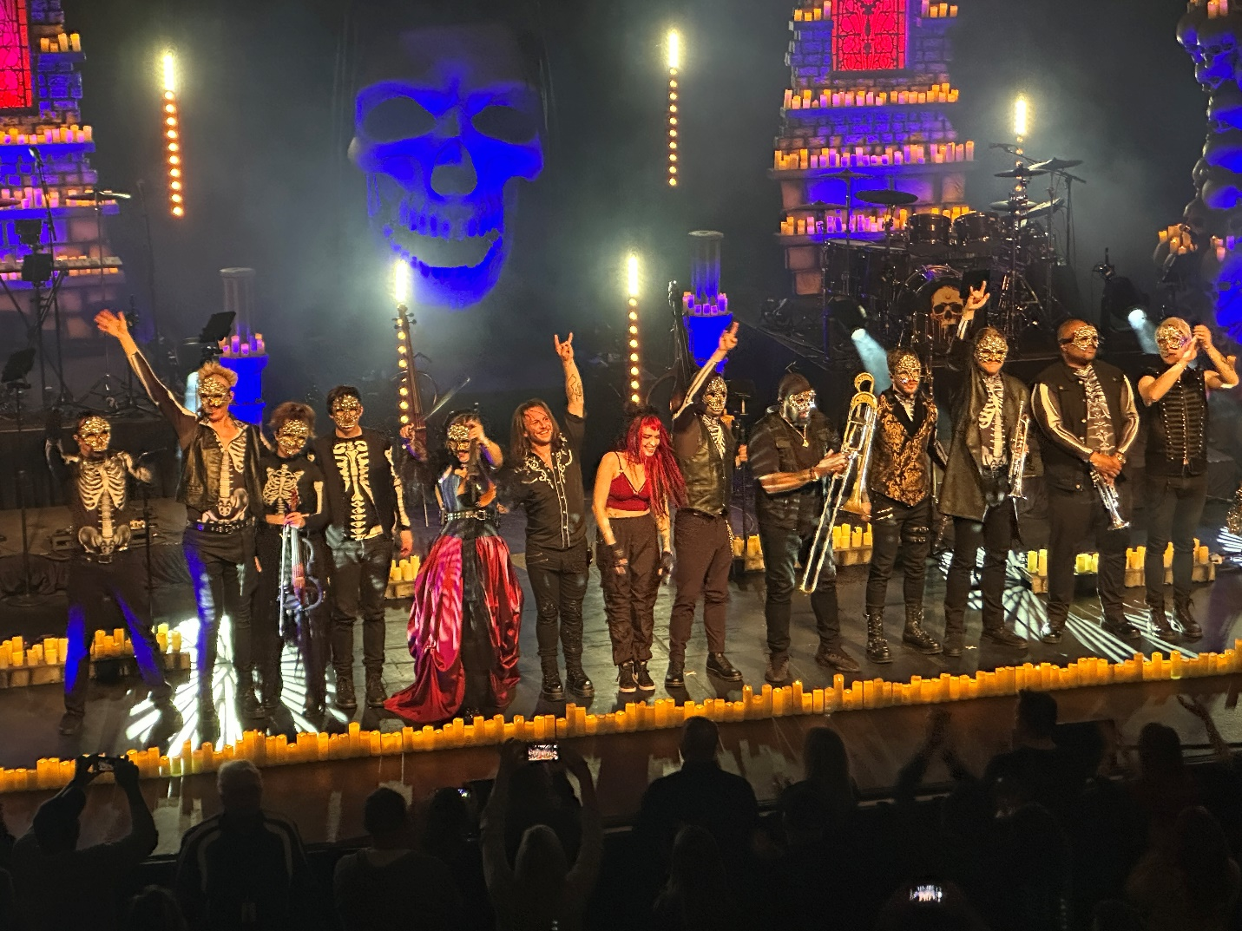
So, that wraps up episode #17 of Beard Reviews. Stay tuned to all our sites for the latest in pictures, videos, and scintillating opinions from your dynamic duo. Remember to check out and support:
- The Metal Decibel website
- Thebeard0728 on TikTok
- Mark McQueen on Facebook
- The Beard and Little Johnny on Facebook
- Thebeardandlittlejohnnyreviews webpage
Until next time, this is the Beard reminding you, “Live Life,” “Stay Heavy” and as always “Horns Up.”

