Beard & Little Johnny Reviews
Episode #24
Hells Heros Day Three
White Oak Music Hall, Houston, Texas
3-22-25
The final day is upon us and once more, Little Johnny and I headed out to the site of Hells Hero’s. Going in, we were NOT optimistic given what we had experienced thus far over the first two days. But, Little Johnny just said, “Gonna let it all happen today Beard. Especially if we might not be coming back.” Good Lord, what does he mean by that? I hope I have enough bail money.
Band #32: Night Cobra
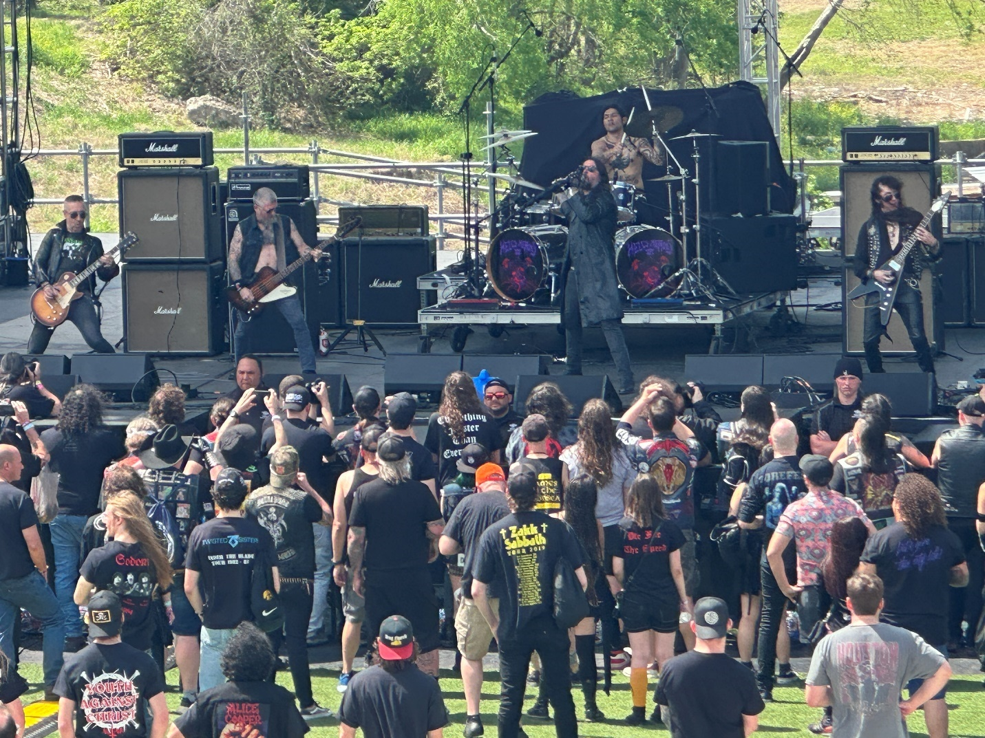
I saw these guys last year at Legions of Metal in Chicago. They have a good act, (plus, right away we all noticed the overall sound had significantly improved on the Lawn stage.) Man, what a difference. Where has this been? Did the tech just read, “So, you want to be a Sound Engineer?” last night or something?)
Semi clear spooky clad singer, Night Cobra was regular metal, and although I was not blown away, the improved sound on the lawn immediately elevated the grade. Going 83/100.
Band #33: White Magician
I was on my way to see this band on the second stage when I got texted Beard, it’s Johnny. I am at security. Come get me. After some fast talking, I was able to convince the security that Johnny was “special” and didn’t mean any harm. They released him to my custody saying one more incident and you are both out of here. Little dude, it is not “optional pants” Saturday. For the last time, there IS no “optional pants” Saturday.
Band #34: Hellripper:
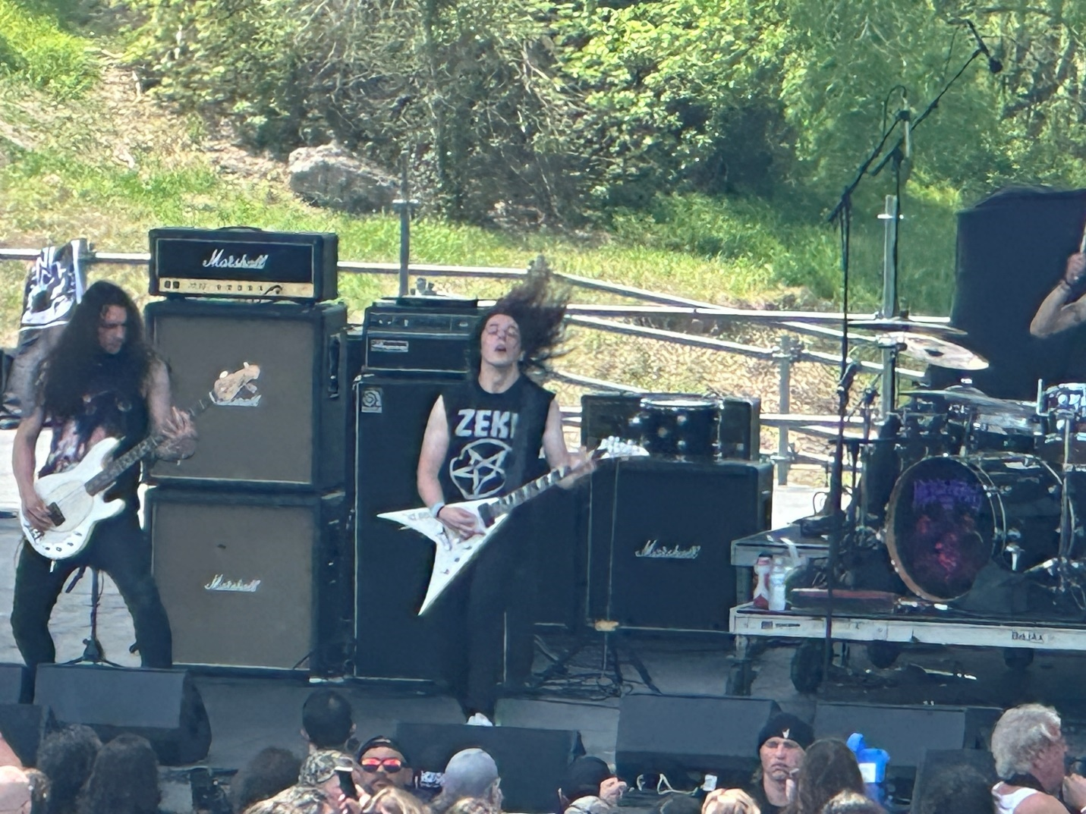
Fortunately, we were back in time for this blackened speed metal band from Scotland.
These guys were one hundred miles per hour from go. They got the crowd cranked early. I enjoyed the set and the droll dry humor these guys had. Being Scottish myself, I find that sort of thing funny.
In fairness, as all the Hellripper songs were pretty much soundalikes, after a while it did have a one trick pony feel to it. That said, this had the best crowd surfing song of the weekend. (Check the video footage at Facebook Mark McQueen) The singer asked the Houston crowd to set the crowd surfing record and even though I don’t think there is one, this crowd figured what the hell let’s try. It even ended with the singer diving off the stage into the crowd. I can imagine a bunch of Hells Hero’s corporate lawyers’ sphincters clenching at that moment, but it was natural, spontaneous, and quite a bit of fun to watch.
I am awarding a 91/100 and I think Johnny was seeing if he can party with these guys later. No! You do not need to buy a pair of Hellripper booty shorts.
Band #35: Overdose:
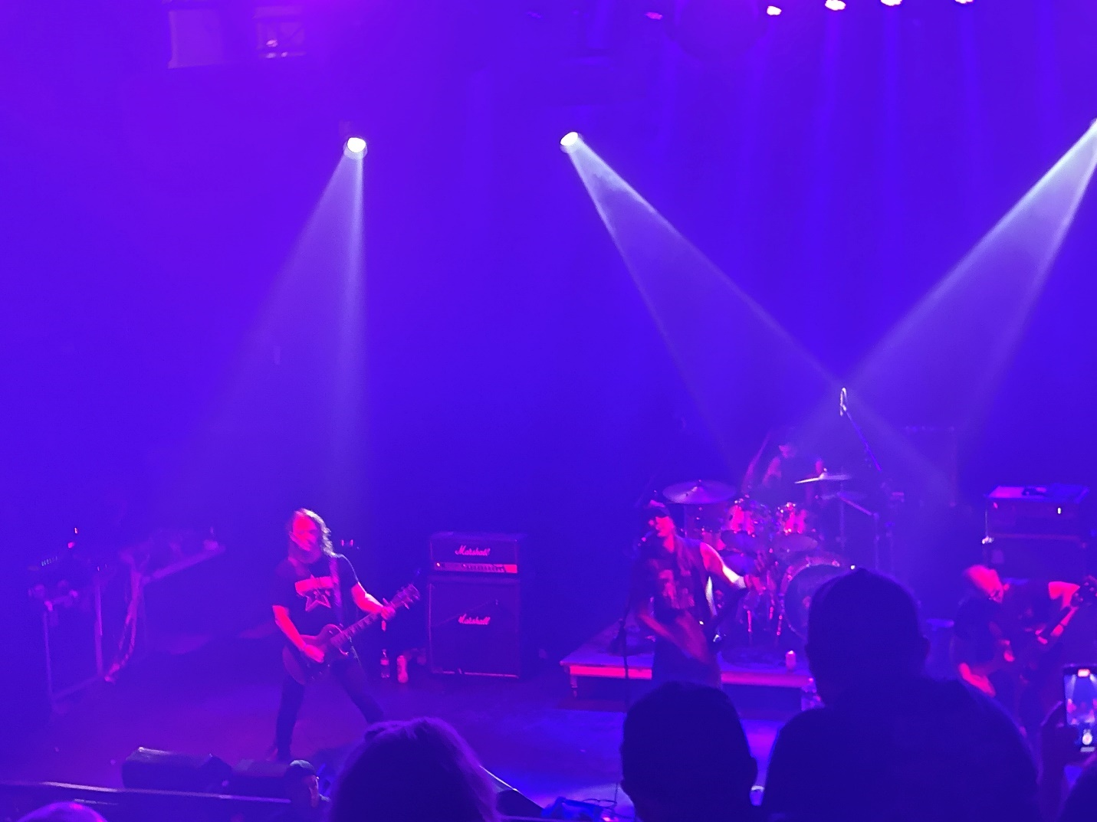
Songs in the vein of Motorhead. The singer even had that scratchy gravel filled Lemmy style voice. Another surprisingly good set. This is how I expected the whole festival to go. Too bad it took until the last day before it did. 87/100.
Band #36: Primordial
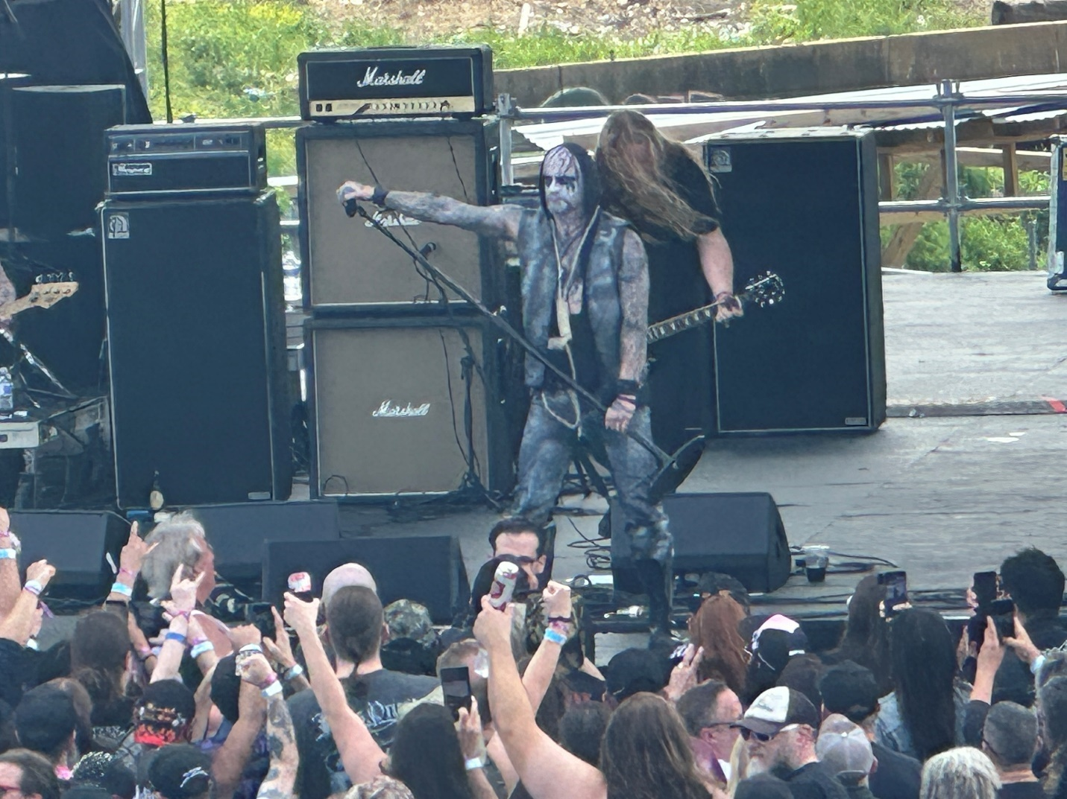
An Irish band mixing black metal and Celtic music. Odd and a step back after the assaults of Hellripper and Overdose. This was a gentler more tribal black metal. A unique style that didn’t quite catch me initially, but after a while I got more and more into them and their Irish black metal dirge tunes. Different but heavy and that now makes three in a row I have enjoyed. 87/100
Band #37: Zemial.
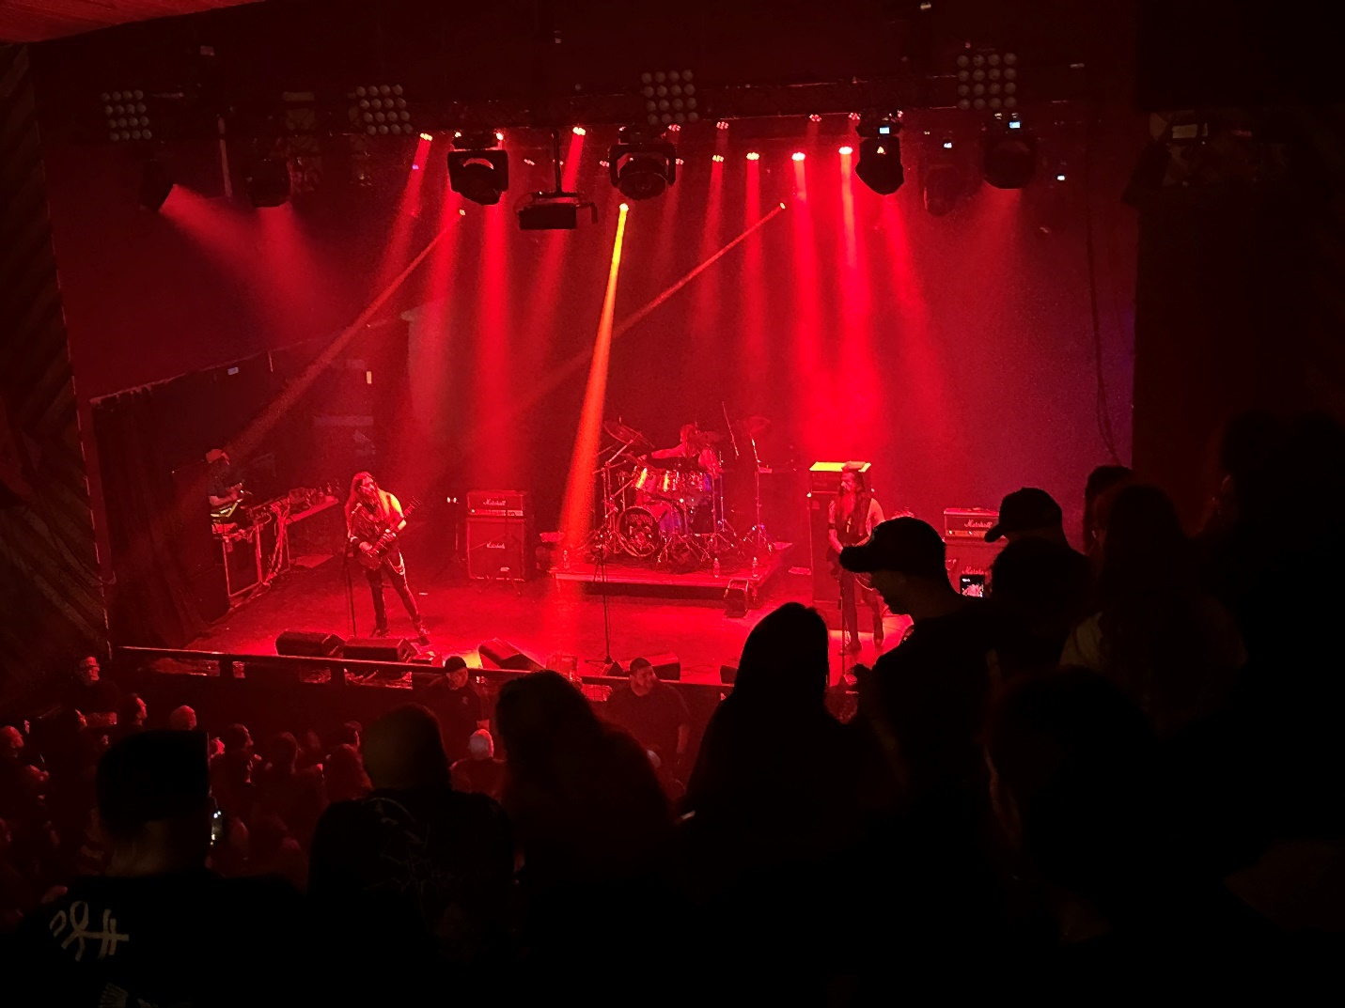
Greek black metal thrash act. These guys had good lights and a spooky dark ambiance thing going on. Yesterday this would have ranked higher but today the bands have all been more interesting, unique, and of course sounded way better. I am awarding a 79/100 for this Greek black thrash.
Band #38: Goatwhore
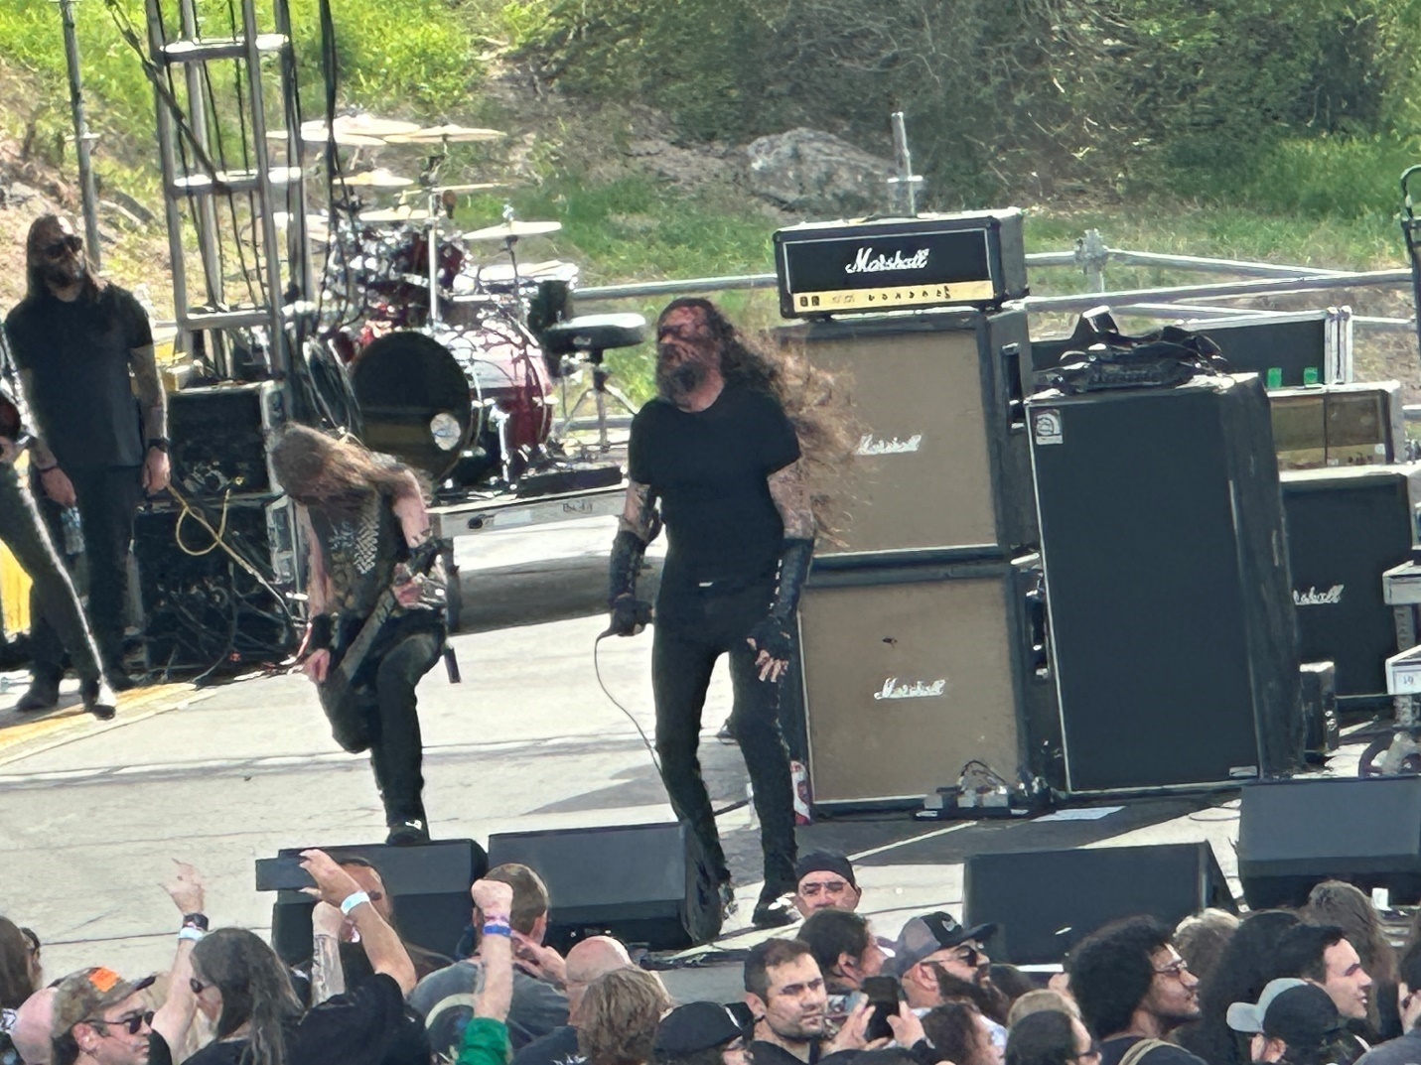
I have seen Goatwhore the most times of any act today. Sometimes they rank really high and other times not so much. It’s often determined by how much the crowd responds to them that determines it. This was in between.
The crowd liked the songs from “The Eclipse of Ages into Black,” their first album, (now celebrating twenty-five years of being out.) Lead vocalist, Ben Falgoust, was as animated as always and it was a normal Goatwhore set. What you get is what you get. Johnny loved it, Beard says 80/100.
Band #39: The Night Eternal
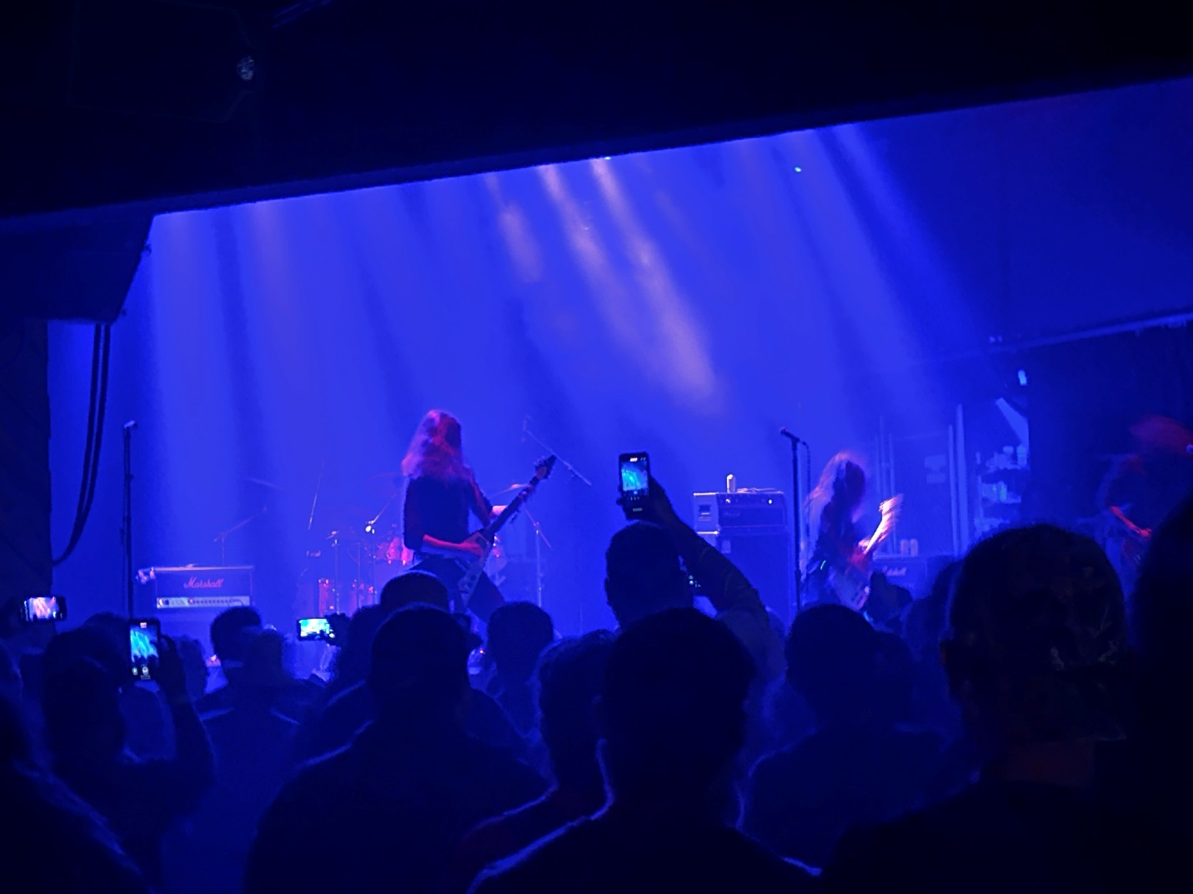
This newer German occult rock band had only put out a couple of albums since forming in 2021, but they had generated a lot of crowd buzz all weekend so not surprisingly the second stage room was packed tight.
I personally wasn’t that moved, possibly because finding a decent spot to watch from was nigh on impossible and I get grumpy when I can’t see or hear the act clearly. This will be my last trip to the small room for this year. I will give The Night Eternal only a 78/100.
Band #40: S.A. Slayer
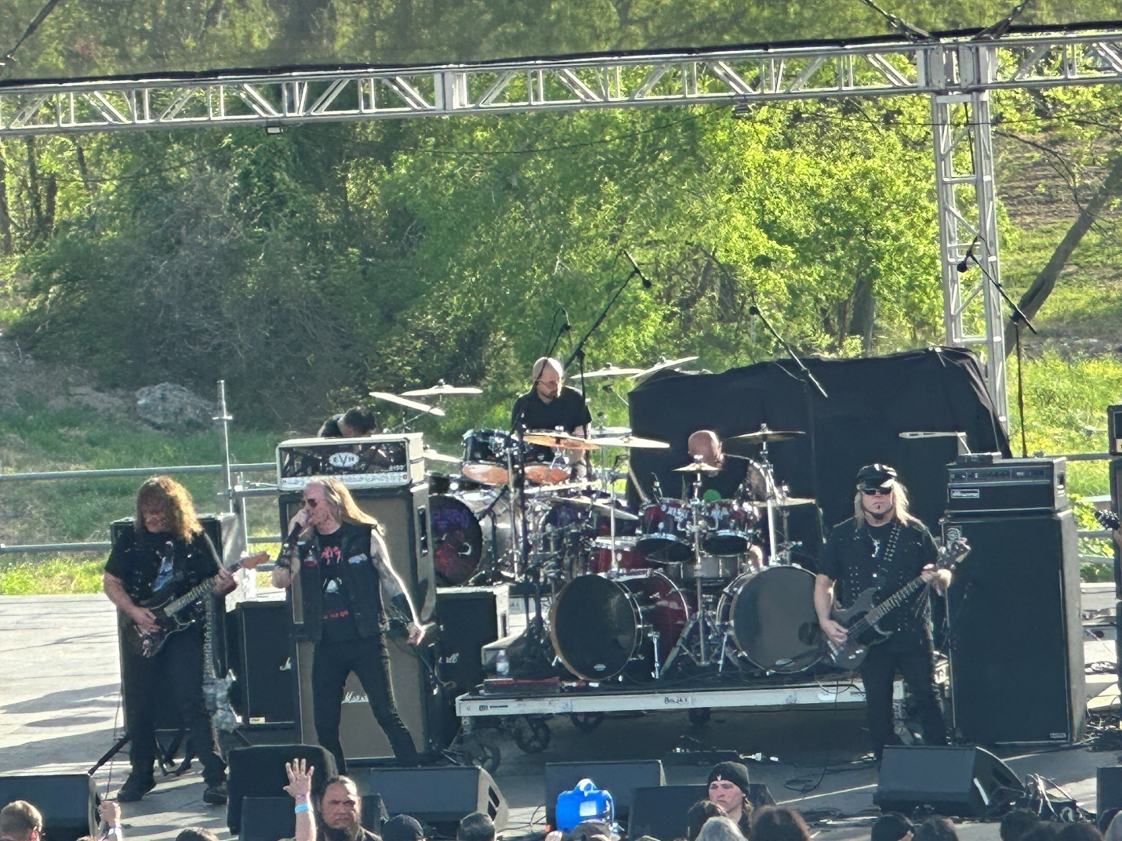
Interesting history as this Texas band formed in 1981 was originally called Slayer. They changed their names to S.A. Slayer in 1983. Some say it was because Metal Blade sent them a cease-and-desist letter from performing under the name Slayer given the other Slayer was becoming nationally known in the metal world. This story might also be an urban myth as no one from either side can produce such a letter.
Although this Slayer (the S.A. stands for San Antonio) would only release one album, (1984’s Go for the Throat), there was an infamous concert in 1984 where both Slayers played on the same bill. That is also one of those stories where maybe a hundred people were there, but a thousand people like to say they were.
After disbanding (since there was no room for two Slayers without a lawsuit), every player has moved on now appearing in bands like Riot, Sacred Riche, Jag Panzer etc. but in one of the most unique moments of this weekend, Hells Hero’s brought together a reformation of this snakebit band that wrote a solid album worth of songs forty years ago and got to play them all today in front of a large appreciative crowd. I am glad I got to see it, and for uniqueness and novelty, I will go 85/100.
Band #41: Coroner
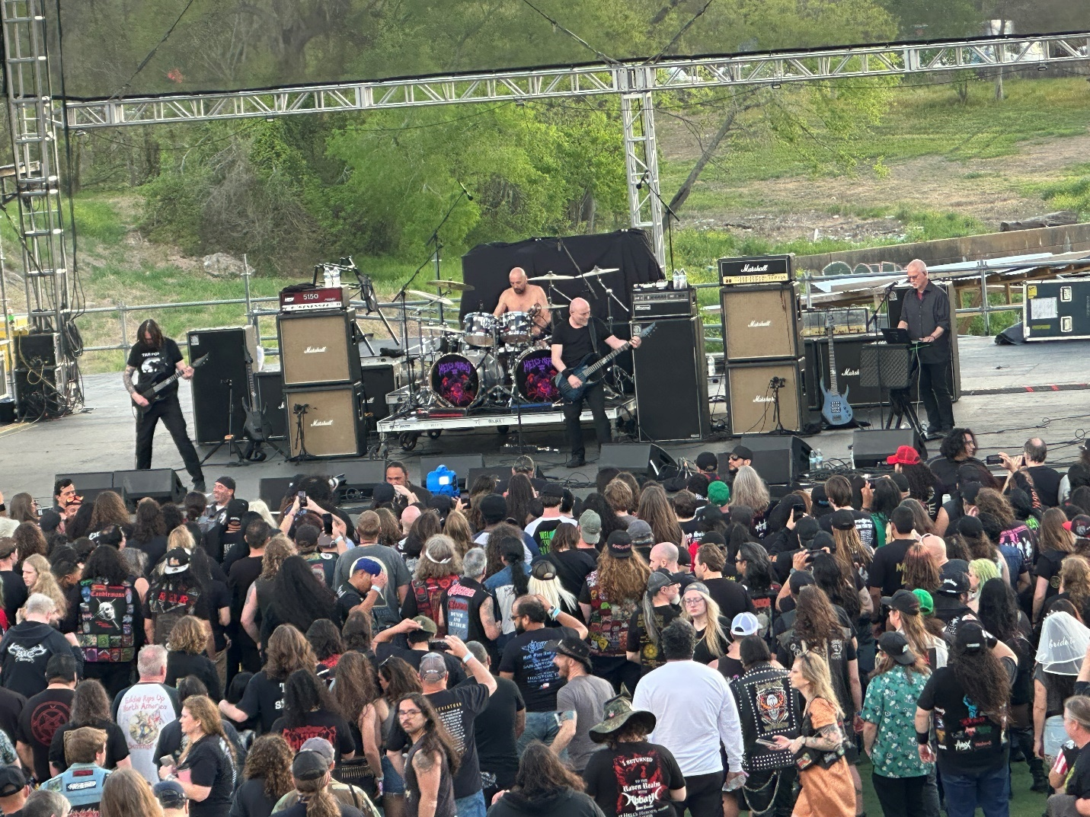
This Swiss thrash metal band was huge in Europe but just never conquered America. This was my first time seeing them and like Sodom last year, I am happy to check another name off the never-ending list of acts I am finally seeing. Coroner was far more prog-like and melodic than their moniker would lead one to believe.
In the meantime, the Houston sun has done a number on poor Little Johnny who now looked like he needed to be fully dipped in a vat of aloe vera. He was reminiscent of a cap wearing Human Torch cartoon.
But, just about the time I was feeling sympathy for him, up came Gretta, Inga, Tilda, and Becky who had come over from Sweden to support Swiss bands Coroner & Samael. They took Johnny with them saying they would make sure to rub lotion everywhere he was sunburnt. As he headed away, he looked back at me and said, “Beard, I am sunburned everywhere,” Then the little #@$@ smiled. I hate you Johnny.
In the meantime, Coroner finished their mix of thrash with Avant-garde elements, (including jazz) making the set a kind of prog-thrash. Although they are sometimes dubbed the RUSH of thrash, and the three guys to my right really loved this set, Coroner was a lot to take in for most of this audience who politely listened and amused themselves with crowd surfing and melodic pit circling.
I have now seen Prog Thrash, and I have to say I was kind of bored by it. Maybe I should go check on Johnny. 75/100
Band #42: Samael
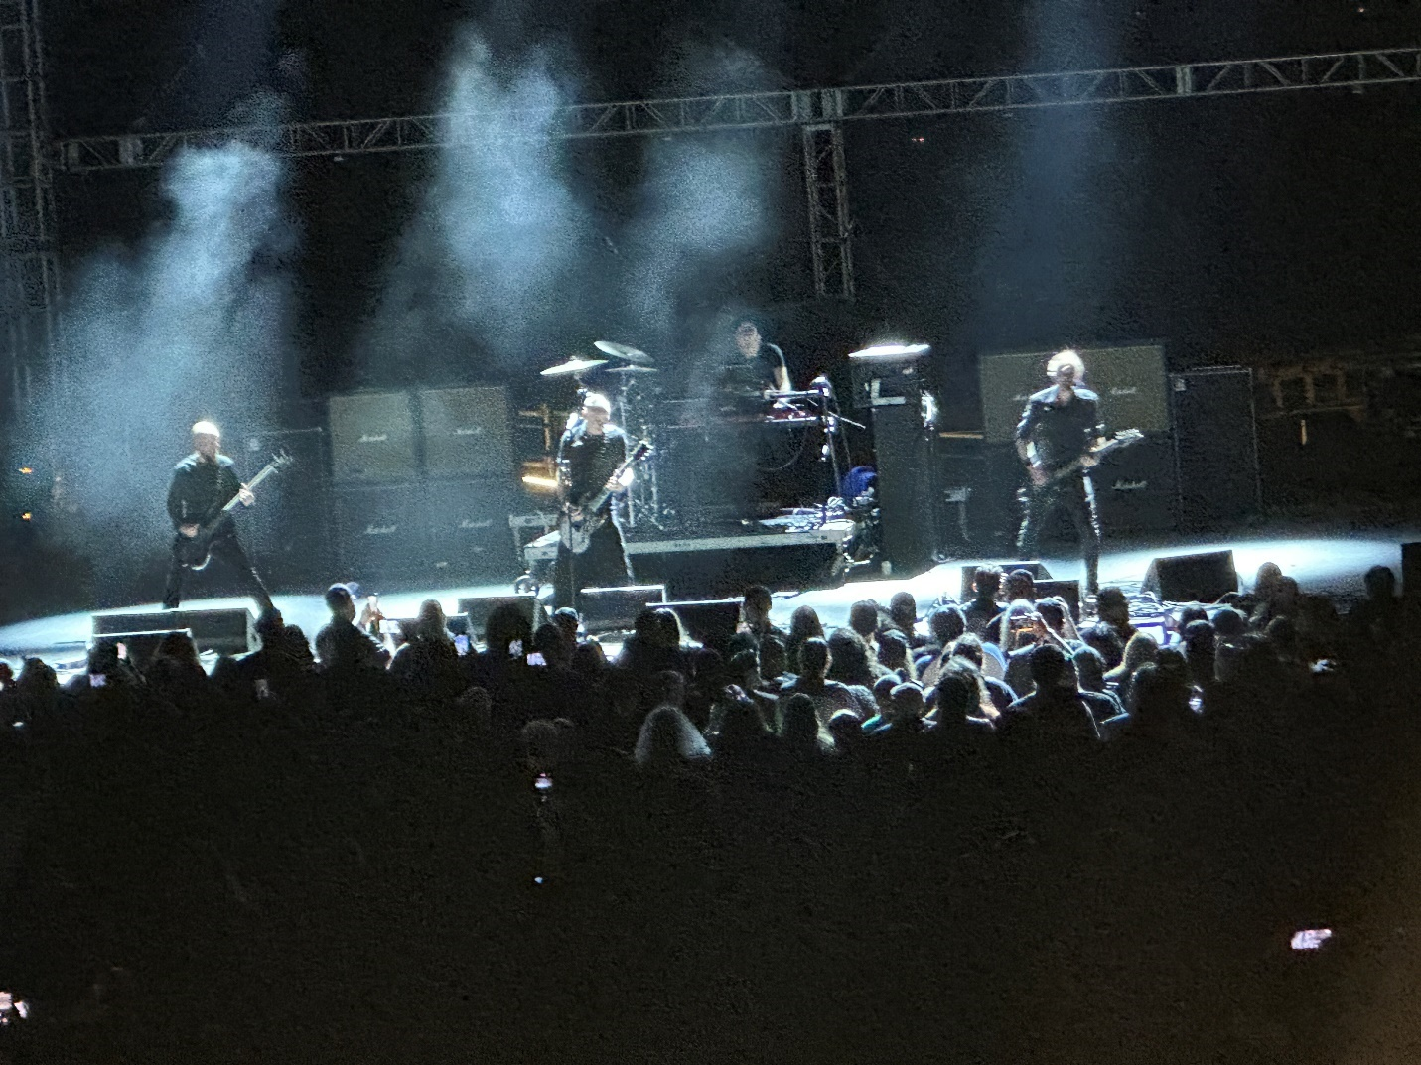
This Swiss band was also quirky mixing black metal with industrial and symphonic. They were an odd sort of mix for a big festival.
Samael played the entire Ceremonies of Opposites album plus the song Black Supremacy. Although they had excellent lighting and a drummer who you kind of had to see play to really understand, (check out thebeard0728 on TikTok), even though they were a polished band, they never fully had me and my interest. Going 83/100 and that might be a bit high.
Band #43: Saxon
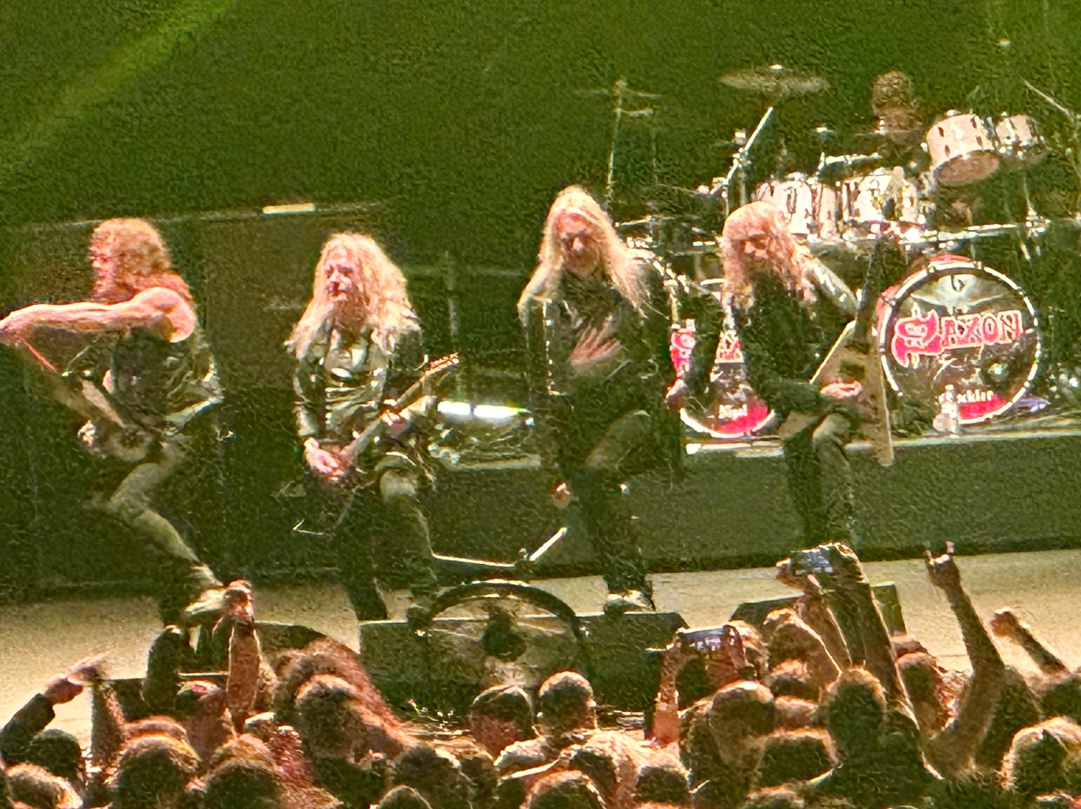
Having been around for half a century, Saxon was the granddaddy of the festival. Even with twenty-five albums to draw from, most fans were still there to hear Denim and Leather, Crusader, Power and Glory and Wheels of Steel.
Saxon was fronted by old warhorse Biff Byford who still leads a band with two original members and one with over four decades in the outfit.
With Saxon, it’s old school NWOBHM and plenty of it. Nostalgia for the senior members in the crowd (like the Beard) and the opportunity to see how it’s done for the youngsters.
The first four songs killed. These guys are 70+ years old, and they were still amazing. What a good long-term band. It is not only the music but also the timing and knowing how to do just enough but not too much. This was a band that had the touch of a master artist. Saxon took a crowd where many probably only knew them by reputation and brought them in to loving them.
There was a funny moment relating to their ages when a fan tossed his own band’s CD up on stage. Biff picked it up, looked at it and said, “It’s a nice CD mate but I can’t bloody read it. We’ll listen to it later, but if we hate it we’ll just burn it. That okay with you?”
For their giant hit “Denim & Leather,” a fan was cool enough to toss up their war vest so newest Saxon member Brian Tatler could wear it during the number. When it came back at the end of the set, it had a lot of Saxon mech in it which was such a cool thing to do. In fact, by sets end the lawn was rocking and cheering with genuine respect for a band that metal fans passed over many times but never stopped making the music they loved.
Saxon was the band of the festival. The seniors won it. And to those who think, of course Beard the old man picked an old man band, check out the videos. Saxon earned their spot with their history and proved they deserved it with their performance tonight. 95/100
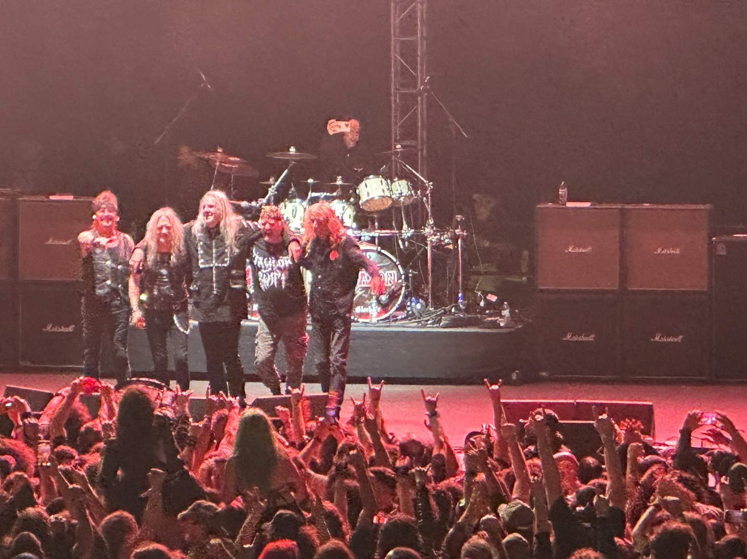
So, that does it for Hells Heros 2025. A lot of things that I admittedly didn’t like, corporate cutting of the VIP stuff, bad sound for two days, many major bands canceling and the fest not revealing some cancellations until just before they were supposed to play. The bathroom situation, the balcony situation, the merch distribution situation. For all these reasons, I may well not return next year in 2026.
There are other metal festivals worth an opportunity, and I am inclined to do just that. That said though, once again I saw some great sets of music, and met some fantastic knowledgeable people. I say every festival I learn things I never knew about metal and this fest was no different. So, thank you to every person that I had a cool conversation with over these four days. We raise our horns and no matter how old we get; we remain proudly and defiantly METAL.
Thank you also to each person still reading this. I write a lot of words because I have a lot of passion for this music, and I appreciate each one of you who offered me your valuable time to read about it. The brotherhood of metal is amazing and better than any other genre. In the words of our Metal godfather Ozzy, “I love you all!”
As always, follow the Beard & Little Johnny for all the metal and rock reviews, and friend or follow Mark McQueen for all the Beard reviews including, movies, plays, alcohol events and pairings, other musical show and just anything and everything under the sun. Follow me on TikTok thebeard0728 and be sure to pass this stuff forward to anyone who you think might enjoy it.
Until next time, this is the Beard saying Live Life, Stay Heavy, and Horns Up.

