Beard & Little Johnny Reviews
Episode #23
Hell’s Hero’s Metal Festival Day Two
White Oak Music Hall, Houston, Texas
3-21-25

Good day friends, fans, and followers and welcome to part three, (of our four-part series), covering Hells Heros.

On our third day of Hells Heroes, the pluses, (so far) were that we have had almost perfect weather. Now, we hope yesterday’s sound problems have been addressed and we get a super Friday full of top-notch metal and rock.

Little Johnny and I took a stroll through the vendor section of the festival, and he bought a shirt that said, “Metal God.” He felt he should advertise himself even though he then said he was pretty certain everyone already knew that. One cannot ever say Little Johnny lacks confidence.
Today’s continuation of live acts:
Band #21: Solicitor
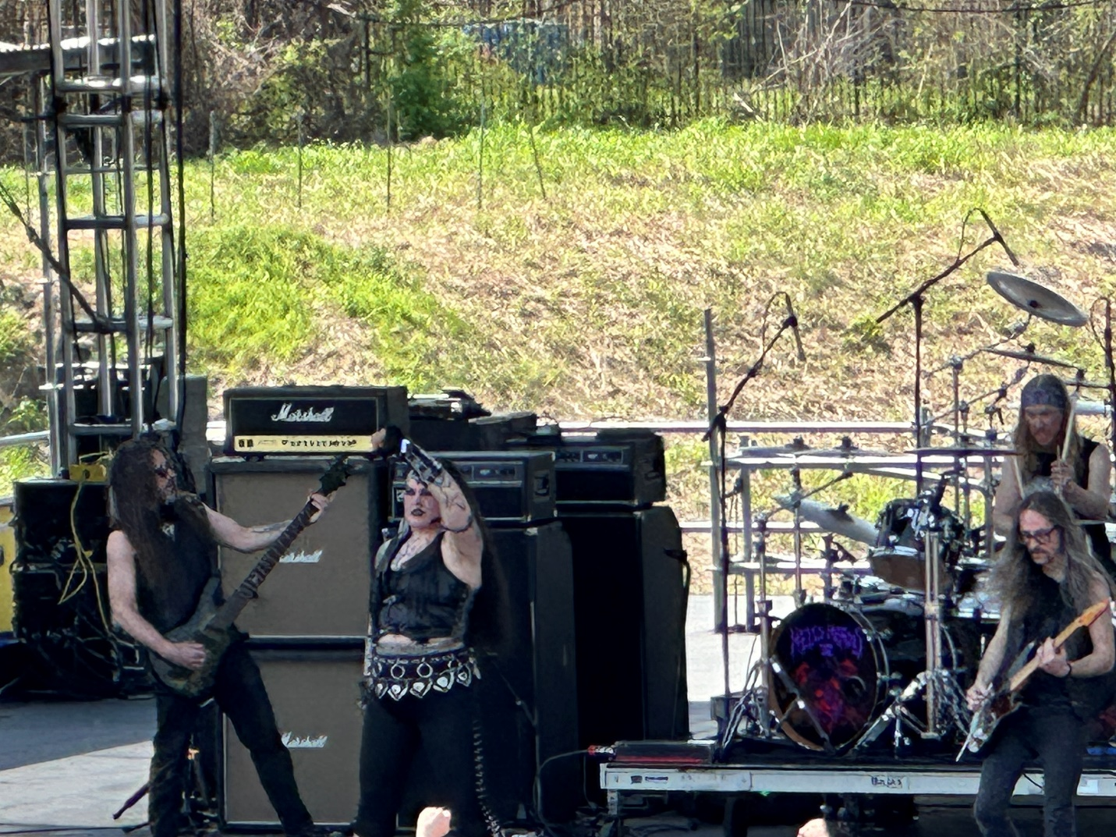
Although I have seen this west coast band a few times, this was the biggest stage I had seen them perform on, so I decided to check them out again anyway.
The singer Amy Carlson has really grown out her hair since I last saw them. It looks good. Amy is a big girl with a big voice to match.
Already there were sound issues just two songs in (even though vocally I thought it sounded a bit better.)
Solicitor has that car racing down the hill without brakes style to them. I always think they would be better if they had just a bit more structure and a bit less chaos. It is speed metal so I get that, but I also get that race car drivers can go 200mph with control. I have always felt Solicitor lacked musical control. Certainly, others may disagree, but I am going 81/100.
Band #22: Knights & Gallows
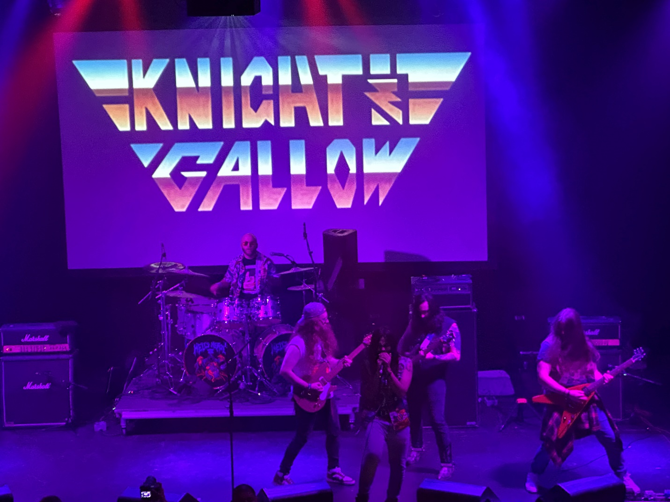
This was a band I knew nothing about. They were power metal, but they seemed rushed. While the singer could scream, the act was a mashup of noise. I would say that these guys were slotted correctly in an opening spot on second stage. 72/100
Band #23: Nasty Savage
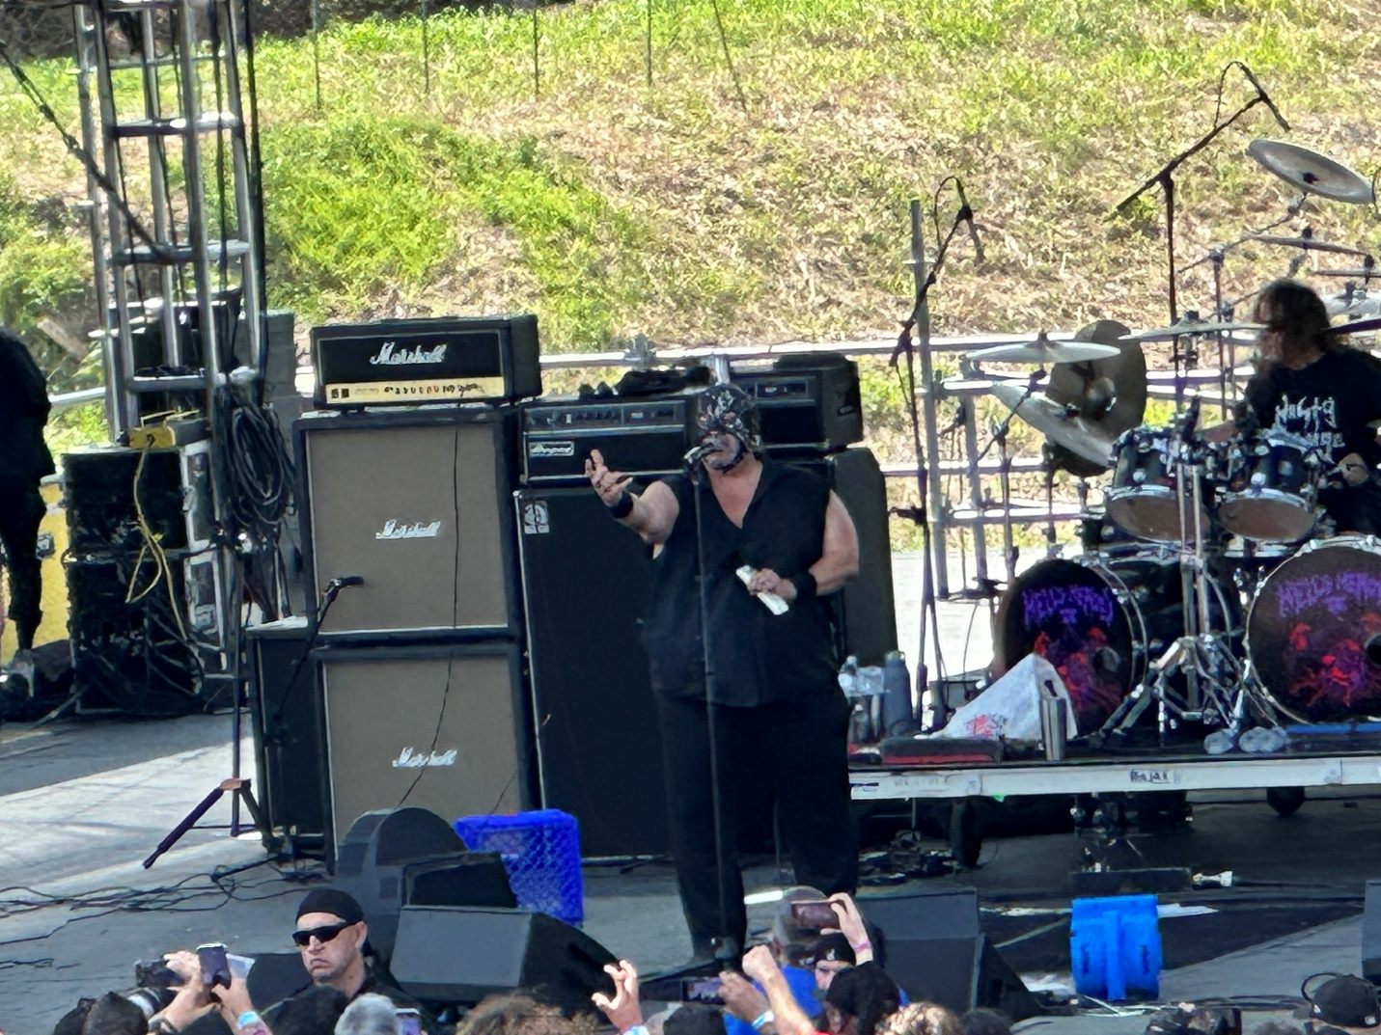
I have seen Nasty a few times. The last was in Lombard where he dropped a tv set on his face over and over until he broke through it and bled all over. So, I had to see what he had planned for Houston.
Long spooky intro music to start? Nasty, you do realize it’s sunny and 1:30pm on a Friday right?

Finally, Nasty walks out with his hooded gladiator mask on his head, starts singing annd..his microphone doesn’t work. Lol you can’t make this up. What the ever loving #$%#@ Hells Heros. Two lawn bands, two sound disasters.
So, we stop, reboot, and start again. This time he got to start Gladiator, but the lawn sound was off once again. Seriously?
Nasty vamped while sound tried to get shit straight again. This was a clusterfuck.
Plus, by this point Nasty has to be topping 350lbs, so the man gets winded standing. So far he doesn’t have much of a rap beyond yelling “Is everybody in?” (If by “IN” you mean in saddened hysterics over how bad this set has been so far, yep I am sure EVERYBODY is in.)
Finally, the sound was restored, and we started yet again. Now, not everything sucked. During “The Morgue” Nasty (clad in a skull death mask), did throw funeral flowers out to the crowd. That was either original, or he was just apologizing for the death of his set today. There was also some fresh material, so I heard some new songs which gave a touch of redemption to this sad thirty minutes. Given the rough start, I will go 76/100
Band #24: Hitten.
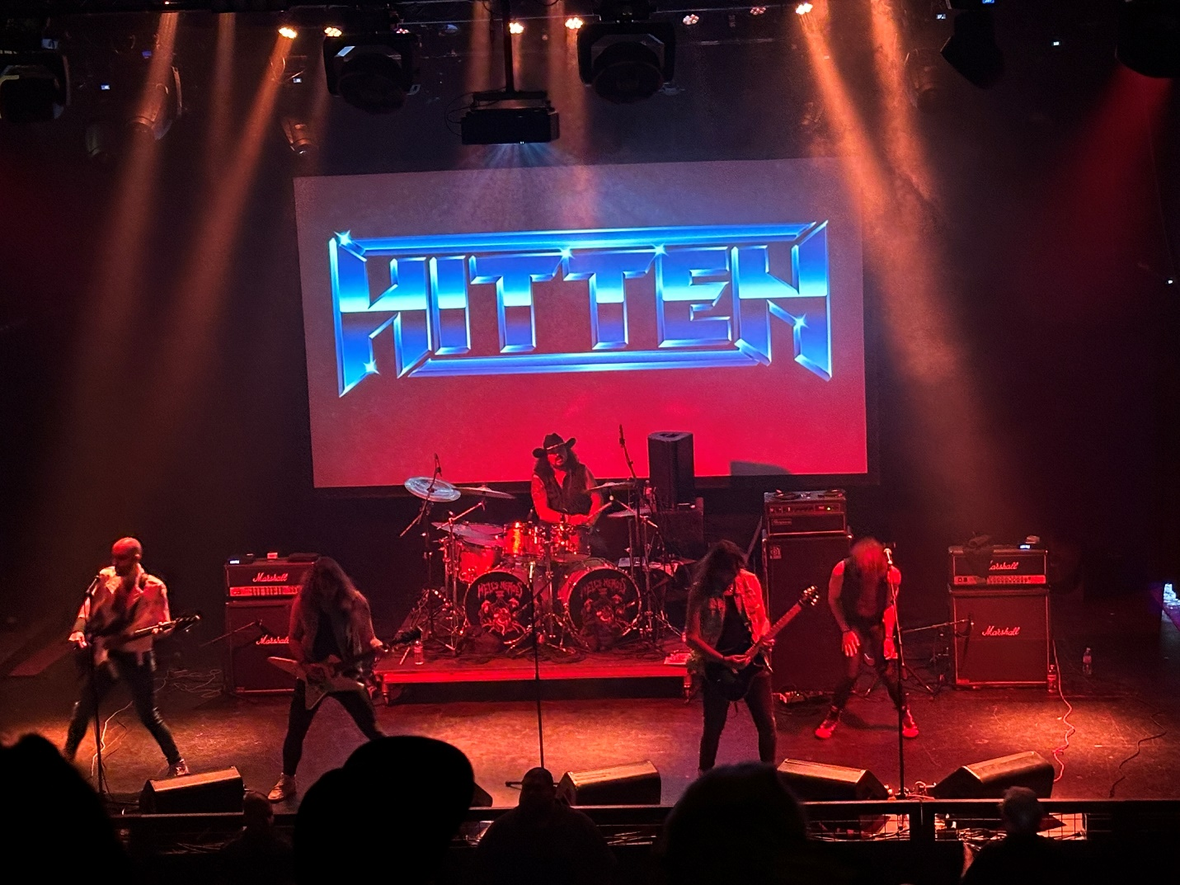
I exhausted myself trying to convince Johnny this band was in fact NOT called Kitten. I still don’t think he got it. He was bummed that the Nasty Savage set bombed, and Nasty didn’t do anything crazy like in Lombard, so he told me he was going to hang outside and not go see the band about the baby cats. Hitten Johnny. For the last time, it’s HITTEN!!

For me though, A band from Spain was worth checking out since international acts are a big deal at these festivals. So, I headed to the second stage for these guys and my first thought was, they were the European Sammy Hagar with a touch of Geoff Tate’s vocal sound?

This 80’s-90’s take on metal was decent, and everyone had a lot of energy up there. Plus, the sound didn’t suck in here, so I am going with a solid 83/100.
Band #25: Enforcer set II.
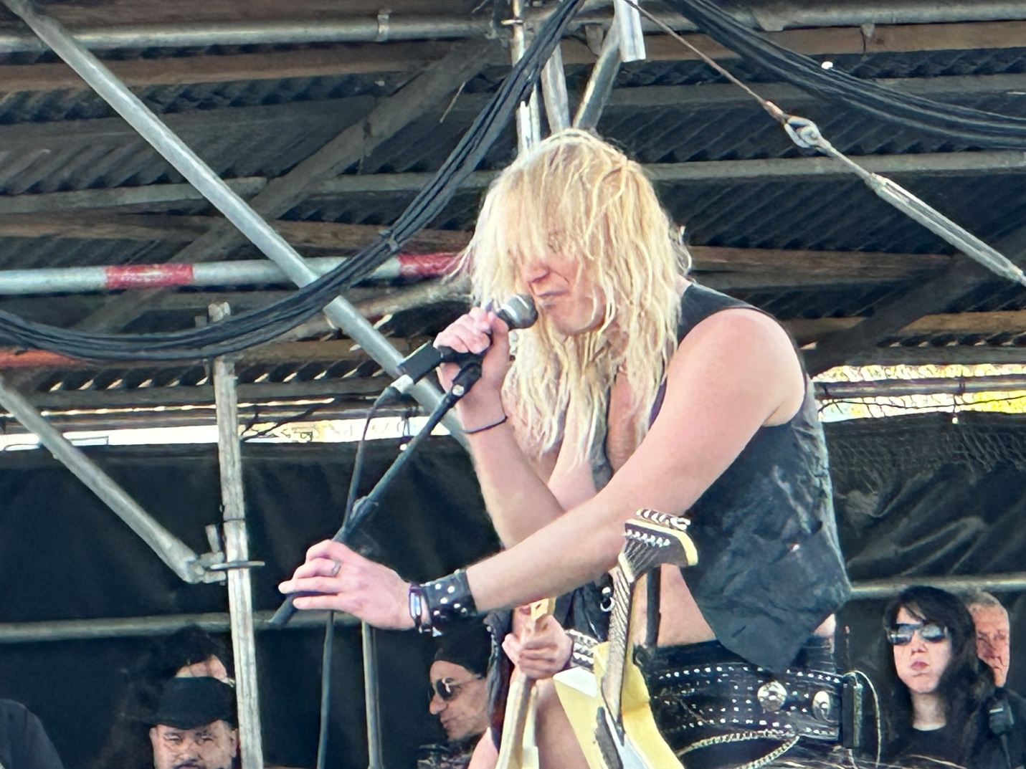
Enforcer didn’t try anything new and just played pretty much the same set as yesterday. This time though, I went down and watched from behind the sound board to see if that was any better. Marginally at best. I simply do not know what is going on with the lawn sound. Metal is supposed to sound bassy and weighty. I just don’t understand what this guy is hearing that he thinks yep, this is how it ought to sound.

Maybe he just hates Swedish people or something. Perhaps a meatball trauma as a young child that he never worked through. I will give a sympathy 80/100 and hope that Enforcer doesn’t take it personally and just say @#$% America.
Band #26: Haunt
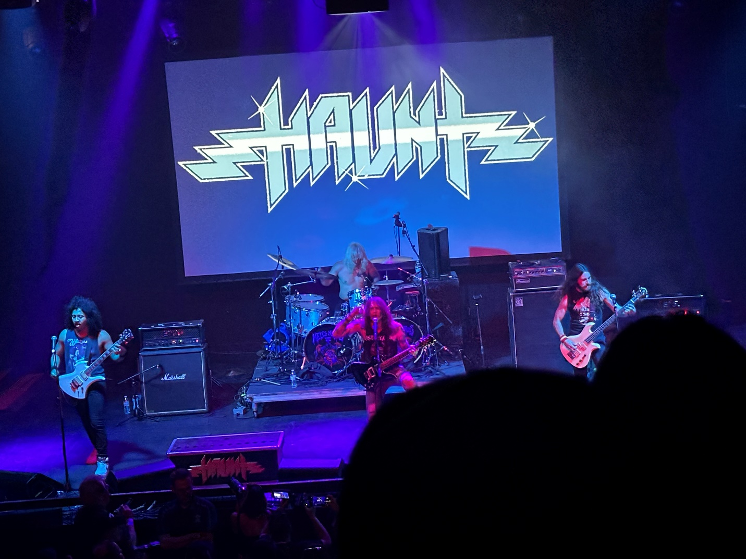
Haunt was another band I saw last August. Although I wasn’t a huge fan then, I figured why not check it out since I am still searching for anyone to wow me on this (so far at best) lackluster Friday.

Haunt had a mix of traditional, speed, and prog metal. Their older stuff sounded a little like Cauldron. The faster material not so much, but at least it was a good set of balanced sounding music. At this point, I am thankful for that at least. 81/100.
Band #27: Gammacide
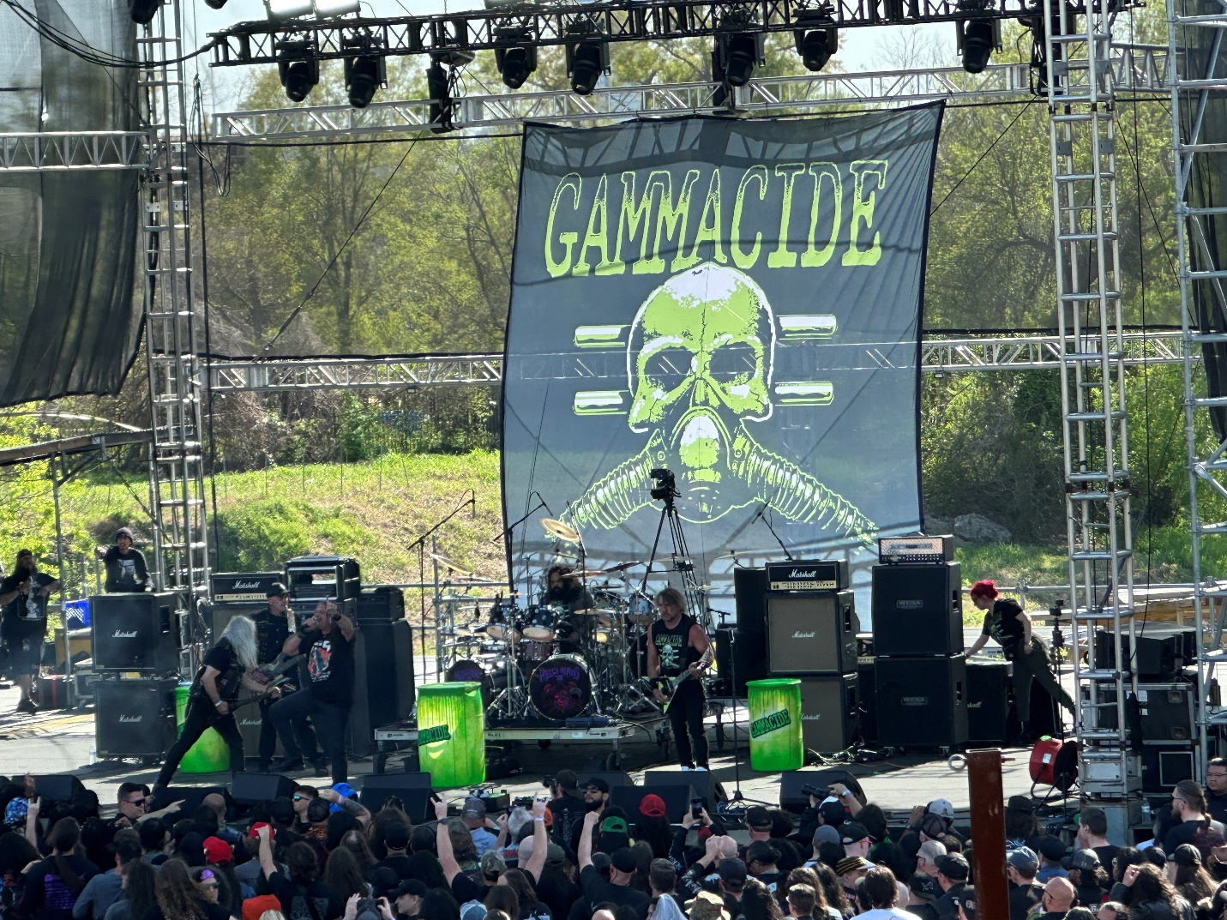
This was a thrash metal band I had never seen. Gammacide was thrash in the vein of Municipal Waste meets Hirax.

Fast lyrics fast leads fast drums. Some effects, with toxic barrels on stage spewing smoke and a guy in a type “A” radiation suit running around. I will say the crowd dug them, and with their thrash/punk it was easier to not notice the overall bad quality sound from the lawn. A fast energetic set. 82/100
Band #28: Absu
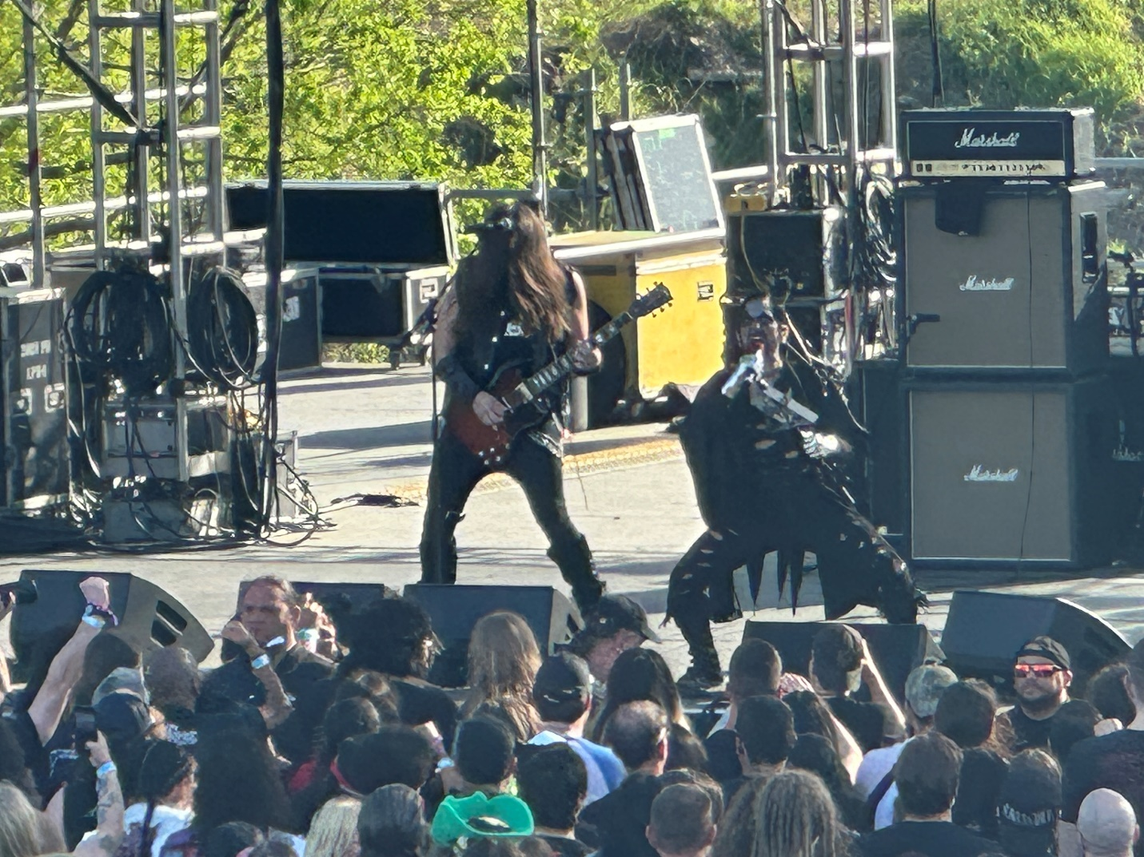
Absu is both a long-time black metal act, and an excellent burger at Kumas Corner if you happen to be in Chicago.
The very first number and OF COURSE we can’t hear the vocals. Way to stay consistent lawn stage sound. At least the music sounds heavy. The worst thing was looking at the sound guy. He was just staring straight ahead like “whatever.” I would think he would say “geez, maybe we should be able to hear the singer.” To be fair though, perhaps this guy had his issues with Absu and just wanted to screw them over because of singer Givens view on trans people. I really have no idea, but the first five minutes of this one was abysmal.
About five minutes in they got his vocals up. Now at least I can hear him and his cohort be both an evil black demon and Ethel Merman. Not too sure about that high female sound and of course now that vocals are understandable, there’s issues with the music. Forget Mike Pence, hang the sound engineer. Oooh. Now a whole bunch of people will jump my @#$! About that comment.
After performing two thirds of their album “The Sun of Tiphareth” in celebration of its 30th anniversary, Proscriptor McGovern aka Russ Givens said something. I don’t know what it was about, but it sounded evil. I would love to hear this guy order food at Subway.
The final chunk of the set finally had good sound and vocals so that helped Absu get from abysmal to just not particularly good. I understand this guy is seriously into his Sumerian, Mesopotamian deities, and the great old ones or whatever but I have to tell you, where King Diamond comes off as spooky, Absu’s Proscriptor McGovern comes off like the McDonalds Hamburgler went satanic.

Black metal as a whole is hit and miss for me. While Abbath, last night, wasn’t bad, when it comes to Absu, honestly, I prefer the Kuma’s Corner burger to the actual band. 75/100
Band #29: Omen set II
Another set by Omen. This one was celebrating the 40th anniversary of their first album “Warning of Danger.” They tried to motivate the crowd but today has been a disappointing slog through the mud on the backs of gout ridden turtles.
I will give Omen credit for effort, but we just did not need two sets from this band at this festival. There was also not a need for additional pictures or videos. Yesterday’s set is already on TikTok, (thebeard0728) and this didn’t feel like anything special. 77/100
Band #30: Cavalera
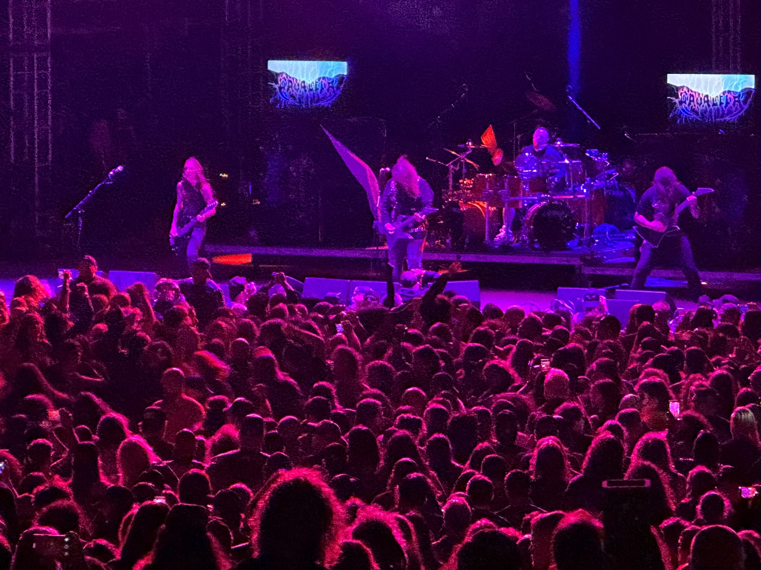
My hopes were raised when Cavalera’s techs were perp-walking the sound guy out of the way and installing their own person. You could just hear the improvement immediately. Doing a largely Sepultura style set, Cavalera was the most professional looking and sounding band of the fest so far.

I thought all the facets were good, sound, lights, positioning, crowd energy etc. I have been waiting all weekend for that first killer set on the main stage and there it finally was. I am awarding Cavalera a 92/100. This was Metal!

As added enjoyment, on the final song they created the Wall of Death. That is where the crowd splits down the middle and on the downbeat and command of “GO!!!!” each half of the crowd tried to run over the other half of the crowd like two marauding armies of suicide jockeys. I never know how someone doesn’t die in one of those things, but man Johnny loved it.
Band #31: Crimson Glory
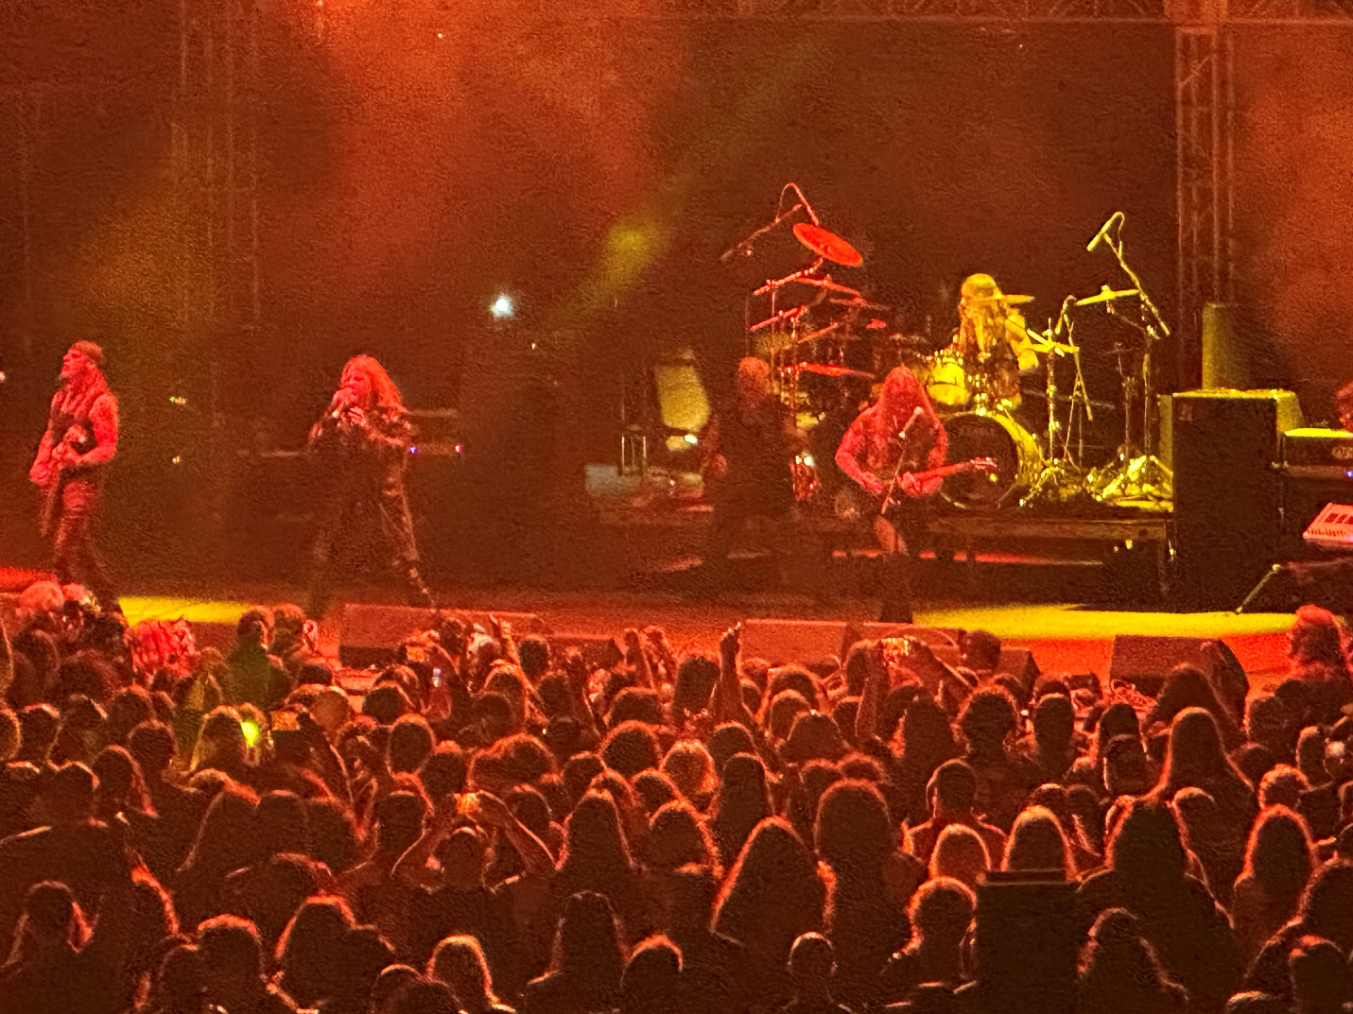
Night two’s headliner produced a Geoff Tate voiced singer in Travis Wills. Crimson Glory has a long-storied history, yet I really knew next to nothing about them except Todd Latorre once sang for them before replacing Geoff Tate in Queensryche.

Crimson Glory was prog metal but very well played. This set was far more technically proficient than Cavalera but there’s such a different energy between the two bands that it seemed like a really odd pairing. Like hearing Rush play a set right after Slayer. Both are great but not comparable and it was an odd festival decision to have these two acts finish up the night.
That said, Crimson Glory easily deserved a 90+ but I don’t want to award them a better set than Cavalera so I will stick with 92/100. At minimum, these last two sets saved the worst day of this fest in the three years.

So, that wraps up night two of the main festival. A lot of crap and a couple diamonds shining through it. This was the first night in three years that I am heading home thinking maybe I don’t want to spend two grand on plane, hotel, tickets, food, and drinks plus a VIP upgrade that isn’t worth it to come here next year.

It might be time to give another festival an opportunity and vote with my checkbook. Little Johnny says he can rock out anywhere, so he is good either way but so far, Hells Heros is just not getting it done.

But Beard & Little Johnny, we ARE done for today. Be sure to check out the videos from TikTok on my site thebeard0728, and follow all the reviews by searching
- Mark McQueen on Facebook
- Beard and Little Johnny on Facebook
- The Mighty Decibel at themightydecibel, com
- Thebeardandlittlejohnnyreviews.com

Until next time, this is the Beard saying Live Life, Stay Heavy & Horns Up.

