**Breakfast with St. Nicholas**

**Sunday December 5th after Divine Liturgy**

**Sponsored by the Ladies Guild**

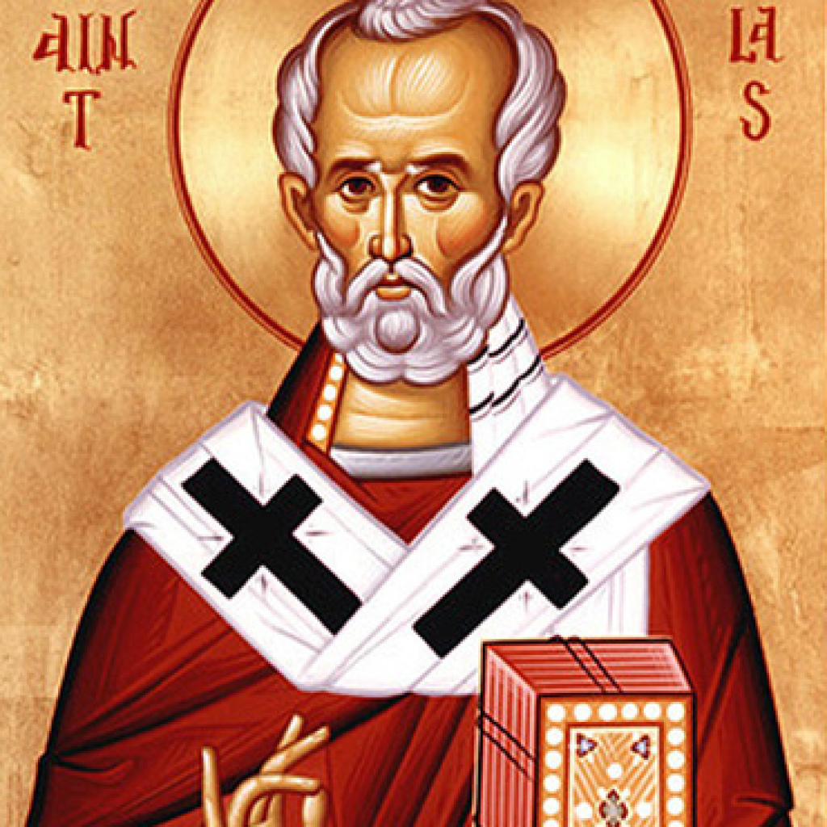

**Scrambled Eggs, Link Sausage**

**Pancakes with Maple Syrup**

**Breakfast Pastries, Fresh Fruit Bowl**

**Fruit Juice, Coffee Tea and Cocoa**

**Adults $8 and Children Under 12 Free**

**Please pay Dawn Harmon or Martha Majkut**