Protection of the Blessed Virgin Mary Ukrainian Catholic Church
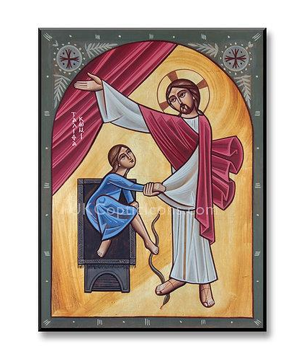
54 Walnut St. Manchester, NH 03104
Parish: www.pbvmnh.org / PBVM.Manchester.NH@gmail.com
Rev. Father Ihor Papka (860) 617-6357 vipapka@yahoo.com
Deacon Jon Messer (603) 233-9948 NHbagpiper@gmail.com

Cantors: Christina Vogel and John Housty
Trustees: Mrs. Pam Young (603) 315-9536 pjyoungnh@gmail.com
Dr. OlehPankewycz:(716)449-2309 Olehgp@gmail.com
Mr. Taras Zubrytskyy(603)757-3426 Taraszub0@gmail.com

Facebook: AnyaVogelPBVM@Comcast.net
Religious Education for Children: Christina Vogel mrsvogelchristina@gmail.com
Bulletin for Sunday November 9, 2025
TWENTY-SECOND SUNDAY AFTER PENTECOST
Divine Liturgy, Intentions and Various Services for the month
Sat 15 (6pm) Vespers Services  Sat 11/15 (9am) Divine Liturgy for +John and +Pelagia Babski By Morales Family  Sun 11/16 (10am) Divine Liturgy | Sat 11/22 (9am) Divine Liturgy for +Yuriy Orest Tarnawsky  (40 Days)  (6pm) Vespers Services  Sun 11/23 (10am) Divine Liturgy  Sat 11/29 6pm) Vespers Services  Sun 11/30 (10am) Divine Liturgy

Celebration of the Holy Mysteries:
RECITATION OF THE HOLY ROSARY & CONFESSIONS: ½ HR before Divine Liturgy
BAPTISM / MARRIAGE/ ANOINTING OF THE SICK / COMMUNION: Contact FR. IHOR (AT LEAST SIX MONTHS PRIOR TO WEDDING for MARRIAGE)
SCHEDULE OF DIVINE LITURGIES: Sundays 10AM (Sept- May) Sundays 9AM(June-Aug.) Holy Days of Obligation: 7PM
SATURDAY SERVICES: Fr. Ihor is celebrating Vesper services every Saturday at 6 PM. All parishioners are invited to attend this beautiful service. Those who wish to have a Divine Liturgy celebrated for a loved one whether living or deceased or for a private intention are still able to do so. Please request your Divine Liturgy by contacting Fr. Ihor at (860) 617-6357 Deacon Jon at (603) 233-9948. Please note that Saturday Divine Liturgies will now be celebrated only at 10 AM (9 AM during the summer months) whenever they are requested. If no Divine Liturgy has been requested for a particular Saturday, then none will be celebrated on that day. The Divine Liturgy schedule in the bulletin will only show 9AM Divine Liturgies on Saturdays when they have been requested. If the bulletin does not show a 9 or 10 AM Divine Liturgy for a given Saturday, then this means that particular Saturday is available for your request.
Суботні Богослужіння: Oтeць Ігор святкує Bечірню кожної суботи у 7-мі годині вечером. Ласкаво просимо усіх парафіян до участи. Парафіяни які бажають замовити Божественну Літургію в суботу для померших або на особисті інтенції можуть дзвoнити дo o. Iгopя нa нoмep (860) 617-6357 aбo дo дякa п. Яpocлaвa Maкcимoвичa нa нoмep (603) 627-2042. Суботні Божественні Літургії будуть відслужені тільки о годині 10-тій ранком (о годині 9-тій ранком y лiтниx мicяцяx) кoли замoвлeні. Якщо Літургія в певну суботу не будe замовлeнa, то в цей день не буде жодна відпpaвлeна. Порядок Богослужінь в бюлетeнi покаже тільки ті суботні Служби Божі які є замовлені. Якщо в бюлетені не відображається Божественна Літургія на дану суботу, то це означає, що ця субота доступна нa Baшe замовлeня.

Please Pray for our Sick and Homebound Parishioners
Будь ласка, моліться за наших хворих і прибулих до дому парафіян
Fr. Ihor Papka, Fr. Zbigniew Brzezicki, Oleh and Valentina Babski, Marylou Blaisdell, Josephine Housty, Ian Brown, Adrianna Halloran, Cole Cheney-Halloran, Carmel Horangic, Christine Kolagji, Helen Kucman, Martha Majkut, Karen and Jaroslaw Maksymowych, Jean Mandych, Sherri Martel, Katie Mattay, Katherine Masso, Jennifer McMillan, Katharine McNaughton, Richard Merlini, Jackie Morales, Lauren Morales, Tanya and Ronald Morales, Lena Puciw, Patty Enright, Jean Koromaus, Alan Pasicznyk, Billie Sheesley, John Terninko, Elisha Wallace, Greg and Mary, Deacon Jon Messer. Please contact Fr. Ihor or a Trustee if you would like to add a friend or loved one to this prayer list.
Visiting a Byzantine Catholic Church? What to Expect!
The Byzantine Rite, Ukrainian Catholic Church has been called “the best-kept secret in America.” Whether you’re from a different Christian tradition or exploring for the first time, some things may feel unfamiliar. Below are answers to common questions to help you feel more at home:
- What is the Divine Liturgy? It’s our main worship service—literally, “the work of the people” where we celebrate the Eucharist. Most Sundays use the Liturgy of St. John Chrysostom (5th c.), w/the Liturgy of St. Basil (4th c.) on certain feast days.
- What about children? Children are full participants in worship. We do not separate them for a different service, their presence—even their noise—is welcome!
- Why all the icons? Icons are not idols; they’re sacred images that teach, inspire prayer, and connect us with the heavenly reality. We venerate them as a sign of love and honor, not worship.
- Why do people make the Sign of the Cross? It’s an ancient Christian gesture expressing our faith and devotion, used during prayer or at moments of blessing.
- Why the incense and chanting? Worship involves all the senses. Incense represents our prayers rising to God. Chanting helps proclaim Scripture and prayer beautifully and clearly.
- Why do we stand? Standing is the biblical posture of prayer and reverence—just as it is in heaven (Isaiah 6:2, Revelation 7:11).
- What is the Eucharist? Eastern Catholics believe that the bread and wine truly become the Body and Blood of Christ. This mystery is approached with awe and reverence.
- Can I receive Communion? Communion is for baptized Catholic Christians who have prepared through prayer, fasting, and confession.
- How can I become Eastern Catholic? Speak with our priest. After a time of learning and preparation as a catechumen, you may be received through baptism or chrismation.

We’re glad you’re here. “Come and see” (John 1:46)—and if you have questions, don’t hesitate to ask Fr. Ihor or Deacon Jon, or any member of our community.
 | ​111/1 Doug V.  111/6 Yury S.  111/6 John T.  ​111/10 Andrew & Maria Bobiak  (Wedding Anniv)  ​111/15 Laurent M.  111/17 Andrew W. & Tracy C.  (Wedding Anniv) | 1/17 Pamela Y.  1​1/21 Katarina V.  1​1/25 Cassie G.  1​1/28 Richard Y.  1​1/30 Mila B.

Our parish community wishes this month’s birthday and anniversary celebrants peace, joy, love and good health on their special day as well as throughout the year. May our dear Lord grant all of you many more healthy, happy and blessed years. Happy Birthday, Happy Anniversary and Ha Многая літа! (Na Mnohaya Lita!).
Bishop’s Annual Appeal
Our small parish has been assessed $1,300 for the Annual Appeal, Your donations go directly toward the most pressing needs — the spiritual, intellectual, and physical support of our faithful throughout the Eparchy.. Please
give from the heart—every contribution, large or small, makes a difference. Return the white and yellow copies with your gift by November 1 (place in the collection basket or mail to the parish—do not send to Stamford, our church will not get credited for your contribution).
Your kindness and support strengthen our Ukrainian Catholic Church today and for generations to come.

TWENTY-SECOND SUNDAY AFTER PENTECOST
Troparion (5): Let us the faithful acclaim and worship the Word, co-eternal with the Father and the Spirit, and born of the Virgin for our salvation. For He willed to be lifted up on the cross in the flesh, to suffer death and to raise the dead by His glorious resurrection. Glory be to the Father, and to the Son, and to the Holy Spirit.
Kontakion (5): You, my Savior, descended to Hades, and as the Almighty, You shattered its gates. With Yourself You, as Creator, raised the dead and shattered the sting of death, and delivered Adam from the curse, O Lover of Mankind. And so we cry out: Save us, O Lord. Now and for ever and ever: Amen.
Theotokion (5): Rejoice, O Impassable Door of the Lord! Rejoice, O Rampart and Protection of those who have recourse to you! Rejoice, O Tranquil Haven and Virgin, who gave birth in the flesh to your Maker and God! Fail not to intercede for those who sing and worship the Child you bore.
Prokimenon (5): You, O Lord, will guard us and will keep us from this generation, and for ever.
Verse: Save me, O Lord, for there is no longer left a just man.
Prokimenon (5): You, O Lord, will guard us and will keep us from this generation, and for ever.
Epistle:
Reading of the Epistle of St. Paul to the Galatians. (Gal 6:11-18)
Brethren: See with what large letters I am writing to you in my own hand! It is those who want to make a good appearance in the flesh who are trying to compel you to have yourselves circumcised, only that they may not be persecuted for the cross of Christ. Not even those having themselves circumcised observe the law themselves; they only want you to be circumcised so that they may boast of your flesh. But may I never boast except in the cross of our Lord Jesus Christ, through which the world has been crucified to me, and I to the world. For neither does circumcision mean anything, nor does uncircumcision, but only a new creation. Peace and mercy be to all who follow this rule and to the Israel of God. From now on, let no one make troubles for me; for I bear the marks of Jesus on my body. The grace of our Lord Jesus Christ be with your spirit, brothers. Amen.

Alleluia Verses:
Verse (5): Your mercies, O Lord, I will sing for ever; from generation to generation I will announce Your truth with my mouth. Alleluia, Alleluia, Alleluia.
Verse (5): For You have said: Mercy shall be built up for ever; in the heavens Your truth shall be prepared. Alleluia (3)
Gospel: (Lk 8:41-56)
TWENTY-FOURTH SUNDAY AFTER PENTECOST
At that time, a man named Jairus, an official of the synagogue, came to Jesus. He fell at the feet of Jesus and begged him to come to his house, because he had an only daughter, about twelve years old, and she was dying. As he went, the crowds almost crushed him. And a woman afflicted with hemorrhages for twelve years, who had spent her whole livelihood on doctors and was unable to be cured by anyone, came up behind him and touched the tassel on his cloak. Immediately her bleeding stopped. Jesus then asked, “Who touched me?” While all were denying it, Peter said, “Master, the crowds are pushing and pressing in upon you.” But Jesus said, “Someone has touched me; for I know that power has gone out from me.” When the woman realized that she had not escaped notice, she came forward trembling. Falling down before him, she explained in the presence of all the people why she had touched him and how she had been healed immediately. He said to her, “Daughter, your faith has saved you; go in peace.” While he was still speaking, someone from the synagogue official's house arrived and said, “Your daughter is dead; do not trouble the teacher any longer.” On hearing this, Jesus answered him, “Do not be afraid; just have faith and she will be saved.” When he arrived at the house he allowed no one to enter with him except Peter and John and James, and the child's father and mother. All were weeping and mourning for her, when he said, “Do not weep any longer, for she is not dead, but sleeping.” And they ridiculed him, because they knew that she was dead. But he took her by the hand and called to her, “Child, arise!” Her breath returned and she immediately arose. He then directed that she should be given something to eat. Her parents were astounded, and he instructed them to tell no one what had happened.

Deacon Jon’s Sermon
Today we read a beautiful story of healing and transformation. We have Jairus, and official in the Synagogue, whose 12-year-old daughter was at home dying. We also have an unnamed woman who, who interestingly, has been sick for

12 years. The number 12 has meaning in the Gospels, 12 Apostles, 12 Tribes of Israel, In the book of Revelation there are 12 Gates, and 12 foundations. 12 represents the completeness of God. The name Jairus means “he enlightens” or “he shines.” We also see Jairus as a ruler in the synagogue. This is speaking to us as a place of prayer, we are to be in constant prayer, our minds should always be directed towards God. As a ruler of the Synagogue, he is meant to lead prayers, direct the works of the temple, keeps the temple clear and in order. This symbolizes our souls, our temples. We need to push out the distractions in the temple to keep it clean and holy. But there is a tragedy. His 12-year-old daughter is ill, and, as a man who rules, he has to humbly seek out Jesus, the True Physician. This daughter represents us, our sickness of sin, we are to the point of death from our sinful habits that destroy our soul. At the same time, we have a woman, who has been bleeding for 12 years, seeks Jesus’ healing. Again 12, but the bleeding makes her unclean, impure, an outsider. And, in humility she reaches out, discreetly, to touch Jesus’ garment. And when she is healed, Jesus says to her, “Daughter, your faith has saved you; go in peace.” When we look at this whole passage and see how it speaks to us today, both Jairus and the woman offer us a look at how we are today. We are all sick, or desperate. We cry out to God in desperation looking for answers to prayers. Inside we may be struggling, outwardly we may be the leader of a synagogue and have to keep up the appearance of a whole person. We are all fragmented. We are all broken in one way or another. However, God wants us to be complete, to be spotless, healed. The healing of the woman made her whole. The death of Jairus’ daughter left him empty, her rising gave him hope. Spiritual healing from Christ, in this we find our wholeness, we find true health. We have peace and faith, anything else is not peace. People around us, family, friends, popular culture, the world will constantly try to tell us that true peace is found somewhere else, not with Christ. The devil will try to whisper in our ears, “don’t bother with that rubbish, you don’t need Christ, your loved one is gone and all is lost.” This thinking isn’t peace, doesn’t bring healing. But, like the woman healed by Jesus, we only need to have faith, and listen quietly, “Fear not, only believe and you will be healed.” When Jairus enters his home to find his dead daughter healed, we see Jesus tell the people to give the young girl something to eat. When we find true peace with Christ we also hunger for spiritual food. Because we serve a God who loves us enough to walk among us, heal us, speak with us. And in the middle of all this human misery, we find Christ ready to heal. When we put our faith in Him, He alone gives us healing. When we seek to only touch the hem of his garment, we find relief. My dear brothers and sisters, if we are prepared to receive the Eucharist today, approach as the bleeding woman did, with humility as we are about to touch something greater than the hem of Christ’s garment. Ask him to heal the sickness in our souls. Approach with, “the fear of God and with Faith.” We are not asking him to heal our sick child, this is greater than that. We are about to receive Him bodily and soul. We are about to receive He who conquered death, and continues to conquer death. We approach He who has the power to heal the deepest wounds and the greatest sins. We approach Christ Himself. Jairus and the woman came humbly; we should do the same.
Communion Verse: Praise the Lord from the heavens; praise Him in the highest. Alleluia, Alleluia, Alleluia.
Тропар (5): Рівнобезначальне з Отцем і Духом Слово, що від Діви народилося на спасіння наше, прославмо, вірні, і поклонімся, бо Воно благозволило тілом зійти на хрест і смерть перетерпіти, і воскресити померлих славним воскресінням Своїм. Слава Отцю, і Сину, і Святому Духові.
Кондак (5): До аду, Спасе мій, зійшов Ти, і, як всемогутній, сокрушивши його брами, Ти, Чоловіколюбче, як Творець, воскресив з Собою померлих, жало смерти вирвав, й Адама від прокляття визволив. Тому всі до Тебе взиваємо: Спаси нас, Господи! І нині, і повсякчас, і на віки вічні. Амінь.
Богородичний (5): Радуйся, Брамо Господня, непрохідна! Радуйся, Охороно і Покрове тих, що до Тебе приходять! Радуйся, тиха Пристане і Вседіво, що Свого Творця і Бога тілом породила! Молись безупинно за тих, що прославляють і почитають Народженого від Тебе.
Прокімен (5): Ти, Господи, збережеш нас і захистиш нас від роду цього і повік.
Стих: Спаси мене, Господи, бо не стало праведного.
Прокімен (5): Ти, Господи, збережеш нас і захистиш нас від роду цього і повік.
Апостол:
До Галатян послання св. апостола Павла читання. (Гал 6:11-18)
Браття, гляньте, якими буквами пишу вам власною рукою. Ті, що хочуть показатися гарними тілом, - вони силують

вас обрізатися, щоб тільки уникнути переслідування за хрест Христа. Бо й самі обрізані, не додержують закону, а
хочуть, щоб ви обрізувалися, щоб їм хвалитися вашим тілом. Мене ж, не доведи Боже, чимсь хвалитися, як тільки
хрестом Господа нашого Ісуса Христа, яким для мене світ розп’ятий, а я - світові; бо ані обрізання, ані необрізання є щось, лише - нове створіння. На тих, які поступають за цим правилом, мир на них і милосердя, а й на Ізраїля Божого. На майбутнє нехай ніхто мені не завдає клопоту, бо я ношу на моїм тілі рани Ісуса. Благодать Господа нашого Ісуса Христа нехай буде з вашим духом, брати! Амінь.
Алилуя: Стих (5): Милості Твої, Господи, оспівуватиму повік, і з роду в рід сповіщу устами моїми Твою вірність. Алилуя, алилуя, алилуя.
Стих (5): Бо сказав Ти: Повік милість збудується, на небесах приготовиться істина Твоя. Алилуя, алилуя, алилуя.
Євангеліє:
(Лк 8:41-56) 24-а НЕДІЛЯ ПО ЗІСЛАННІ СВ. ДУХА
Того часу, прийшов чоловік, Яір на ім’я, який був головою синагоги. Припавши до ніг Ісуса, він почав його просити зайти до нього в хату, бо була в нього дочка одиначка, яких дванадцять років, і вона вмирала. І як він ішов туди, люди тиснулися до нього. Аж тут жінка якась, що була хвора дванадцять років на кровотечу й витратила на лікарів увесь свій прожиток, і ніхто з них не міг її оздоровити, підійшовши ззаду, доторкнулась краю його одежі й умить стала здоровою - спинилась її кровотеча. Ісус спитав: “Хто доторкнувся до мене?” А що всі відпекувались, Петро мовив: “Наставниче, то люди коло тебе юрмляться і тиснуться.” Ісус же сказав: “Хтось доторкнувся до мене, бо я чув, як сила вийшла з мене.” Побачивши жінка, що не втаїлася, тремтячи підійшла й, упавши йому до ніг, призналася перед усіма людьми, чому до нього доторкнулась і як негайно одужала. Сказав їй Ісус: “Дочко, віра твоя спасла тебе, йди в мирі!” Він говорив ще, як приходить хтось від голови синагоги й каже: “Твоя дочка померла, не турбуй більш Учителя.” Ісус, почувши це, озвався до нього: “Не бійся, тільки віруй і вона спасеться.” Прийшовши до хати, він не пустив нікого з собою в середину, крім Петра, Івана та Якова з батьком та матір’ю дитини. Всі плакали за нею і голосили. Він же мовив: “Не плачте, вона не вмерла, вона тільки спить.” І ті сміялися з нього, бо знали, що вмерла. А він узяв її руку й голосно промовив: “Дівчино, пробудися!” І дух її повернувсь до неї, і вона миттю стала. Тоді він звелів дати їй їсти. Батьки ж її були здивовані вельми, та він наказав їм нікому не говорити, що сталося.
Проповідь о. Ігоря
Слава Ісусу Христу! Дорогі в Xpиcтi браття і сестри! Цієї неділі маємо Христову науку не у вигляді притчі, а конкретної життєвої історії, яку богослови називають чудом в чуді. Євангеліє розповідає про оздоровлення кровоточивої жінки та воскресіння Ісусом дочки Яіра. Ці події дуже наближені до реалій нашого життя, бо й сьогодні люди хворіють на різні хвороби, а також вмирають. З опису сьогоднішньої євангельської події бачимо, що ніщо не зупинило жінку в дорозі до Спасителя. Бажання оздоровитися з кровотечі і сильна віра у всемогутність Христа дали їй силу протиснутися крізь натовп людей, щоб доторкнутися до краю Його одежі і стати здоровою. Дорога до Ісуса, як бачимо у Євангелії, не завжди легка, як у жінки чи Яіра. У дорозі до дому Яіра Ісуса затримує жінка, Яіра затримує слово про смерть дочки і страх, сумнів за її життя. Цей епізод сьогоднішнього Євангелія запитує нас: а що затримує мене у дорозі до Ісуса? Чи моя віра завжди провадить мене до Ісуса Христа у молитві і Святих Тайнах? Тема оздоровлення завжди актуальна в житті, особливо його способів осягнення, як для нас, так і для ближніх. Бажаючи оздоровитись самому з фізичних чи духовних недуг, або допомогти комусь у його фізичній чи духовній хворобі, навернути до Бога, у нас виникають різні запитання: що і як зробити, щоб покращився стан людини, змінилася ситуація. Якщо хочемо з Божою допомогою оздоровити когось, навернути до Бога, до Церкви, то потрібно дотримуватися такої засади: спочатку маємо відкрити людині Господа Бога – джерело і мету оздоровлення, а тоді пропонувати необхідні для цього середники. Ближньому треба показати Христа як когось близького й важливого для нього, а тим самим допомогти йому відкритися на Бога – Його правду та ласку. Працювати в цьому напрямку потрібно одночасно словом та вчинками. Людині треба донести правду про всемогутність, любов, прощення, милосердя Бога до нас, небезпеку гріха та важливість спасіння. Робити це слід розсудливо, поступово, без зайвого психологічного чи морального тиску, щоб ще більше не відвернути ближнього від Христа; дивитися наскільки він відкритий на Божу правду, готовий прийняти її і нею жити. Працю над наверненням чи оздоровленням ближніх треба завжди поєднувати з молитвою за них. Бо оздоровлення чи навернення є

найперше Божим даром. Тому ці ласки потрібно спочатку випросити в Бога молитвою, а потім донести їх
ближнім словом та вчинком. Маємо пам’ятати, що Тим, хто навертає і оздоровляє людину, є найперше
Господь Бог. Щоб часом в цій справі не брати багато ініціативи на себе й цим не поставити Ісуса на другому місці. Пізнати Бога – означає відкрити для себе унікальний факт, що Він перший полюбив нас (пор.1 Йо 4:19) й що саме Господь є той котрий шукає мене і тебе аж поки не знайде (пор. Лк 15:4) та що Його бажанням є утерти кожну сльозу й звільнивши нас від скорботи, плачу, смутку та болю (пор. Одкр 21:4), дарувати нам повноту життя (пор. Йо 10:10) та бути всім і у всьому (1 Кор 15:28). В цю неділю на прикладі зцілення кровоточивої жінки та воскресіння дочки Яіра, Лука засвідчує, що ти і я є дуже цінними для Ісуса, бо Він не тільки може дарувати нам більше ніж ми просимо і розуміємо (пор. Еф 3:20), але й з любові віддав за наші гріхи Своє життя (пор. Гал 1:4; 2:20; Еф 5:25), й тепер сівши праворуч Отця заступається за нас (пор; Рим 8:34), й бажає, щоб ми пізнали оцю Його надзвичайну любов, котра перевищує розум, і щоб сповнилися всякою Божою повнотою (пор. Еф 3:19). Амінь!

Причасний: Хваліте Господа з небес, хваліте Його на висотах. Алилуя, алилуя, алилуя.

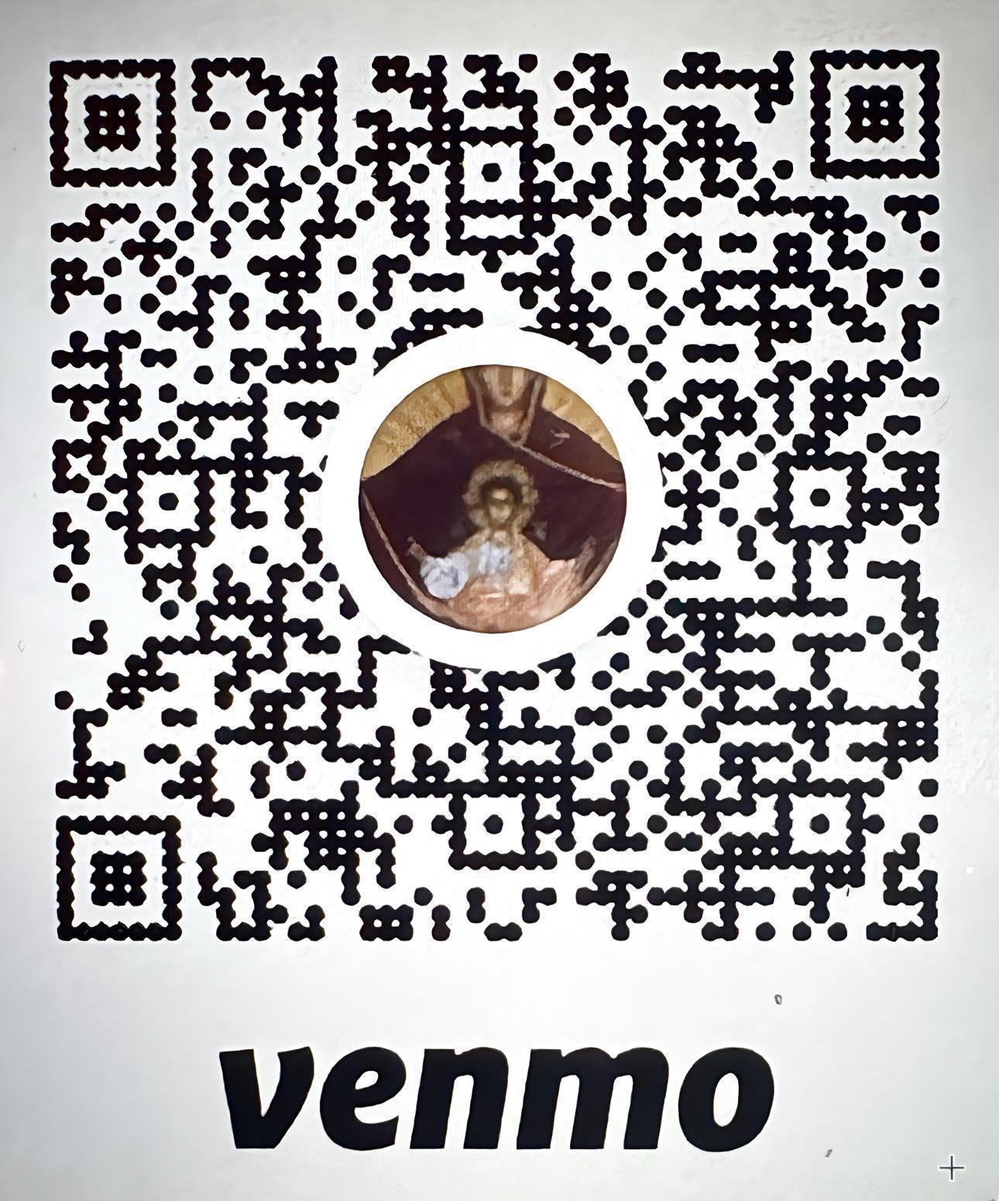 | FORGOT YOUR ENVELOPE?  You can now use Venmo! @PBVMUCC  October 2025 Financial Summary  Income $3,646  Expenses $4677.19  Deficit in the red of $1031.19  Average attendance: 39  Thank you and God bless you for your generous  support of our parish!

💚 Support Our Parish Through TD Bank’s Affinity Program! 💚
TD Bank offers an Affinity Program for non-profit organizations, and our parish is part of it. Through this program, TD Bank makes an annual contribution to our church based on the activity of participating accounts.
When opening or updating an account, simply mention our code: AJ356.
- 🏦 $50 for every new checking account opened
- 💵 $10 for every existing checking account linked
- 💰 Savings Accounts or CDs: 1/10 of 1% of the annual average balance
- 🎁 Plus, receive a $25 certificate when opening a new checking account!
It’s simple, secure, and impactful. By sharing our code AJ356 with TD Bank, your everyday banking helps strengthen our parish community — one account at a time. Small actions. Big blessings.

As lifelong parishioners and proud Ukrainian‑Americans, We understand the importance of faith, family, and community. Choosing us to guide your real estate journey means working with someone who genuinely cares—someone you know and trust. We’re honored to work alongside each other. Together, we offer a heartfelt, mother–daughter partnership built on decades of dedication and local market wisdom.

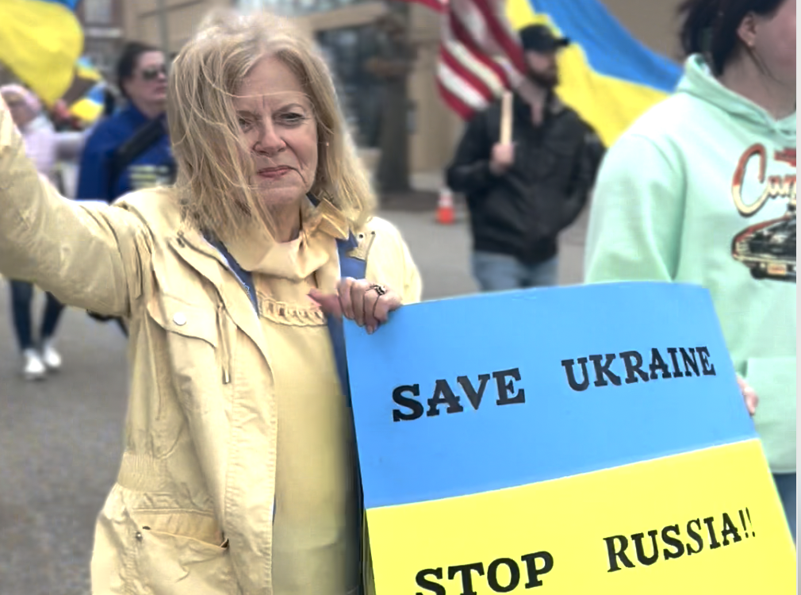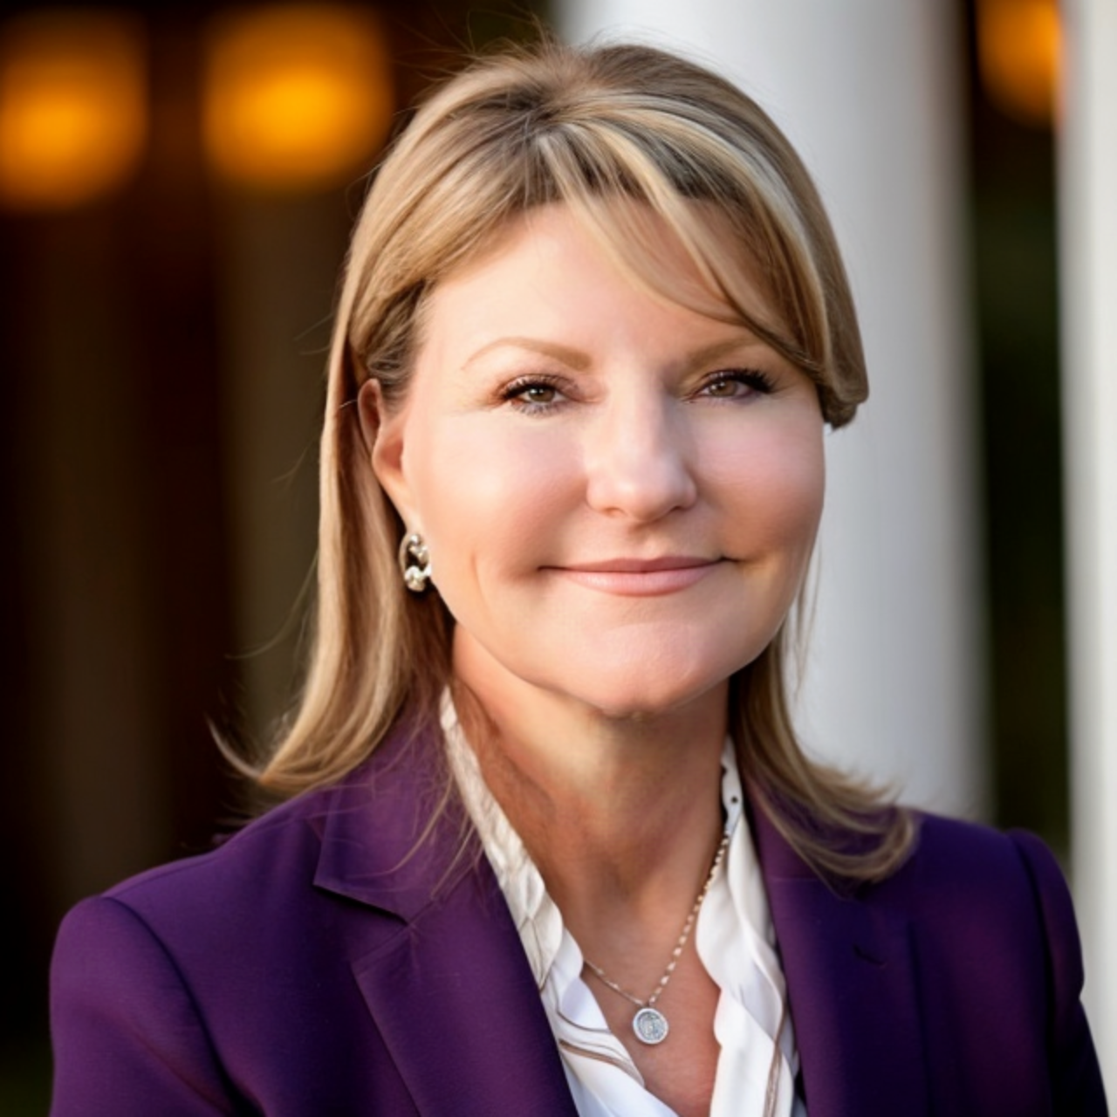
Pamela Young, 603-315-9536 Dawn Harmon, 603-856-3155
Pamela.Young@eXpRealty.com Dawn.Harmon@eXpRealty.com

