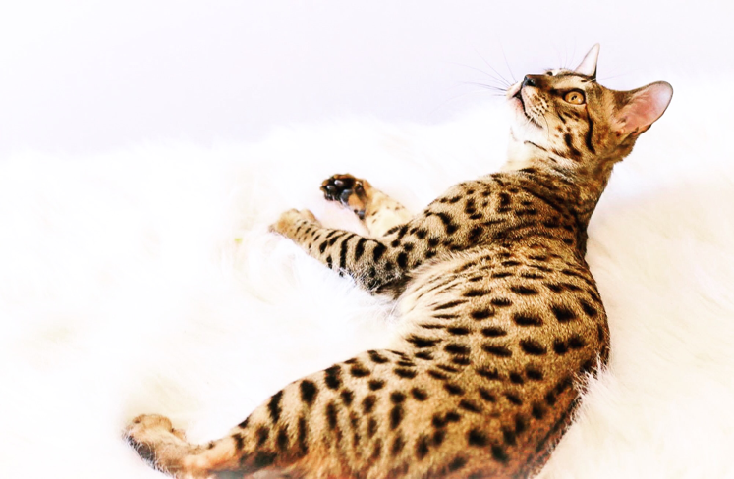
  - Kitten Application Form

Alberta Savannahs
Name:
Phone number:
Location:
- Do you have others pets in the home? Y/N
- ___# cats ___ # dogs Other _______
- Have you considered the extra expense of pet ownership? Y/N
- Have you done research on the Savannah breed? Y/N
Do you own your home or rent? If you rent, you must have written approval from the landlord or provide your lease stating a Feline is permitted. Own______ Rent ______
Do you have young children? Y/N
Are you wanting to breed or considering it? Y/N
Have you ever had an animal that’s been taken away by a Humane Society, or have you ever surrendered an animal to a shelter. If so, please explain below:
Kitten preference:
Coat color BST (brown/black spotted tabby) ____ Silver (SST) ____ Black/Smoke ____
Non-standard (Marble, Snow, Cinnamon etc.) ____
- Male____ or Female ___
- Pet / breeding rights____
- Price range ________ (please keep in mind our prices are $1500-$3000 per pet)
- Are you interested in being placed on our waiting list for a retired adult (adoption fee is $500-$1000)? Y/N
Do you understand that bringing a kitten into your home requires understanding in training and is a lifelong commitment (up to 20 years per individual)? Y/N
Please tell us a little about yourself and why a Savannah kitten would be a good fit for you:

