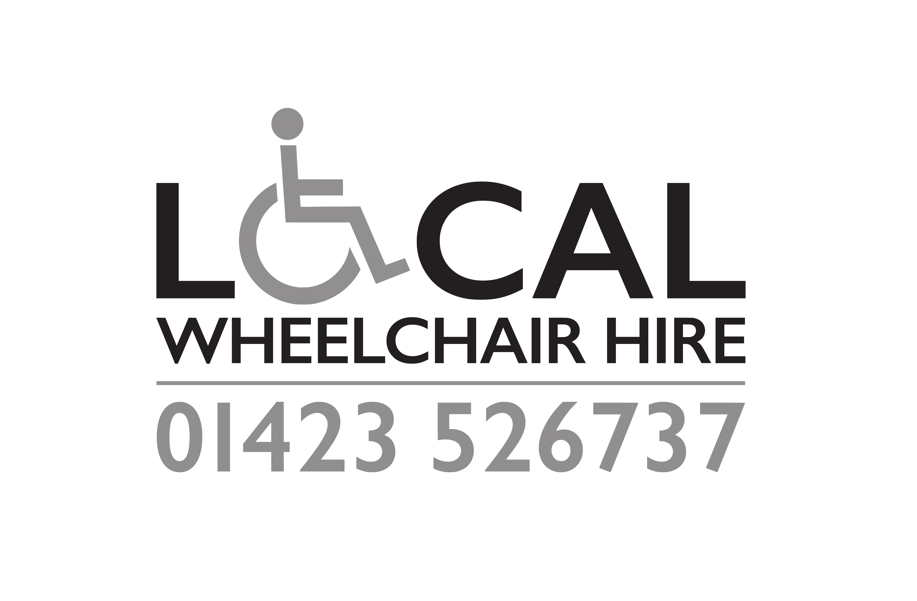
VAT FREE
Eligibility Declaration for a zero-rate VAT supply
If you are chronically sick or have a disabling condition, you may be eligible for VAT relief. Please complete and return his declaration to Local Wheelchair Hire for production to the VAT office. The production of this certificate does not automatically authorize the zero-rating of the supply.
I (Full name) …………………………………………………………………………………...
of (Full Address) ………………………………………………………………………………..
Declare that I am chronically sick or have a disabling condition by reason of:
(Please give full and specific description of your condition)
……………………………………………………………………………………………….and that I am receiving from Local Wheelchair Hire t/a Rise Mobility Ltd., 34c Leeds Road, Harrogate HG2 8BQ the following goods which are being supplied to me for domestic and my personal use (description of goods) WHEELCHAIR HIRE and that I claim relief from Value Added Tax.
Name………………………………………………………………………………………
Signature……………………………………………………………………………………
Date………………………………
Please note there are penalties for make false declarations.
If you are in any doubt as to whether you are eligible to receive goods or services zero-rated for VAT, you should consult HM Customs and Excise, Notice 701/7, VAT reliefs for disabled people or click here
https://www.gov.uk/financial-help-disabled/vat-relief
Alternatively, contact HMRC National Advice Service on 0300 200 3700 before signing the declaration.

You should complete this declaration if you are ‘chronically sick or disabled’ and the goods or services are for your own personal or domestic use. A family member or carer can complete this on your behalf if you wish. You can find out more from the Helpsheets on the GOV.UK website or by telephoning the VAT Disabled Reliefs Helpline on Telephone: 0300 123 1073. HMRC staff cannot advise whether or not an individual is chronically sick or disabled. A person is ‘chronically sick or disabled’ if he or she is a person:
- with a physical or mental impairment which has a long term and substantial adverse effect upon his or her ability to carry out everyday activities
- with a condition which the medical profession treats as a chronic sickness It does not include an elderly person who is not disabled or chronically sick or any person who is only temporarily disabled or incapacitated, such as with a broken limb. If you are unsure, you should seek guidance from your GP or other medical professional.
Please give this completed form back to the supplier. They will keep it with their VAT records.
Please do not send it to HMRC.

