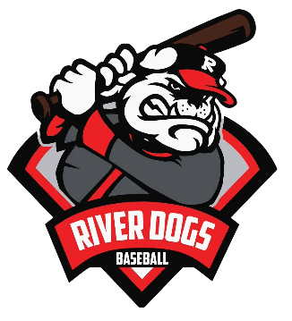
River Dogs Baseball Liability Waiver

Informed Consent/General Release-Youth Baseball Participants
PLEASE READ CAREFULLY AND SIGN BELOW TO INDICATE YOUR AGREEMENT.
NOTE: THIS FORM INCLUDES A RELEASE OF LIABILITY.
Since participation in youth sports activities can be dangerous River Dogs LLC requires that all participants (and their adult parent(s) or guardians) assume all risks associated with youth baseball by signing this general release.
For and in consideration of my child being permitted to participate in any River dogs youth baseball activities, I hereby voluntarily release, discharge, waive and relinquish any and all claims or actions for damages for personal injury, permanent disability, death, or property damage which I or my child may have, or which may here after accrue to me or my child, as a result of my participation in youth baseball activities during play and while I am at the facility while others play or for any other reason. This release is intended to discharge, in advance, River Dogs, it’s officers, employees and agents, and the owners and maintainers of any facility used for baseball practice or activities, from any and all liability arising out of or connected in any way with my child’s participation in baseball camps/clinic activities, even though that liability may arise out of negligence or carelessness on the part of The River Dogs, its officers, agents or employees, or the owners or maintainers of any facility used by The River Dogs for baseball practice or activities.
I further understand that serious accidents occasionally occur during youth baseball activities, and that participants occasionally sustain serious personal injuries, death or property damage as a consequence thereof. Knowing the risks, I have voluntarily applied for my child to participate in the activity and thereby agree to assume those risks to release and hold harmless River Dogs, its officers, employees or agents, or the owners or maintainers of any facility used by the River Dogs for baseball practice or activities, who (through negligence or carelessness) might otherwise be liable to me or to my child (or my heirs or assigns) for damages.
I further understand and agree that this release, discharge, waiver, and assumption of risk is to be binding on my and my child’s heirs, executors, administrators, and assigns.
I further agree to indemnify and to hold harmless The River Dogs, its officers, employees and agents, or the owners or maintainers of any facility used by the River Dogs for baseball practices or activities, for any loss, liability damage, cost or expense which may incur as a result of any injury or property damage I or my child may sustain while participating in the activity.
I agree to comply with the program’s stated and customary terms and conditions for participation according to the River Dogs If I observe any significant change with regards to my child’s readiness for participation in the program, I will remove my child from the program immediately.
I have read this Informed Consent/General Release, fully understanding its terms, that I give up substantial rights. By signing, you are agreeing to the terms explained above.

______________________________________________________ ______________________________
Player Name Date of Birth

______________________________________________________ ______________________________
Parent / Guardian Signature* Date

