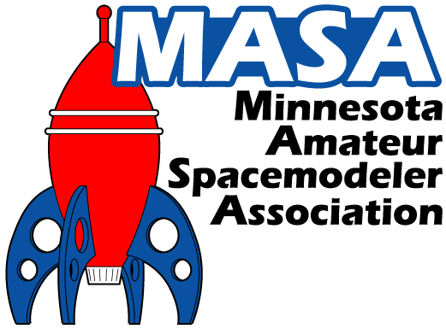
The Minnesota Amateur Spacemodeler Association Bylaws

Version 5.0

Approved by the MASA membership on December 8th, 2012

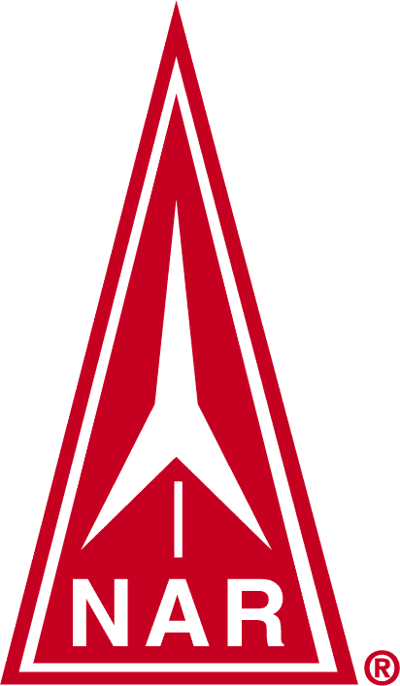
Section #576 of the National Association of Rocketry

http://www.masa-rocketry.org

Article 1.
Name: The name of this organization shall be the Minnesota Amateur Spacemodeler Association (M.A.S.A). (Hereafter referred to as MASA or the Club.)
Article 2.
Purpose: It shall be the purpose of this Club to:
- Have fun with model rocketry.
- Operate and maintain model rockets in a safe manner and in full accordance with the standards and regulations of the National Association of Rocketry (NAR), Federal Aviation Administration (FAA), Bureau of Alcohol, Tobacco, Firearms and Explosives (ATF), National Fire Protection Association (NFPA) and other recognized governing bodies.
- Hold meetings for the purpose of aiding and encouraging all those interested in rocketry.
- Engage in educational, scientific, or other positive activities relating to model rocketry.
- Foster a friendly teaching, learning and sharing environment to members, spectators and the general public to increase the awareness, enjoyment and the safety of the hobby, and to assure that the future growth of the hobby remains viable (Pay Forward)
Article 3.

Section 1.

Membership: Membership shall not be limited to members of the NAR, Tripoli Rocketry Association (TRA) or any other model rocketry organization. Only Club members in good standing (members who’s’ dues are paid in full for the current year) will receive Club mailings and be eligible to compete in Club contests or receive Club sponsored door prizes.

Section 2.
When Current Club Membership is Required: Rocketeers who wish to fly rockets at Club launches weighing over one pound lift off weight or using motors of size “E” or larger, must be members of the Club. Rocketeers who wish to fly rockets weighing less than one pound or using motors of size “D” or smaller at Club launches are not required to be Club members.

Section 3.
High Power Rocketry: Rocketeers who wish to fly high power rockets at Club launches must be:
- Club members in good standing
- Possess a valid high power certification card issued by a nationally recognized rocketry association at or above the certification level that is appropriate for the rocket and motor being flown. In the case of a high power certification flight, the card must show certification at the level below that being attempted.
A high power rocket is defined as one that fulfills one or more of the following criteria:
- Uses a motor with more than 160 Newton-seconds of total impulse (an "H" motor or larger) or multiple motors that all together exceed 320 Newton-seconds of total impulse
- Uses a motor with more than 80 Newtons average thrust
- Exceeds 125 grams of propellant
- Uses a hybrid motor
- Weighs more than 1,500 grams including motor(s)
- Includes any airframe parts of ductile metal.

Section 4.
Membership Revocation: An individual or family Club membership may be revoked at the unanimous discretion of the Club officers in the event that a member repeatedly violates safety regulations and puts the Club, members, property or spectators at risk, or continually undermines the integrity of the Club. Notice of all charges against such member will be made in writing or by email. Said member will be given thirty (30) days to present their defense of said charges to the Club officers in writing. If after consideration of all evidence membership is revoked said person’s dues will be forfeited and said person will be banned from all Club activities for a period of one (1) year. After said period said person will be allowed to rejoin the Club if they choose.

Article 4.

Section 1.

Dues: Dues for new members may be paid at any time during the year. Dues for renewing members should be paid during January or February of each year. Club membership shall run for a calendar year starting on January 1st and expiring on December 31st of each year. All dues shall be kept in a fund by the Secretary-Treasurer and shall be paid out only on order of the President. Club memberships are divided into the following three categories: Individual Membership (individuals 18 years of age and older), Junior Membership (individuals 17 years of age and younger), and Family Membership (families of up to six people). Current membership costs shall be posted on the Club web site and membership application forms. Special assessments may be levied and dues may be changed by a majority vote of the members present at any regular meeting of the Club. Such a vote will only occur provided notice is given at a previous Club meeting and posted on the Club web page at least five days preceding the voting meeting.
In November of each year a portion of the Club funds, as determined by the Club officers, shall be used to help fund the majority of the annual Club Holiday Party. The portion of the funds to be spent shall be based on the current balance with serious consideration taken for future expenditures, such as replacing worn or broken launch equipment, NAR Section fees, web-hosting fees, insurance, Club mailings and badge printing, future rental fees, etc. The remaining balance shall assure that the Club remains viable and can continue to operate.
Section 2.

Club Property: It is the goal of the Club to own no significant property other than property that is deemed necessary to keep the Club operating and viable. This property can include, but is not limited to, launch equipment, PA equipment, safety equipment, office supplies, contest supplies and prizes. Donations presented to the Club will become Club property or the property of individual Club members as determined by the president.
Awards, trophies, ribbons and the like won by the club in regional, national or international competitions will be the responsibility of the Vice-President for storage and care. They will be transferred at election time, as needed.

Article 5.

Section 1.

Meetings: Meetings of the Club shall be held monthly and at least 10 times per year at times and places designated by the Club Officers. Operation of the rocket range shall not be considered a meeting.

Major Club decisions that affect a significant amount of Club funds, including, but not limited to, by-laws changes or dues rate changes, shall require a two-thirds majority vote of the current Club members in good standing present at the voting meeting as well as a two-thirds majority vote of the officers. Votes cast in absentia will be tabulated in the totals.
Section 2

Launches: Club launches shall be held monthly and at least 6 times per year. Rules for operation of the rocket range will follow the NAR safety code for low and high power rocketry and the MASA Launch Site Guidelines. The MASA Launch Site Guidelines may be revised at any time at the discretion of the President and Club officers. Current MASA launch rules, regulations, and procedures will be published on the Club web site.

Banned from ALL MASA Launches: Sparky” type motors, such as Aerotech Metalstorm, CTI/AMW Skidmark, or any other brand of motor that emits showers of sparks, are NOT ALLOWED at any MASA launch due to the fire risk and potential damage to the field and/or other property. Tissue type wadding such as Estes or Quest wadding sheets are not allowed at any MASA launch. MASA provides cellulose “dog barf” type wadding free of charge to all launch participants.

Article 6.

Section 1.

Club Officers: The Club Officers shall consist of a President, Vice President, and a Secretary-Treasurer. All officers shall be members in good standing of the Club and the NAR, and shall be 18 years of age or older.

Section 2.

Terms of Office: All officers shall serve a term of, but not limited to, one year with the exception of officers who are required to vacate their office prior to the end of their term, and for officers who fill such vacancies mid-year as defined in Article 7, Section 3.

Article 7.

Section 1.

Nominations: Nominations shall occur during the official Club meeting held during the month of November. Nominations for all positions shall be made from the floor or through electronic announcements. Nominees shall be required to accept the nomination prior to becoming a candidate.

Section 2.

Elections: Club Officers shall be elected by all members in good standing present at the first meeting of the calendar year. The candidate for each position having the largest number of votes shall be elected. Members not present may vote in absentia at the current President's discretion. Newly elected officers shall assume their new positions during the first meeting of the calendar year.

Section 3.

Vacancies: Vacancies in offices shall be filled by nomination and election of a Club member to fill the unexpired term of the office and shall take place at the Club meeting at which the vacancy is announced or as soon as possible at the discretion of the remaining officers.

Article 8.

Amendments: Notice of a proposed amendment to these bylaws must be presented to Club members a minimum of seven calendar days before a scheduled Club meeting. The notice and a copy of the proposed amendment(s) shall be made available in writing, via email or on the Club web site. Approval of the amended bylaws shall require a two-thirds majority vote of the following: (1) the current Club members in good standing present at the voting meeting, (2) a two-thirds majority vote of the officers, and (3) votes cast in absentia or through official on-line polls posted by the Club officers.
Article 9.

Liquidation: In the event the number of adult dues-paying members of the club as of November 1 of any year drops below five, the club fund will be liquidated and distributed equally to the remaining dues paying members.

Bylaw Revision History:
1.0 December 12, 1997:
1.1 January 11, 1998: Added "Launch Site Guidelines" information under Section 2, Launches.
2.0 January 15, 1999: Updated Fee Structure, added Vice President, elections guidelines, misc
3.0 February 6, 2001: Changed all variations to “spacemodeler”, added NAR logo to title page, removed membership discount structure for insured NAR members, added motor limits for non-members, updated misc phrasing
3.1 February 24, 2001: Revised Articles 6, 7 and 9 to improve clarity of phrasing. Added Article 3, Section 3.
3.1 March 13, 2001: Article 3, Section 3 removed by unanimous vote. Revised bylaws unanimously approved by members in attendance.
4.0 March, 2007 Revised Article 4, Section 1 to provide for changes to dues and to permit retention of some club funds year over year. Revised Article 5, Section 1 to change the definition of quorum. Added Article 10.
5.0 November, 2012 Updated the MASA Logo. Revised Article 2, Purpose (b) and added Purpose (e). Revised Article 3, Section1 & 2, added Section 3 & Section 4. Revised Article 4, Section 1 & 2. Revised Article 5, Section 1 &2. Revised Article 6, Section 1 & 2. Revised Article 7, Section 1, 2 & 3. Renamed Article 9 to Article 8 and revised amendment section. Renamed Article 10 to Article 9.

