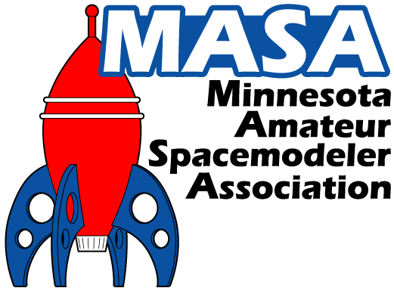
The Minnesota Amateur Spacemodeler Association Bylaws

Version 6.0

Approved by the MASA membership on March 7, 2019

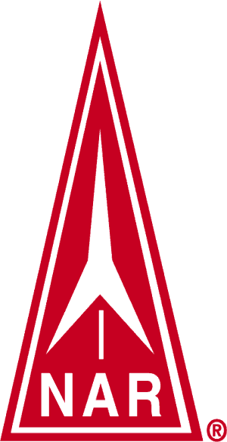
Section #576 of the National Association of Rocketry

http://www.masa-rocketry.org

Article 1.
Name: The name of this organization shall be the Minnesota Amateur Spacemodeler Association (M.A.S.A. or MASA). (Hereafter referred to as MASA or the Club.)
Article 2.
Purpose: It shall be the purpose of this Club to:
- Have fun with model rocketry.
- Operate and maintain model rockets in a safe manner in full compliance with the National Association of Rocketry (NAR) Safety Codes, and in accordance with the applicable standards and regulations of the Federal Aviation Administration (FAA), Bureau of Alcohol, Tobacco, Firearms and Explosives (ATF), National Fire Protection Association (NFPA) and other recognized governing bodies, including state and/or local ordinances.
- Hold meetings for the purpose of aiding and encouraging all those interested in rocketry.
- Engage in educational, scientific, or other positive activities relating to model rocketry.
- Foster a friendly teaching, learning and sharing environment to members, spectators and the general public to increase the awareness, enjoyment and the safety of the hobby, and to assure that the future growth of the hobby remains viable (Pay Forward)
Article 3.

Section 1.

Membership: Membership in the NAR is not required for membership in MASA. However, non-NAR members are not covered by NAR liability insurance and may be held personally liable for any damage or injury caused by their actions. Only Club members in good standing (members whose dues that have been paid in full for the current year) will receive Club mailings, be eligible to compete in Club contests (including NAR sponsored contests), receive Club sponsored door prizes, nominate or vote for club officers, and vote on bylaw amendments. New members that join after September 30 will be considered active members for the remainder of the current year and all of the following calendar year.

Section 2.
When Current Club Membership is Required:

Club membership is required to fly rockets at any Club launch with the exception of visitors competing in any NAR sponsored contest, or spectators flying a Club-donated Fly It/Take It Rocket. Non-members or guests are allowed to fly rockets weighing less than one pound and using a “D” motor or smaller at the discretion of the Club officers.

Section 3.
High Power Rocketry: Rocketeers who wish to fly high power rockets at Club launches must be:
- Club members in good standing
- Possess a valid high power certification card issued by a nationally recognized rocketry association at or above the certification level that is appropriate for the rocket and motor being flown. In the case of a high power certification flight, the card must show certification at the level below that being attempted.
A high power rocket is defined as one that fulfills one or more of the following criteria:
- Uses a motor with more than 160 Newton-seconds of total impulse (an "H" motor or larger) or multiple motors that all together exceed 320 Newton-seconds of total impulse
- Uses a motor with more than 80 Newtons average thrust
- Exceeds 125 grams of propellant
- Uses a hybrid motor
- A motor designed to emit sparks
- Weighs more than 1,500 grams including motor(s)
- Includes any air frame parts of ductile metal.

Section 4.
Membership Revocation: An individual or family Club membership may be revoked at the unanimous discretion of the Club officers in the event that a member repeatedly violates safety regulations and puts the Club, members, property or spectators at risk, or continually undermines the integrity of the Club. Notice of all charges against such member will be made in writing or by email. Said member will be given thirty (30) days to present their defense of said charges to the Club officers in writing. If after consideration of all evidence membership is revoked, said person’s dues will be forfeited, and said person will be banned from all Club activities for a period of one (1) year. After said period, said person will be allowed to rejoin the Club if they choose.
Article 4.

Section 1.

Dues: Dues for new members may be paid at any time during the year. Dues for renewing members should be paid during January or February of each year. Club membership shall run for a calendar year starting on January 1st and expiring on December 31st of each year. New members that join after September 30 will be considered active members for the remainder of the current year and all of the following calendar year. All dues shall be kept in a fund by the Secretary-Treasurer and shall be paid out only on order of the President. Club memberships are divided into the following three categories: Senior Membership (individuals 18 years of age and older), Junior Membership (individuals 17 years of age and younger), and Family Membership (families of up to six people). Current membership costs shall be posted on the Club web site and membership application forms. Special assessments may be levied and dues may be changed by a majority vote of the members present at any regular meeting of the Club. Such a vote will only occur provided notice is given at a previous Club meeting and posted on the Club web page at least five days preceding the voting meeting.
A portion of the Club funds, as determined by the Club officers, may be used to help fund the majority of the annual Club Picnic and/or Holiday Party. The portion of the funds to be spent shall be based on the current balance with serious consideration taken for future expenditures, such as replacing worn or broken launch equipment, NAR Section fees, web-hosting fees, insurance, Club mailings and badge printing, future rental fees, etc. The remaining balance shall assure that the Club remains viable and can continue to operate.
Section 2.

Club Property: It is the goal of the Club to own only property necessary to keep the Club operations safe and viable. This property can include, but is not limited to, launch equipment, an equipment trailer, PA equipment, safety equipment, Fly It/Take It rockets, office supplies, contest supplies, prizes and party supplies. Donations presented to the Club will become Club property.
Awards, trophies, ribbons and the like won by the club in regional, national or international competitions will be the responsibility of the Vice-President for storage and care. They will be transferred at election time, as needed.
Article 5.

Section 1.

Meetings: Meetings of the Club shall be scheduled no more than once per month and held a minimum of six times per year at times and places designated by the Club Officers. Operation of the rocket range shall not be considered a meeting.

Club officers shall meet at least once per year, following elections as soon as can be accomplished, to set upcoming dates for Club meetings and launches for that calendar year.
Major Club decisions that affect a significant amount of Club funds, including, but not limited to dues rate changes or large property purchases, shall require a two-thirds majority in-favor vote of the current Club members present at the voting meeting as well as a two-thirds majority in-favor vote of the Club officers.
Section 2

Launches: Club launches shall be scheduled monthly (typically with the exception of December due to the proximity to the holidays), and may be canceled or rescheduled due to weather or field availability at the discretion of the Club Officers. Rules for operation of the rocket range will follow the NAR safety codes for low and high power rocketry, as applicable, and the MASA Launch Site Guidelines. The MASA Launch Site Guidelines may be revised at any time at the discretion of the Club officers. Current MASA launch rules, regulations, and procedures will be published on the Club web site.

Banned from all MASA Launches: “Sparky” type motors, such as Aerotech Metalstorm, CTI/AMW Skidmark, or any other brand of motor that emits showers of sparks, are NOT ALLOWED at any MASA launch due to the fire risk and potential damage to the field and/or other property.
Tissue type wadding, such as Estes or Quest wadding sheets, are not allowed at any MASA launch. MASA provides cellulose “dog barf” type wadding free of charge to all launch participants.
Article 6.

Section 1.

Club Officers: The Club Officers shall consist of a President, Vice President, and a Secretary-Treasurer. All officers shall be members in good standing of the Club and the NAR, and shall be 18 years of age or older.

Section 2.

Terms of Office: All officers shall serve a term of, but not limited to, one year with the exception of officers who are required to vacate their office prior to the end of their term, and for officers who fill such vacancies mid-year as defined in Article 7, Section 3.

Article 7.

Section 1.

Nominations: Nominations shall open during the official Club meeting held during the month of November. Nominations for all positions shall be made from the floor or through electronic announcements. Nominees shall be required to accept the nomination prior to becoming a candidate.

Section 2.

Elections: Club Officers shall be elected by all members in good standing present at the first meeting of the calendar year. The candidate for each position having the largest number of votes shall be elected. Newly elected officers shall assume their new positions during the first meeting of the calendar year.

Section 3.

Vacancies: Vacancies in offices shall be filled by nomination and election of a Club member to fill the unexpired term of the office and shall take place at the Club meeting at which the vacancy is announced or as soon as possible at the discretion of the remaining officers.

Article 8.

Amendments to These Bylaws: Notice of a proposed amendment to these bylaws must be presented to Club members a minimum of seven calendar days before a scheduled Club meeting. The notice and a copy of the proposed amendment(s) shall be made available on the Club web site. Approval of the amended bylaws shall require a two-thirds majority in-favor vote of the current Club members present at the voting meeting as well as a two-thirds majority in-favor vote from the Club officers.

Proposed amendments that receive the required minimum in-favor votes shall become effective immediately upon completion of voting. Proposed amendments that do not receive the required minimum in-favor votes may be canceled, or further amended, or tabled for a future re-vote.

Article 9.

Liquidation: At the beginning of the NAR Section renewal month, in the event the number of senior dues-paying members of the club falls below the minimum required by the NAR, the Club will not renew, and the Club shall cease to be a recognized NAR Section. The Club can continue to operate as a stand-alone club, but shall forfeit all associated NAR benefits, including, but not limited to site owner liability insurance.

In the event that the Club membership decreases to a point that the remaining members decide to dissolve the Club, the Club assets shall be liquidated. Club property will be sold, or returned to the original donor, or donated to a school, or another rocket club, or a STEM-based organization, or to the NAR. The remaining Club funds will be donated to the NAR.

Bylaw Revision History:
1.0 December 12, 1997:
1.1 January 11, 1998: Added "Launch Site Guidelines" information under Section 2, Launches.
2.0 January 15, 1999: Updated Fee Structure, added Vice President, elections guidelines, misc
3.0 February 6, 2001: Changed all variations to “spacemodeler”, added NAR logo to title page, removed membership discount structure for insured NAR members, added motor limits for non-members, updated misc phrasing
3.1 February 24, 2001: Revised Articles 6, 7 and 9 to improve clarity of phrasing. Added Article 3, Section 3.
3.1 March 13, 2001: Article 3, Section 3 removed by unanimous vote. Revised bylaws unanimously approved by members in attendance.
4.0 March, 2007 Revised Article 4, Section 1 to provide for changes to dues and to permit retention of some club funds year over year. Revised Article 5, Section 1 to change the definition of quorum. Added Article 10.
5.0 November, 2012 Updated the MASA Logo. Revised Article 2, Purpose (b) and added Purpose (e). Revised Article 3, Section1 & 2, added Section 3 & Section 4. Revised Article 4, Section 1 & 2. Revised Article 5, Section 1 &2. Revised Article 6, Section 1 & 2. Revised Article 7, Section 1, 2 & 3. Renamed Article 9 to Article 8 and revised amendment section. Renamed Article 10 to Article 9.
6.0 March, 2019 Revised Article 1, Article 2, Article 3 Sections 1, 2, 3 and 4, Article 4 Sections 1 and 2, Article 5 Sections 1 and 2, Article 7 Section 1, Article 8 and Article 9.

