2009 Meeting Reports

January Meeting Minutes (1/20/2009)
The January 2009 MASA meeting was held on the 8th at Aero Systems Engineering in Plymouth.

A total of 5 people attended the meeting.
Next Launch: The next regular launch will be on Saturday, January 24 at Sunrise Park Middle School in White Bear Lake. This will be a mod-roc launch (max 1 lb).
Next Meeting: The date and location of the February meeting will be announced soon. The topic will be "Ground Support Equipment". In particular, we will be discussing homemade launch controllers and pads.
Meeting Locations: We discussed various known and potential options for MASA meeting locations for 2009.
Waiver: Our waiver application for the Nowthen sod field site is in progress. The FAA will be issuing it after the new FAR changes take effect in February.
Dues: 2009 dues for new and renewing members may be paid anytime. Dues remain at $12 family, $10 individual, and $5 junior. If you choose to have paper copies of the Planet newsletter mailed to you, we are asking for an additional $6 to cover printing and postage. (PDF versions of the Planet are always available for download from the MASA web site.)
NARAM Fly-It / Take-It: Remember to build a rocket (or two) this winter to donate for kids to fly and take home with them at NARAM 51.
NSL: Memorial Day weekend in Wisconsin. Road trip!
Show and tell:
- Lyle Merdan brought several kits from his to-build pile: Alway Saturn V, Zooch Saturn V, Qmodeling WAC Corporal. He also brought some balsa nose cones that he custom turned.
- Tim Barr brought his night-flight rocket complete with sequenced flashing LEDs.
A major part of the meeting was spent brainstorming ideas for meetings and launches this year. (Thanks to all who submitted ideas!)
Meeting Ideas (if you'd like to volunteer to lead a meeting on any of these ideas, or some other idea that you may have, please speak up!)
- finishing/painting
- how to prepare for contests
- Large Model Rockets
- zipperless construction
- RockSim
- clustering/staging
- rocket gliders
- how to make decals
- junkyard rockets
- UFO building
- TARC mentoring
- Outreach
- RSO/LCO
- ground support equipment
- reloadable motors
- electronic deployment
- competition basics
- NARTREK
- camroc/vidroc
- rocket locators
- L1/2 certifications
Launch ideas
- July - 40th anniversary of Apollo 11
- oddrocs
- Mars
- regional contest
- "beauty" contests (for rockets)
- MASA records
- scale contest
- kitbashing
(Alan Estenson)

February Meeting Minutes (2/21/2009)
The February 2009 MASA meeting was held on the 5th at the Science Museum
A total of 14 people attended the meeting.
Next Launch: The next regular launch will be on Saturday, February 28th at Sunrise Park Middle School in White Bear Lake. This will be a mod-roc launch (max 1 lb).
Next Meeting: The date, location, and topic (NARCON review?) of the March meeting will be announced soon. The March, April, and May meetings will NOT be held at the Science Museum.
Discussions
- Possible MASA display at MarsCon scifi convention in Bloomington. Anyone interested?
- NARAM Fly-It / Take-It: Remember to build a rocket (or two) this winter to donate for kids to fly and take home with them at NARAM 51.
- NSL: Memorial Day weekend in Wisconsin. Road trip!
- Dues: 2009 dues for new and renewing members may be paid anytime. Dues remain at $12 family, $10 individual, and $5 junior. If you choose to have paper copies of the Planet newsletter mailed to you, we are asking for an additional $6 to cover printing and postage. (PDF versions of the Planet are always available for download from the MASA web site.)
- Badge entries? The contest for the 2009 MASA badge design is still open. Only a few entries have been received.
- Reports from TARC mentors
- FAR changes are now in effect - model rocket definition goes all the way up to 53 ounces, propellant to 125 grams. No more LMR notifications!

Show and tell:
- Glen Overby had a "sonic rocket locator" - a $1 door alarm from Harbor Freight. Glen also had a BigRedBee transmitter.
- Lyle Merdan brought a prototype of his new fin alignment jig.
- Dave Schaffhausen brought along his L1 cert rocket.
Ground Support Equipment (GSE)
The topic for the evening was GSE. In particular, home built or modified launch controllers and pads. Nearly everyone in attendance brought along an example. We reviewed the fundamental requirements (interlocks, cord lengths, etc) and some good parts sources.
- Alan Estenson brought along his 6-pad controller (seen at most recent MASA launches) and his simple 2-pad controller (seen in a past issue of the Planet).
- Glen Overby had his 3 channel launch controller. It features a pad-side disarm feature. Glen also brought a homemade head for a pvc pad. It featured a swivel made from a plastic ball.
- Dave Whitaker brought a stock Quest controller, an Estes Electron Beam controller modified with longer lead wires and 12 volt operation, an Estes Command Control, and a Pratt Hobbies launch controller for hybrid motors.
- Tim Barr brought his classic 2 channel relay controller and his pad made from aluminum extrusions.
- Ted Cochran brought his 12 pad controller and one 6-pad relay box as well as his single pad launch controller.
- Caleb Boe brought his 8 pad controller that he built as a 4-H project.
- Jason Colt brought his custom launch controller. He built it based upon a hand-crank flashlight, so his launch controller is "green".
- Dwayne Shmel had his highly modified Electron Beam that he extended into a 3-pad controller.
- Lyle Merdan brought an example that he built of the simple GSE plans found on the NAR web site.
(Alan Estenson)

March Meeting Minutes (3/21/2009)
The March 2009 MASA meeting was held on the 16th at Aero Systems Engineering in Plymouth.
A total of 9 people attended the meeting.
Next Launch: The next regular launch will be on Saturday, March 28 at the Elk River VFW. TARC teams are welcome to attend. The field is big enough for mid-power flights, but safe recovery will depend upon wind speed and direction.
The annual "Apple Valley Invitational Launch" will be on the following Saturday, April 4 (rain date of Sunday, April 5) at Apple Valley High School. TARC teams and all other rocketeers are invited to come and fly.
Next Meeting: The date and location of the April meeting will be announced soon.
We Win!!!: The day's big news was the announcement of the court's ruling - IN OUR FAVOR - in the long-running case against the BATFE. In honor of the momentous news, cupcakes and drink were served at the meeting. For more information on the ruling, please see the NAR web site - here and here.
Planet: Jeff is looking for submissions for the MASA Planet newsletter. Please send him those articles, photos, kit reviews, etc...
Regional Contest: MASA will be holding its first ever official NAR regional contest on June 27 & 28. Details will be posted on the web site soon.
NARAM Fly-It / Take-It: Remember to work on those rockets to donate for kids to fly and take home with them at NARAM 51. VP Carol Marple will be collecting them in April to ship to the NARAM organizers.
NSL: Memorial Day weekend in Wisconsin. Road trip!
Meeting Topic - Clusters & Multi-staging
A discussion was held about the use of multiple motors per rocket flight - clusters & multi-staging. Some safety concerns were noted - "complex" rockets always carry a larger chance of something going wrong. These days, clustering is often just done for fun. In "olden times", clusters were a necessity to launch larger rockets because larger single motors were generally unavailable. Multi-staging may be done just for fun, or to achieve greater altitudes. Both clustering and multi-staging bring some challenges for the rocketeer.
Jeff Taylor brought along some examples of clustered rockets - a FlisKits Deuce, FlisKits Tres, and his NWA Renegade as an example of a 2-stage rocket.
David Whitaker brought along some cluster examples too - a LOC Viper III, kitbashed Renegade, and a Mini Katana II.
Alan Estenson brought along a variety of cluster and multi-stage rockets.
Various topics related to cluster rockets were discussed - ignition power, clip whips vs igniter lead extensions, checking igniters and motors before flight, clustering of AP motors versus BP motors, design & construction, available kits, failure modes... A similar discussion was held for multi-stage rockets.
Some good reading on these subjects:
- PDF of Estes "The Classic Collection" of Technical Reports and Notes
- PDF of Centuri "TIR-123 Multi-Staging Principles"
- PDF of Centuri "TIR-52 Reliable Cluster Ignition"
- Apogee's "How Multi-Stage Rockets Work"
- Apogee's links for multi-stage and clustered rockets
(Alan Estenson)

April Meeting Minutes (4/23/2009)
The April 2009 MASA meeting was held on the 20th at Aero Systems Engineering in Plymouth.
A total of 9 people attended the meeting.
Next Launch: The next regular launch will be on Saturday, April 25. [Late breaking announcement, the April launch will be postponed one week due to poor weather. The April launch will now be held on Saturday, May 2.]
Next Meeting: The date and location of the May meeting will be announced soon. The topic will be contest rockets and how to prepare for June's big contest meet.
TARC: Some of the recent TARC activities and qualification flight attempts were discussed.
Outreach Season: The busy time of year for school and group rocket outreach activities is upon us. Watch the mailing list for announcements and opportunities to Pay Forward!
Planet: Jeff is looking for submissions for the MASA Planet newsletter. Please send him those articles, photos, kit reviews, etc...
Regional Contest: MASA will be holding its first ever official NAR regional contest on June 27 & 28. Details are available on the web site.
NARAM Fly-It / Take-It: Remember to work on those rockets to donate for kids to fly and take home with them at NARAM 51. All donations must be turned in to Carol by no later than the June launch.
NSL: Memorial Day weekend in Wisconsin - roughly a 6 hour drive from the Cities. At least some MASA members are planning to be there.
2009 Badges: Rick is starting to mail out the 2009 MASA name badges to those people who have paid their 2009 dues.
Show & Tell
- Lyle Merdan brought his custom fin jig - "standard rocket assembly tool version 1". He talked about his sales at NARCON and plans for the product.
- Jason Colt brought along a heavily modified Stormcaster. It's intended to release trails of tracking powder throughout the entire boost phase of the flight.
- Ted Cochran brought along a newly-built Semroc Hawk boost glider and Semroc Drifter
Meeting Topic - Making Your Own Decals
A discussion was held about techniques, materials and methods for making your own waterslide decals.
Alan Estenson talked about printing decals on laser printers and/or copy machines. Every machine can be somewhat different. You typically need to experiment (and waste a few sheets of decal paper) to find the right printer settings. Paper is available from many different sources. Alan showed some decals that he had created and various rockets with homemade decals. He also talked a little about redrawing decal scans from old kits using a vector graphics program to clean up and improve the artwork. Alan uses Xara Xtreme for that purpose.
Alan also shows what happens when you put colored homemade decals on top of colored paint. The decals aren't opaque, so the paint shows through them and makes the colors look different.
Dwayne Shmel talked about his use of the Alps printers to create custom decals. He brought along a bunch of examples, and his upscale 2.6" Der Red Max with homemade decals. The Alps printers aren't sold new in the U.S. anymore, but you can still find used ones on Ebay. The custom color ribbon tapes for them can still be found, but can be expensive. The Alps is the only practical method for making your own decals that have white areas. Getting the best results from the Alps is both art & science, but there are several great resources on the Internet where you can find information.
Dwayne recommended http://www.labelsbythesheet.com/ as a source for some neat label and decal stock.
Jeff Taylor talked about using Adobe Illustrator to create artwork. Jeff makes waterslide decals using laser printers and copiers. He brought along four rockets for which he had created very cool custom decals - his "Mars Lander styled" Outlander, NARCON 2007 Deuces Wild, NARCON 2008 Space Shuttle, and October Sky Festival VF-261. He also said that it may require experimentation to get the best results in a particular printer, and you may need different settings for clear paper versus white paper.
[Here are links to some useful resources.]
Two types of blank paper stock for waterslide decals: laser (can be used in laser printers, copiers, and Alps printers), and inkjet. Paper can be purchased either clear or white. Inkjet decals require a spray fixative to seal the ink.
Sources for decal paper:
- Testors (inkjet, found at most hobby shops) - http://www.testors.com/product/0/9198/_/Custom_Decal_System
- Tango Papa (laser) - http://www.tangopapadecals.com/prod01.htm
- Bel Decal (laser or inkjet) - http://www.beldecal.com/
- Decal Paper (laser or inkjet) - http://www.decalpaper.com/ (when you order from Bel Decal, you actually end up at this web site)
- HPS LLC (laser or inkjet) - http://www.texascraft.com/hps/
- Many, many others…

Tips on making and applying decals:
- http://www.tangopapadecals.com/Make%20your%20own%20decals%20101.pdf
- http://towrowrow.tripod.com/printerfriendlydecalapplicationinstructions/
- http://www.xs4all.nl/~robdebie/models/decals.htm
Programs for creating your own decals: Adobe Illustrator, CorelDraw, Xara Xtreme, Inkscape, Word, Powerpoint, many more.
Font resources: http://www.dafont.com/, http://www.webpagepublicity.com/free-fonts.html, http://www.fontfreak.com/main.htm, http://www.pcfonts.com, http://www.themeworld.com/, http://new.myfonts.com/WhatTheFont/, http://www.identifont.com/, http://ufonts.com/, http://famousfonts.smackbomb.com/
Resources for rocket decal scans and decal files:
- Ye Olde Rocket Plans - http://www.oldrocketplans.com/
- JimZ Rocket Plans - http://www.spacemodeling.org/JimZ/index.htm
- Kurt’s Decal Page - http://www.rocketshoppe.com/decals.htm

Sources for purchasing pre-printed or custom decals:
- Excelsior Rocketry (waterslide) - http://www.excelsiorrocketry.com/
- Tango Papa (waterslide & vinyl) - http://www.tangopapadecals.com/
- Sticker Shock 23 (vinyl) - http://www.stickershock23.com/
(Alan Estenson)

May Meeting Minutes (5/30/2009)
The May 2009 MASA meeting was held on the 28th at Alan Estenson's house. A total of 9 people attended.
This meeting consisted of a rocket build (& bull) session in Alan's garage starting around 6:30pm with refreshments - cookies & lemonade. Thanks to Buzz for buying pizza, too!
In preparation for the June contest, four Edmonds Deltie-B's were constructed. Thinking ahead to Saturday's odd-roc themed launch, several people built "Sputniks", too.
Buzz brought a variety of contest rockets, and showed us competition streamers and how they're folded.
About 8:30, rocket building was abandoned as everyone headed indoors to enjoy Alan's personal collection of vintage video arcade and pinball games for an hour.
[Thanks for coming; it was fun! - Alan]

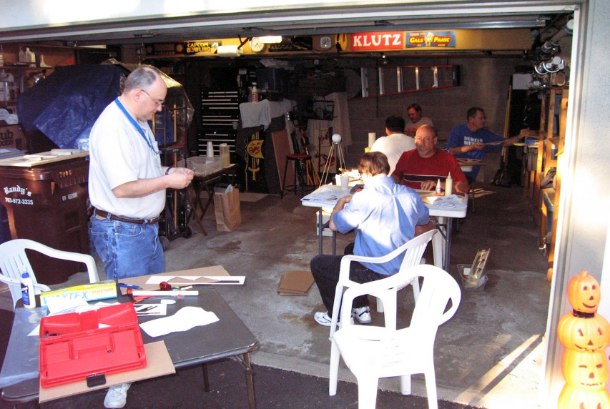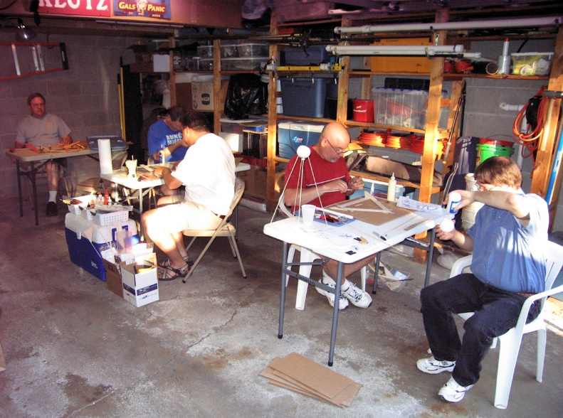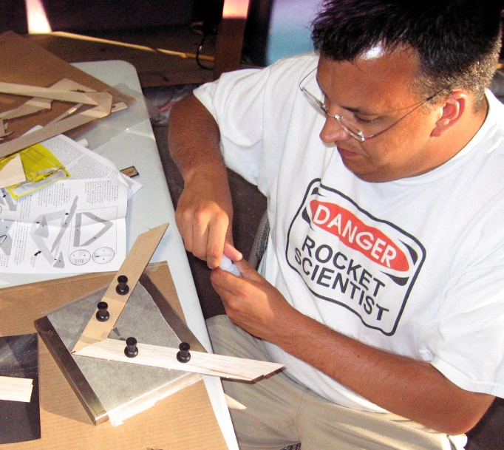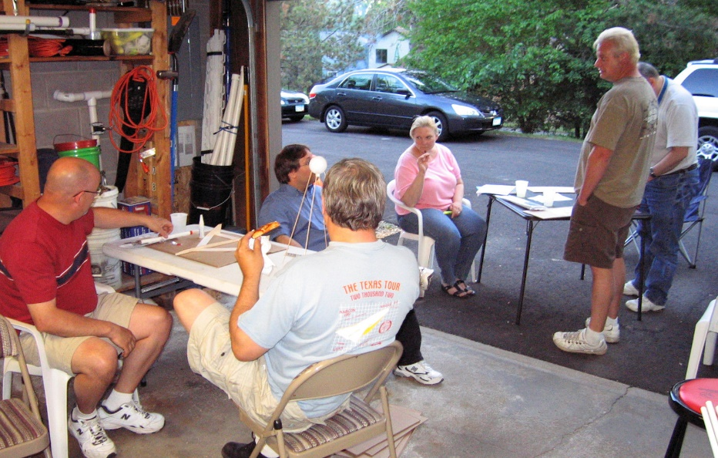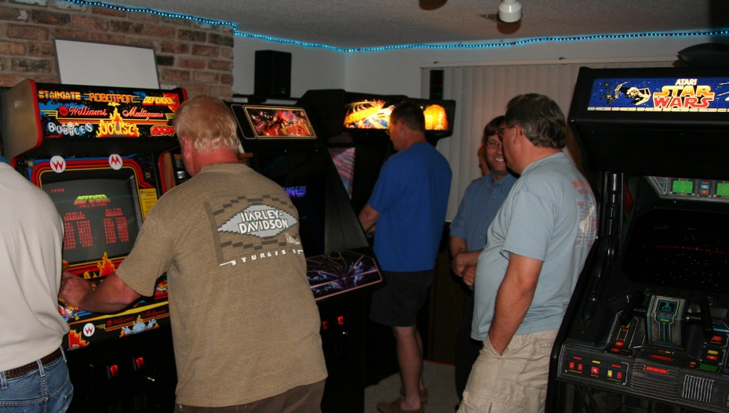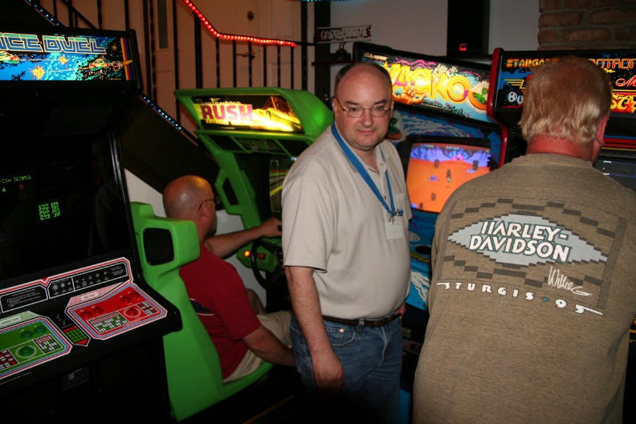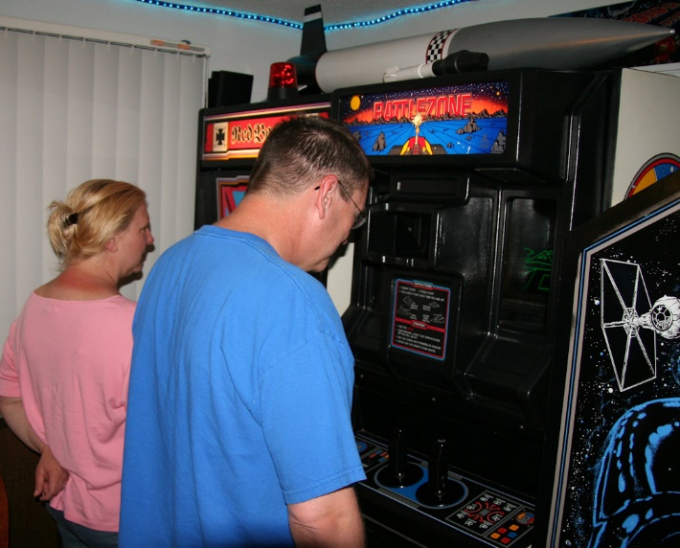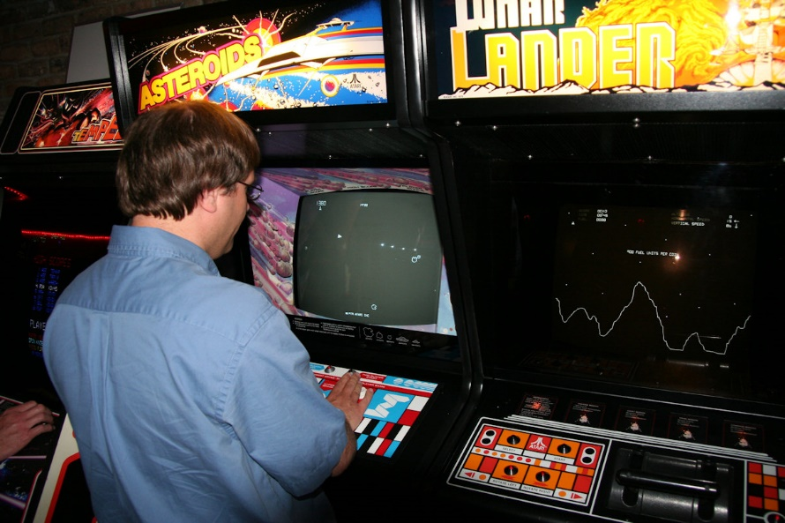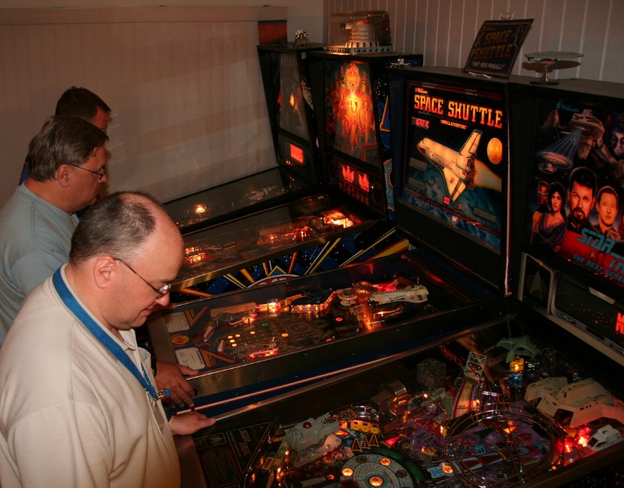
(click on thumbnails to see fullsize pics)
(Alan Estenson)

June Meeting Minutes (6/16/2009)
The June 2009 MASA meeting was held on the 4th at the Science Museum
A total of 8 people attended the meeting.
Next Launch: The next regular launch will be the solstice evening launch on Saturday, June 20. [Late breaking news! Due to a soccer tournament at the VFW, this launch will now be at the Nowthen sod farm.] This will be a model rocket launch (NO waiver).
The monthly MASA launch and MASA's first 2-day regional contest will be held on the weekend of June 27-28. Please see the contest page for the details.
Next Meeting: The summer picnic will be held on July 18 at the VFW soccer fields near Elk River. Details will be posted on the web site soon.
Discussions
- NSL: Quite a few MASA people traveled to the National Sport Launch in Wisconsin over the Memorial Day weekend.
- TARC Finals: Ted & Buzz made the trip to Virginia to volunteer at the Finals.
- FiTi Rockets: If you are building rockets to donate for the Fly It - Take It at NARAM 51, please get them to Carol at the June launch.
- Planet: Jeff has put together another great issue! As always, he needs content for future issues, so send some articles his way!
- The May launch was held on the 30th. It was quite breezy. This kept attendance and the number of flights fairly low.
- MASA members have assisted with several outreach activities recently.
MASA Regional Contest
The topic for the evening was MASA's first 2-day regional contest. Alan had prepared a handout that covered the basics of contest flying and the important rules for each of the events. We talked about each of the events, suitable rockets, and potential strategies. Caleb & Buzz both brought some contest rockets for us to examine.
(Alan Estenson)

MASA summer picnic (7/20/2009)
MASA members gathered on Saturday, July 18, at the Elk River & Rogers VFW post for the 12th annual MASA summer picnic.
The site was the VFW soccer complex where occasional MASA launches are held. There was rocket flying, eating, and a bunch of socializing. Well over 40 people attended the launch & picnic.
The picnic began after 5pm as the launch was winding down. Grill-meister Art cooked up the vittles for us all. As always, there was a ton of food and cold beverages.
Several people brought various items for the annual swap -n- sell. Ted had a whole basket of rocket kits. Tim had a bunch of kits, too. Alan had nylon parachutes. Lyle had his fin jig tools. Ken also brought a couple kits.
Liftoff of Apollo 11 was on July 16, 1969 with the first manned lunar landing occurring on July 20, 1969. As part of the picnic, we remembered this historic event. Several people brought along Saturn models to display (and fly).
Launchin!
This was also an official MASA launch. A misfire-alley range was set up on the soccer fields. Launching began about 2:00 pm and ended just after 5:00 pm. The launch report tells that side of the story.
Lots of prizes!
At about 7:15 pm, drawings were held for the free "door" prizes. There were a HUGE number of prizes, and everybody who stayed for (and entered) the drawing went home with something. Here's the rundown of who got the loot: [apologies for any misspelled names!]
- Donated by Hub Hobby Center, Little Canada
  - Estes "Taser Twin" kit - Alyssa Taylor
  - Estes "Paveway" kit - Jeff Taylor
  - Estes "Echostar" kit - Hunter Anderson
  - BMS "Arcas" kit - Scott Murphy
  - Estes "Loadstar" kit - Carol Marple
  - BMS balsa nose cone assortment pack - Alissa Hoyme
  - Aerotech G79-7W/L LMS motor - John Carlson
  - Quest First Time Flight Pack motors - Mike Erpelding

- Donated by Hub Hobby Center, Richfield
  - Quest "Full Moon" kit - Mark Thell
  - Quest "Sprint" kit - Alan Estenson
  - Quest "Harpoon" kit - Kevin Anderson
  - Sunward "Mercury Lander Jr." kit - Joshua Boe
  - Sunward "Rocket Glider" kit - Ken Jarosch
  - Estes "X-Ray" kit - Deb Thell
  - Estes B6-4 motor pack - Don Boe
  - Estes B6-4 motor pack - Levi Anderson
  - Estes B6-4 motor pack - Lyle Merdan
  - Estes D12-5 motor pack - David Whitaker
  - Custom "Sierra" kit - Brendan Carlson
  - Custom "S.L.V." kit - Art Gibbens
  - FlisKits "Espresso" kit - Brelynn Carlson
  - Apogee "Texas Twister" kit - Ken Joyme
  - LOC "EZI-65 Mini" kit - Andy Heren
  - LOC 28" nylon parachute - Blaine Carlson

- Donated by Todd Schweim
  - FlisKits "RockStar" kit - Susan Shmel
  - Custom "Galileo" kit - Ted Cochran
  - Model Minutes "Flying Spider" kit - Dwayne Shmel
  - Sunward "DesertFox" kit - David Gensler
  - Quest "HL-20" kit - Caleb Boe

- Donated by Lyle Merdan
  - v1.1 Standard Rocket Assembly Tool - Neal Higgins

- Donated by Dwayne Shmel
  - Estes Snitch - Renee Gibbens
  - BalloonTime Helium Balloon Kit - Amber Erpelding
  - Estes C6-5 motor pack - Ethan Erpelding
  - Estes C6-5 motor pack - Caroline Andrews

- Donated by Ken Jarosch
  - Estes Blast Off Flight Pack - McKenna Taylor

- Donated by Mark Thell
  - Estes "Prowler" kit - Daniel Boe

- Donated by Carol Marple
  - Estes "Alpha" kit - Quinn Carlson
  - Estes "Hi-flier" kit - Tim Barr

- Donated by Ted Cochran
  - ASP "WAC Corporal" kit - Cheryl Anderson
  - US Army Patriot rocket - Lancy Murphy

A big "Thank You!" to:
- Everyone who participated
- Everyone who donated door prizes
- Grillmeisters Art and Lyle
- RSO/LCO volunteers Art, Tim, and Ted
- Neal for running home and bringing back his grill
(Alan Estenson)

August Meeting Minutes (8/7/2009)
The August 2009 MASA meeting was held on the 6th at the Science Museum
A total of 7 people attended the meeting.
Next Launch: The next regular launch will be August 22 at the sod farm near Nowthen. The traditional UFO and Comanche-3 drag races will be held. The launch theme is "multi-staging".
Next Meeting: The next meeting will be on September 3 at the Science Museum. Suggestions for a topic are needed!
Discussions
- MASA had a very busy June & July! In June, we had a meeting, the solstice launch, and the regional contest. In July, we had a launch on the 4th, picnic and launch on the 18th, and another launch on the 25th!
- NARAM 51: Starts this Saturday. A handful of MASA members are heading to PA to attend.
- NARAM 52 in 2010 will be held in Pueblo, Colorado.
- Planet: As always, Jeff welcomes content for future issues, so send some articles his way!
- A suggestion was made that MASA have business cards printed with the club name and web site address on them. Another suggestion was made to look into having a club banner made.
- Outreach. Several MASA members helped with a cub scout outreach on Wednesday night. Over 100 rockets were flown safely in only 90 minutes. Thanks to all who volunteered!
Cardstock Fun!
For a meeting activity, Alan printed out piles of the free, 13mm rocket designs from Art Applewhite onto cardstock. We all spent about an hour constructing Qubits, flying saucers, cones, pyramids, and such. Everyone built two or three of these flying paper creations, and took home several more to build later.
For those who couldn't make it, you can download the pdf files from Art Applewhite's web site. If you like these paper rockets, he also has larger versions available for sale.
(Alan Estenson)

September Meeting Minutes (9/8/2009)
The September 2009 MASA meeting was held on the 3rd at the Science Museum
A total of 8 people attended the meeting.
Next Launch: The next regular launch will be September 26 at the sod farm near Nowthen. The launch theme is "multi-staging". A Deuces Wild drag race is planned.
Next Meeting: The next meeting will be on October 1 at the Science Museum. Suggestions for a topic are needed!
Stuff
- The various MASA launch sites may now be viewed on Google Maps. A link to this has been added at various places on the web site.
- A preliminary 2010 club schedule has been added to our Google Calendar. This may be viewed on the Events page on the web site.
- The August launch had perfect weather and 184 flights.
- At NARAM 51, the MASA Planet newsletter won the LAC trophy for best NAR section newsletter for the second year in a row! Congratulations to editor Jeff and thanks to everyone who contributed! As always, Jeff welcomes your contributions for upcoming issues.
- An outreach opportunity will be coming up at the end of October to help a group of Cub Scouts build and launch rockets. More info will be sent out on the mailing list.
- NARAM 52 will be held in Pueblo, Colorado. NSL 2010 will be held near White Sands, New Mexico.
- Club President Alan wishes to remind everyone that he will be retiring from that position at the end of 2009.
- Extreme Rocketry magazine has stopped publishing.
- MASA members had fun and did well at NARAM 51 and the FAI competitions. It sounds like several club members are already planning to attend NARAM next year.
Show -n- Tell
- Alan Estenson brought his rocket "Back to Cool" - built from a dollar store crayon bank. He also brought a vintage Estes Power Pulse launch controller.
- Jason Colt brought a rocket that he built from spare parts and a "sputnik style" twine ball rocket.
- Lyle Merdan showed us the results of a paint problem he had with his new Semroc Vega. He also had an under-construction P-Chuter Extreme.
- Since Caleb wasn't there, Ted blinded us with the glare from the many shiny medals that Caleb won at NARAM.
Cornfields
The evening's discussion centered on how to find your rockets in those evil, evil cornfields. By far the best idea was:
Don't let your rocket go into the corn in the first place. ;-)
We discussed methods for helping to find a rocket that has disappeared into the corn. These included:
- Audio beepers, buzzers, and other noisemakers.
- GPS
- Really, really, really long streamers.
- Radio tracking
- Have the person in the corn hold a flag to mark their location, and be directed by an observer outside the corn using FRS radios or cell phone.
- Having a highly trained golden retriever named "Gus".
- Psychics in hot air balloons.
(Alan Estenson)

October Meeting Minutes (10/2/2009)
The October 2009 MASA meeting was held on the 1st at the Science Museum
Turnout was light with 4 people attending the meeting.
Next Launch: The next regular launch will be October 24 at the sod farm near Nowthen. The launch theme is "odd-rocs". This will be the last launch of the year at the sod fields.
Next Meeting: The next meeting will be on November 5 at the Science Museum. Suggestions for a topic are needed! Nominations will open for 2010 MASA officers.
Stuff
- The September launch was a success with 184 flights and nice weather.
- An Outreach opportunity with Cub Scouts in Lino Lakes is coming up in a few weeks. There will be a build session on October 20 and a launch on October 25. More info will be sent out on the email list.
- As always, contributions to the Planet newsletter are welcomed by Jeff!
- Planning for the December holiday party has started. The date will be announced soon.
"Falling with Style" - a roundtable discussion of boost gliders and rocket gliders
The evening's discussion was all about rockets with a gliding recovery - the various types and styles of boost gliders and rocket gliders. For example, pop-pod, scissor wing, flex wing,
Alan Estenson brought several examples from Edmonds Aerospace - Deltie, Deltie B, Tinee, CiCi, and Ecee. David Whitaker also brought a CiCi along with a Quest Flat Cat and a Squirrel Works Red Baron.
Edmonds offers all sorts of boost/rocket gliders. Most are very easy to build, inexpensive, and fly nicely. They also offer some models that are higher performance, more challenging to build, and contest-oriented. We talked about kit offerings from various other companies, too - Estes, Quest, Semroc, Squirrel Works, etc.
We also briefly discussed radio controlled rocket-boosted sailplanes.
For more information on glide recovery of model rockets, see Chapter 13 in the Handbook of Model Rocketry.
(Alan Estenson)

November Meeting Minutes (11/7/2009)
The November 2009 MASA meeting was held on the 5th at the Science Museum
Turnout was very light with only 3 people attending the meeting.
Next Launch: The next regular launch will be November 21 (one week earlier than normal) at the VFW soccer fields near Elk River. This will be misfire alley - no community pads will be set up.
Next Meeting: The next regular meeting will be on January 7 (location TBD). Suggestions for a topic are needed! The election will be held for 2010 MASA officers.
Holiday Party: The MASA holiday party will be held on Saturday, December 12 at the Chaska Community Center. See the holiday party page for all the info.

2010 MASA Officer Nominations
Nominations for 2010 MASA officers opened at the meeting. Nominations will remain open through the date of the next MASA launch, November 21. During that period, nominees are asked to either officially accept their nomination and become a candidate, or decline their nomination and have their name withdrawn. Nominees must be MASA
members and senior NAR members. If, at the end of the nomination period, there is not a minimum of one candidate per office, then nominations will remain open for one additional week to allow time for arm-twisting. You may nominate someone for an office by sending Alan an email directly, or by posting to the masarocketry mailing list. You may nominate yourself. A description of the officer's duties is located here. If you have any questions, please ask!

The election will be held at the January 2010 MASA meeting.
The nominees thus far are:
President
- Carol Marple [Candidate]

Vice President
- Jeff Taylor [withdrawn]
- Neal Higgins [Candidate]

Secretary/Treasurer
- Rick Vatsaas [Incumbent] [retiring]
- Jason Colt [Candidate]

Stuff
- The October launch was a success with a lot of flights and nice weather. The "high power smackdown" drag races were a lot of fun!
- As always, contributions to the Planet newsletter are welcomed by Jeff!
- The recent Cub Scout outreach build & fly went well.
Show & Tell
- Alan Estenson brought along an Estes E2 Launch Controller that he recently bought on ebay (NOS & NIB). He also showed off some LED lamps that are a direct substitution for the incandescent bulbs in the Estes Electron Beam launch controller. He may be selling these LED lamps at Hub Hobby in the future.
- Ted Cochran showed the nifty padside box that he built. It provides continuity check and pad power disconnect.
"Winter Challenge"
Most of us have a stash of rocket kits that we intend to build "some day". I'm issuing a challenge to start at this meeting. Pick out one of those kits. One that you've been really wanting to build but just haven't gotten around to it. Bring it with you to the meeting to show it off. Then, actually build it over the winter, and fly it at the April 2010 MASA launch!
We'll have a drawing for prizes amongst those who complete the challenge.
Challenge Participants:
- Rick Vatsaas: Semroc SST Shuttle
- Alan Estenson: Pemberton "Bucky Jones Space Cadet"
- Ted Cochran: Kosrox Saturn 1B

Let's see some more people participating!
(Alan Estenson)

December 2009 Holiday Party (1/1/2010)
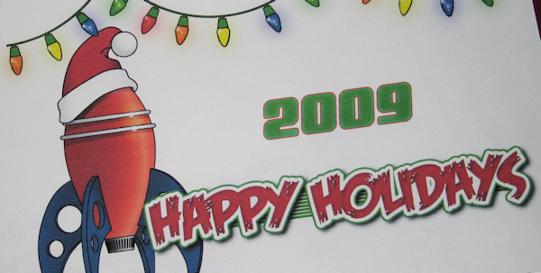
(artwork by Jeff Taylor)
On Saturday evening, December 12, around 40 MASA-ites gathered at the Chaska Community Center in the Sun Room for the annual club holiday party. There were all sorts of potluck goodies to eat and holiday treats to enjoy. Plus, rockets and other mementos to look at. The party started around 6:30 pm and ended around 10pm.
Thanks to Carol Marple for organizing the party, and to Lyle Merdan for arranging the use of the room! Thanks to everyone who attended!
Thanks to Todd Carpenter for bringing the liquid nitrogen and providing oodles of science-filled fun for everyone!
Thanks to Carol Marple and Jeff Taylor for the MASA holiday greeting cards. Party attendees signed these cards to be sent to various friends of MASA.
The annual MASA wacky gift exchange game was once again a popular activity with more than 30 people participating.
2009 MASA Year in Review
- MASA's 11th Year
- 10 meetings plus the summer picnic and winter holiday party.
- 13 club launches in 2008: 1,052+ flights, 1,205+ engines burned, 33,991 N-s of total impulse ("O" motor equivalent!), roughly $7k worth of engines used!. The total number of MASA flights to date is over 10,000! This was the first year with more than 1,000 flights since 2002. We had 39 high power flights; that's the most ever in one year! We had several launches with near-perfect weather. David Whitaker flew the first J hybrid flight at a MASA launch
- MASA donated 36 rockets to NARAM 51 for the "Fly-It / Take-It". Thanks to all who built and donated rockets: Andy Heren, Mark Thell, Neal Higgins, Carol Marple, Ben Ericksen, Daniel Boe, Caleb Boe, Joshua Boe, Mike Erpelding, Jeff Taylor, Todd Carpenter, Ted Cochran, Alan Estenson, David Whitaker, Jim Myers, Buzz McDermott.
- The LAC trophy for best NAR section newsletter was awarded to the MASA Planet for the 2nd consecutive year! Thanks to all the newsletter contributors: Alan Estenson, Ken Jarosch, Jeff Taylor, Ted Cochran, Ray King, Art Gibbens, Scott Gleason, Carol Marple, Lyle Merdan, Glen Overby, Andy Heren, Neal Higgins, Todd Schweim, Mike Erpelding, Buzz McDermott, Rick Vatsaas, David Whitaker, Larry Schwartz
- Many, many outreach events.
- MASA staffed the NAR booth at the NSTA convention.
- We won the long-running court case against the BATFE!
- MASA held its first ever regional contest.
- Many MASA members trekked over to Wisconsin for NSL 2009.
- Several traveled to PA for NARAM 51.

Recognition
- Thanks to Carol Marple for her service as MASA Vice President and for organizing the FiTi donations for NARAM.
- Thanks to Rick Vatsaas for his service as MASA Secretary/Treasurer.
- Thanks to Jeff Taylor for his service as editor of the (multiple award winning) MASA Planet newsletter.
- Thanks to Ted Cochran for his service as NAR Vice President.
- Thanks to Mike Erpelding for serving as director of MASA's first regional contest.
- Congratulations to those with successful Level 1 certification flights at MASA launches this year: Andy Juntunen, Scott Gleason, Kevin Anderson, Todd Carpenter.
- Thanks to all those who volunteered their time to serve RSO/LCO shifts this year: Ted Cochran, Mark Thell, Buzz McDermott, Dwayne Shmel, Lyle Merdan, Ken Jarosch, Jeff Taylor, Art Gibbens, Tim Barr, Neal Higgins, Rick Vatsaas, David Whitaker, Glen Overby
- Congratulations to MASA's FAI Internats crew: Caleb Boe, Ray King, Todd Schweim.

Ted Cochran and Jeff Taylor presented retiring club president Alan Estenson with a framed photo of his "Warrior 300" rocket as thanks for his service. [Thanks!]
2009 MASSY Awards
Following MASA tradition, club president Alan Estenson presented a few special awards.
- "Scavenger Hunt Award", presented to Art Gibbens in recognition of his outstanding achievement in a "Successful cornfield expedition - Bagging three rockets, a fin, and a duck."
- "Thermal Hunter Award", presented to Caleb Boe: in recognition of his outstanding achievements in "Achieving a new national record in 'A' streamer duration, B division... twice!"
- "Angler Award", presented to Glen Overby in recognition of his outstanding achievements in "Demonstrating exemplary rocket fishing abilities that went above and beyond the call of duty."
- "Passion Award", presented to Larry Schwartz in recognition of his outstanding achievements in "Hating Corn. [I mean it. This guy really, really, really hates corn! Really.]."
2009 Prang Awards
There were a number of notable prangs this year.
Prangs Worth a Mention:
- 3 foot ejection crunch – Ted Cochran’s Super Sprite on an E15
- 2 foot ejection crunch – Mark Thell’s SPEV on a B6-4
- Rod kick, cruise missile, lawn dart, then eject – Ken Hoyme’s Big Daddy on a D12
- Lawn “dart” – Dwayne Shmel’s Death Star on a D13 (twice!)
- POINK – Dwayne Shmel’s Dude on an E11 (Popped On Impact, No Kidding)
- CATO, separation, early eject, QT meltdown – David Gensler’s Matrix on an H180

Prangs Worth a Dishonorable Mention:
- “It was the best of times. It was the worst of times.” – The crunching of Art Gibbens’ 2-stage Saturn V at the club picnic.
- Big Ballistic Lawn Dart – Ken Jarosch’s B4R on an H238
- Rooftop No-Eject Crunch – Bob Moyle’s Black Mustang on a F22
- “Anyone bring a garbage bag?”, Impressive no eject core sample – Glen Overby’s Aerobee 150 on an I146.

Honorary Prang Award:
“The Death of Dead Cow” – Hope Christian Academy’s TARC rocket CATO at the March launch.
Prang of the Year Award:
Jim Myers' "Flying Jenny Upscale" on a D12-3
Nomination - "This rocket did an arcing, low-altitude pass from west to east along the entire flightline, plunged right into the middle of Overby Pond, and THEN ejected its motor pod! It was literally fished out by Glen using a long pole."
"Jim Meyers launched a nice Jenny
And power it had more than plenty
It flew very straight
At a height of oh-eight
Hit the weeds....survivors? Weren't any.
The pilot did try to correct
But ultimately had to eject
Flew into the air
But he had no prayer
As Jim's little Jenny got wrecked
Did I mention that very low pass
Straight down the flight line, clipping grass?
It dove into Glen's pond
Not two inches beyond
Now Jim has no Jenny, alas." - Ted Cochran
Free Prizes for RSO/LCO volunteers
(The names of everyone who had served RSO/LCO duty during 2009 were placed in a "hat", once for each shift.)
- (The following prizes were donated by Hub Hobby Center and Alan Estenson.)
- F25 motor - Lyle Merdan
- F40 reload kit - David Whitaker
- G76 reload kit - Jeff Taylor

Free Door Prizes
- (The following prizes were donated by Hub Hobby Center of Little Canada.)
- Estes Screaming Mimi kit - Levi Anderson
- Estes Fat Boy kit - Buzz McDermott
- Estes Canadian Arrow kit - Dwayne Shmel
- Estes Rock-It kit - David Schaffhausen
- Estes Rubicon kit - Renee Gibbens
- Balsa nose cones and Estes Viking kit - Susan Shmel
- Quest C6-5 motors - Hannah Gibbens
- Quest motor pack - Don Boe
- (The following prizes were donated by anonymous rocketeers.)
- Sunward Cluster Motor Mount kit - Neal Higgins
- Quest Flash kit - Caleb Boe
- Quest Sprint kit - Austin Whitaker
- Estes Alpha kit - Jeff Taylor
- Quest HL-20 kit - Bob Moyle
- Dynastar nylon chute - Alyssa Taylor
- Journey to the Moon dvd - Mark Thell
- Estes Python 4 kit - Phillip Gibbens
- Speed Freak kit - Aimee Whitaker
- Custom Redliner kit - Art Gibbens
- (The following prizes were donated by MASA.)
- Handbook of Model Rocketry - Alyssa Hoyme

Congratulations to the winners! (apologies for any misspelled names)

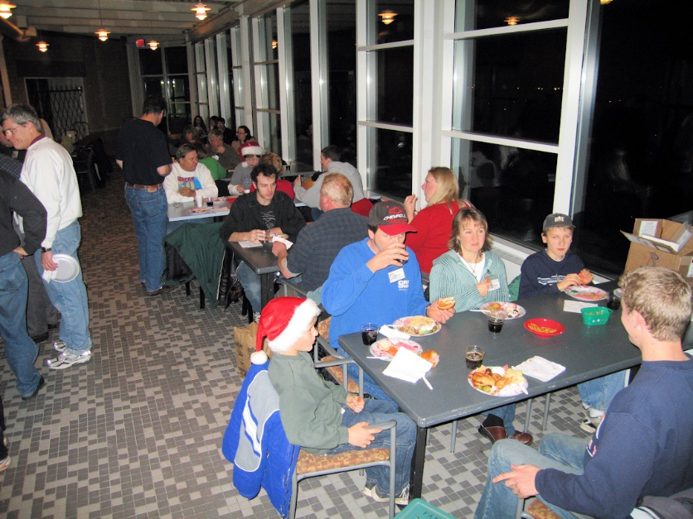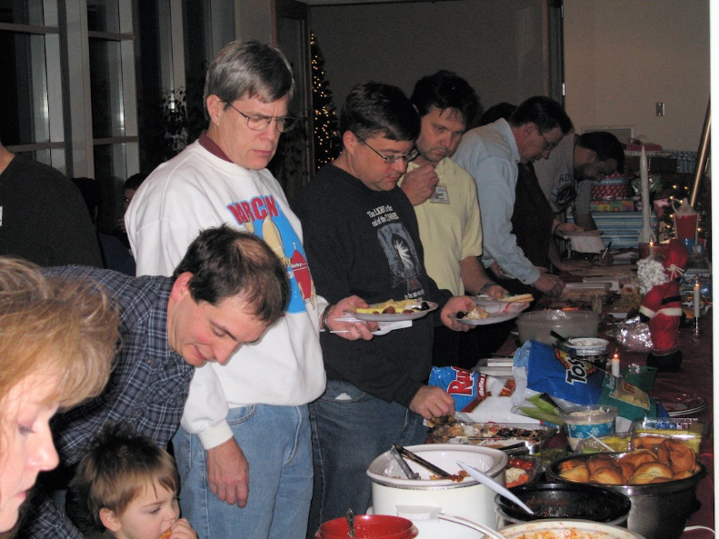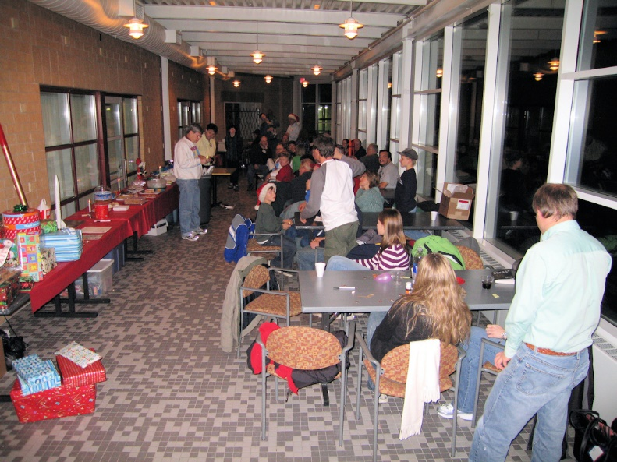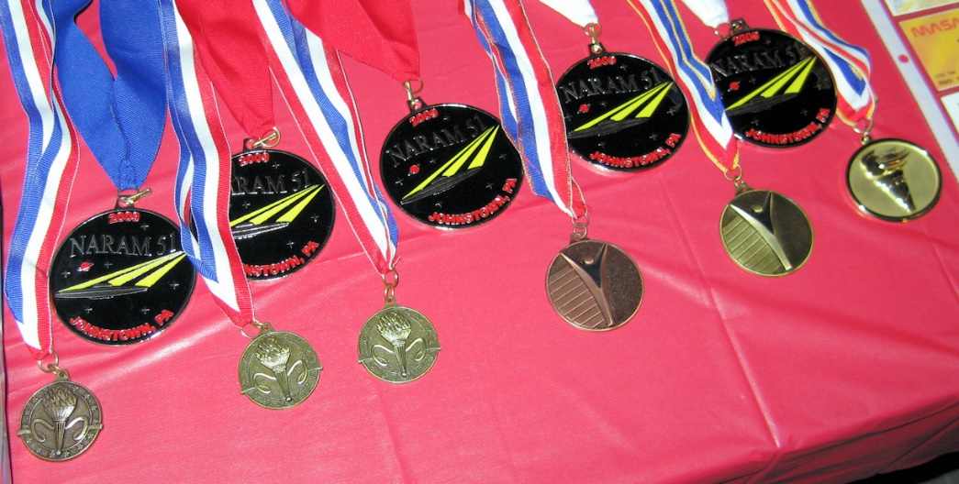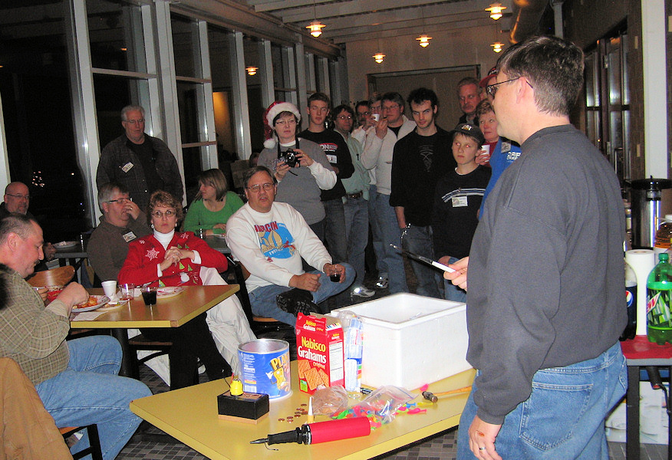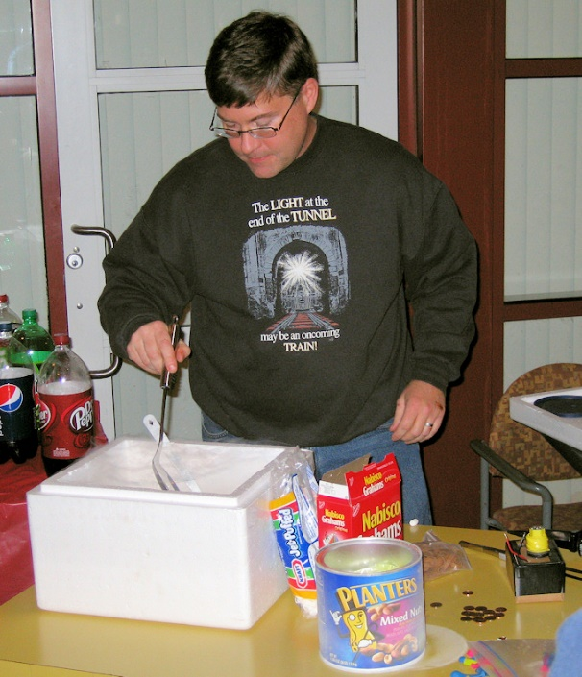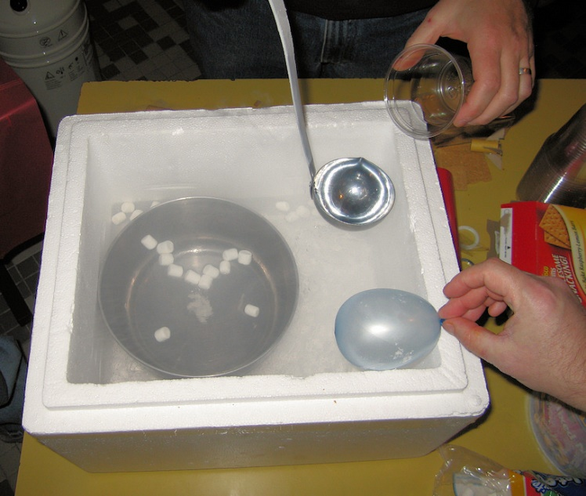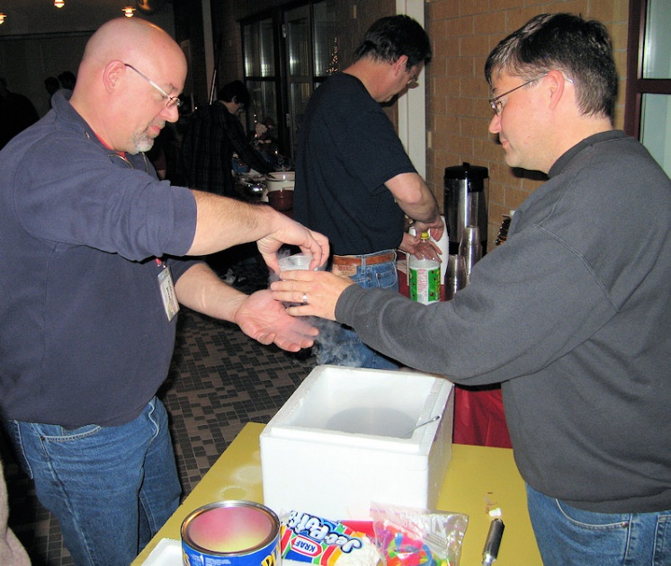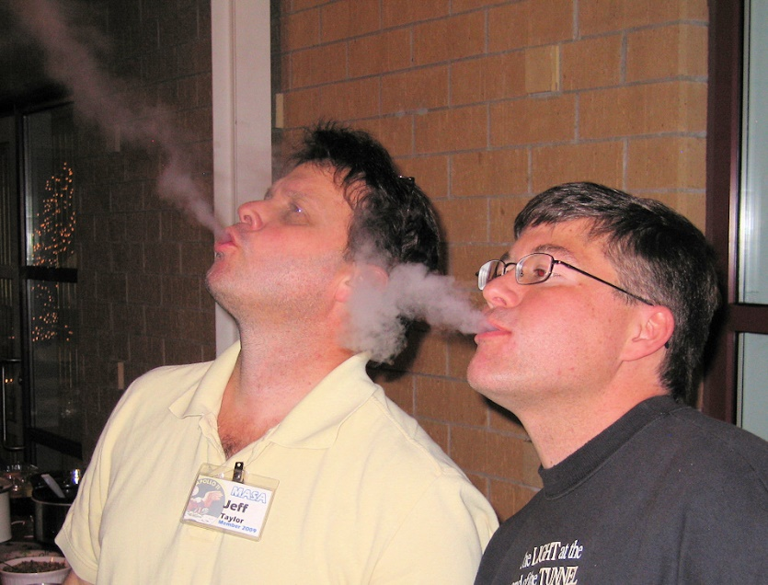
(Alan Estenson)

