2011 Meeting Reports

January MASA meeting – Science Museum of Minnesota, January 6, 2011
The January MASA meeting was held on the 6th at the Science Museum of Minnesota. Approximately 9 club members attended.

Launch:
The next regular club launch will be on Saturday, January 22, at Sunrise Middle School in White Bear Lake. It’s currently planned for 10:00 a.m. – 1:00 p.m., but the time might change due to the weather. Be sure to watch the email list and our website for final times.

Meeting:
The next meeting is planned for Thursday, February 3. There is a conflict at the Science Museum, so it is being moved to a different location. Watch the email list and the website for location details.

2011 MASA Officers
Since there was only one candidate for each office, MASA tradition and precedent allowed those candidates to be placed directly into office by a majority vote of those club members present at the meeting. (motion was made and seconded to place the three candidates directly into office)

The 2010 MASA officers are: President – Carol Marple; Vice President – Neal Higgins; Secretary/Treasurer – Gerald Meux, Jr.
Congratulations to everyone, and thank you for serving!
Reminders:
- 2011 dues for new and renewing members may be paid anytime. Dues remain at $12 family (up to 4 members), $10 individual, and $5 junior. If you choose to have paper copies of the MASA Planet mailed to you, there is an additional $6 fee to cover printing and postage costs. Remember that PDF versions of the Planet are always available for download from the MASA website. The membership application will be updated ASAP with Gerald’s address. You may also renew through PayPal.
- The 2010 MASA Holiday Party was held at the Chaska Community Center on Saturday, December 4. Approximately 25 people attended. There was a rocket project/memorabilia display, a few rocket beauty contests, lots of food, a bunch of prizes, a fun gift exchange, and tons of fun with liquid nitrogen. Thanks to everyone who attended!
- Reminder that we are planning to implement a club FiTi. Please consider donating a rocket and/or motor. Prefer new/never flown rockets, and A/B/C only motors. Winter is a great time to build a few extra rockets!
- Reminder that Jeff needs articles for the MASA Planet!
- Treasury - Club funds remain in good shape.
Show and Tell
- None of the attendees brought anything for show ‘n tell
Meeting Topic:
Meeting topic and launch theme discussion for 2011. If you have any ideas for a meeting topic or launch theme, or if you’re willing to present at a meeting, please contact me.
[Carol Marple]

February MASA meeting – Hennepin County Brookdale Library, February 3, 2011
The February MASA meeting was held at the Hennepin County Brookdale Library on February 3, 2011. A total of 9 people attended the meeting.

Launch:
The next regular club launch will be on Saturday, February 26, at Sunrise Middle School in White Bear Lake. It’s currently planned for 10:00 a.m. – 1:00 p.m., but the time might change due to the weather. Be sure to watch the email list and our website for final times.

Meeting:
The next meeting is planned for Thursday, March 3. There is a conflict at the Science Museum, so the March meeting will be held at the Hennepin County Southdale library.

Reminders:
- 2011 dues for new and renewing members may be paid anytime. Dues remain at $12 family (up to 4 members), $10 individual, and $5 junior. If you choose to have paper copies of the MASA Planet mailed to you, there is an additional $6 fee to cover printing and postage costs. Remember that PDF versions of the Planet are always available for download from the MASA website. The membership application has been updated for 2011 and is available on the website. You may also renew through PayPal.
- MASA Membership Renewals – in an effort to make membership processing and badge printing more efficient, we’re going to hold a membership drive again. Anyone who renews or joins by March 15 will have the opportunity to win one of two $10 Hub gift cards (a total of two prizes will be awarded). Two names will be drawn prior to the April club meeting. You do not need to be present to win, but your membership application and dues must be received by March 15th in order to be eligible.
- There are schedule conflicts and events at the Science Museum and Xcel, which affect our March, April, and May meetings. These meetings will be moved to new locations. Watch the website for details.
- Reminder that we are planning to implement a club FiTi (beginning in April). Please contact me if you’re willing to donate a rocket and/or motor for this program. Prefer new/never flown rockets, and A/B/C only motors. Winter is a great time to build a few extra rockets!
- Reminder that Jeff needs articles for the MASA Planet! The next two issues are “sweeps” before NARAM and the LAC Trophy judging. We really need contributions from across the club. One cool note – MASA is the only club to win 3 years in a row on their first win (only rookie winner to have back-to-back-to-back wins)
- Treasury – duties are being transitioned to Gerald.
Meeting Topic:
Winter project show ‘n tell, cool gadgets to use in rocketry, building tips and tricks:
- Neil brought super alpha (won from Christmas party 2010) with 3 engine cluster.
- Jeff T. brought a club FiTi rocket, along with an airbrushed 3-engine cluster Fat Boy.
- Jason P. showed new launch controller he is working on.
Attendees also discussed the possibility of holding an airbrush demo at an upcoming MASA meeting. Buzz McD. generously offered to host the April meeting at his house (he has an awesome shop which includes a paint booth).

Ted C. discussed NFPA 1122, 1125, and 1127. He also noted that the next NFPA meeting is in Minneapolis.
[Carol Marple]

March MASA meeting – Hennepin County Southdale Library, March 3, 2011
The March MASA meeting was held at the Hennepin County Southdale Library on March 3, 2011. Approximately 10 people attended. The meeting began with Alan distributing our embroidered MASA wear. Thanks, Alan! It looks great!

Launch:
The next regular club launch will be on Saturday, March 26, at the VFW in Otsego/Elk River. It’s currently planned for 10:00 a.m. – 1:00 p.m., but the time might change due to the weather. Be sure to watch the email list and our website for final times.

Meeting:
The next meeting date is Thursday, April 7. Buzz has offered to host this meeting at his house so we can hold an airbrush demonstration.

Reminders:
- 2011 dues for new and renewing members may be paid anytime. Dues remain at $12 family (up to 4 members), $10 individual, and $5 junior. If you choose to have paper copies of the MASA Planet mailed to you, there is an additional $6 fee to cover printing and postage costs. Remember that PDF versions of the Planet are always available for download from the MASA website. The membership application has been updated for 2011 and is available on the website. You may also renew through PayPal.

- MASA Membership Renewals – Anyone who renews or joins by March 15 will have the opportunity to win one of two $10 Hub gift cards (a total of two prizes will be awarded). Two names will be drawn prior to the April club meeting. You do not need to be present to win, but your membership application and dues must be received by March 15th in order to be eligible.

- There are schedule conflicts and events at the Science Museum and Xcel, which affect our April and May meetings. The April meeting will be held at Buzz’s house, and the May meeting will be held at Alan’s house.

- Apple Valley bonus launch/TARC qualification day is now officially scheduled for 2 April. Ted is the POC and will communicate the time as the day gets closer.

- National Model Rocket Day - Starlight Model Rockets has declared May 14, 2011 to be National Model Rocket
Day. This is the second year for this event. Perhaps we could hold a bonus launch at the VFW? Or move the May launch date to coincide with National Model Rocket Day? (this is also the weekend of TARC finals, and the Tripoli North Branch launch

- There’s a new printed magazine being published this summer, titled NewSpace Magazine. It will be published quarterly with the purpose of introducing and explaining the new space industry to people of all ages, gender, and interest levels. Check it out at www.newspacemagazine.com.

- NARCON is March 12-13 in Seattle, NSL is June 10-12 in Lucerne Valley, CA, and NARAM is July 23-29 in Lebanon, OH (near Cincinnati). NARAM hotel info is on-line at www.naram53.quarkers.net/

- Reminder that we are planning to implement a club FiTi (beginning in April). Please contact me if you’re willing to donate a rocket and/or motor for this program. Prefer new/never flown rockets, and A/B/C only motors. Winter is a great time to build a few extra rockets!

- Reminder that Jeff needs articles for the MASA Planet! The next two issues are “sweeps” before NARAM and the LAC Trophy judging. We really need contributions from across the club, and no contribution is too small! Ideas include kit reviews, build articles, techniques and tips, new products, old products with a new use, etc.

- Treasury – club funds and membership levels are in good shape.
Meeting Topic:
Safety in Sport Rocketry – Presentation by Ted Cochran.
[Carol Marple]

April MASA meeting – Buzz McDermott's house, April 7, 2011
Introductions:
Two students from the U of M, who are leading a First Nation Launch rocket team, attended the meeting to discuss their rocketry project and meet club members.
Launch:
The next regular club launch will be on Saturday, April 23, at the Nowthen sod farm (weather permitting).
Meeting:
The next meeting date is Friday, May 13th, at Alan’s house (“Alan’s Arcade”). There will be a few fun rocketry projects to work on, treats to share, and lots of rocket conversation. After a few hours of rocket fun, Alan will open up Alan’s Arcade for a few hours of pinball and video game fun.
Reminders:
- The 2011 MASA membership drive is closed. We had approximately 80 people either renew their membership or sign up as a new member. The drawing for two $10 Hub gift cards was held at the meeting; the winners were Stuart Lenz and Espen Federick. Thank you to everyone who participated!
- National Model Rocket Day - Starlight Model Rockets has declared May 14, 2011 to be National Model Rocket
Day. This is the second year for this event.
- Outreach events:
  - Tuesday, May 3 – build session for home school group, in New Brighton area
  - Tuesday, May 10 – launch for home school group, at Long Lake Regional Park
  - Saturday, May 14 – Space Day with Girl Scout group, in Willmar
  - Sunday, May 15 – launch with Boy Scout group, at Long Lake Regional Park (returning group)
- National Event Reminder - NARCON is March 12-13 in Seattle, NSL is June 10-12 in Lucerne Valley, CA, and NARAM is July 23-29 in Lebanon, OH (near Cincinnati). NARAM hotel info is on-line at www.naram53.quarkers.net/.
- Reminder that we are starting a club FiTi, beginning this month. Please contact me if you’re willing to donate a rocket and/or motor for this program. Prefer new/never flown rockets, and A/B/C only motors. We have some Estes Alpha III and Quest Astra III kits available to build for the club FiTi. The only request is that the paint color be changed so we don’t have a large selection of rockets that look exactly the same. (note: we’ve received a nice selection of rockets for the FiTi program, but we are still in need of a few motor donations.) Thanks to everyone who has built and donated rockets so far!
- Reminder that Jeff needs articles for the MASA Planet! We really need contributions from across the club, and no contribution is too small! Ideas include kit reviews, build articles, techniques and tips, new products, old products with a new use, etc.
- Treasury – club funds and membership levels are in good shape.
Show ‘n tell:
- Gerald Meux, Jr., brought along his SPAM rocket to share with the attendees. No, it’s not based on computer spam… it’s decorated in SPAM colors (complete with SPAM decals) in honor of Gerald’s employer, Hormel.
Meeting Topic:
Airbrushing – Jeff Taylor and Buzz McDermott
After the business portion of the meeting, MASA members Jeff Taylor and Buzz McDermott led a discussion and demo on airbrushing. Jeff and Buzz explained the various compressors, airbrush accessories, and paints that are available. Jeff also painted (airbrushed) rockets for anyone who had brought along a completed model. Many members brought along their own air compressors and airbrush accessories.
[Carol Marple]

May MASA meeting – Maple Grove, May 13, 2011
The May 2011 MASA meeting was held on Friday the 13th at Alan Estenson's house. A total of about 20 people attended.
This meeting consisted of a rocket build (& bull) session in Alan's garage starting around 6:00pm. There were many tasty refreshments - cookies, cupcakes, brownies (and other goodies) along with pop and lemonade. It was a cool evening, but everyone had fun.
Quite a number of Sputnik (aka "Snowball") oddrocs were constructed. Some were decorated in creative ways too.
About 8:00, rocket building came to a halt as people headed indoors to enjoy Alan's personal collection of vintage video arcade and pinball games.

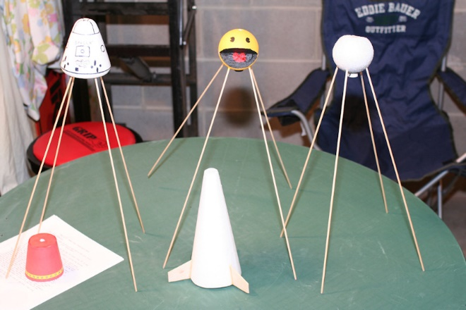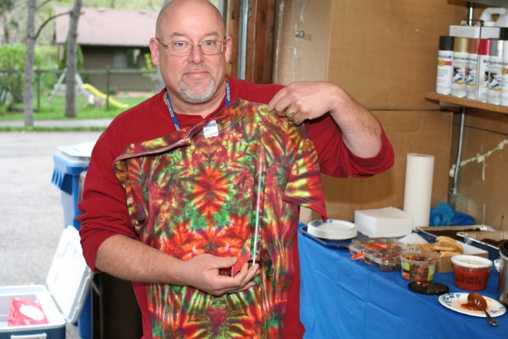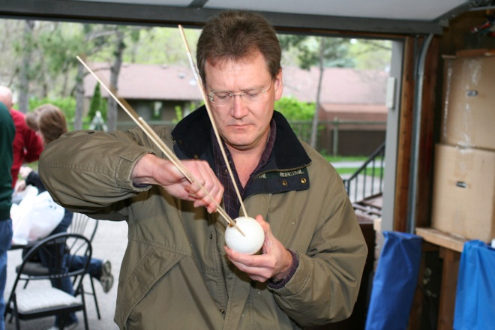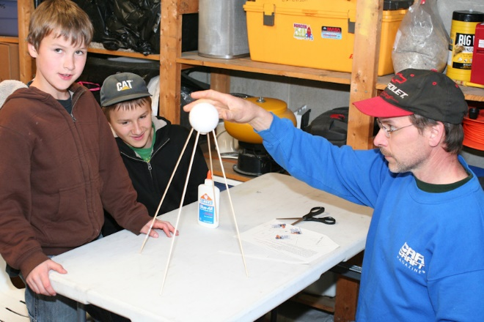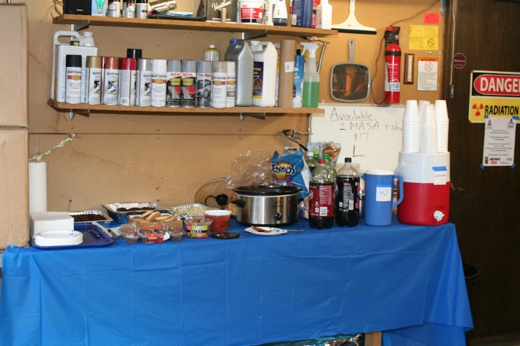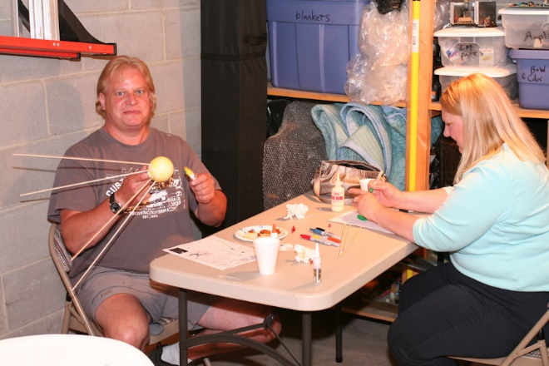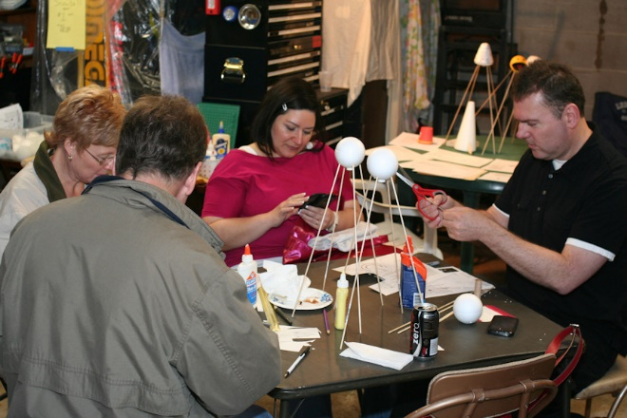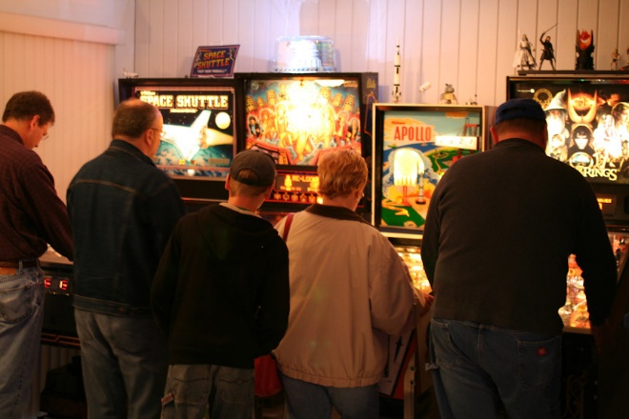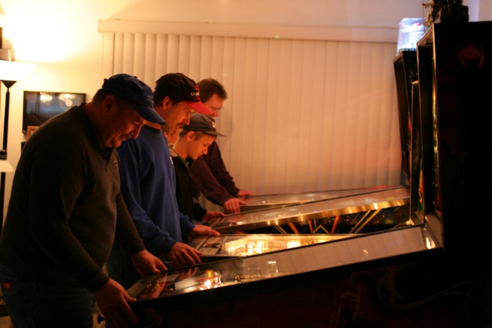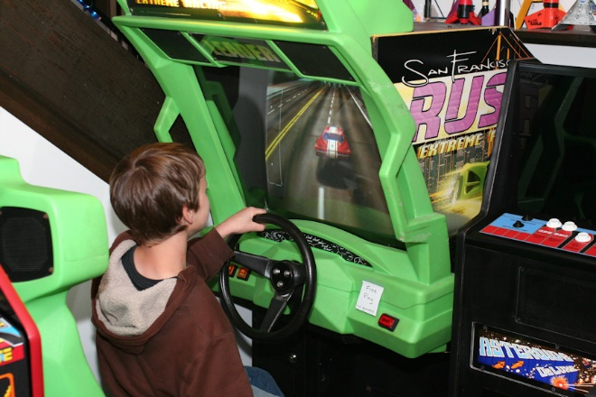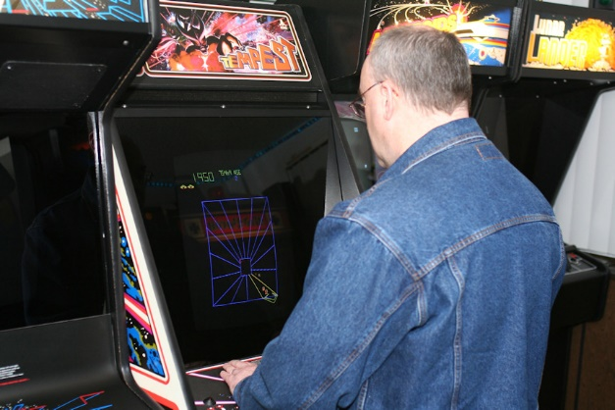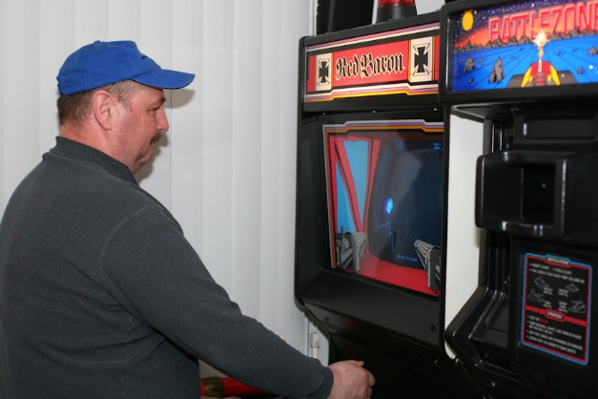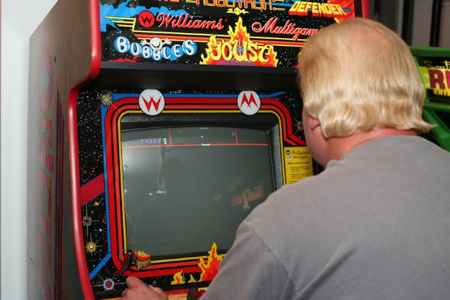
(Alan Estenson)
June MASA meeting – Science Museum of Minnesota, June 2, 2011
The June MASA meeting was held at the Science Museum of Minnesota on Thursday, June 2, 2011. A total of 13 people attended.
Introductions:
Two students from the Inver Thrills USLI team attended the meeting as part of a presentation about the USLI competition.
Launches:
The MASA Summer Regional and sport launch is Saturday and Sunday, June 4-5 at the Nowthen sod farm. The waiver will be open on at least one of the days.
The Summer Solstice launch is planned for Saturday, June 18, from 5 p.m. to 9 p.m. at the VFW soccer field in Otsego.
The next regular club launch will be on Saturday, June 25, at the Nowthen sod farm. The theme is “Patriotic.”
Meeting:
The next meeting date is Thursday, August 2, at the Science Museum. The topic is “NARAM 53 discussion.” NOTE: We will not have a meeting on the first Thursday of July, due to the club picnic being held in July.
Reminders:
- Outreach events (always check email list or website for updates as dates may change):
  - Tuesday, June 7 – Westwood School launch, 1:45 p.m., at Westwood School in Blaine
  - Monday, June 13 – launch for home school group, 6:30 p.m., at Long Lake Regional Park in New Brighton
  - Thursday, June 16 – launch for Cub Scout group, 6:00 p.m. – 8:00 p.m., at Eden Prairie High School
- National Event Reminder - NARCON is March 12-13 in Seattle, NSL is June 10-12 in Lucerne Valley, CA, and NARAM is July 23-29 in Lebanon, OH (near Cincinnati). NARAM hotel info is on-line at www.naram53.quarkers.net
- The club picnic is being planned for Saturday, July 16th. There will lots of food, a couple of fun contests, and door prizes! The 2011 Picnic website will be up soon…
- If you’re planning a high power certification attempt, please notify Carol in advance so we can make there’s a cert team available. Also, if you’re planning an L2 attempt, please contact Carol to make arrangements to take the L2 exam.
- Reminder that Jeff needs articles for the MASA Planet! We really need contributions from across the club, and no contribution is too small! Ideas include kit reviews, build articles, techniques and tips, new products, old products with a new use, etc.
- Treasury – club funds and membership levels remain in good shape.
Show ‘n tell:
Rick V brought along a rocket that he’s making out of a large Christmas decoration. David W brought along 2 vintage kits to share with the group – an MPC kit (I can’t recall the specific model) and a Vaughn Brothers Buzzard.
Meeting Topic #1: MASA Summer Regional
Alan led a discussion about the upcoming MASA Summer Regional. He reviewed each of the planned events, including basic contest rules and rules that are specific to each event.
Meeting Topic #2: Inver Thrills USLI Team
Caleb, Colin, and Jon, of the Inver Thrills USLI team, shared their experiences from the NASA USLI competition. They presented information on the USLI competition and requirements, talked about the challenges they faced, shared video from their on-board camera, and showed off the various parts of their team-designed rocket. Very cool stuff!!
A more detailed description of the USLI competition, courtesy of the Inver Thrills team website:
The Inver Thrills USLI team is one of 33 team competing in the 2010-2011 NASA University Student Launch Initiative (USLI) competition. The competition involves designing, building, and flying a high power rocket (usually 10-15ft tall) that will carry a scientific payload up to a mile high. The scientific payload must contain some sort of scientific experiment on-board. Examples of science experiments include measuring the vertical temperature profile or monitoring the strain on the rocket structure during flight. Throughout the 8-month process, the teams are required to write three reports detailing progress of the rocket's design. In addition to each written report, teams will give a Power Point presentation to a panel of NASA engineers via video teleconference. Each team will travel to Huntsville, AL April 13th-18th, 2011 to fly their rocket in the presence of NASA engineers. The USLI competition follows the same process that a NASA engineer would follow on an actual NASA project. Through this competition, students learn and apply many skills including rocketry, electronics, computer skills, teamwork, engineering, math, science, physics, meteorology, and communication skills.”
For more information on the Inver Thrill USLI team, please visit their website at www.inverthrillsusli.com
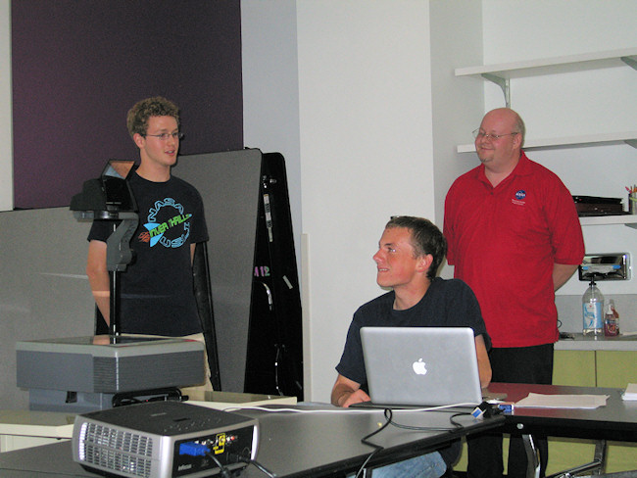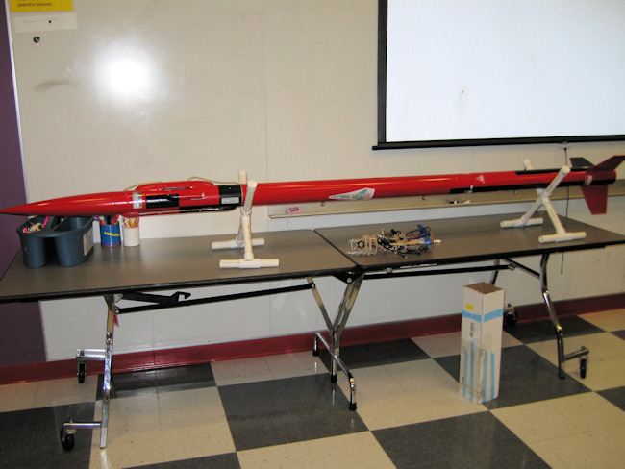

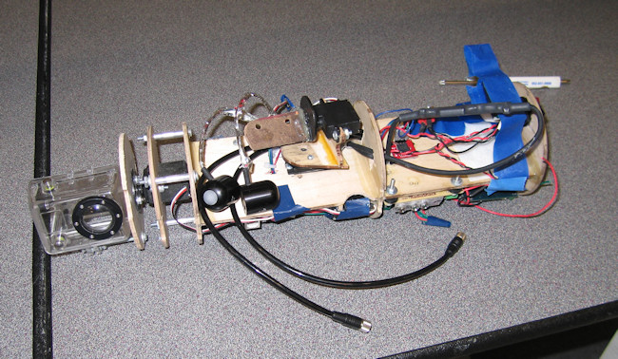
[Alan Estenson]

MASA summer picnic 2011
Lots of MASA members gathered on Saturday, July 16, at the Elk River & Rogers VFW post for the 14th annual MASA summer picnic.

Due to the heat, the couple hours of afternoon rocket launching were called-off. Undaunted, a large number of people still turned out for the picnic.

There was an enormous quantity of delicious food and picnic treats. Art Gibbens and Stuart Lenz watched over the grill. Neal Higgins roasted mass quantities of sweet corn for all to enjoy.

After everyone was done eating, a special Qubit Build-It Fly-It race was held. The race involved constructing a cardstock Qubit, successfully launching it, and then bringing it back to the finish line. About 10 rocketeers of all ages participated. The first couple Qubits to the launch pads suffered from a lack of sufficient glue-drying time, and they didn't fly successfully. Having the motor fly through the Qubit was a common problem. However, a number of the Qubits did fly!

The winners of the 2011 Qubit Build-It Fly-It Competition were:
- Youth 1st place - Lance Murphy
- Youth 2nd place - Hunter Anderson
- Adult 1st place - Kevin Anderson
- Adult 2nd place - Ellison Lenz

Congratulations! The 1st place winners each went home with a trophy, Custom "Scavenger" rocket kit, and a pack of Estes D12-5 engines. The 2nd place winners each went home with a rocket kit. Thanks to Hub Hobby Center of Little Canada and MASA for sponsoring the prizes.

Lots of prizes!
At about 7:30 pm, drawings were held for the free "door" prizes. There were a HUGE number of prizes, and everybody who stayed for (and entered) the drawing went home with a prize. Thanks to all the businesses and individuals who donated prizes! Here's the list of who donated the door prizes and who won them: [apologies for any misspelled names!]

- Donated by Hub Hobby Center, Little Canada:
  - Pack of Estes D12-5 engines - Cheryl Anderson
  - Pack of Quest A8-3 engines - Jeff Taylor
  - Semroc "Squire" kit - Corey Bedford
  - Quest "Terrier-Orion" kit - Ken Hoyme
  - Quest "Force 5" kit - Art Gibbens
  - Estes "Spin Control" RTF rocket with engines - Renee Gibbens
  - Estes "Spin Control" RTF rocket with engines - Julie Hoyme

- Provided by MASA:
  - 6-pack of Estes C6-5 engines - Scott Murphy
  - Estes "Photon Probe" kit - Ellison Lenz
  - Estes "Laser Lance" kit - Mike Erpelding
  - Guillow's "Flying Machine" balsa airplane - McKenna Taylor
  - Semroc "Launch Missile" kit - Kevin Bedford
  - Buzz Lightyear kite, "Turbo Jet 2000" foam glider, MiTi kit - Kari Kieger
  - Transformers kite, Frisbee, Softball - Austin Whitaker
  - Water Rocket Set - Ethan Erpelding
  - Pack of Estes D12-5 engines - Don Boe
  - Pack of Estes D12-5 engines - Neal Higgins
  - Bottle of thick CA - Renee Gibbens
  - Bottle of thin CA - Kevin Bedford

- Donated by Carol and Ben:
  - Quest "Sprint" kit - McKenna Taylor
  - 6-pack of Estes C6-5 engines - Kevin Anderson
  - Pack of Estes B6-4 engines - Caleb Boe

- Donated by Alan Estenson:
  - "Space Buddies" DVD - Jeff Taylor
  - "Space Buddies" DVD - Julie Hoyme
  - "Space Buddies" DVD - Lilia Bedford
  - Fisher Space Pen - Ben Ericksen

- Donated by various and anonymous sources:
  - Quest "Future Launch Vehicle" kit - Gerald Meux
  - Custom "Ion Pulsar" kit - Alyssa Taylor
  - Estes "Mini Max" kit - Hunter Anderson
  - Quest Q2G2 igniters - Lance Murphy
  - Top Flight 15" parachute - Scott Murphy
  - Top Flight 18" parachute - Kevin Anderson
  - FlisKits Deuces Wild Dual Canted 18mm motor mount kit - Stuart Lenz
  - Quest "Grunt" kit - Buzz McDermott
  - Apollo EECOM book - Ben Ericksen
  - Laika book - Aimee Whitaker
  - Toob 'Oh kit - David Whitaker

- Donated by Dwayne Shmel:
  - Sunward "Khufu's Pyramid" kit - Glenn Bedford
- Donated by Hub Hobby Center, Richfield:
  - Pack of Estes C6-5 engines - David Whitaker
  - Pack of Estes C6-7 engines - Caleb Boe

- Donated by Gerald Meux:
  - Aerotech G77 SU motor - Alissa Hoyme
- Donated by Mark Thell:
  - FlisKits "Tri-Glide" kit - Lance Murphy
  - Estes "X-Ray" kit - Glenn Bedford
  - Estes "SR-71" kit - Hieu Murphy
  - Estes "Pathfinder" kit - Lyle Merdan
  - BMS "Astron Invader" kit - Stuart Lenz

- Donated by Chutes by Boe
  - parachute - Lyle Merdan
  - parachute - Mike Erpelding

- Donated by Stuart Lenz of Micro Classics
  - Two Micro Classics kits - Levi Anderson
(Alan Estenson)

July MASA meeting – Science Museum of Minnesota, August 4, 2011
The July MASA meeting was held at the Science Museum of Minnesota on Thursday, August 4, 2011. A total of 7 people attended.
Introductions:
New member Chris Feld attended. Welcome to the club, Chris!
Launches:
The next regular club launch will be on Saturday, August 27, at the Nowthen sod farm. The theme is “Come On Out To The Races.” We’ll be holding the 13th annual Great UFO drag race, the 10th annual Commanche-3 drag race, and the 2nd annual Back-to-School Crayon race.
Meeting:
The next meeting date is Thursday, September 1, at the Science Museum. We need a presenter for the September meeting; please let me know if you’re interested.
Reminders:
- Outreach events: None planned at this time.
- National Events for 2012 - NARCON is not confirmed, but will likely be in Kansas; NSL is in Geneseo, NY; and NARAM is July 28 through August 3 in Muskegon, MI.
- If you’re planning a high power certification attempt, please notify Carol in advance so we can make there’s a cert team available. Also, if you’re planning an L2 attempt, please contact Carol to make arrangements to take the L2 exam.
- The picnic was held on Saturday, July 16th. We had a great turn-out, despite the high heat and humidity.
- Reminder that Jeff needs articles for the MASA Planet! We really need contributions from across the club, and no contribution is too small! Ideas include kit reviews, build articles, techniques and tips, new products, old products with a new use, etc.
- Treasury – club funds and membership levels remain in good shape.
Show ‘n tell:
Carol Marple brought along a few of the kits she acquired (purchased and freebies) at NARAM 53, including a Semroc Moonglow, Semroc Arcas, and an Estes QCC Explorer (with NARAM 53 decals).
Recognition:
Congratulations to MASA members Ray King, Todd Schweim, Alyssa Stenberg, and Zackary Stenberg, who competed at NARAM. They all did very well and brought home some impressive hardware!
Meeting Topic:
The group discussed NARAM 53, including the auction, launch, scale viewing, banquet, competition results, etc.
We also reviewed Trip Barber’s “What’s Happening in Our NAR” report, which was presented at the NAR Town Hall meeting at NARAM. The full presentation is available on the NAR website.
Highlights include:
- NAR Membership levels are going back down. - Reached 5150 in March 2011, but losing ground since then despite continuing the $5 per new member recruiting bonus. - Still not attracting and retaining enough young NAR members to sustain the future. Junior membership is only ~600 (used to be 1000), and there are not enough 25-40 adults to move into key positions in the future.
- NAR finances are very good, with about $300K in unrestricted funds.
- Sport Rocketry is excellent, but Tom Beach needs more “how to” article submissions - Begin offering $250 payment for 1-2 substantial “feature” articles per issue on “how to” and/or technical topics
- NAR Outreach programs such as TARC, NASA SLI, and 4-H partnership are doing well.
- Plan to restructure the NAR website
- The NAR needs volunteers! - Every committee is just 1-2 people deep and needs more people to share the work
- Igniter issue with BATFE is not an immediate threat - NAR met with them in March, and the meeting went well. The BATFE near-term plans to not include detailed regulation.
- Insurance coverage has been increased as of April 2011 - $2M limit vs $1M - $300K for fire damage to launch site vs $100K - TARC and SLI teams are covered when participating in section launches
- Recent NFPA 1125 changes in effect as of June 20, 2011 - Raised propellant mass limit for “model rocket motor” to 125 grams; 160 N-sec and 80N average thrust limits remain - Added major labeling requirements to “sparky” motors and other G and below motors that are considered HPR - Clarified that only solid propellant motors can be “model rocket motors”; all hybrid and sparky motors are HPR
- NFPA 1122 and 1127 changes are in draft form, with one more review before final update takes effect mid-2012 - Greater standoff range for mass launches (such as drag races) - For HPR with onboard pyro systems, must only be armed when in launch position, then only minimum people at the pad
[Carol Marple]

October MASA meeting – Science Museum of Minnesota, October 6, 2011
The October MASA meeting was held at the Science Museum of Minnesota on Thursday, October 6, 2011. A total of 6 people attended.
Launches:
The next regular club launch will be on Saturday, October 22, at the Nowthen sod farm. The theme is “Oddtober.” This includes Halloween rockets, Steam Punk, Goony, anything out of the ordinary. This is the last launch at Nowthen for 2011.
Meeting:
The next meeting date is Thursday, November 3, at the Science Museum. We need a presenter for the November meeting; please let me know if you’re interested.
Reminders:
- Outreach events: Boy Scouts - Build session on Monday, October 10. Location is Living Waters Church in Lino Lakes. The kids will be building Alphas, Wizards, Vikings and Spacelofts (older kids). The launch is planned for Saturday, October 15. Location is still TBD.
- Sport Rocketry – Tom Beach is looking for articles, and SR is willing to pay up to $250 for feature articles. Please see the NAR website for details.
- NAR Member Guidebook – Todd Schweim is beginning work on the next Member Guidebook, and he’s looking for photos. Respond to his post (or contact him directly) if you’re interested.
- If you’re planning a high power certification attempt, please notify Carol in advance so we can make sure there’s a cert team available. Also, if you’re planning an L2 attempt, please contact Carol to make arrangements to take the L2 exam.
- Reminder that Jeff is retiring as the MASA Planet Editor, as soon as the November/December issue is published (by mid-November).
- Holiday party – we need a location for the holiday party. It’s usually held one of the first two weekends in December. If you’re interested in hosting, please let me know.
- Treasury – club funds and membership levels remain in good shape.
Recognition:
Congratulations to Jeff Taylor, who won the TRF Best Rocket Contest for September with his awesome Steampunked Acme Spitfire. His prize is a single-digit FlisKits Journeyman kit (and bragging rights for a month!).
Meeting Topic:
We didn’t have a specific meeting topic for October, so we held a build session. Attendees spent the time building winter-themed rockets, including Snowballs and Snowflakes, in preparation for November’s winter themed launch.
[Carol Marple]

November MASA meeting – Hennepin County Library - Plymouth, November 3, 2011
The November MASA meeting was held at the Hennepin County Library in Plymouth on Thursday, November 3, 2011. A total of 14 people attended.
Launches:
The next regular club launch will be on Saturday, November 19 at the Elk River/Otsego VFW. This is one week earlier than usual due to Thanksgiving. The theme is “Let It Snow.” This includes all winter-themed rockets. There will also be a “Snowball Fight” drag race. This is the last launch of 2011.
Meeting:
The next meeting date is Thursday, January 5. The location will likely be the Science Museum, but it depends on availability of the classroom (the reservation schedule for 2012 won’t be set until sometime in December).
Reminders:
- Sport Rocketry – Tom Beach is looking for articles, and SR is willing to pay up to $250 for feature articles. Please see the NAR website for details.
- Reminder that Jeff is retiring as the MASA Planet Editor, as soon as the November/December issue is published (by mid-November). We need a new Editor ASAP, or the MASA Planet will cease to exist!
- Holiday party – we need a location for the holiday party. It’s usually held one of the first two weekends in December. If you’re interested in hosting, please let me know.
- Treasury – club funds and membership levels remain in good shape.
Meeting Topic:
Nominations for 2012 MASA officer positions will open at the meeting and remain open until November 30th. Nominees will have until December 10th to accept their nomination and become a candidate, or decline their nomination and have their name withdrawn. Nominees do not become candidates until they accept their nomination.
The election/vote will be held at the January 2012 MASA meeting. However, if there is only one candidate per officer position when the nomination period closes, MASA custom and precedent allows us to confirm those candidates as your 2012 MASA Officers without holding a formal vote.
You may nominate yourself or a fellow club member - either at tomorrow’s meeting, by email to me (cjmarple@peoplepc.com), or by posting the nomination to the Yahoo email list. Reminder - MASA officers must be current NAR members and MASA members.
For anyone who is interested, descriptions of the positions are at: http://www.mn-rocketry.net/masa/officerjobs.htm
I am not currently planning to run for re-election. Both Neal and Gerald have stated their willingness to continue as club officers, though.
If you have any questions regarding club officer responsibilities, you can post on the Yahoo email list or email me directly.
[Carol Marple]

2011 MASA Holiday Party
On Saturday evening, December 10, about 30 MASA members gathered at the residence of Buzz & Kathy McDermott in Blaine for the annual club holiday party. There was plenty of food to eat and holiday treats to enjoy, plus rockets and other mementos to look at.

Thanks to Buzz and Kathy for hosting the party! Thanks to everyone who attended!

The annual MASA gift exchange game was once again a popular activity with nearly all the attendees participating. As usual, there were a couple "hot ticket" items that changed hands a few hundred times.

2011 MASA Year in Review
- MASA’s 13th year
- We now have more than 150 members
- 12 club launches were held in 2011, including a 2-day regional contest (stats are courtesy of Alan Estenson):
  - 1100+ flights (second highest in club history)
  - 1200+ engines burned (second highest in club history)
  - Nearly $8000 worth of engines used (a club record!)
  - The total number of MASA flights to date is nearly 13,000!
  - We had 71 high power flights, which is the most ever in one year (and nearly double last year’s total)
(all stats are courtesy of Alan Estenson)
- We were fortunate to have some amazing flying weather this season, with only a few launches needing to be rescheduled.
  - We held 9 meetings plus the summer picnic and winter holiday party.
  - We had 7 members completed their L1 and L2 certifications (5 L1s and 2 L2s). In the first 10 years of MASA, approximately 25 members completed their L1 or L2 HPR certification. In 2010, we had 12 members completed their L1 and L2 certifications (6 of each). Approximately 30% of our total club members have obtained their HPR certification at some point in their rocketry career.
- We supported many outreach events, including long-standing events like Westwood and TARC, and new events with some boy/girl scout troops and homeschool groups.
- MASA held is third annual regional contest.
- About 10 club members traveled to Cincinnati, OH for NARAM 53 (and some are already making plans for NARAM 54 in Muskegon, MI).
Recognition
- A HUGE thank you to Buzz and Kathy for hosting this year’s holiday party! We appreciate it!!
- Thanks to Neal Higgins for his service as MASA Vice President, and to Gerald Meux for his service as MASA Treasurer/Secretary.
- Thanks to Jeff Taylor for his service as editor of the (multiple award winning) MASA Planet newsletter.
- Thanks to Mike Erpelding for serving as event director of MASA’s regional contest (first, second, third, and counting).
- Thanks to Alan Estenson for running a number of fun contests, and serving as MASA Webmaster, flight statistician, and Section Advisor.
- Thanks to Ted Cochran for his continued service as the NAR Vice President.
- Thanks to all those who volunteered their time to serve RSO/LCO shifts this year: Todd Carpenter, Ted Cochran, Mike Erpelding, Alan Estenson, Chris Feld, Neal Higgins, Ken Hoyme, Carol Marple, Gerald Meux, Buzz McDermott, Bob Moyle, Glen Overby, Kent Peterson, David Schaffhausen, Todd Schweim, Dwayne Shmel, Jeff Taylor, and David Whitaker. Our launches run smoothly and are safe because of all of you!
- Thanks to all the newsletter contributors: Ted Cochran, Jason Colt, Mike Erpelding, Alan Estenson, Art Gibbens, Ken Jarosch, Ray King, Carol Marple, Buzz McDermott, Gerald Meux, Jason Pokorny, Todd Schweim, Alyssa Taylor, Jeff Taylor, and Brian Uhlenkamp.
- Thanks to all the meeting topic presenters: Caleb Boe and the Inver Thrills USLI team, Ted Cochran, Alan Estenson, Carol Marple, Buzz McDermott, Jeff Taylor, and the many club members who participated in build sessions and show ‘n tell sessions we held throughout the year.
- Congratulations to Caleb Boe and the Inver Thrills USLI team. They competed in the NASA USLI contest, and placed 4th out of 33 teams.
- Thank you to Kurt Knox, who is the new MASA Planet Editor. Thank you for volunteering your time to make sure the club continues to have a great newsletter!
- Congratulations to the 2012 MASA Officers: Neal Higgins (President), Art Gibbens (Vice President), and Gerald Meux (Treasurer/Secretary). Thank you for volunteering your time for the club!
2011 MASSY Awards
Following MASA tradition, club president Carol Marple presented a few special awards.
- Service to the club - Jeff Taylor
Jeff recently retired from his position as MASA Planet Editor, after serving for 4 years in the role. During that time, the MASA Planet won the LAC/North American Rockwell Trophy for best NAR Section Newsletter three times (in 2008, 2009, and 2010). The newsletter also won Honorable Mention in 2011. Thank you, Jeff!
- Congratulations to those with successful Level 1 certification flights this year:
  - Craig Bowman
  - Chris Feld
  - Kent Peterson
  - Alyssa Taylor
  - Anand Vyas

- Congratulations to those with successful Level 2 certification flights this year:
  - Kent Peterson
  - Todd Schweim

2011 Prang Awards
There were a number of notable prangs this year - in no particular order.
Prangs Worth a Mention:
- Buzz’s “Candy Striper” on 3 D12-5s with Quest Q2G2 long-lead igniters. In his own words, “I was hooking up to an Estes controller that had been modified for 12 volts. As soon as I put in the safety key, one of the motors list. There wasn’t enough current to light more than 1 of 3, though. The rocket lobbed 50 feet into the air and then pranged right next to me. Ejection was AFTER impact.”
- Neal’s 4” Crayola crayon rocket on an H165 in the Back to School drag race. The chute did not open, it came close to hitting Ken, and he got a very impressive core sample. Neal said, “I think it would work great for cutting new holes on putting greens.”
- Neal’s LOC Norad in the OctoberFAST G80 drag race. According to Neal, “Watching 6 rockets take off and 1 explode made for a very exciting drag race. Jeff and I posted pictures of the CATO aftermath. It will get rebuilt and fly again next year.”
- Todd Carpenter’s beautifully steampunked “Steamship One” on a D13-7, which suffered late ejection and lawn darted.
- Alan’s Fat Boy on a C6-5, which suffered rod whip, turned into a cruise missile, lawn darted, and then ejected.
- Neal’s “Angry Bird” on an E20-7, which shredded at ejection.
- Neal’s “Tres Super Alpha” on 3 B6-6s, or at least he attempted to light 3 motors… only one lit, it lawn darted, and then the ejection charge went off.
- Dave Schaffhausen’s “Mega Baron” on a D12-3. According to the flight card, it suffered a core sample and “explosion.”
Prang of the Year Award:
Neal Higgins’ Crayola Crayon Rocket on an H165
Nomination – With 50% of the notable prangs, Neal has earned the 2011 Prang Award. The specific flight that earned him this honor was his 4” Crayola Crayon rocket that core sampled during August’s Back to School drag race.
Free Prizes for RSO/LCO volunteers and meeting presenters
(The names of everyone who had served RSO/LCO duty OR presented a topic at a meeting during 2011 were placed in a "hat")
We didn't record who won what, but the prizes given away were a $10 Hub gift card, a History of NASA DVD set, a one-year free MASA 2012 membership, and a Stanley motor toolbox
Free Door Prizes
Prizes provided by MASA
- Custom "Liberty" kit - Andy Heren
- Estes "Der Red Max" kit - Jeff Taylor
- Estes "Astron Elliptic II" kit - Maaren Schweim
- Estes "Hyper Bat" kit - Susan Shmel
- Pegasus "Apollo 27 Rocket" plastic model kit - Jace Flansburg
- Estes C11-3 engines - David Whitaker
- Estes D12-5 engines - Alan Estenson
- hobby knife - Nancy Schaffhausen
- hobby knife - David Whitaker
- 15 minute epoxy, Sig-Bond glue, Sig Super-Weld glue, Medium & Thick CA - Kurt Knox
- Independence Day DVD - Mike Erpelding
- Paid MASA 2012 membership - Nancy Schaffhausen

Prizes donated by Hub Hobby Center, Little Canada
- Aerotech "IQSY Tomahawk" kit - Todd Schweim
- Semroc "SPEV" kit - Buzz McDermott
- Estes "Sky Duster" rtf rocket - Ethan Erpelding

Prizes donated by Sirius Rocketry (Thanks David & Evie!)
- Detail decal sheet set - Dave Schaffhausen
- 9" nylon parachutes - Nancy Schaffhausen, Alan Estenson, Dave Schaffhausen, Kari Kieger, David Whitaker
- Interrogator kit - Gerald Meux
- Discount coupons for everyone!!!

Prizes donated by MASA club members (Thanks to Alan Estenson, Jeff Taylor, Gerald Meux, Carol Marple, Dwayne Shmel, and Rick Vatsaas!)
- Vaughn Brothers "Buzzard" kit - Neal Higgins
- BMS "Gyroc" kit - Dave Schaffhausen
- Semroc "Aerobee Hi" kit - Kathy McDermott
- Estes "Orbital Transport" kit - David Miller
- Estes "BLU-97B" kit - David Whitaker
- Holverson Designs "Tangent" kit - Bob Moyle
- Rockets of the World poster - Kari Kieger
- Quest "Terrier Orion" kit - Todd Carpenter
- Formula 54 kit - Evie Miller
- Semroc "Moonglow" kit - Mike Erpelding
- Estes "Satellite Interceptor" kit - Aimee Whitaker
- Semroc "Astron" kit - Dwayne Shmel
- LOC Mini Missiles "Cruiser Mini" kit - Ted Cochran
- Quest C6-5 motors - Dwayne Shmel
- Sunward "Star Watcher" kit - Alyssa Taylor
- Squirrel Works "Space Ranger" kit - Rick Vatsaas
- FlisKits "Thing-a-ma-jig" kit - Austin Whitaker
- Quest "Superbird" kit - Jeff Flansburg
- FlisKits "Adfecta" kit - Jen Flansburg

Congratulations to the winners! (apologies for any misspelled names)
[Carol Marple]

