2012 Meeting Reports

January MASA meeting – Hennepin County Brookdale Library
The first MASA meeting of 2012was held at the Hennepin County Brookdale Library on January 5. A total of 14 people attended the meeting.
Launch:
The next regular club launch will be on Saturday, January 28, at Sunrise Middle School in White Bear Lake. It’s currently planned for 10:00 a.m. – 2:00 p.m., but the time might change due to the weather. Be sure to watch the email list and our website for final times.
Meeting:
The next meeting is planned for Thursday, February 2 at the Science Museum.
2012 MASA Officers:
Since there was only one candidate for each office, MASA tradition and precedent allowed those candidates to be placed directly into office by a majority vote of those club members present at the meeting. (motion was made and seconded to place the three candidates directly into office)
The 2012 MASA officers are: President – Neal Higgins; Vice President – Art Gibbens; Secretary/Treasurer – Gerald Meux, Jr.
Congratulations to everyone, and thank you for serving!
Reminders:
- 2012 dues for new and renewing members may be paid anytime. Dues remain at $12 family (up to 4 members), $10 individual, and $5 junior. If you choose to have paper copies of the MASA Planet mailed to you, there is an additional $6 fee to cover printing and postage costs. Remember that PDF versions of the Planet are always available for download from the MASA website. The membership application has been updated for 2012 and is available on the website. You may also renew through PayPal.
- Kurt Knox has taken over the duties of editing the MASA Planet newsletter. Please, send him your article submissions!
Show -n- Tell:
- Buzz McDermott brought along his new "Guillotine Fin Jig from Apogee Components.
- Rick Vatsaas brought along a couple cool new rockets that he is building.
- Gerald Meux brought along a cool night-launch rocket that he built. It has many LEDs that flash in different colors and patterns

Meeting Topic:
Those present discussed possible meeting topics, launch themes and launch contests for the year. The 2012 schedule will be up on the web site in the near future.
[Alan Estenson]

February MASA meeting – Science Museum
The second MASA meeting of 2012 was held at the Science Museum in St Paul on February 2. A total of 10 people attended the meeting.
Launch:
The next regular club launch will be on Saturday, February 25, at Sunrise Middle School in White Bear Lake. It’s currently planned for 10:00 a.m. – 2:00 p.m., but the time might change due to the weather. Be sure to watch the email list and our website for final times. The launch theme is You've Got to Love Rocketry (Valentine's Rockets).
Meeting:
The next meeting is planned for Thursday, March 1 at the Hennepin County Southdale Library in Edina. The topic will be Safety Review and RSO/LCO Training.
2012 MASA Officers - Secretary/Treasurer Needed:
Gerald Meux received a promotion at work and will be moving to Las Vegas. This will leave the position of MASA Secretary/Treasurer open.
Nominations for MASA Secretary/Treasurer will open at the February meeting and remain open until February 29th.

Nominees will have until March 1st to accept their nomination and become a candidate, or decline their nomination and have their name withdrawn. Nominees do not become candidates until they accept their nomination.

The election/vote will be held at the March 2012 MASA meeting. However, if there is only one candidate for the position when the nomination period closes, MASA custom and precedent allows us to confirm that candidate as your 2012 MASA Treasurer without holding a formal vote.

You may nominate yourself or a fellow club member - by email to Neal (nthiggins@gmail.com), or by posting the nomination to the Yahoo email list. Reminder - MASA officers must be current NAR members and MASA members.

For anyone who is interested, descriptions of the positions are at: http://www.mn-rocketry.net/masa/officerjobs.htm.

Reminders:
- 2012 dues for new and renewing members may be paid anytime. Dues remain at $12 family (up to 4 members), $10 individual, and $5 junior. If you choose to have paper copies of the MASA Planet mailed to you, there is an additional $6 fee to cover printing and postage costs. Remember that PDF versions of the Planet are always available for download from the MASA website. The membership application has been updated for 2012 and is available on the website. You may also renew through PayPal.
- Kurt Knox welcomes your article submissions for the MASA Planet
Show -n- Tell:
- Jeff Flansburg brought along his custom heavy-duty tripod launch pad. He made it starting from a tool stand that was on clearance at Menards. Several other MASA members have gone out and bought some of these tool stands, so we'll probably be seeing them at MASA launches this year.
- Alan Estenson brought along his "30th Anniversary Rocketry Memento" - the original Estes invoice from his first model rocketry purchase in February of 1982.

Meeting Topic:
The meeting topic was a discussion, led by Alan Estenson on "Most everything that you ever wanted to know about Level 1 and 2 high power certification".
Areas discussed included suitable rocket kits, motor types & sizes, parachutes, the use of tubular nylon, motor retention, past certifications at MASA launches, and a lot more.
A PDF file of the meeting handout is available for download: L1-L2 cert meeting handout -Feb 2 2012.pdf
Your other excellent source for info on the certification process is the NAR web site, http://www.nar.org/hpcert/NARhprintro.html
Thanks to all who participated, and to those who brought in example high power rockets.
[Alan Estenson]

March MASA meeting – Hennepin County Southdale Library
The third MASA meeting of 2012 was held at the Hennepin County Brookdale Library on March 1. A total of 7 people attended the meeting.
Launch:
The next regular club launch will be on Saturday, March 24, at the VFW soccer fields near Elk River. The launch theme is "Flyin' o' the Green - St. Patricks"
Meeting:
The next meeting is planned for Thursday, April 5 at the Hennepin County Brookdale Library. The topic will be a Review of Regional Contest Events. Contest rocket building, prep & strategy discussion. - Led by Buzz McDermott
2012 MASA Secretary/Treasurer:
One candidate, Jeff Taylor, was nominated for the open position of MASA Secretary/Treasurer. Jeff was placed unanimously into office by a voice vote of those MASA members present at the meeting.
Summer Regional
The MASA Summer Regional Contest is planned for June 2 & 3 (rain dates June 9 & 10) The application for contest sanction has been submitted by Contest Direction Mike Erpelding. The planned events are:
- G Egg Loft Altitude w/ altimeters, C & T div
- D Egg Loft Altitude w/ altimeters, A & B div
- A Helicopter Duration
- B Boost Glide Duration
- C Streamer Duration
- Open Spot Landing
- Drag Race, C & T div
- Set Duration (30 seconds), A & B div

Reminders:
- 2012 dues for new and renewing members may be paid anytime. Dues remain at $12 family (up to 4 members), $10 individual, and $5 junior. If you choose to have paper copies of the MASA Planet mailed to you, there is an additional $6 fee to cover printing and postage costs. Remember that PDF versions of the Planet are always available for download from the MASA website.
- Editor Kurt Knox welcomes your article submissions for the MASA Planet newsletter.
- NARCON 2012 is coming up on April 13-15 in Hutchinson, Kansas.
- MASA's 2012 NAR Section Renewal has been received.
- MASA's FAA waiver renewal for the Nowthen sod fields has been submitted.

Show -n- Tell:
- A discussion was held about the launch pads that several MASA members have constructed from tool stands purchased at Menards.
Meeting Topics:
Art Gibbens - "Why the answers are correct" on the level 2 exam.
Art led a discussion on the Level 2 high power written test. The pool of all possible questions along with on-line practice tests may be found on the NAR web site. http://www.nar.org/hpcert/NARhprintro.html
Safety Review, RSO/LCO/Launch Controller Training.
Neal gave a short presentation on safety practices at MASA launches.
Alan has updated the RSO/LCO checklists. All MASA members (not just RSO & LCO's) should be familiar with these. The PDF is available for download.
Range & flight safety is everyone's responsibility!
[Alan Estenson]

April MASA meeting – Hennepin County Brookdale Library
The fourth MASA meeting of 2012 was held at the Hennepin County Brookdale Library on April 5. A total of 11 people attended the meeting.
Launch:
The next regular club launch will be on Saturday, April 28. This launch is planned for the Nowthen sod fields. The theme is Saucers & UFOs. There will be a Fun Contest - 1/2A streamer duration. Hub Hobby Center will be providing free 1/2A3-4t motors to the contest participants.
Meeting:
The next meeting is planned for May 12 at Alan Estenson's house in Maple Grove. There will be refreshments, free rocket kits for kids to build, the Kitbash Contest Kickoff build session, and vintage arcade game and pinball party.
Reminders:
- Spring outreach season is coming up fast! Details on outreach events will be sent out on the club email list.
- NARCON is coming up.
- The club's finances are in good shape.
- MASA has roughly 90-100 paid members right now.

Meeting Topic:
Contest Strategies for Casual Competitors. - Presentation by Buzz McDermott
Buzz led us through his presentation covering the events planned for the MASA Summer Regional. He also brought a number of example contest rockets. Thanks Buzz!
You can download Buzz's presentation as a PDF file: Contest Strategies for Casual Competitors - McDermott.pdf
The MASA Summer Regional Contest is planned for June 2 & 3 (rain dates June 9 & 10) The events are:
- G Egg Loft Altitude w/ altimeters, C & T div
- D Egg Loft Altitude w/ altimeters, A & B div
- A Helicopter Duration
- B Boost Glide Duration
- C Streamer Duration
- Open Spot Landing
- Drag Race, C & T div
- Set Duration (30 seconds), A & B div

[Alan Estenson]

May "Family Fun Night" – Maple Grove, May 12, 2012
For the several-th year in a row, Alan Estenson hosted the May club meeting at his home in Maple Grove. This meeting, build session, and Fun Night kicked off about 5pm. More than 20 people attended.
There were free rocket kits (provided courtesy of Alan and Hub Hobby Center) for all the kids to build. There were cookies, lemonade, sloppy joes, macaroni casserole, and all sorts of treats to enjoy. Thanks to all who brought some potluck goodies!
There were also MASA-themed Qubits for people to build, or take home and build later.
This event also kicked off the 2012 MASA kitbash kontest. Quest "Force 5" rocket kits were available for participants to purchase for $10. See below for the Kontest rules.
There was a high score contest held throughout the evening on an original Atari Asteroids arcade game. At 9pm, the high score table was:
1 18790 KMK
2 15460 IAN
3 15410 NTH
4 15220 STL
5 15160 KMK
6 13570 DAV
7 11960 DAV
8 11460 NTH
9 10560 IAO
10 9640 DAV
First prize went to Kurt Knox, and second prize went to Ian Ross. Congrats!
After 7:30pm, everyone stopped to try out Alan's collection of restored vintage video arcade games and pinball games. Retro fun was had by all!
Follow this link for photos from this event.

2012 MASA Kitbash Kontest
The goal of kitbashing is to build a flyable rocket from the parts contained in a particular rocket kit. However, you don’t build the rocket intended to be built from that kit! Instead, you use your imagination to create a different rocket from those parts.
*KIT*
The donor kit chosen for this year's kitbash is the Quest "Force 5".
http://www.rocketreviews.com/quest-aerospace-force-5--by-frank-casey.html
This kit will be available at the May meeting for a purchase price of $10 each. I have about a dozen kits available. They'll be sold first-come, first-served, limit one per person. You can also acquire one of these kits from other sources. If I have any left after the meeting, I will bring them to the May 19 launch.
*KONTEST*
Your mission is to seek inspiration for your kitbash kreation from the 1972 Centuri catalog.
http://www.ninfinger.org/rockets/nostalgia/72cencat.html
Exactly what you do is up to you! You just need to draw inspiration for your kitbash design from something in the 1972 Centuri catalog.
Links to plans and such can be found at
http://www.spacemodeling.org/JimZ/centuri.htm
http://plans.rocketshoppe.com/centuri.htm
*RULES*
- You may use or not use any and all contents of the kit in your rocket, including the packaging and instructions, at your discretion.
- You may NOT substitute or add any balsa wood.
- You may swap out the motor mount tube for one of equal length if you'd prefer to build for a 24mm motor instead of 18mm. [If you do this, I encourage you to swap out the stock 1/8" launch lug for a 3/16" lug of equal length.]
- You may add internal material to the nose cone if necessary to ensure stability of your design.
- You may use any paint and decals that you desire to finish your rocket.
- You may use a different shock cord than what is included in the kit.
- You may add a snap swivel to your parachute.
- You may not add or substitute any other parts.

*PICNIC*
If you have your Kitbash creation complete and bring it to the club picnic in July, you'll be eligible for a special prize drawing. Extra bonus points if you fly it at the picnic!
(Alan Estenson)

MASA summer picnic 2012
Nearly 40 MASA members gathered on Saturday, July 21, at the Elk River & Rogers VFW post for the 15th annual MASA summer picnic.

Rain and thunderstorms had moved through the area in the morning, but things dried out for the afternoon. It was hot and humid with just the tiniest bit of breeze. The rocket launch went from 3 until 5pm, followed by eating, conversation, and door prizes.

There was an enormous quantity of delicious food and picnic treats. Art Gibbens and Chris Feld did stellar duty as Fabulous Grill-Meisters. Thanks guys!

Thanks to MASA President Neal Higgins for organizing the picnic and hauling tons of stuff to the VFW!
Thanks to everyone who brought all the delicious food! I don't think that anyone went home hungry.

Kitbash Kontest
Alan Estenson kicked off the 2012 MASA Kitbash Kontest back at the May meeting. The donor kit for this contest was the Quest "Force 5". Participants were directed to seek inspiration for their kitbash kreations from the 1972 Centuri catalog. http://www.ninfinger.org/rockets/nostalgia/72cencat.html

Five completed kitbash kreations were flown at the picnic.

Stuart Lenz built the "Ozone Research Project II". He flew it on a C6-5. It looks like Stuart found his inspiration in the SST Shuttle-1.

Jeff Flansburg flew his kitbash on a C6 motor also. Unfortunately, it suffered a lawn dart and some substantial damage. Jeff drew his inspiration from several different kits in the catalog.

Art Gibbens flew his "Laser-X Knock-off" on a B6-4. Art drew his inspiration from the Laser-X Space Probe.
Ian Ross flew his kitbash on a B6-4 and then again on a C6-5. Ian found inspiration from a couple different kits in the catalog.

Jeff Taylor flew his creation, "Plaid Brad", on a C6-3. It was "awesomely nerdy"! Jeff said, "When I first started the project I had a hard time trying to find a rocket in the 72 catalog that I wanted to try to build from the Force 5 kit, but then I noticed one of the kids that showed up in a few pictures (here and here). He was the typical 1972 nerd: thick glasses, button up shirt and plaid pants. So I based my rocket on him, using the Force 5 pods as his arms, painting plaid pants, and using the art card from the kit to produce details like his belt, shirt and even the thick glasses. I RockSimmed a close representation of it and the results indicated that a C6-3 would be the best motor with an altitude of 400', which based on the actual flight was the perfect choice."

Alan presented some prizes to the kitbashers. Jeff Flansburg received a 100-pack of #11 hobby blades. Art Gibbens got a pack of Estes D12-5 motors. Ian Ross got a FlisKits "Tumbleweed" kit. Jeff Taylor received a FlisKits "Corona" kit with booster stage. [Stuart had to leave early but will receive a prize at a future date.] Thanks to all the kitbash participants! Thanks to Hub Hobby Center of Little Canada for donating prizes.

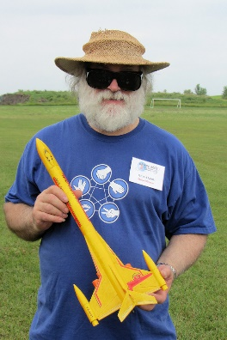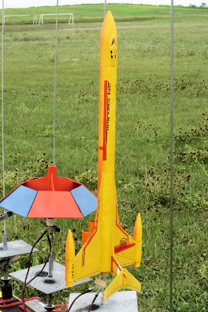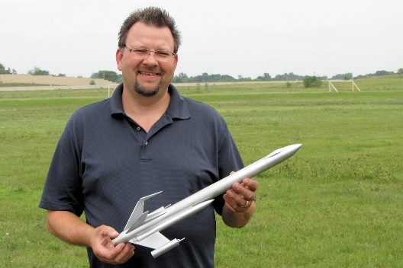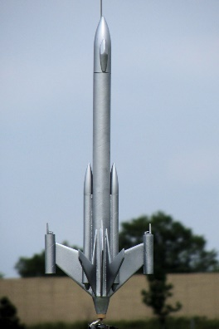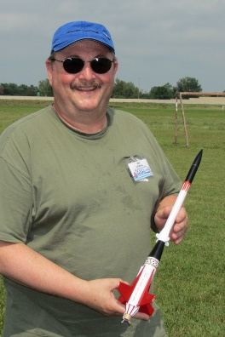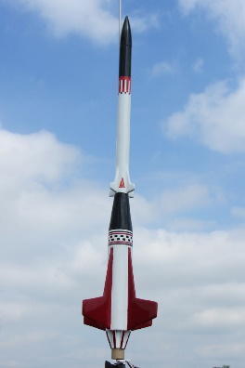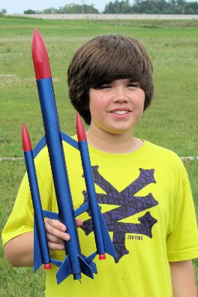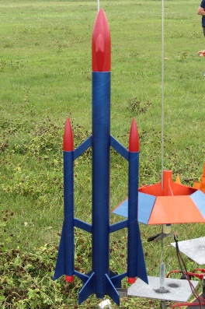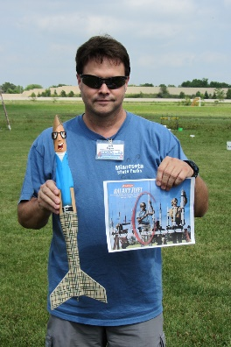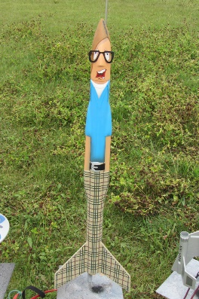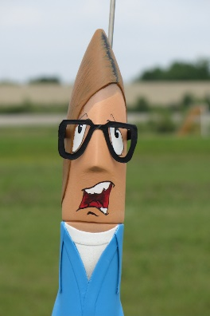
(click on thumbnails to see larger photos)
Launchin!
This was also an official MASA launch. Launching began about 3:00 pm and ended just after 5:00 pm. The launch report tells that side of the story.
Prizes!
Jeff Taylor was presented with an official NAR plaque in recognition of his award-winning years as editor of the MASA Planet newsletter.

At about 6:30 pm, drawings were held for the free "door" prizes. Thanks to all the businesses and individuals who donated prizes!

Here's the list of the prize winners: [apologies for any misspelled names!]
Group 1 (Age 14 and under) PrizeWinners:
- Provided by MASA
  - Estes "Monarch" kit - Ethan Erpelding
  - Quest "America" kit - Zachary Stenberg
  - Custom "P.O.N.G." kit - Tanner Getchie

- Donated by various and anonymous sources
  - Super Soaker Monster Rocket - Ian Ross
  - Estes "Patriot" Starter Set - Logan Stouer
  - Estes "Code Red" Starter Set - Jace Flansburg
  - Estes "Mach 12" kit - Alyssa Stenberg

Group 2 (Age 15 and up) Prize Winners:
- Donated by Hub Hobby Center, Little Canada
  - Semroc "Hydra VII" kit - Carolyn Stenberg
- Provided by MASA
  - Estes "Interceptor-E" kit - George Gassaway
  - Pack of Estes E12-4 motors - Renee Gibbens
  - Aerotech G78G-7 single-use motor - Alyssa Taylor
  - Home Depot $20 Gift Card - Buzz McDermott
  - Quest 6'x6' shade canopy - Cindy Whitaker
  - Quest 6'x6' shade canopy - Susan Shmel

(Alan Estenson)

August MASA meeting – Science Museum
The August MASA meeting was held at the Science Museum in St Paul on Thursday, August 2nd. A total of 11 people attended the meeting.
Launch:
The next launch will be on August 25th at Nowthen. Special events include the 14th Annual Great UFO Drag Race, 11th Annual Comanche-3 Drag Race, 3rd Annual Back To School Crayon Drag Race.
Meeting:
The next meeting will be on September 6 at the Hennepin County Brookdale library. Topic will be "Thinking Outside the Tube" - building rockets from non-rocket parts - Rick Vatsaas
Reminders:
- There are several upcoming outreach events. Neal will send out details via email.
Meeting Topic:
Rocket Locating and Tracking - Gary Stroick
You may view and/or download Gary's presentation using this link. (PDF)
[Alan Estenson]

September MASA meeting – Hennepin County Brookdale Library
The September MASA meeting was held at the Hennepin County Brookdale Library on the 6th. A total of 10 people attended the meeting.
Launch:
The next regular club launch will be on September 22 and 23. There will be two days of both sport flying and contest flying. There may be extra visitors on Saturday as it is a Minnesota Aerospace and Aviation Week 2012 - Flight Day Community Event

The theme on Saturday is Missiles & Military Rockets. The special event is a Mega Mosquito drag race.
Contest info is here.

Events are:
- A Helicopter Duration
- 1/2A Boost Glide Duration
- A Streamer Duration
- C Rocket Glider Duration
- A Super-Roc Duration

Meeting:
The next meeting is planned for Thursday, October 4 at the Hennepin County Southdale Library. For the topic, Neal Higgins will be talking about rocket software - RockSim, Open Rocket, etc.

Reminders:
- Big 2-day sport and contest launch coming up later this month!

Show -n- Tell
- Chris Feld brought his scratchbuilt HALO 38 rocket. It will use altimeter-based rear ejection. First flight planned for an H motor.
- Many boxes and totes of old (and not-so-old) rocket kits were brought to the meeting by an individual looking to sell them. We had fun looking through the many, many kits. Nearly everyone ended up buying some.
Discussions:
- We discussed the logistics and costs associated with having a "porta potty" on site at the sod farm for MASA launches. A dues increase would be necessary to cover the expense.
- A short discussion was held about the need to make some updates to the club bylaws.
- The topic of sparky motors at MASA launches was brought up. The consensus was to continue NOT permitting sparky motors at MASA launches.
[Alan Estenson]

October MASA meeting – Hennepin County Southdale Library
The October MASA meeting was held at the Hennepin County Southdale Library on the 4th. A total of 12 people attended the meeting.
Launch:
The next regular club launch will be on October 27. This will be the last launch of the year at the Nowthen sod fields

The theme is "If it's weird, fly it!" - Oddrocs and Halloween Rockets. The special event is the OktoberFAST G motor drag race. The fun contest is D Altitude (must use an AltimeterOne or AltimeterTwo)
Meeting:
The next meeting is planned for Thursday, November 1. Location TBA.
Reminders:
- There are several upcoming Outreach events. Watch the masarocketry email list for details.
- Newsletter editor Kurt Knox has been swamped over the summer, but we hear that he is working on a new issue of the Planet.
- President Neal says "The poll results have been tabulated and the majority of members who responded support a dues increase. The majority also supported the idea of having porta-potty at the launches. The dues increase will be used for other club related items besides the porta-potty. The dues increase will require a Bylaw change and my hope is to have the draft done within a week and posted to all members by email. Voting for the proposed change will happen at the Novemeber meeting."
Show -n- Tell
- Art Gibbens brought his "Perch of Apophis" flying pyramid that he built from a Sunward kit.
- Alyssa Stenberg showed her upscale Orbital Transports. She built a prototype first (and test flew it at the MASA picnic back in July), and then built a final version. The glider had radio control on its rudder. Alyssa also showed us one of her R/C rocket gliders.
- Zackary Stenberg showed us his FAI S8D WSMC individual bronze medal and trophy. Congrats!!!
- Jon Stenberg talked about their experiences in R/C rocket glider competition at the last two World Space Modeling Championships in Europe. He also shared a neat video with us.
Topic - Rocket Simulation Software:
- Neal Higgins led a group discussion about the various computer software available (both commercial and free) for rocket design and simulation.
- Here are some examples of available programs:
- RockSim (PC or Mac)
- SpaceCad (PC)
- OpenRocket (multi-platform, Android)
- RocketModeler (online)
- RASAero (PC)
- Virtual Range (Mac)
- Rocket Sim (Android or iOS)
- Model Rocket Calculator (Android)
- Rocketry Tools (Android)
- iPowerRocket (iOS)
[Alan Estenson]

November MASA meeting – Science Museum
MASA November Meeting
1 Nov 2012
Science Museum of Minnesota
Attendance: Jeff Taylor, Neal Higgins, Chris Feld, David Gensler, Michael Farrell, Gary Stroick, Art Gibbens, Rick Vatsaas, and noticeably tardy: Todd Carpenter.
Neal made the following club announcements:
· November Launch: The November launch is scheduled for Saturday November 17, one week earlier than the usual date due to Thanksgiving. Neal said that the launch will be at the Otsego field, and was asked why it couldn’t be at the Nowthen field. Neal said that the sod is fairly robust this time of year and he will contact the landowner to see if we can have the November launch in Nowthen.
· Holiday Party: Neal said that plans for a location and date for this year’s Holiday Party are to be determined. Art offered that it could be held at Bailey’s Nursery in Cottage Grove on Saturday December 8th if another location and date did not become available.
· 2013 Club Officer Nominations: Club Officer Nominations (President, Vice President and Secretary/Treasurer) officially opened at the meeting. No nominations were announced for any of the officer positions, but Art announced that his 2013 schedule is so busy that he will not seek out or accept a nomination for VP next year.
· NARCON 2013: Registration for NARCON 2013 is now open as Alan described in a post on the Yahoo Group.
· 2013 Dues Increase: Neal announced that the new dues structure will be voted on by the club members at the Holiday Party. This proposal will increase dues for a Junior membership to $10, an Individual Membership to $20, and a Family Membership to $20 for the first person and $2 for each additional family member (with no maximum).
· MASA Bylaws Amendment: The proposed amendment to the MASA Bylaws has been posted and will be voted on by the club members at the Holiday Party.
New Business: Rick announced that he attended a model boat show and suggested that MASA might consider putting on a model rocket show somewhere. Different ideas were kicked around such as having it at the Science Museum, FIRST LEGO League tournaments, or holding it in conjunction with other hobby shows/conventions.
Speaker Presentation: "Thinking Outside the Tube"
If you have ever seen any of Rick Vatsaas’ rockets, you know that he doesn’t build “ordinary” rockets from straight body tubes. He builds whimsical and fun rockets using some very interesting materials and techniques. Rick’s enlightening presentation called “Thinking Outside of the Tube: Alternate Approaches to Rocket Airframe Construction” focused on different ways to build very different rockets. Standard rocket designs include a round tube for the airframe, but Rick prefers to design and build rockets that capture the imagination of the whimsical sci-fi bulbous-shaped rockets that you see in classic sci-fi. Rick discussed several different construction methods that he has used, and along with a slideshow presentation, he had examples of his incredible work to pass around. Such construction methods included; (A) hotwire bow cutting of foam then covering with fiberglass, (B) building plugs and molds to lay up shapes from fiberglass, (C) the extensive use of disposable and reusable drink ware such as paper coffee cups, plastic tumblers and plastic wine glasses, (D) using Christmas ornaments, Easter eggs, and plastic bowling pins, (E) tapered paper shrouds, and (F) Rick’s latest works using 3D printers to make lightweight ABS parts. His nephew built a homemade 3D printer that allowed Rick to generate the parts needed to build an actual flying scale model of the MASA logo rocket! With advancements in 3D printing technology and Rick’s pioneering use of this application to generate rocket parts, this could definitely be the future of rocketry for anyone who wants to think outside the tube.
[Jeff Taylor]

2012 MASA Holiday Party
On Saturday evening, December 18, about 25 MASA members gathered at Bailey's Nursery in Newport for the annual club holiday party. There was plenty of food to eat and holiday treats to enjoy.

Thanks everyone who came to the party and for all of the great food. MASA supplied turkey and ham.

Thanks Art for setting up the party and for getting us access to the Bailey Nursery meeting room for the event. The room and setup worked out great for the party.

The music played, a year's worth of photo's showed on the screen while all who were there mingled and talked. The food was ready and we all sat down to very good meal.

The annual MASA gift exchange game was once again a popular activity with nearly all the attendees participating. As usual, there were a couple "hot ticket" items that changed hands a few hundred times.

2012 MASA Year in Review
- MASA’s 14th year
- MASA set a record this year with the most total impulse of 44,658, 1314 flights and 1429 motors. We also saw a rise in the use of H, I and J motors. Thanks Gary for being on-site and making it so easy to buy J motors.
- 12 club launches were held in 2012, including two 2-day regional contests:
  - 1,314+ flights (highest in club history)
  - 1,429+ engines burned (highest in club history)
  - Over $9,000 worth of engines used (a club record!)
  - The total number of MASA flights to date is nearly 14,000!
  - We had 78 high power flights, which is the most ever in one year.
- MASA held its fourth annual summer regional contest, and its first fall regional contest.
- The year saw 8 successful L1 flights by Mike Karsten, Jeff Karsten, Brian Uhlenkamp, Adrian LArson, Ryan Foss, Aaron Sheriff, Michael Ferrell (also 1 failed attempt), Allan Grover (also 1 failed attempt).
- There were also 4 failed L1 attempts by Allan Grover, Michael Ferrell, Kris Frederick and Ron Worth.
- 2012 also saw several L2 attempts. Allan Grover made 1 failure and 1 successful flight. Glen Overby and Kris Frederick also had failures on their L2 flights but I am sure they will be back next year to try again.
2012 MASSY Awards
Following MASA tradition, club president Neal Higgins presented a few special awards.
- Prolific Flyer: Alan Estenson with 79 flights. Mike Farrell with 74 flights but that number went to 100 counting his flights at Tripoli.
- Most Dedicated Flyer: Allan Grover for the distances he is willing to drive to get motors and to fly with us. The prize was a certificate, an 8x10 US map for directions and a bottle of 5 hour energy.
- The Edge of Wetness: Michael Farrell so many times came back from a rocket hunt soaking wet from fording the ditches or from the sprinklers watering the nearby fields. His prize included a certificate and a small paper hat for him to wear to stay dry.

2012 Prang Awards
Prang of the Year Award:
The Flansburg Family for 4 Lawn Darts and CATO's
Nominations included:
Breelyn Carlson - Big Betty - CATO
Alan Estenson - Screaming Yellow Zonker - CATO; Fat Boy - No Chute; Cherokee G - Core Sample
Jason Colt - Mim's Arrow - Core sample
Michael Ferrell - Leviathan - Lawn Dart
Chris Feld - 2 lawn darts, 2 no chutes, 2 core samples all on version of his Halo rear eject rockets
Jace Flansburg - Kitbash Kontest rocket - Lawn Dart, Big Daddy - CATO
Jeff Flansburg - EPM 010 - CATO, Initiator - CATO
Owen Frederick - Arachnid - Lawn Dart, The White Rocket - CATO
Kris Frederick - Purple Cow - Core Sample
Art Gibbens - Genesis - CATO
Neal HIggins - Bad Daddy - Lawn Dart, Mini Max - Lawn Dart, Solar Venture - Lawn Dart
Jeff Karsten - Grappler - No Chute
Ben Katzke - Snipe Hunter - Lawn Dart
Kurt Knox - Bandit & V-32 - Core Sample
Stuart Lenz - Pokemon 2 & Ring Fin #2 - CATO, Dragonship 7 & Ozone Research Project II - No Chute
Buzz McDermott - Hydra 7 & Onyx - CATO
Ted Meisner - Mars Lander - Lawn Dart
Doug Reitmeier - Hawk - Lawn Dart
Chuck Ross - Helicat - Lawn Dart
Larry Schwartz - Stretch D Fatboy - No Chute
Aaron Sheriff - Lune R1 - Lawn Dart
Samir Sheriff - Vector (Micromax) - No Chute
Dwayne Schmel - Applewhite Pyramid - CATO
Alyssa Stenberg - 2.5xx Orbital Transport - Lawn Dart
Jeff Taylor - Big Daddy - Lawn Dart, LOC IV - CATO (very spectacular)
Glen Overby - IQSY Tomahawk - Lawn Dart
Rick Vatsaas - Black Adder - Lawn Dart
Anand Vyas - Rose-a-roc - Lawn Dart
Charlie Weisman - NoNamer - No Chute
Dave Whtaker - Centurian & X-15 - Lawn Dart
Ron Wirth - Horn Dog - Lawn Dart, Praetor II - No Chute, Swift BG - Shred
Free Door Prizes
Here's the list of the prize winners: [apologies for any misspelled names!]
Group 1 (Age 14 and under) PrizeWinners:
- Provided by MASA
  - Semroc Sprite kit - Blake Grover
  - Quest Courier kit - Jace Flansburg
  - X-ray kit - Samir Sheriff

Group 2 (Age 15 and up) Prize Winners:
- Donated by Hub Hobby Center, Little Canada
  - Pyramid Rocketry 9" pyramid kit - Jeff Flansburg
  - Box of 24 Estes C6-5 engines - Philip Gibbens

- Provided by MASA
  - Estes Leviathan kit - Aaron Sheriff
  - Dremel tool - Jen Flansburg
  - Husky toolbox/organizer - Andy Heren

- Donated by Ted Cochran:
  - Estes Dark Energy kit - Jeff Taylor
Congratulations to the winners! (apologies for any misspelled names)
The voting results are in: The dues increase and Bylaws changes were passed by a unanimous YES vote. The membership application with the new dues amounts will be available sometime after the January meeting. The new Bylaws (version 5) have been posted to the website.
[Neal Higgins and Alan Estenson]

