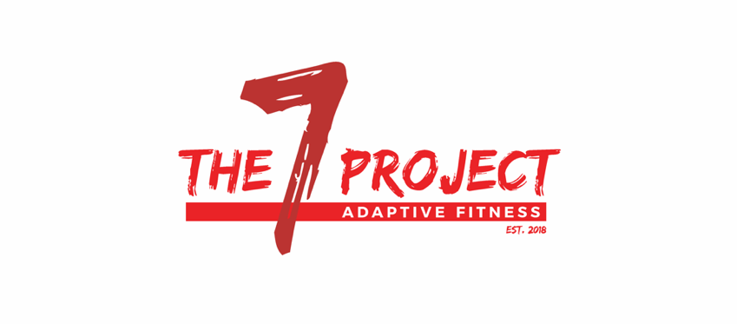
The Seven Project, Inc. FIN 83-1783055
7567 Howard Dean Lane www.the7proj.com
Pensacola, Fl 32526 (850) 972-9555

CLIENT SUPPORT FORM

The Seven Project is a brand new non-profit organization which will provide both physical and nutritional training, as well as peer support, primarily for those living with physical disabilities, and their caregivers. The mission of this project is to provide a non-medical, long-term lifestyle alternative for said audience, in order to enhance and maintain a better quality of life, which we all are worthy of.

In order to make a difference, The Seven Project will be relying on the support of generous individuals and businesses in our community. As an organization acting as a 501(c)(3), all contributions to The Seven Project, Inc. are deductible in accordance with current IRS regulations.

Attached is an example of membership packages, tax not included. Your support could be life changing.

Client obtaining contribution : Advertiser:

Contact person: Phone:

Email: Cash/Check #:

Amount Received:

*** A client may not obtain fees from an individual or business within direct relation. No goods or services were provided by The Seven Project, Inc. in consideration of this donation. Further tax information may be requested. 1308 West Nine Mile Rd, Suite 5, Pensacola, Fl 32534. Please attach business card.***

Payments made to: The Seven Project
Via: Check, Cash, Credit/Debit
. Checks are preferred. All packages are non- refundable and subject to change. Sales tax of 7.5% not yet included in pricing. All memberships and packages are pre-pay.

Adaptive Personal Training Packages
Personal Training members take priority when scheduling specialized equipment. Any session not canceled prior to 24 hours in advance will be deducted from package. Packages do not expire.

4 pack - $140 12 pack - $405
($15 off) unlimited nutrition classes
8 pack - $275
($5 off) 16 pack - $540
($20 off) unlimited nutrition classes, one on one
10 pack - $340 ($10 off) unlimited nutrition classes nutritional guidance

FES Cycling
FES sessions may count as a personal training session, or packages can be bought separately.

4 pack - $80 8 pack - $120 10 pack - $200 12 pack - $240 16 pack - $320

Monthly Contract Deals
Package expires at the final date of contract.

1 month 3 month
$400 ($100 discount) $1200 ($300 discount)
12 pack unlimited nutrition, 4 FES sessions 36 pack, unlimited nutrition, 12 FES sessions

6 month 12 month
$2,400 ($600 discount) $5000 ($1000 discount)
72 pack, unlimited nutrition, 24 FES sessions 144 pack, unlimited nutrition, 48 FES sessions

Individual services:
Individual service item value.

Adaptive/Personal Training
Non-member $70/1 hr

Open Gym (Independent workouts) $10 drop in

Caregiver/Family Membership $10 drop in

FES Cycling $25/hr

Nutrition Class $25

Support Group FREE

Punchcards will be provided. If a client reaches 10 visits in a row, they will receive one for free.
5% of total revenue for 2019 will be devoted to a scholarship fund that will be divided amongst qualified recipients in January 2020, based on an application process.

