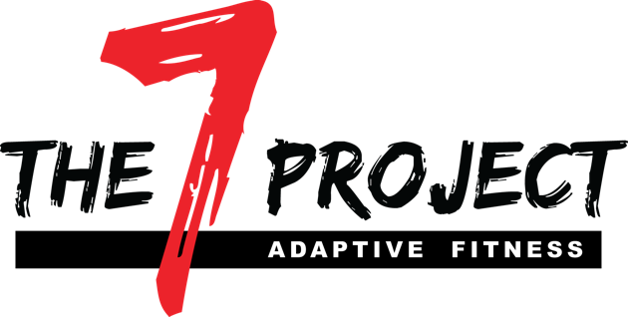

The Seven Project is a lifestyle movement based on seven core covenants; COMMITMENT, DETERMINATION, FAITH, FORTITUDE, SUPPORT, VITALITY, & WELLNESS.

The Seven Project Adaptive Fitness facility acts as a non-medical, wellness center, primarily (but not limited to) serving those living with physical disability, through exercise, nutrition, and support. We are also equipped to accommodate caregivers and family members referred by clients.

All services are provided by both paid and volunteer, certified professionals in each particular field.

The founder of The Seven Project, Tara Blackwell, is a quadriplegic, who has achieved maintaining optimal health and strength from her own home gym, while creating this platform for other disabled individuals. The Seven Project Adaptive Fitness facility aims at a quality-of-life enhancement for its members, and provides a sustainable, long-term solution to fighting many of the secondary complications that come with being physically limited.

We believe that by applying a wellness approach towards your environment, community, belief systems, physical activities, self care, and healthy eating, we can create a healthier, more quality-filled life, no matter our circumstances.

5% of total revenue at the end of each year will aid in the scholarship of qualified applicant(s). Percentage is subject to change upon growth.

WWW.THE7PROJ.COM

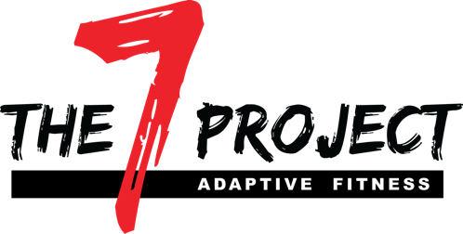
TEAM REGISTRATION
EMAIL PLAYER NAMES TO CONNECT@THE7PROJ.COM

2019 SPONSORSHIP OPPORTUNITIES

Presenting Sponsor: $1500
- Four Man Team, Large Banner, 3 Minute Presentation at Start, 2 Tee Signs, Registration Presence, Watering Hole

Gold Sponsor: $750
1 Four Man Team, Banner, 2 Tee Signs, Watering Hole

Silver Sponsor: $500
1 Four Man Team, Watering Hole

Bronze Sponsor: $250
Watering Hole, Tee Sign

Closest to the Pin, Longest Drive, Hole in One Sponsor: $250 Each

Your business can set up on a hole and offer food, refreshments, treats or giveaways as the golfers come by.

Tee Sign: $75

Business/Organization: _________________________________
Billing Address: ________________________________________
Email:________________________Phone:__________________
Sponsor Type________________________
Method of Payment: Check (preferred) Credit Card
Credit Card #:___________________________Exp:_______
CCV:______________Total:________________
Authorizing Signature:_______________________________________

EMAIL SPONSOR INFO TO CONNECT@THE7PROJ.COM
As a 501©3, contributions made to The Seven Project are deductible within current IRS regulations.

