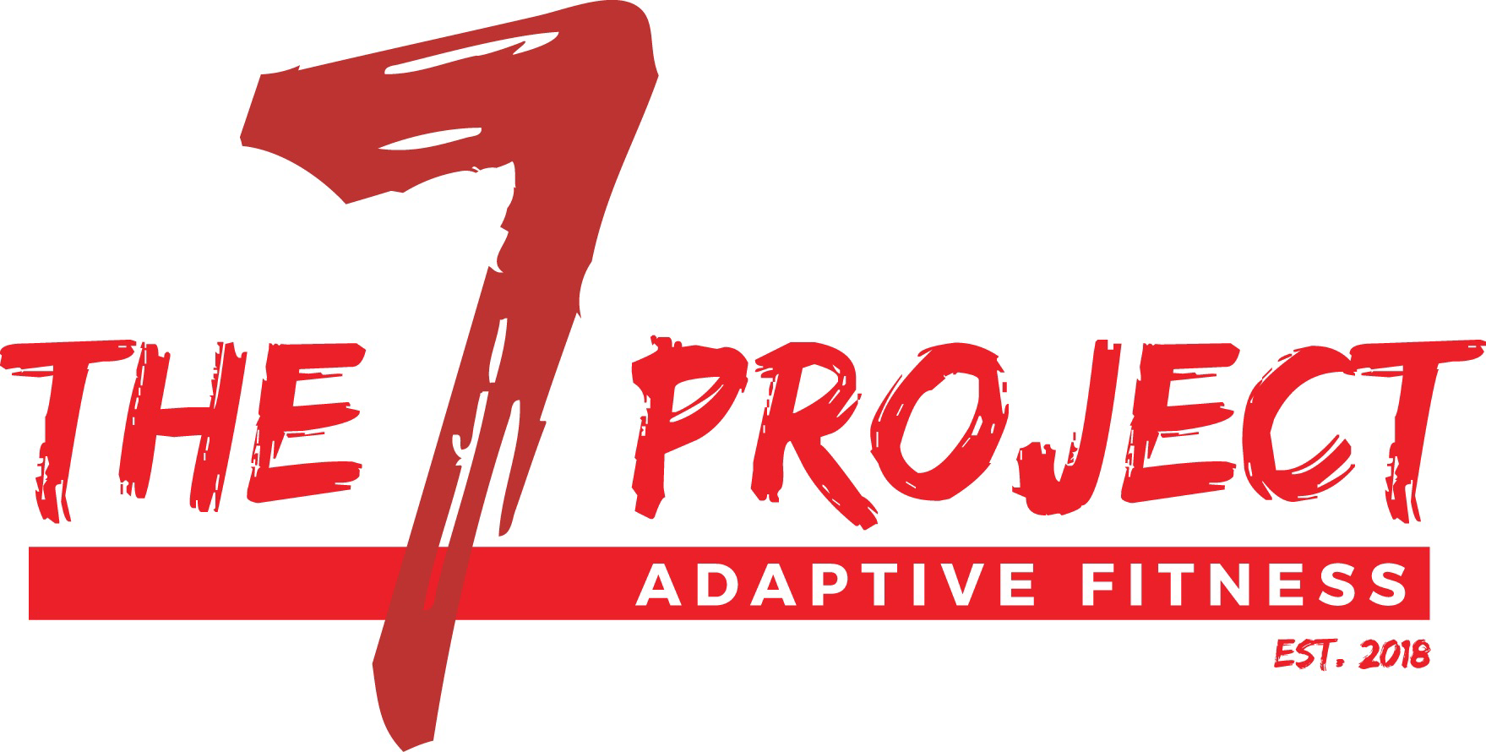

**Payments made to: The Seven Project (Due at the 1st of each month)**

**All memberships are pre-pay**

**Via: Check, Cash, Credit/Debit (Apps: Square, PayPal)**

***NOTE:*** *All monthly packages expire in 30 days from the date of purchase.* *Members take priority when scheduling specialized equipment. All packages are subject to change.*

**Pre-Sale Membership $425 ($100 off)**

Rules & Limitations:

3 consecutive months of the ALL-INCLUSIVE membership; non-transferable

New members only. If have attended training for more than two weeks, not considered a new member.

**All-Inclusive: Up to 4 Sessions/week $175**

Includes up to 4 adaptive personal training sessions per week, free peer group for client and caregivers, free nutritional guidance, free FES Cycling, 1/2 off any additional classes, 3 one-on-one caregiver training sessions (if needed), open gym.

**Limited: 8 Sessions/mo $150**

Includes 8 sessions of adaptive personal training sessions, free peer group for client & caregivers.

**Other packages:**

6 MONTH ALL-INCLUSIVE $945 (Savings of 10%)

12 MONTH ALL-INCLUSIVE $1785 (Savings of 15 %)

**Adaptive/Personal Training**

Non-member $70/1 hr

**Open Gym** $75/mo

Non-member

**Walk/Roll-in** (unassisted) $30/session

**Caregiver {Assisted Exercise}**

**Training** $50/mo (twice monthly)

**Caregiver/Family Membership** $25/mo for caregivers/direct family of members

**FES Cycling** $15/hr

**Adaptive Yoga**  $30/class

**Health & Wellness/ Support Group** FREE