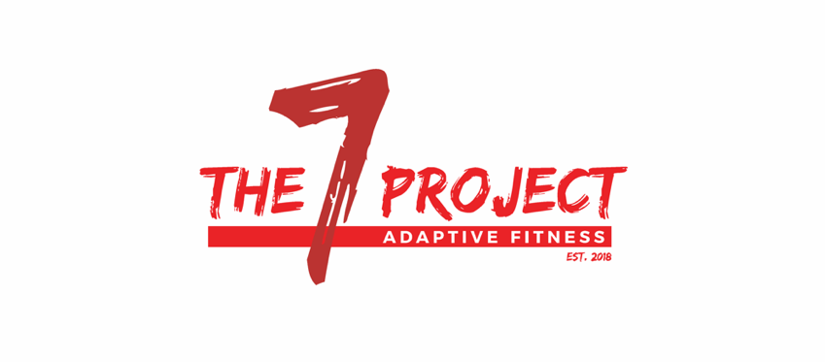
The Seven Project, Inc. 83-1783055
7567 Howard Dean Lane www.the7proj.com
Pensacola, Fl 32526 (850) 972-9555

CLIENT SUPPORT FORM

The Seven Project is a brand new non-profit organization which will provide both physical and nutritional training, as well as peer support, primarily for those living with physical disabilities, and their caregivers. The mission of this project is to provide a non-medical, long-term lifestyle alternative for said audience, in order to enhance and maintain a better quality of life, which we all are worthy of.

In order to make a difference, The Seven Project will be relying on the support of generous individuals and businesses in our community. As an organization acting as a 501(c)(3), all contributions to The Seven Project, Inc. are deductible in accordance with current IRS regulations.

Please consider contributing membership fees in one or more of the following membership packages. Your support could be life changing.

(All totals include sales tax.)
- Pre-Sale Special (New Member, 3 Month Package) $457.95
- Limited Membership $161.25
- All-Inclusive Membership $188.13
- Adaptive Personal Training 4 pack_______________$129

- Caregiver (Assisted Exercise) Training $53.75/ 2x Mo
- Caregiver/Family Membership $26.88/mo

Client obtaining contribution : Advertiser:

Contact person: Phone:

Email: Cash/Check #:

Amount Received:

*** A client may not obtain fees from an individual or business within direct relation. No goods or services were provided by The Seven Project, Inc. in consideration of this donation. Out of gratitude for your support, your logo will be represented on the appreciation wall at The Seven Project facility. 1308 West Nine Mile Rd, Suite 5, Pensacola, Fl 32534. Please attach business card.***

