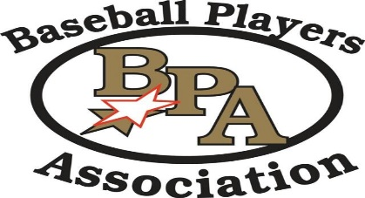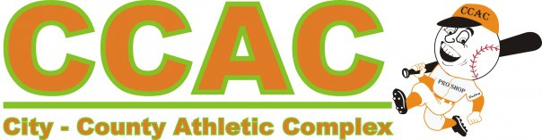

**BPA Super State Tournament**

**June 22-23**

**CCAC Warsaw**

**11U Pool**

1. **Indiana Land Sharks Black**
2. **Michiana Scrappers Orange**
3. **Triple Crown Threat**

**Saturday 3:00 PM East 1 Indiana Land Sharks Black vs. Michiana Scrappers Orange 14-4**

**Saturday 4:45 PM East 1 Indiana Landsharks Black vs. Triple Crown Threat 7-1**

**Saturday 6:30 PM East 1 Michiana Scrappers Orange vs Triple Crown Threat 2-4**

**All pool games are 90 minute time limit, teams are asked to be at field and ready to play 15 minutes prior to game time.**

**Pool games may end in a tie.**

**The highest seeded team has choice of home or visitor in bracket play**