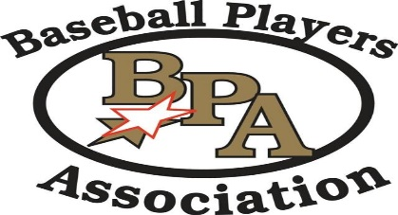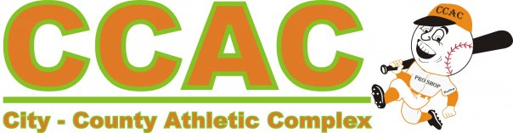

**BPA Super State Tournament**

**June 22-23, 2019**

**CCAC Warsaw**

**14U Pool**

**Pool A Pool B Pool C**

1. **Attack 1) Ind Chargers FW 1) LakeShore Riptide**
2. **Wabash Baseball Club 2) SC Vipers 2) Ind Chargers**
3. **Dekalb County 3) LandSharks Blue 3) Sliders**

**Saturday 8 AM East 2 Ind Chargers FW vs SC Vipers 1-5**

**Saturday 8 AM East 3 Attack vs. Wabash Baseball Club 3-4**

**Saturday 10 AM East 2 In Chargers FW vs. LandSharks Blue 0-17**

**Saturday 10 AM East 3 Attack vs. Dekalb County 4-1**

**Saturday 12 PM East 2 SC Vipers vs. LandSharks Blue 5-7**

**Saturday 12 PM East 3 Wabash Baseball Club vs. Dekalb County 7-2**

**Saturday 2 PM East 3 Lakeshore Riptide vs Ind Chargers 3-4**

**Saturday 4 PM East 3 Lakeshore Riptide vs. Sliders 8-0**

**Saturday 6 PM East 3 Ind Chargers vs Sliders 10-0**

**All pool games are 105 minute time limit, teams are asked to be at field and ready to play 15 minutes prior to game time.**

**Pool games may end in a tie.**