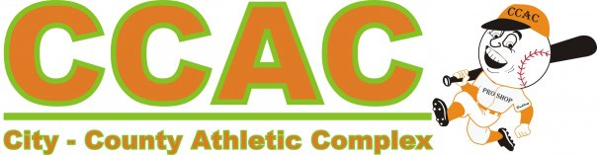 

BPA World Series Coaches Slowpitch Softball Game

We are again offering a Coaches Slowpitch Softball game at the 2018 BPA World Series. This is a way to give back to the coaches and let them have a little fun as well. The game will take place at 6PM Tuesday, July 17, 2018.

This will also be a great time for teams to interact and participate in swapping team pins while cheering their coaches on!

Please fill out the form below and email back to [jeff@ccacwarsaw.com](mailto:jeff@ccacwarsaw.com) by Saturday July 14th. We will then take all applicants and place them on 2 teams. This will be a fun event for the coaches and even more fun for the players to watch their coaches in action.

**Name**:

**Team Name/Age Division**:

**Positions**:

Thank you for your support of BPA Baseball and the City-County Athletic Complex

