Help Your Doctor Make the Best Treatment

Decisions About Your Severe Asthma

If you struggle to manage your asthma, it may be time to talk to your doctor about additional treatment options.

This tool enables a frank and open discussion between you and your asthma specialist about your severe asthma and which treatment options make the most sense for you. The tool takes into consideration a variety of treatment options based on both the medical validity of each treatment as well as your preferences and values. It begins with a series of questions to focus in on your current asthma symptoms and challenges as well as questions that highlight your treatment preferences and any lifestyle constraints that may limit your ability to adopt specific treatment options.

Once you’ve completed the questions, you and your doctor will examine and discuss the pros and cons of treatment options that might be right for you so that together you can decide on the best course of action. Finally, the tool also offers downloadable information with more detail about the treatment option you and your doctor select.

Ultimately, by working together with your doctor to determine the best next step for you, you can achieve the most important goals of reducing asthma symptoms and improving the quality of your life.

**Please Note**: Non-FDA approved treatments are not be included in this tool because they have not yet been shown in clinical studies to be safe and effective, and are therefore not covered by insurance.

*The information and reference materials contained here are intended solely for the general information of the reader. It is not to be used for treatment purposes, but rather for discussion with the patient’s own asthma specialist. The information presented here is not intended to diagnose health problems or to take the place of professional medical care.*

**Let’s Get Started**

Your Perspective

*Please answer every question.*

1. Are you able to control your asthma triggers?

• Stress triggers □ Yes □ No

• Environmental triggers □ Yes □ No

• Allergy triggers □ Yes □ No

• Medication triggers □ Yes □ No

• Other triggers □ Yes □ No

2. Is your asthma keeping you from doing what you want □ Yes □ No

even when you take your controller medication?

3. Does your current controller medication reduce your □ Yes □ No

asthma symptoms most days?

4. Do you use a quick relief inhaler more than 2 times per week □ Yes □ No

other than pretreatment for exercise?

5. Are you experiencing new symptoms since the last □ Yes □ No

time you visited the doctor?

6. Are you experiencing any side effects from your current □ Yes □ No

treatment?

7. Are asthma symptoms waking you up at night? □ Yes □ No

8. Does your asthma impact your ability to function during □ Yes □ No

the day?

9. Can you tolerate a treatment that is delivered via □ Yes □ No

injection or infusion?

10. Are you able to visit your doctor’s office or a medical □ Yes □ No

facility at least once a month for treatment?

11. Is there anythibng that makes it hard to take your medications □ Yes □ No

as prescribed every day?

Your Answers

1. Are you able to control your asthma triggers?

• Stress triggers **■ Yes ■ No**

• Environmental triggers **■ Yes ■ No**

• Allergy triggers **■ Yes ■ No**

• Medication triggers **■ Yes ■ No**

• Other triggers **■ Yes ■ No**

2. Is your asthma keeping you from doing what you want **■ Yes ■ No**

even when you take your controller medication?

3. Does your current controller medication reduce your **■ Yes ■ No**

asthma symptoms most days?

4. Do you use a quick relief inhaler more than 2 times per week **■ Yes ■ No**

other than pretreatment for exercise?

5. Are you experiencing new symptoms since the last **■ Yes ■ No**

time you visited the doctor?

6. Are you experiencing any side effects from your current **■ Yes ■ No**

treatment?

7. Are asthma symptoms waking you up at night? **■ Yes ■ No**

8. Does your asthma impact your ability to function during **■ Yes ■ No**

the day?

9. Can you tolerate a treatment that is delivered via **■ Yes ■ No**

injection or infusion?

10. Are you able to visit your doctor’s office or a medical **■ Yes ■ No**

facility at least once a month for treatment?

11. Is there anything that makes it hard to take your medications **■ Yes ■ No**

as prescribed every day?

Your Results

(needs to be shown graphically)

Functionality on chart will allow the doctor to cursor over a treatment option and click on it to get the subsequent pages with the domain answers

**Note:** Order on all charts and results page should be from left to right:

Anti-IgE

Anti-IL4/IL13

Anti-IL5

Bronchial Thermoplasty

LAMA

Macrolide

Oral Steroid

Standard of Care

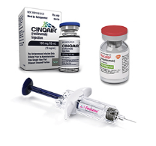

Anti-IgE

(omalizumab)

**What Is it?**

Shot taken in the doctor’s office every 2-4 weeks.

**Who Does It Work Best For?**

This treatment works best in patients who have uncontrolled moderate to severe allergic asthma documented by high blood levels of IgE and positive allergy test (skin test or blood test) showing sensitivity to at least one allergen that cause symptoms all-year round, such as dust mite, molds, dog, cat or cockroaches.

**Why This Treatment May Not Be Right For You**

If you have asthma but do not have allergies, omalizumab may not be the right treatment for you. Also if you are overweight and have very high levels of blood IgE, you may not qualify for this treatment. If you have an allergic reaction to the medication, you will not qualify for further treatments with this drug.

**How Long Will I Have to Use This Treatment?**

The exact duration of omalizumab therapy in patients who have clinical improvement in their asthma has not been determined. Studies found that reducing the dose of omalizumab at 6 months led to a recurrence of asthma symptoms in patients. Other studies suggest that there may be persistent improvement for some periods after omalizumab treatment has been stopped.

**Does This Treatment Require Any Biomarker Testing?**

Yes. IgE is a type of antibody in your blood which may cause an allergic reaction and make your asthma symptoms worse. Total IgE testing is recommended to detect elevated IgE levels in addition to allergy testing.

**What Are the Most Common Side Effects?**

The most common adverse effects reported are injection site pain, swelling, redness and itching, and headache in adolescents and adults.

**How Expensive Is This Treatment?**

$$$

**Is Financial Aid Available?**

In some cases. For Xolair - <https://www.xolairhcp.com/access-resources/financial-assistance.html>

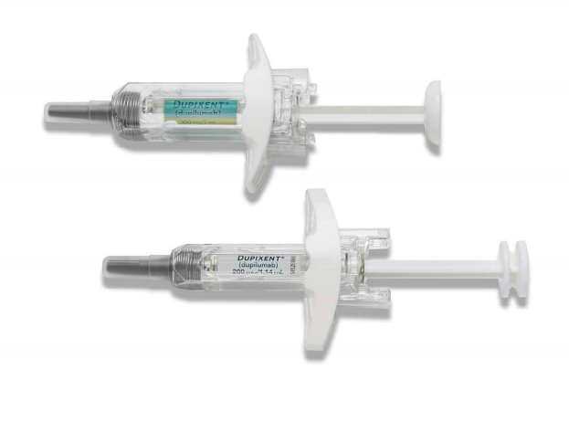

Anti-IL4/IL13

**What Is it?**

This is a shot every two weeks that can be taken at home or in the doctor’s office.

**Who Does It Work Best For?**

This treatment works best in patients who have uncontrolled moderate to severe asthma with high blood eosinophils or oral steroid dependent asthma.

**Why This Treatment May Not Be Right For You?**

This treatment may not work well for those without elevated blood eosinophils or fractional exhaled nitric oxide or those who have an allergic reaction to the medication.

**How Long Will I have to Use this Treatment?**

There is no clear answer to the time to stop treatment.

**Does this Treatment Require Any Biomarker Testing?**

Fractional exhaled nitric oxide testing is recommended to determine response to this treatment.

**What Are the Most Common Side Effects?**

Side effects may include pain, redness, swelling or itching and transient rise in eosinophils at the injection site.

**How Expensive Is This Treatment?**

$$$

**Is Financial Aid Available?**

In some cases for:

Dupixent - <https://www.dupixenthcp.com/asthma/dupixent-myway>



Anti-IL5

**What Is it?**

Shot or IV taken in the doctor’s office every 4-8 weeks.

**Who Does It Work Best For?**

This treatment works best for patients who have a history of more than two exacerbations per year requiring oral corticosteroids and who have increased counts of eosinophils (white blood cells that can cause inflammation in the airways), which predict response to therapy. Candidates for this therapy should also be taking at least three long‐term asthma controller medications.

**Why This Treatment May Not Be Right For You**

The treatment may not work well for those without elevated blood eosinophils or those who have an allergic reaction to the medication.

**How Long Will I Have to Use This Treatment?**

There is no clear answer to the time to stop treatment.

**Does This Treatment Require Any Biomarker Testing?**

Yes. Testing is recommended to detect elevated eosinophils. Eosinophils are white blood cells that can

cause inflammation in the airways.

**What Are the Most Common Side Effects?**

Side effects are relatively rare but may include skin rashes, lip swelling, a drop in blood pressure and wheezing.

**How Expensive Is This Treatment?**

$$$

**Is Financial Aid Available?**

In some cases. For:

Cinqair - <https://www.cinqair.com/getting-cinqair>

Faserna - <https://www.fasenra.com/fasenra-savings.html>

Nucala - <https://www.nucala.com/severe-asthma/steps-to-start/coverage-options/index.html>



Bronchial Thermoplasty

**What Is it?**

Three outpatient procedures requiring anesthesia.

**Who Does It Work Best For?**

This treatment is recommended for patients who have not responded to other treatment options tried.

**Why This Treatment May Not Be Right For You**

The treatment may not be right for anyone who cannot undergo general anesthesia or those who cannot have a bronchoscopy due to a medical condition.

**How Long Will I Have to Use This Treatment?**

The three procedures are done just one time. No studies have been done repeating the procedure.

**Does This Treatment Require Any Biomarker Testing?**

No.

**What Are the Most Common Side Effects?**

Initially asthma may worsen with increased symptoms. There is no clear research indicating which asthma patient will improve using this treatment option.

**How Expensive Is This Treatment?**

$$$

**Is Financial Aid Available?**

No.

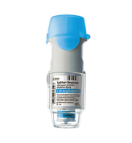

LAMA

**What Is it?**

Inhaler taken at home 1-2 times daily.

**Who Does It Work Best For?**

This treatment works best for patients with uncontrolled asthma symptoms despite standard of care treatment.

**Why This Treatment May Not Be Right For You**

The treatment may not be right for patients who have narrow angle glaucoma or urinary bladder obstruction.

**How Long Will I Have to Use This Treatment?**

There is no clear answer to the time to stop treatment. Your asthma specialist may discontinue if symptoms become well controlled.

**Does This Treatment Require Any Biomarker Testing?**

No.

**What Are the Most Common Side Effects?**

Side effects include dry mouth, cough, headache, constipation or diarrhea.

**How Expensive Is This Treatment?**

$$

**Is Financial Aid Available?**

In some cases for Spiriva - <https://www.spiriva.com/asthma/savings/>



Macrolide

**What Is it?**

Antibiotic pills taken as prescribed.

**Who Does It Work Best For?**

Currently, there is no specific test or blood study that allows your doctor to know for sure if you will benefit from taking macrolides. This treatment is usually added when other asthma therapies fail to work.

**Why This Treatment May Not Be Right For You**

The treatment may not be right for you if you have had an allergic reaction to the medication or if you are concerned about side effects like diarrhea, hearing loss, antibiotic resistance, etc.

**How Long Will I Have to Use This Treatment?**

Most doctors feel comfortable prescribing this medication for months. There are no studies that determine how long a patient should remain on the medication.

**Does This Treatment Require Any Biomarker Testing?**

No.

**What Are the Most Common Side Effects?**

Nausea and diarrhea are the most common side effects seen with macrolides. A decrease in hearing has been reported but almost always returns to normal once the antibiotic is stopped.

**How Expensive Is This Treatment?**

$

**Is Financial Aid Available?**

In some cases for:

[Azithromycin](http://www.pfizerrxpathways.com/) - <https://www.pfizerrxpathways.com/>



Oral Steroid

**What Is it?**

A pill that is taken at home.

**Who Does It Work Best For?**

Most asthma patients with unresolved symptoms will respond to oral corticosteroids.

**Why This Treatment May Not Be Right For You**

Some patients are concerned about the short‐term and long‐term side effects of oral corticosteroids.

**How Long Will I Have to Use This Treatment?**

Typically your doctor will prescribe oral corticosteroids for a few days at a time. Very few patients are required to take daily oral corticosteroids long term to optimally control asthma symptoms.

**Does This Treatment Require Any Biomarker Testing?**

No.

**What Are the Most Common Side Effects?**

Side effects include increased appetite and weight gain; lower resistance to infection; mood and sleep disturbances; “puffy” moon-faced swollen ankles; and higher blood pressure in the short term. Potential long term side effects include adrenal insufficiency, diabetes, osteoporosis and glaucoma.

**How Expensive Is This Treatment?**

$

**Is Financial Aid Available?**

No.



Standard of Care

**What Is It?**

Controller inhalers used at home 1 to 2 times daily plus quick relief rescue inhalers as needed.

**What Does It Work Best For?**

Standard of care works best for those who achieve control, meaning no symptoms or limitations to activities of daily living.

**Why This Treatment May Not Be Right For You**

If you are experiencing worsening symptoms that require frequent use of quick relief medication and/or more than 2 bursts of oral steroids per year and/or more than 1 emergency room/hospital visit per year, the standard of care treatment may not be adequate for you.

**How Long Will I Have to Use This Treatment?**

There is no clear evidence to suggest a patient with severe asthma can stop high dose controller medications. Your asthma specialist may reduce the dose if symptoms become well controlled.

**Does This Treatment Require Any Biomarker Testing?**

No.

**What Are the Most Common Side Effects?**

Standard of care high-dose controller medications can cause serious side effects, including thrush (fungal infection in throat or mouth), pneumonia, weakened immune system, reduced adrenal function which may lead to eye problems, bone thinning, etc., and slight chance of severe allergic reaction.

**How Expensive Is This Treatment?**

$

**Is Financial Aid Available?**

In some cases for:

Advair - <https://www.gskforyou.com/>

AirDuo - [http://myairduo.com/(X(1)S(r52jm4q02r5f5v5gxyct0gad))/teva-patient-assistance program.aspx?AspxAutoDetectCookieSupport=1](http://myairduo.com/(X(1)S(r52jm4q02r5f5v5gxyct0gad))/teva-patient-assistance-program.aspx?AspxAutoDetectCookieSupport=1)

Dulera - <http://www.merckhelps.com/DULERA>

Symbicort - <http://www.azandmeapp.com/resources/download_application>

Medical Benefits of Treatment Options

Anti-IL4/IL13

✓

✓

✓

✓

✓

✓

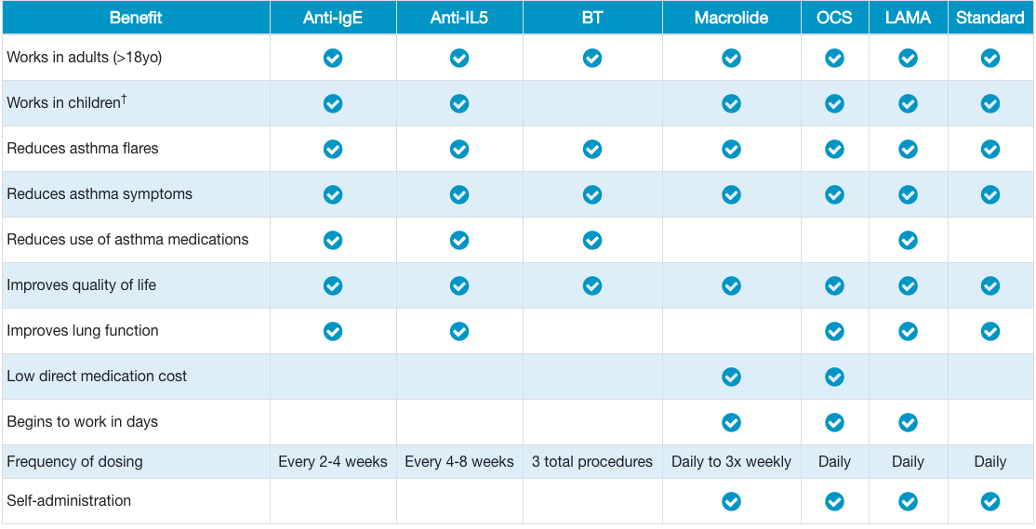

† *Age requirements vary by treatment and many start at age 6. Anti‐IL5 agents have minimum ages of 12 (dupilumab, mepolizumab and benralizumab) or 18 (reslizumab), LAMAs can be used as young as 1 year old, and oral steroids can be used as young as 6 months old. Contact your asthma specialist for more details about treatment options for children.*

Top of Form

Bottom of Form

Lifestyle Benefits of Treatment Options

|  |  |  |  |  |  |  |  |  |
| --- | --- | --- | --- | --- | --- | --- | --- | --- |
|  |  |  |  | **Bronchial** |  |  |  | **Standard** |
| **Benefit** | **Anti-IgE** | **Anti-IL4/IL13** | **Anti-IL5** | **Thermoplasty** | **LAMA** | **Macrolide** | **Oral Steroid** | **of Care** |
|  |  |  |  |  |  |  |  |  |
| Nothing to carry around | X | X | X | X |  |  |  |  |
|  |  |  |  |  |  |  |  |  |
| Can be used in conjunction with standard of care treatments | X | X | X | X | X | X | X |  |
|  |  |  |  |  |  |  |  |  |
| Frequent doctor visits | X | X | X |  | X |  |  |  |
|  |  |  |  |  |  |  |  |  |
| Doesn't impact sleep | X | X | X | X | X | X |  | X |
|  |  |  |  |  |  |  |  |  |
| Doesn't reduce appetite | X | X | X | X | X | X |  | X |
|  |  |  |  |  |  |  |  |  |
| Doesn't restrict operating heavy equipment | X | X | X | X | X | X |  | X |
|  |  |  |  |  |  |  |  |  |
| Generally covered by insurance | X | X | X |  | X | X | X | X |

Medical Risks and Side Effects

|  |  |
| --- | --- |
| **Treatment** | **Risks and Side Effects** |
| Anti-IgE | Side effects may include:  • Pain, redness, swelling or itching at the injection site  • Severe allergic reaction requiring epinephrine  Studies have shown that there is no risk of cancer |
| Anti-IL4/IL13 | Side effects may include:  Pain, redness, swelling or itching at the injection site. |
| Anti-IL5 | Side effects may include:  • Pain, redness, swelling or itching at the injection site  • Severe allergic reaction requiring epinephrine |
| Bronchial Thermoplasty | Asthma flares or exacerbations may occur, but typically resolve in one week |
| LAMA | Side effects may include:  • Dry mouth, cough, headache, constipation or diarrhea |
| Macrolides | Side effects may include:  • Decreased hearing, cardiac arrhythmias or gastrointestinal distress |
| Oral Steroids | Side effects may include:  • Osteoporosis, cataracts, diabetes, weight gain, high blood pressure, stroke, heart disease, bruising and skin thinning  • Psychiatric effects such as mood disturbances, depression, mania or steroid psychosis may occur  • Insomnia or other sleep disturbances  • Due to these side effects, oral steroids are only recommended for short-term use, not to exceed 12 bursts over 12 months |
| Standard of Care | Side effects include:  • Thrush (fungal infection in throat or mouth)  • Pneumonia  • Weakened immune system  • Reduced adrenal function which may lead to eye problems, bone thinning, etc.  • Slight chance of severe allergic reaction. |

Downloadable Handouts

For more information about each treatment option, simply click on the symbol to download a handout with more information.

**Anti-IgE LAMA**

**Anti-IL5 Macrolides**

**Anti-IL4/IL13 Oral Steroids**

**Bronchial Thermoplasty Standard of Care**

What Now?

Now that you’ve been introduced to your treatment options, there are a couple of other questions you need to consider:

1. Do you understand the treatment option your doctor is recommending and why it might be the best next step for you? Be sure to read the additional information you can download about your treatment option and ask your doctor any questions about how it works and what it may accomplish for reducing your asthma symptoms.

2. Do you understand what your health insurance out-of-pocket expenses are for the proposed treatment and are you willing and able to pay them? This is an important issue for you to consider before committing to a specific treatment.

Finally, click on the link below to download your answers and results. If you want to learn more about severe asthma, visit the asthma microsite at **asthma.chestnet.org**.

**Download My**

**Answers and Results**