*(PCT Nurture Packet: Email #1 – Version 1)*

Procalcitonin: A proven biomarker for diagnosing sepsis

With more than 150,000 cases diagnosed and 250,000 deaths each year, sepsis remains one of the leading causes of death in the U.S. Yet research shows that up to 80% of deaths could be prevented with early detection.

**Now there’s a better way to identify sepsis.**

Procalcitonin (PCT) is a biomarker that can be used for early detection of sepsis. It is a better diagnostic indicator in the intensive care unit (ICU) than other commonly used biomarkers with greater sensitivity and accuracy.

Healthcare providers are using PCT successfully to:

* Gain an accurate early prognosis of patients who have, or are likely to get, sepsis
* Manage ICU treatment
* Guide effective antibiotic therapy

Click below to download our comprehensive guide on the benefits and uses of PCT.

**Get the guide**

*(PCT Nurture Packet: Email #1 – Version 1)*

Procalcitonin: A proven biomarker for diagnosing sepsis

With more than 150,000 cases diagnosed and 250,000 deaths each year, sepsis remains one of the leading causes of death in the U.S. Early identification is key to reducing both risk and mortality.

Procalcitonin (PCT) is a biomarker that can be used for early detection of sepsis. It is a better diagnostic indicator than other commonly used biomarkers, like CRP and lactate.

PCT enables:

* Accurate, early prognosis of sepsis patients
* Streamlined ICU treatment
* More targeted antibiotic therapy

Click below to download our comprehensive guide on the benefits and uses of PCT.

**Get the guide**

*(PCT Nurture Packet: Email #2 – Version 1)*

Procalcitonin helps prevent bacterial coinfection in COVID-19 cases

PCT is a biomarker widely used to assess the risk of bacterial infections and their progression to sepsis and septic shock. But procalcitonin (PCT) provides valuable information that can aid in early risk assessment of bacterial coinfection in COVID-19 patients as well.

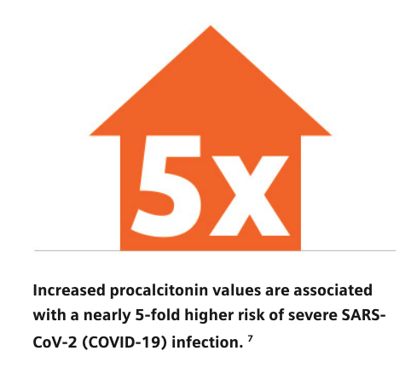

PCT supports effective COVID-19 treatment by enabling:

* Accurate, early prognosis of sepsis as a secondary bacterial infection, which can be used to prevent severe sepsis and septic shock
* Serial sepsis evaluation to guide antibiotic therapy decision making in both the ICU and ED

Click below learn how PCT testing can highlight bacterial coinfection in COVID-19 patients.

**Get the guide**

*(PCT Nurture Packet: Email #2 – Version 2)*

Procalcitonin helps prevent bacterial coinfection in COVID-19 cases

Procalcitonin (PCT) provides valuable information that can aid in early risk assessment of bacterial coinfection in COVID-19 patients.



PCT enables:

* Accurate early prognosis of sepsis as a secondary bacterial infection, which can be used to prevent severe sepsis and septic shock
* Serial sepsis evaluation to guide antibiotic therapy decision making in both the ICU and ED

Click below learn how PCT testing can highlight bacterial coinfection in COVID-19 patients.

**Get the guide**

*(PCT Nurture Packet: Email #3 – Version 1)*

B•R•A•H•M•S Procalcitonin (PCT) Assay helps you detect sepsis earlier

Despite our knowledge about the pathophysiology and therapeutic concepts associated with sepsis, severe sepsis and septic shock remain among the leading causes of death in critically ill patients. The fact is that early diagnosis and treatment of sepsis reduces risk and mortality for patients.1

**Now you can improve your sepsis outcomes.**

The Siemens Healthineers Procalcitonin (PCT) Assay provides an accurate, sensitive, and precise method for measuring PCT in human serum and plasma. The B•R•A•H•M•SPCT Assay aids in:

* Early risk assessment of critically ill patients
* Examination of the 28-day risk of all-cause mortality for patients diagnosed with severe sepsis or sepsis shock
* Decision making on antibiotic therapy for patients with confirmed or suspected LRTI

Click the button below to learn more about the clinical utility of the B•R•A•H•M•S PCT Assay.

**Learn more**

1 Hwan II, Kim et al: Tuberculosis and Respiratory Diseases, 2019 Jan, 82(1):6-14

*(PCT Nurture Packet: Email #3 – Version 2)*

B•R•A•H•M•S Procalcitonin (PCT) Assay for early sepsis detection

Despite our knowledge about the pathophysiology of sepsis, severe sepsis and septic shock remain among the leading causes of death in critically ill patients. Recognizing sepsis early is the key to better patient outcomes.

The Siemens Healthineers Procalcitonin (PCT) Assay provides an accurate, sensitive, and precise method for measuring PCT in human serum and plasma. The B•R•A•H•M•S PCT Assay aids in:

* Early risk assessment of critically ill patients
* Examination of the 28-day risk of all-cause mortality for patients diagnosed with severe sepsis or sepsis shock
* Decision making on antibiotic therapy for patients with confirmed or suspected LRTI

Click the button below to learn more about the clinical utility of the B•R•A•H•M•S PCT Assay.

**Learn more**