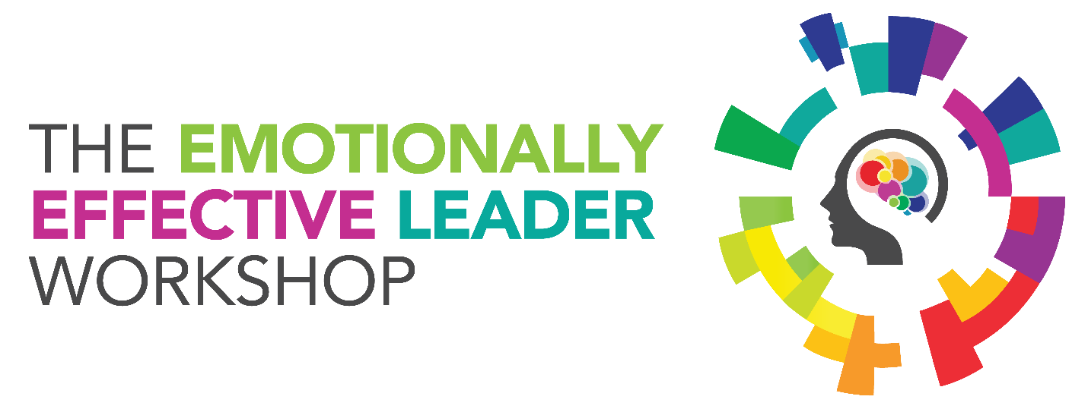

About the Emotionally Effective Leader Workshop

The Emotionally Effective Leader Workshop is an interactive comprehensive program for leaders at all levels. Alternating between group activities and individual reflective exercises, this engaging workshop encourages leaders to focus on their leadership strengths and areas they can develop further. Leveraging results from leaders’ EQ-i 2.0® Leadership Reports, participants of this session will learn the importance of emotional intelligence in effective leadership and leave with a better understanding of his or her strengths and areas to develop to enhance their leadership skills, as well as an action plan on how to increase his or her effectiveness.

Program objectives

• Increase participants' understanding of emotional intelligence and its role in effective leadership

• Create understanding of emotional intelligence using the EQ-i 2.0 model as a platform

• Enable participants to identify specific areas in their own EQ-i 2.0 Leadership Reports and build an action plan to work on areas to develop further and leverage strengths

**Upon completion of this session, participants will:**

• Understand the role of emotional intelligence in effective leadership

• Explore key areas of leadership in relation to emotional intelligence

• Understand the key elements of the EQ-i 2.0 Leadership Report

• Articulate strengths and areas with opportunity for growth

• Identify and understand how aspects of emotional intelligence leads to derailing behaviors

• Apply what they have learned in the session by developing a personal EQ-i 2.0 learning plan

To find out more contact Bill Matheny at 734.693.4929 or Bill@Constructivedynamicslc.com