EMBODIMENTS OF XPXP
94AA revised 2025 M.D.Earl 2023

The obvious evidence for universal exponential expansion is the Hubble Flow. However, XPXP also applies to local situations which seem to have no resemblance to an expansion. “Embodiments” of the expansion are shown below. They differ from the cosmic flow in the distribution and amount of matter present. It is proposed that the same process applies to both the expansions of concentrated matter and of spiral galaxies, as well as the cosmos itself. A significant consequence is that gravitation is an expansion of the space surrounding a concentrated mass...and does not apply to all distributions of matter.

An exponential expansion coefficient H for each embodiment determines the character of that embodiment. The Hubble constant, Ho, is the coefficient for the universe, and applies only to the universal flow. The parameters forming the cosmic Ho (GE, Mo, Vo, Ro) are those of the universe.

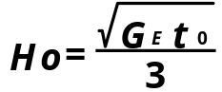

While the principles of universal XPXP apply to other (local) forms, the unequal expansion of matter and space create the embodiments of XPXP displayed in the universe. Mo, Vo, To, and Ro are defined for each embodiment, and define H (not necessarily Ho) for that embodiment.

By determining H for a given local expansion, then multiplying H by R (the radius from the center of expansion), radial velocities for the embodiment are produced. The radial velocity thereafter defines the nature of the expansion. This is shown below.

Embodiment #1
COSMIC EXPANSION:
FROM THE HUBBLE/LEMAITRE LAW:

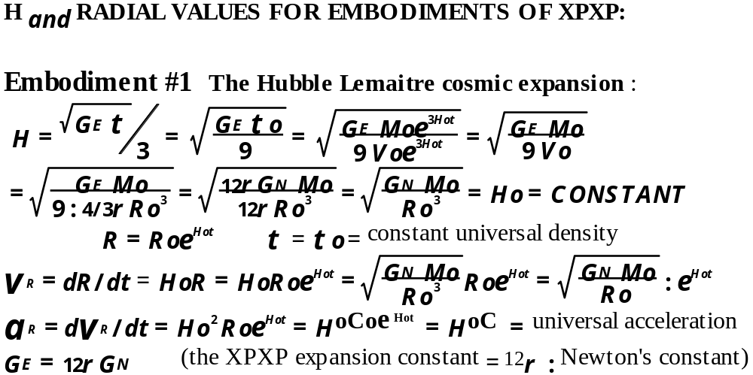

The universe has an exponentially increasing radial velocity, in accord with the Hubble/LeMaitre law and where the radial velocity = dR/dt = HoR. GN = Newton’s constant. GE = Universal expansion constant.
Cosmic expansion is “FREE EXPANSION” ,where galaxies have virtually no interaction with other galaxies.
Figure 94-1. What Hubble saw:
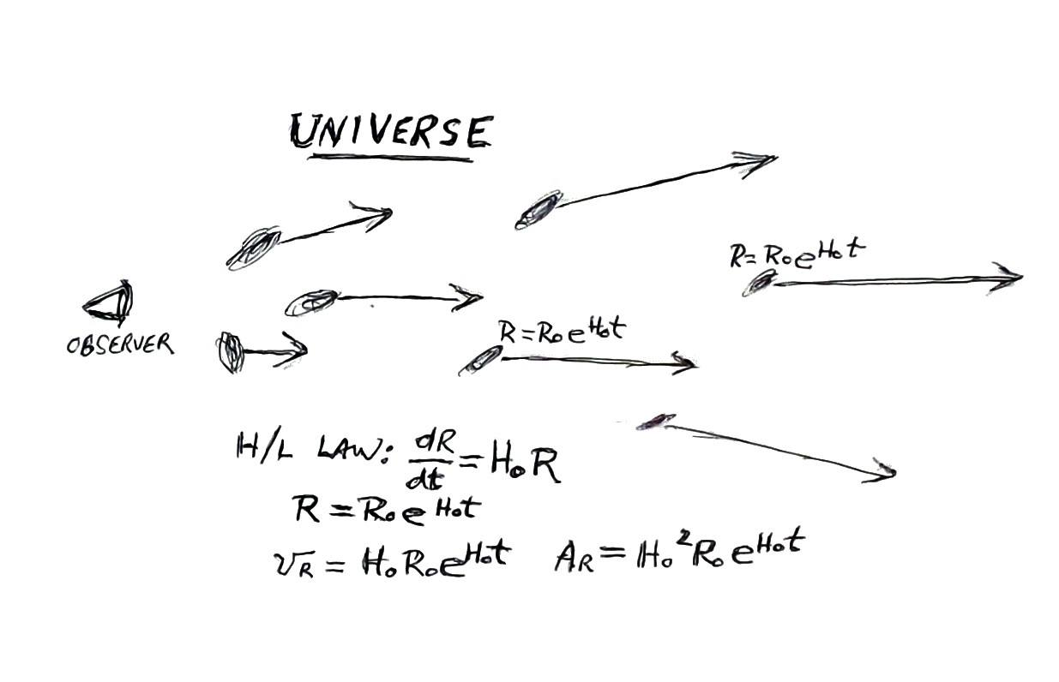

Embodiment #2; Concentrations of matter

INTERNAL EXPANSION
OF CONCENTRATED MATTER:

MASS DENSITY DECREASES FROM CENTER
Internal matter expands exponentially with the radius, rather than with the radius cubed, due to interaction with adjacent expanding matter until the surface.
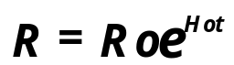
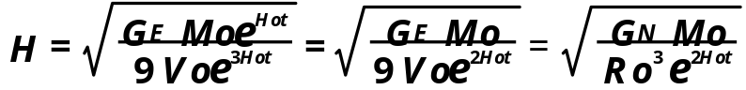
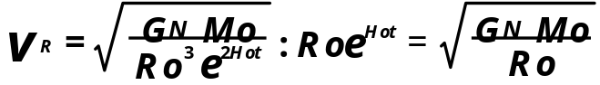
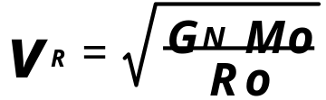
This expression indicates a constant internal radial velocity, equivalent to Newtonian orbital velocity at the surface. Externally, Newtonian gravitation is produced.

Figure 94-2 Internal XPXP of concentrated matter:
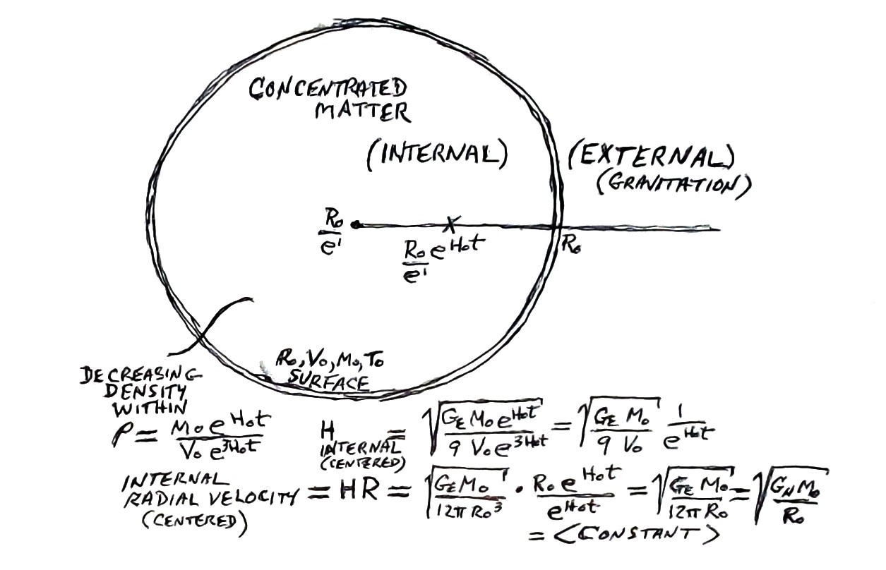

“GRAVITY” IS EXTERNAL SPATIAL EXPANSION OF CONCENTRATED MATTER:
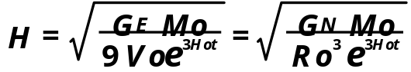
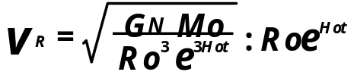
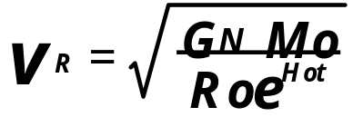
This expression corresponds to the Newtonian orbital velocity in a gravitational field.

Figure 94-3 External expansion of concentrated matter (Gravity):
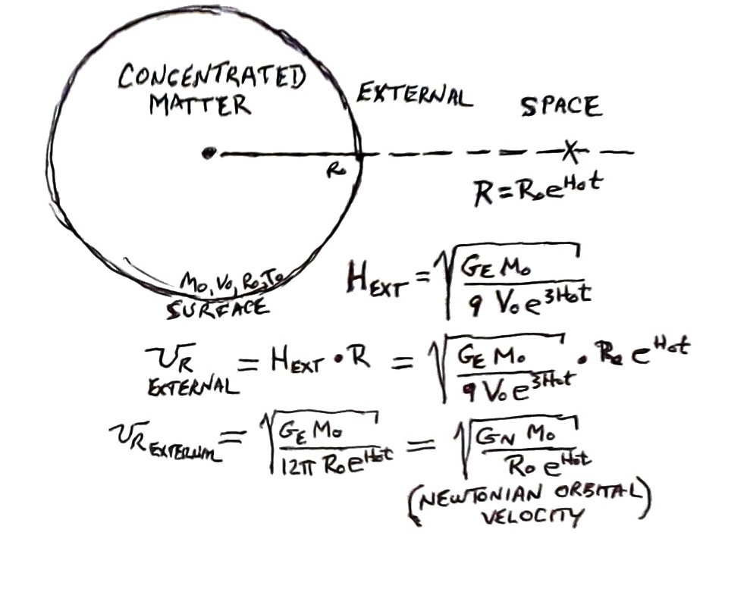
Differentiating this radial velocity produces a negative-inverse squared acceleration, in agreement with the “pull” of Newtonian gravitation.
Embodiment #3; Spiral Galaxies
IN THE STANDARD MODEL, STARS IN THE ARMS OF SPIRAL GALAXIES SHOW AN UNEXPLAINABLE CONSTANT VELOCITY. RATHER THAN SUGGESTING “DARK MATTER”, THE XPXP MODEL PROVIDES AN ANSWER.
Figure 94-4. A velocity vs. distance rendering of a typical spiral galaxy:
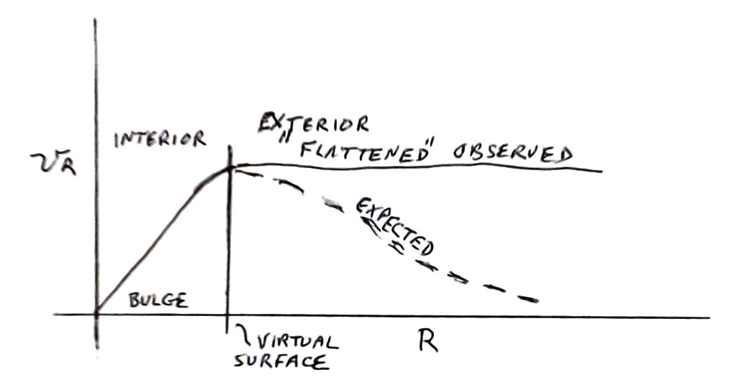
According to Newtonian gravitation, the stars beyond the bulge are expected to have a radial velocity that diminishes as the distance from the center increases... just as in the space around planets and stars. Instead, those stars maintain a speed which is equal to the stars at the edge of the bulge. It is proposed in the XPXP model that, rather than abruptly stopping the matter as in a surface, the external stars exponentially add sufficient mass to cause the radial velocity to be constant.

EXPANSION WITHIN THE BULGE
OF SPIRAL GALAXIES:
The stars within the bulge of spiral galaxies are free to move in much the same manner as the galaxies of the cosmos move. There is virtually no interaction between stars. Both the internal mass and volume of the galaxy increase proportionately to the cube of the radius. As shown below, a constant Ho produces an exponentially increasing radial velocity until the (virtual) surface.
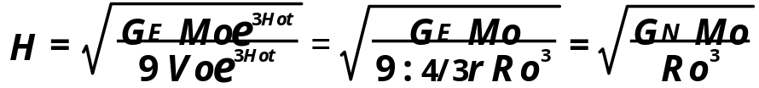
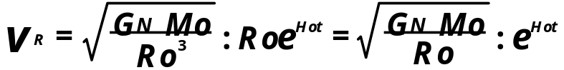
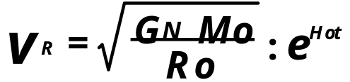

Figure 94-5 XPXP within galactic bulge
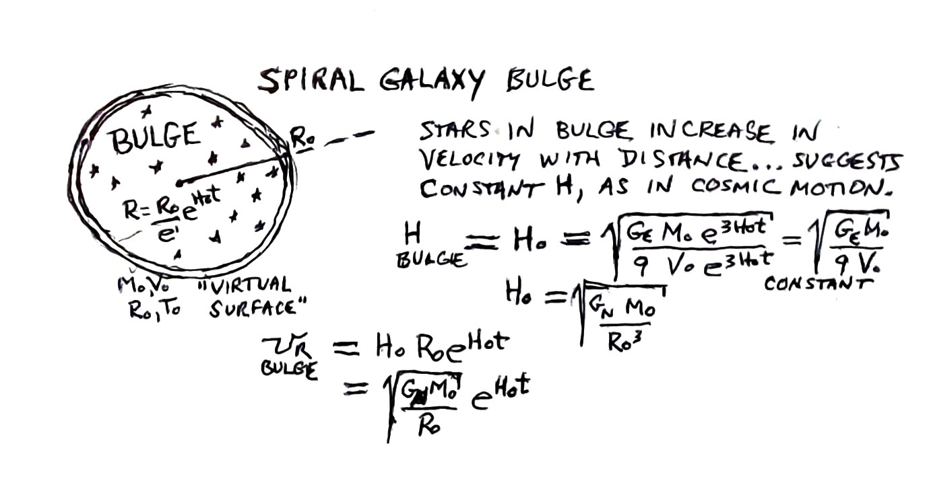

EXPANSION IN THE ARMS
OF SPIRAL GALAXIES:
In the bulge of spiral galaxies, both the mass and volume increase proportionately to the cube of the radius. Because the stars have freedom to move, a definitive surface is not created at Ro, as in Newtonian gravitation. Instead, a state of equilibrium is created wherein the stars stars continue to exponentially add enough matter to produce an expansion field having a constant radial velocity. Beyond the bulge, the stars add matter in proportion to the radius :
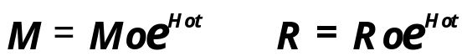

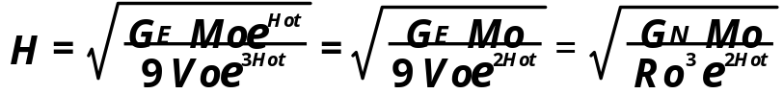
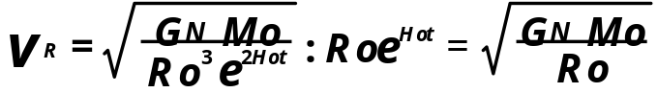
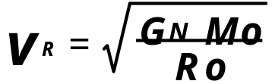

The Expansion field surrounding the bulge contains stars which have the same velocity. This creates the arms of the spiral galaxy, since the stars farther out must go a greater distance than the closer stars. Observationally, galactic stars produce a “flattening of the velocity curve” in spiral galaxies. Because the external stars were expected to obey Newtonian gravitational principles, Dark Matter was invented.

Figure 94-6. The exponentially decreasing distribution of stars in galaxy arms
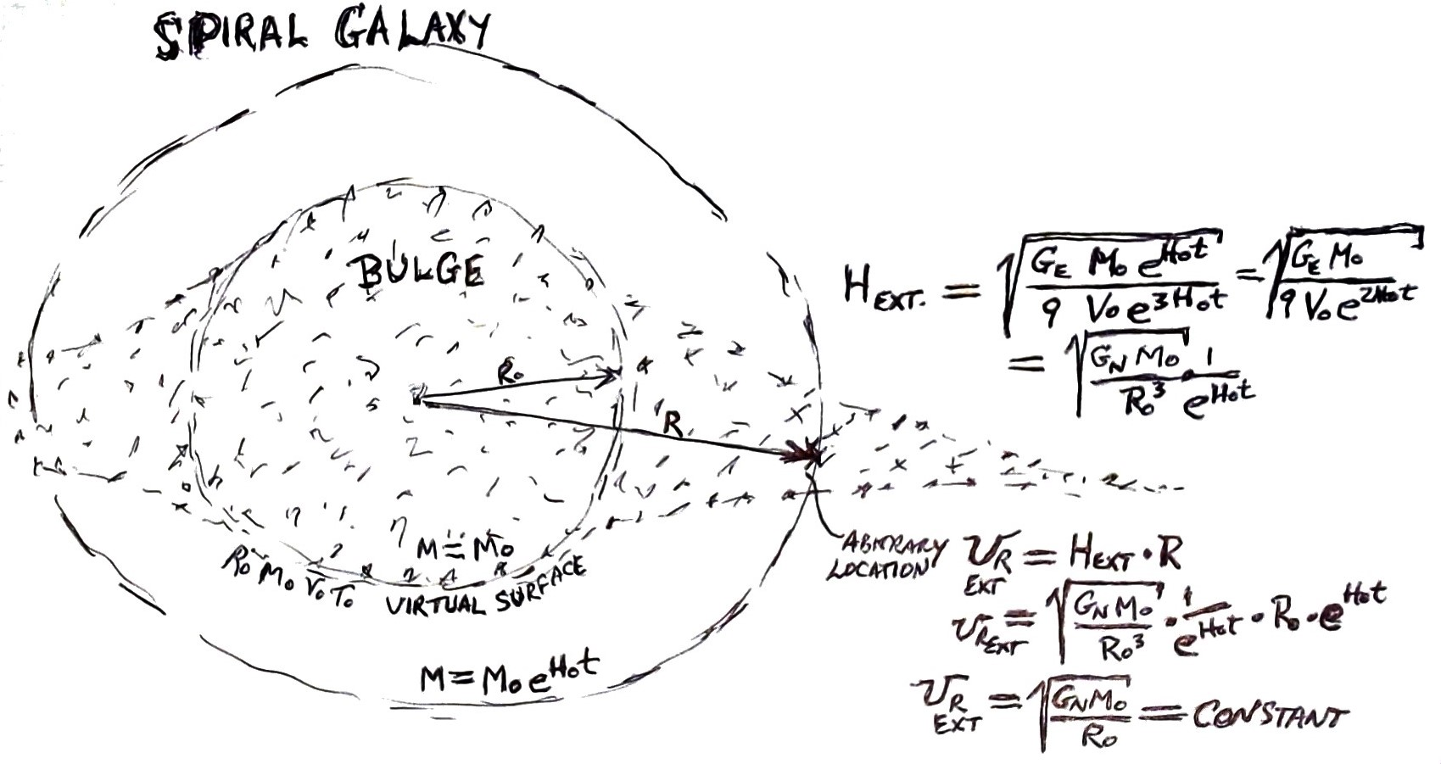

Therefore, the three major embodiments of exponential expansion explain how the XPXP theory is superior to the standard model. It requires no deviation from the theory, such as a creation of a mythical dark matter and dark energy.

