May 17, 2022

How to use the CamPro body camera

While in the performance of our duties as security officers there are times, we need to collect evidence. The best way to collect evidence is by using video. Video gives the review party rather it be the client or a jury a first hand of what happened. Body cameras are in place to protect the officer against wrong doing. We need to wear them and have them ready to record. The cameras do not need to be recording the whole entire shift; however, they should be turned on when the store opens. The camera’s have an approximate battery life between 11-12 hours. When the officer goes on there break, they should place the camera into the charging dock. This will hopefully allow the camera to last the whole time the store is open. The following describes who to use the CamPro camera.

This is the front of the camera. On the front you have the camera, a light and an inferred light.

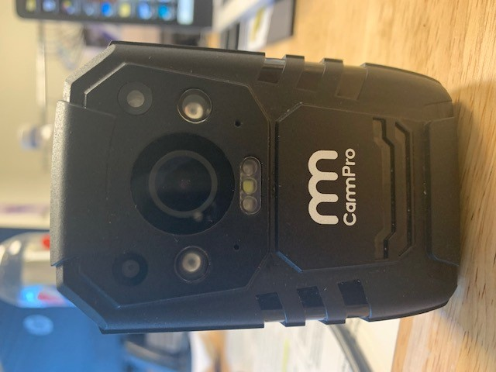

This is the back of the camera which is your display. It displays your battery life, storage compacity resolution and the date and time.

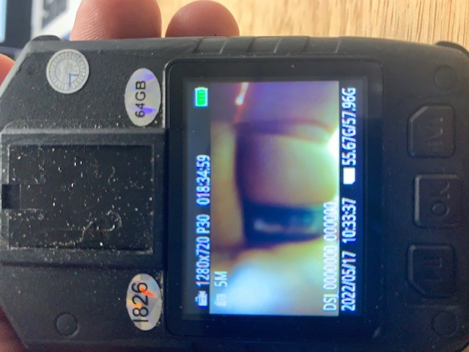

This is the left side of the unit. On this site you have you download ports.

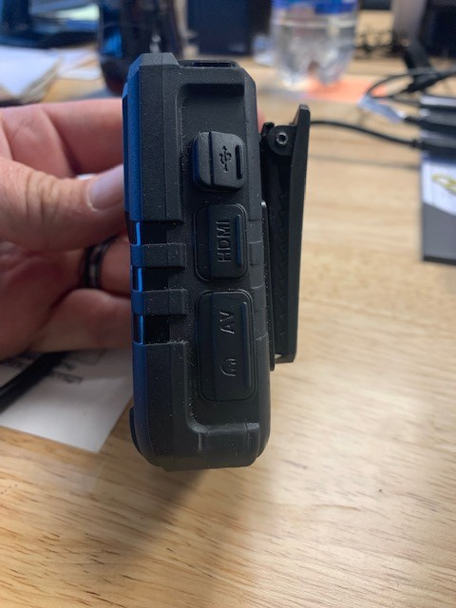

This is the right side of the camera. This is the side with record, picture, mute and bookmark.

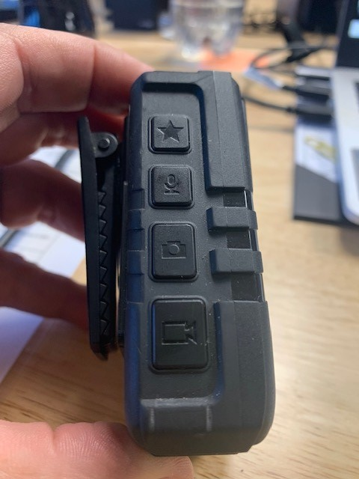

Bookmark button

Mute button

Picture button

Record button

* Bookmark button mark and locks video and pictures from being deleted
* Mute button allows you to continue to record but without sound
* Picture button allows you to take pictures
* Record button begins and stops the recording.

This is the top of the body camera. On the top of the camera, you have your light switch and your power button along with indicator lights

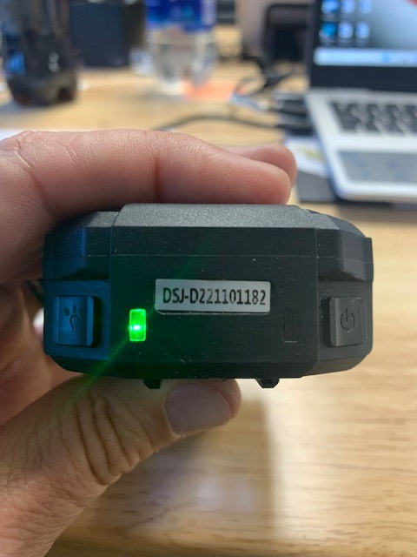

On indicator is green

Recording indicator is red

Charging or error indicator light

Power switch

Light switch

Operating the camera

* Place the camera on you person which will give the best view
* Once on your person, using your left hand grip the camera.
* With your left index finger, press and hold the power button until you hear the chime sound and feel the camera vibrate.
  + Look down to visually check for the green indicator light is on
* Your camera is now on. The camera is the same as a computer, it has a screen / power saver. After about a minute the camara will go into stand-by mode.
* Recording: with you left hand reach under the camera and feel for the record button. Give the button two presses.
  + You will feel the camera vibrate. If you want look down and verify the red light is on.
* To stop the recording press the record button again. If you have been recording for a duration you will have to double press the record button
* Taking photos with the camera. The photo button is the second button up on the left side. When you press the button, you will hear a shutter sound. Keep in mind if you take a picture the other person is going to hear it.
* Mute button is use ONLY for two officers talking about the incident and discussing how they are going to handle it.
* Bookmark Button will be used when an incident happens and documentation is needed. (fighting, threats, thefts, etc..)
* Turning off the body camera, just like turning it on your going to go in reverse. Use your left index finger and press the power button until the camera chimes. Look down and make sure there are no indicator lights.
* Place the camera in the charging port.