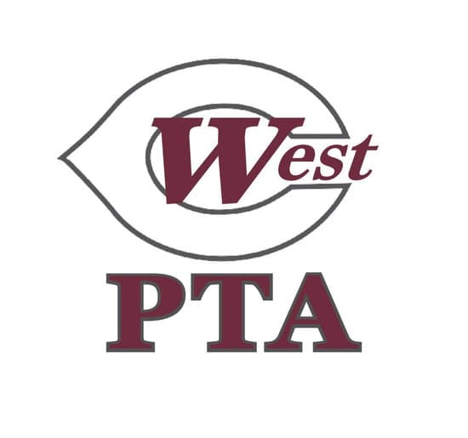

WCMS PTA General Membership Meeting Minutes
August 24, 2026, 5pm WCMS Library

Call to Order: 5:02 pm, quorum established

Principal’s Welcome: Mrs. Shaw welcomed and thanked everyone for a great turnout to the meeting
- School year off to a good start
- A few glitches noticed as school adjusts to block schedule but school is working through them
- Students seem happy and are adjusting well
- Open door policy- please feel free to reach out if you need anything

President’s Report: Angela welcomed everyone to the meeting and curriculum night
- Membership update- 400 members is this year’s goal
  - Membership helps fund events like conference night dinners for teachers and used for students and teachers all year
  - 266 members currently
  - 9/18 is date to meet goal to qualify for incentives, register by student’s lunch class
- Sponsorship updated- $6500 at the current time
  - Reach out to Myra if you or anyone you know is interested in becoming a sponsor
  - Deadline for sponsors to be included on banner is 9/9
- West Fest 9/24- Thursday this year
  - Will reach out to parents via givebacks for volunteers at West Fest
  - Rain date 9/28- Monday
- Parent/Teacher Conferences scheduled for 9/10

Approval of Minutes: Minutes posted to website from April meeting
- No changes received
- No discussion
- Voice vote held
- All approved
- Minutes approved as previously posted

Treasurer’s Report: Jana Manlove introduced herself as new treasurer
- Bank balance is currently $21,899.94
- Most money coming from sponsorships and memberships
- All money given goes back to school, teachers, and students

New Business:
- Vote on 26-27 Budget: Proposed budget email out prior to meeting and provided with agenda at meeting
  - Motion made by Angela Brunson to approve budget as provided
  - No second needed as budget already approved by budget committee and WCMS PTA BOM
  - No discussion
  - Voice vote held
  - All approved
  - Budget approved as presented
- West Fest- Rebecca Coleman introduced herself
  - Explained West Fest event and fundraising
  - Will kick off right after Labor Day
  - Free donut to everyone that registers
  - More incentives will be sent out after kickoff
  - Look to parent square for more details

Meet the WCMS Counselors: Counselors introduced themselves and explained role of counselors at the middle school level
- Mrs. Grammer (6th-8th grade students)
- Mr. Alford (8th grade counselor)
- Mrs. Reich (7th grade counselor)
- new counselor Mrs. Cleaves coming in September
- Will get a flyer and needs assessment with info about counselors via Parent Square soon
- Happy birthday to Mrs. Grammer whose birthday is today!

Adjourn: 5:24 pm

WCMS PTA 26-27 Budget Proposal Document
 | 26-27 Budget | 25-26 Actual
INCOME
Balance Forward | $13,987.37 | $12,377.55
Memberships | $5,000.00 | $5,060.00
WestFest Fundraiser | $30,000.00 | $28,208.59
PTA Sponsorship | $9,250.00 | $9,750.00
Kroger Rebates | $1,000.00 | $1,009.12
Other | $150.00 | $663.31
TOTAL INCOME | $45,400.00 | $44,691.02
EXPENSES | Budget
Communications  - Go Daddy Website Hosting & Domain July-Jun | $340.00 | $330.55
Cultural Arts  - Reflection Art Contest Awards  - Reflections Award Ceremony Refreshments | $250.00 | $191.18
Explore Culture  -Explore Culture Night  - Bulletin Board Supplies | $300.00 | $253.28
Hospitality: Family and Teacher Engagement  - Back to School Breakfast  - WestFest Food and Drink for volunteers  - Teacher Appreciation Week | $7,100.00 | $6,373.95
Bus Driver/Crossing Guard Appreciation | $300.00 | $207.09
Teacher & Staff Appreciation  - Sept/Feb Conf Night Dinners  - Quarterly Bday Treats | $4,500.00 | $2,942.51
Student Engagement  - Recess Days  - Open House/Literacy Night  - Field Days | $7,000.00 | $6,766.40
Family Engagement  - Veteran's Day  - Open House/Literacy Night  - Glow Run | $500.00 | $157.58
Membership  - Membership incentives | $500.00 | $415.03
WestFest Campaign  -WestFest event, incentives, prizes, publicity | $7,000 | $7,353.14
Beautification  - Supplies for Outdoor Club to water, plant flowerbeds and flower pots  - Refresh wreaths and holiday deccorations | $200.00 | $184.28
Health Room  - Health Room Supplies | $250.00 | $159.63
Sponsorship  -Sponsor Banner | $400.00 | $388.29
Administration  - BOM T-Shirts, Name Tags  - Office Supplies/Organizational Supplies  - Personalized WCMS PTA items | $965.00 | $854.92
Printing | $500.00 | $211.30
Life Achievment Award  - 2 Award Certificates with pins  - Frames for award presentation | $315.00 | $313.96
Insurance | $450.00 | $450.00
2027 Start Up | $5,000.00 | $5,000.00
State/National/Local/Fees  - 400 members * 4.50 (400 x $5.50 in 2026-2027) | $2,200.00 | $1,670.50
Training/Meetings  -TN PTA State Conference/ National PTA  Conference  - TN PTA Conference 2024 pricing $100/person  - National PTA Conference 2024 pricing $75/person  - May Volunteer/BOM appreciation/crossover mtg | $500.00 | $28.24
General School Support  - Spirit Items for all students  - TCAP Snacks  - Dragon Games Snack donation  - August and January Welcome Back Treats  - Approved virtual/in person speakers  - Teacher Scholarships | $6,830.00 | $3,555.64
TOTAL EXPENSES | $45,400.00 | $37,807.47

