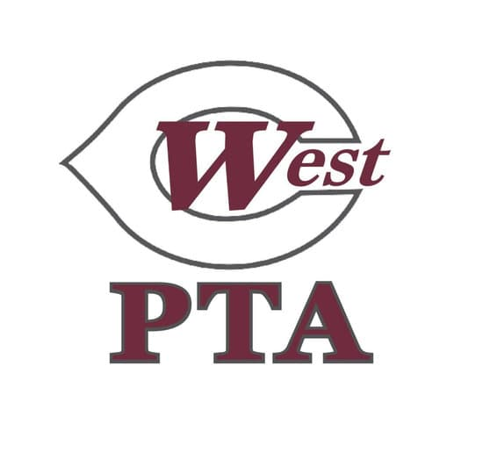
WCMS PTA General Membership Meeting Minutes
April 14, 2026, 5:30pm at WCMS

Call to Order: 5:31pm, quorum of 15 members established

President’s Report: Welcome, Thank you for coming, Susan thanked everyone for allowing her to serve, Susan gave a recap of PTA’s year including WestFest- raised over $28,000, were able to purchased new mascot, pep rally to present to students, treated teachers and staff with monthly treat days, also provided teachers with conference dinners, TAW coming up in May, treated students with rally towel, snacks at recess days, TCAP snacks coming up, will provide sno-cones on field days, huge thank you to current board and parent volunteers for sending in treats, volunteering, and/or contributing to WestFest. THANK YOU!

Reading/Approval of Minutes: No changes received, Minutes approved as posted

Treasurer’s Report: report provided with agenda, let Susan or Jennifer know if you have any questions

Old Business:
-Budget Vote:
  - Susan proposed reserving $1,500 of carryover for 2026 Welcome Back Breakfast
  - Move $70 from Administration to Bank Fees to increase bank fees to $160, slightly over original budget due to international banking fees for mascot, also covers two $30 stop payment fees if needed for two outstanding checks
- Motion made by Susan, Rebecca Coleman seconded, call for discussion made, no discussion, voice vote performed, motion passed unanimously

New Business:
-Vote on 25-26 Board Of Mangers: Rebecca Coleman presented proposed slate:
  - 8th VP Health and Safety: Monica Russom
  - 7th VP Cultural Arts: Lori Parker
  - Chair Explore Culture: Cristina Smith
  - 6th VP Hospitality: Lindsay Carter
  - Chair Teacher Morale: Leslie Stallings
  - Chair Student Engagement: Candace Guardado
  - Chair Family Engagement: Scott Clark
  - Chair Transportation Appreciation: Thiru Yennegiri
  - 5th VP Volunteers: Tenoria West
  - Chair Beautification: Cortney Young
  - 4th VP Communications: Amber Turner
  - Chair Website: Misty Koopman
  - Chair Newsletter: Katie Diggs
  - Chair Legislation: Rebecca Coleman
  - 3rd VP Fundraising: Alana Juelfs
  - Chair Sponsorship: Myra McCaskill Crenshaw
  - Chair Fundraising Platform: Julie Cropp
  - Chair Fundraising Incentives: Tonia Hughes
  - Chair WestFest Event Day: Ansley Kei
  - 2nd VP Membership: Latosha Askew
  - 1st VP: Rajani Narra
  - Secretary: Julie Gentry
  - Treasurer: Jana Manlove
  - President: Angela Brunson
- Call for nominations from floor made, no candidates nominated, voice vote performed, approved unanimously

Presentation of Life Achievement Award:
- Presented by Milly Mount on behalf of committee
- Coach Ray and Susan Schwartz recognized, both recipients were given a certificate, lapel pin and flowers

Adjourn: 5:44 pm

-Following PTA meeting: PTA Reflections awards presented and snacks provided, QR code on agenda to view presentation or visit website below

https://sway.cloud.microsoft/mBVP477H6EgaNOHB?ref=Link&loc=play



