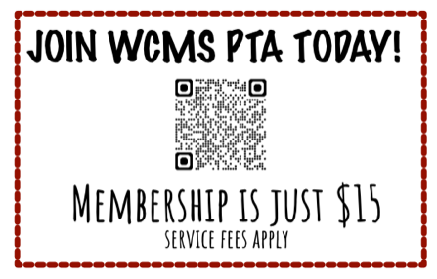
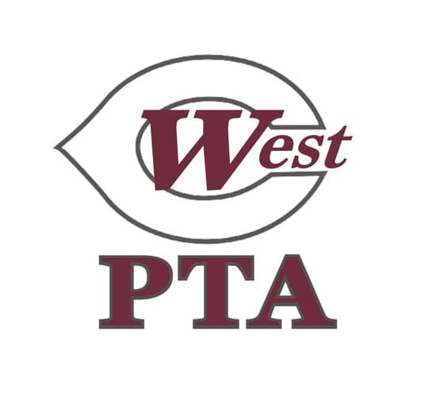
WCMS PTA General Membership Meeting Minutes
August 25, 5:00pm at WCMS

Call to Order: 5:00pm

Audit Committee Report: Millie presented audit committee findings, reviewed books from last year, all looked great, let PTA know if anyone has any questions

President’s Report: Welcome, thank you for coming, introduction of board members, please use the QR code to join PTA, money raised this year will go to several things including: dragon mascot, sponsor quarterly recess days, teacher treats, conference dinners, field days, WestFest

Reading/Approval of Minutes: minutes approved as posted

Treasurer’s Report: report provided with agenda, let Susan or Jennifer know if you have any questions

New Business:
-Vote on 2025-2026 PTA Budget: handout provided of proposed budget, reviewed big spending items, Susan made motion to approve budget as presented, Autumn Peterson seconded, opened for questions and discussion, no questions, approved unanimously

-WestFest: Explanation of WestFest fundraiser and day of event, this year’s goal is $25,000, reviewed incentives (see flyer attached to agenda), more information will be coming out soon

- Membership Drive: drive going on now, please join if you have not joined yet, no time commitment, membership supports WCMS, TN and National PTA, class incentives for classes with most members

Adjourn: 5:10 pm

-Following PTA meeting: WCMS Counselors introduced themselves and discussed their roles and services provided to students and families



