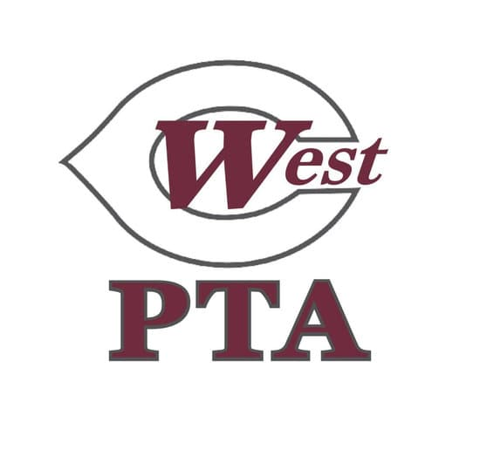
WCMS PTA General Membership
Meeting Minutes
October 21, 5:30pm via Teams

Call to Order: 5:38pm, quorum established (see attendance record listed below)

Reading/Approval of Minutes: August GB Meeting minutes approved as posted

New Business:
- WestFest Update: Originally set goal at $25,000 for WestFest, went above goal by $3,204. Due to increase in prices and tariffs, cost for the mascot has increased from original quote that was presented in August.
- Motion Presented: Susan motioned to increase the mascot budget from $8,000 to $10,274 to cover the increase in costs for the mascot and to increase the Student Engagement budget from $7,000 to $7,435 to cover the increase of costs for recess and field days.
  - Call for questions and discussion: none
  - Voice vote: All approved, motion passed

Adjourned: 5:42pm

Members on Teams:
Jennifer Brown, Angela Brunson, Scott Clark, Rebecca Coleman, Julie Gentry, Kimberly Hicks, Misty Koopman, Kimberly McNutt, Carly McWatters, Milly Mount, Amy Paul, Autumn Peterson, Ashleigh Pickering, Monica Russom, Brent Schwartz, Susan Schwartz, Jala Walker

