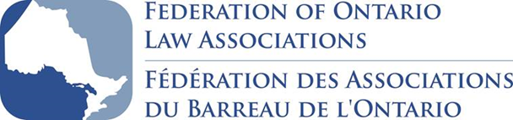

PAST FOLA CHAIRS

Willson McTavish 1980 – 1982
Colin McKinnon * 1982 – 1984
Douglas Thoman 1984 – 1986
Lloyd Brennan * 1986 – 1988
Nancy Mossip * 1988 – 1990
Michael O’Dea† 1990 – 1992
David Lovell 1992 – 1994
Harrison Arrell * 1994 – 1996
Richard Gates * 1996 – 1998
Johanne Morissette * 1998 – 2000
Lawrence Eustace 2000 – 2002
David Sherman 2002 – 2004
W. Ormond Murphy 2004 – 2006
Paul Kowalyshyn † 2006 – 2008
Randall Bocock § 2008 – 2009
Robert Zochodne 2009 – 2011
Michael Johnston 2011 – 2012
Janet Whitehead 2012 – 2014
Cheryl Siran 2014 – 2015
Eldon Horner 2015 – 2017

* Now of the Ontario Superior Court
† Now of the Ontario Court of Justice
§ Now of the Tax Court of Canada

