CONSCIOUS CONTACT
__________________________________________________________________________

A Record of Service and Sharing in Wayne County since 1983

January 2026 - A.A of DETROIT/WAYNE COUNTY  CENTRAL OFFICE 4750 Woodward Ave  Ste. 311, Detroit, MI 48201  Literature Room: 313-831-2555  Hotline: 313-831-5550  E-Mail: aadwcco@hotmail.com  Office Hours: Monday, Wednesday: 12:30 – 5:00 p.m., Friday: 10 a.m.-2:30 p.m.  Monthly Board Meetings: Third Wednesday of every month at 5:30 p.m.  General Membership Meetings: Even months, 4th Wednesday at 5:30 PM.  Board of Trustees  Chairperson: Vacant  Co-Chair: Stephen W.  Treasurer: Vacant  Secretary Vacant  Office Mgr.: Vercina H.  Hotline: Kathlene D.  Liaison: Stephanie L.  IT Specialist: Vacant  Message from the Office:  In the A.A. General Service Conference approved pamphlet “Self-Support: Where Money and Spirituality Mix”, examples of Group Contributions to A.A. Service Entities include the following.  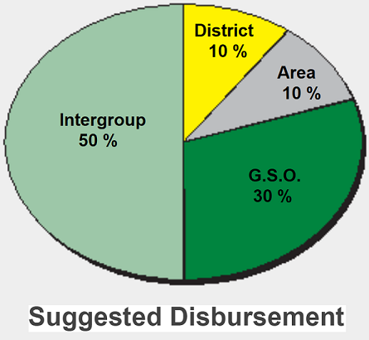 | We Are Not A Glum Lot  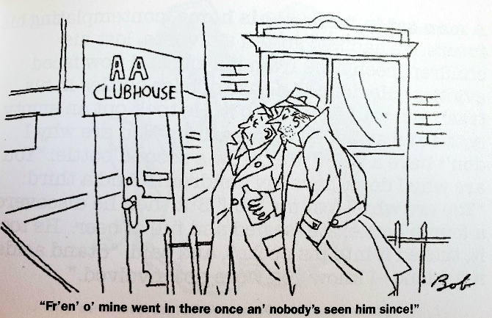    Steps Ten, Eleven, and Twelve  Step Ten: Continued to take personal inventory and when we were wrong promptly admitted it.  Step Eleven: Sought through prayer and meditation to improve our conscious contact with God as we understand him, praying only for knowledge of His will for us and the power to carry that out.  Step Twelve: Having had a spiritual awakening as the result of these steps, we tried to carry this message to other alcoholics, and to practice these principles in all our affairs.  (e.g., pp. 88-Step Ten, 96-Step Eleven, and 106-Step Twelve) Twelve Steps and Twelve Traditions. AAWS. New York, NY.  Wayne County Intergroup website:  http://www.waynecountyintergroup.org
GROUP CONTRIBUTIONS, FAITHFUL FIVERS, AND AA ANIVERSARIES - OCTOBER 25 TO DECEMBER 25
GROUP CONTRIBUTIONS |  |  | FAITHFUL FIVERS
OCTOBER |  |  | OCTOBER
Saved By Grace | $50.00 |  | Linda M. | $25.00
Cass Grand River | $100.00 |  | Harvey S. | $60.00
First Things First Livonia | $475.00
T.N.T. Group | $25.00 |  | TOTAL | $85.00
TOTAL | $650.00 |  | NOVEMBER
 |  |  | Sharon L. | $25.00
NOVEMBER |  |  | Harvey S. | $61.00
Federal Group | $100.00 |  | Linda M. | $25.00
Calvary Group | $168.00 |  | Rozell S. | $10.00
New Step One | $50.00 |  | Elizabeth K. | $25.00
Local 22 Group | $20.00
Sunday Serenity | $200.00 |  | TOTAL | $146.00
Non-Smoking Noontide | $210.00
Trumbull #1 | $50.00 |  | DECEMBER
Friendly Group | $50.00 |  | Elizabeth K. | $25.00
Belleville Keep It Simple | $200.00 |  | Fred P. | $5.00
Sunday Morning Lit. Study | $49.29 |  | Robert B. | $5.00
 |  |  | Cecil H. | $5.00
TOTAL | $1,097.29 |  | Linda M. | $25.00
 |  |  | Robert B. | $5.00
DECEMBER |  |  | Sharon L. | $20.00
Mack Alive | $25.00 |  | Deborah S. | $10.00
Mercy Group | $50.00
7:15 Samaritan | $25.00 |  | TOTAL | $100.00
New Step One | $50.00
Metropolitan Group | $50.00 |  | GRAND TOTAL - 3 MONTHS | $331.00
Thank God Let's Talk About It | $125.00
Westside Group | $200.00
Dearborn Heights Group | $100.00 |  | ANNIVERSARIES
Alive On Mack | $50.00
 |  |  | OCTOBER
TOTAL | $675.00 |  | Lewis H.
GRAND TOTAL - 3 MONTHS | $2,422.29 |  | NOVEMBER
 |  |  | Vanessa S.-36 years
 |  |  | DECEMBER
 |  |  | None

