CONSCIOUS CONTACT
__________________________________________________________________________

A Record of Service and Sharing in Wayne County since 1983

March 2026 - A.A of DETROIT/WAYNE COUNTY  CENTRAL OFFICE 4750 Woodward Ave  Ste. 311, Detroit, MI 48201  Literature Room: 313-831-2555  Hotline: 313-831-5550  E-Mail: aadwcco@hotmail.com  Office Hours: Monday, Wednesday: 12:30 – 5:00 p.m., Friday: 10 a.m.-2:30 p.m.  Monthly Board Meetings: Third Wednesday of every month at 3:00 p.m.  General Membership Meetings: Even months, 4th Wednesday at 3:00 PM.  Board of Trustees  Chairperson: Kathlene D. Office Mgr.: Vacant  Co-Chair: Stephen W. Hotline: Stephanie L.  Treasurer: Mike S. Liaison: Stephen W. Secretary Vacant IT Specialist: Mike S.  Message from the Office:  Special thanks go out to all the groups and individuals who provided financial support to the Detroit/Wayne County Intergroup Office. Please continue to make group donations, honor the Birthday Club and Faithful Fivers!  In the A.A. General Service Conference approved pamphlet “Self-Support: Where Money and Spirituality Mix”, examples of Group Contributions to A.A. Service Entities include the following.  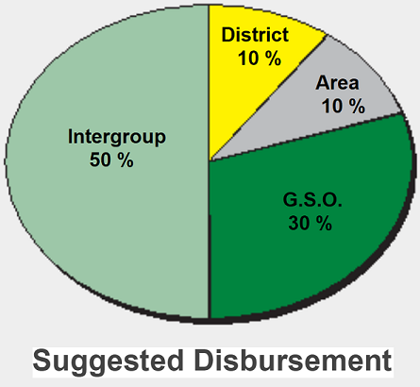 | We Are Not A Glum Lot  * A drunk goes into a bar and asks for a shot of  whiskey.  The bartender pours it and the drunk pushes it aside and asks for another shot of whiskey.  The bartender pours it and the drunk drinks it.  The bartender says, “I watched what you did and I don’t understand why you pushed the first one away and drank the second one!”  The drunk stated, “I’ve been going to those AA Meetings, and they said WHATEVER YOU DO, DON’T TAKE THAT FIRST DRINK!!!”  * A man busts into an AA meeting with a vial in hand. He yells out "I have the cure to alcoholism! All you have to do is drink this one vial and you'll be cured forever!"  Another man in the back of the room raises a hand and say’s "what happens when we drink two?"    Steps One, Two, and Three  Step One: We admitted we were powerless over alcohol and that our lives have become unmanageable.  Step Two: Came to believe that a power greater than ourselves could restore us to sanity.  Step Three: Made a decision to turn our will and our lives over to the care of God as we understand him.  Wayne County Intergroup website:  http://www.waynecountyintergroup.org
GROUP CONTRIBUTIONS, FAITHFUL FIVERS, AND AA ANIVERSARIES - JANUARY 2026 TO MARCH 2025
GROUP CONTRIBUTIONS |  |  |  | FAITHFUL FIVERS
JANUARY |  |  |  | JANUARY
Districts 2, 3, and 4 | $300.00 |  |  | Sharon L. |  | $20.00
Spring Into Action | $75.00 |  |  | Rozell S. |  | $20.00
Dearborn Woods | $100.00
New Step One | $50.00 |  |  | JAN TOTAL |  | $40.00
Acceptance Group | $950.00
The Wagon Years | $100.00 |  |  | FEBRUARY
The Next Right Thing | $160.00 |  |  | Sharon L. |  | $20.00
H.O.W. | $31.23 |  |  | Rozell S. |  | $5.00
Crazy But Still Sober | $29.19 |  |  | Gilbert H. |  | $60.00
JAN TOTAL | $1,795.42 |  |  | FEB TOTAL |  | $85.00
FEBRUARY |  |  |  | MARCH
Turning Pointe | $77.00 |  |  | Sharon L. |  | $20.00
Calvary Group | $168.00 |  |  | James T. |  | $5.00
New Hamburg | $50.00 |  |  | Nate C. |  | $60.00
Sunday Morning Lit. Study | $32.10 |  |  | Gregory C. |  | $30.00
New Step One | $50.00
Non-Smoking Noontide | $200.00 |  |  | MAR TOTAL |  | $115.00
St. Mary's Group | $110.85
Friendly Group | $150.00 |  |  | TOTAL |  | $240.00
St. Rita Group | $250.00
FEB TOTAL | $1,087.95 |  |  | ANNIVERSARIES
MARCH |  |  |  | JANUARY
Garage Group | $25.00 |  |  | None
Joys of Recovery | $49.65
Thank God, Let's Talk About It | $133.00 |  |  | FEBRUARY
New Hamburg | $50.00 |  |  | Anthony B. |  | 27 yrs.
Ford Group | $100.00 |  |  | Rozell B. |  | 49 yrs.
Spring Into Action | $75.00 |  |  | Gilbert H. |  | 44 yrs.
New Step One | $50.00
 |  |  |  | MARCH
MAR TOTAL | $482.65 |  |  | Jeff T. |  | 30 yrs.
 |  |  |  | Nate C. |  | 40 yrs.
TOTAL | $3,366.02

