CONSCIOUS CONTACT
__________________________________________________________________________

A Record of Service and Sharing in Wayne County since 1983

October 2026 - A.A of DETROIT/WAYNE COUNTY  CENTRAL OFFICE 4750 Woodward Ave  Ste. 311, Detroit, MI 48201  Literature Room: 313-831-2555  Hotline: 313-831-5550  E-Mail: aadwcco@hotmail.com  Office Hours:  Monday, Wednesday: 12:00 PM - 5:00 PM  Friday: 10:00 AM - 2:30 PM  Monthly Board Meetings: Third Wednesday of every month at 3:00 PM.  General Membership Meetings: Even months, 4th Wednesday at 3:00 PM.  Board of Trustees  Chairperson: Kathlene D. Office Mgr.: Vacant  Co-Chair: Stephen W. Hotline: Stephanie L.  Treasurer: Mike S. Liaison: Stephen W.  Secretary: Vacant IT Specialist: Mike S.  Message from the Office:  Special thanks go out to all the groups and individuals who provided financial support to the Detroit/Wayne County Intergroup Office. Please continue to make group donations, honor the Birthday Club and Faithful Fivers!  In the A.A. General Service Conference approved pamphlet “Self-Support: Where Money and Spirituality Mix,” examples of Group Contributions to A.A. Service Entities include the following.  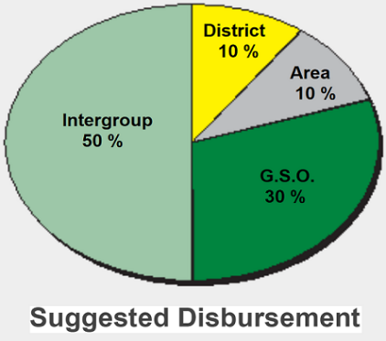 | Founders Corner  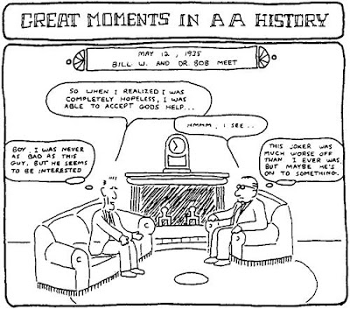  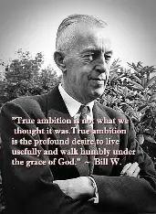  Steps Seven, Eight, and Nine  Step Seven: Humbly asked him to remove our shortcomings.  Step Eight: Made a list of all persons we had harmed and became entirely ready to make amends to them all.  Step Nine: Made direct amends to such people wherever possible, except when to do so would injure them or others.  Wayne County Intergroup Website  http://www.waynecountyintergroup.org  In Memoriam  Bobby Kennedy: 02/19/1953 to 08/02/2026
GROUP DONATIONS, ANNIVERSARIES AND FAITHFUL FIVERS FOR JULY, AUGUST, AND SEPTEMBER 2026
GROUP CONTRIBUTIONS |  |  | FAITHFUL FIVERS/PERS. DONATIONS
JULY |  |  | JULY
 |  |  | Sharon L. | $20.00
Metropolitan Group | $100.00 |  | Rozell S. | $10.00
Foxhall Book Study | $446.01 |  | Elizabeth K. | $50.00
New Hamburg | $50.00 |  | Linda M. | $30.00
Trenton Morning | $12.00 |  | Freddie J. | $20.00
Sunday Step Discussion | $100.00 |  | July Total | $130.00
The Garage Group | $25.00
Friendly Group | $40.00 |  | AUGUST
Trumbull #1 | $100.00 |  | Elizabeth K. | $50.00
Federal Group | $100.00 |  | Linda M. | $30.00
July Total | $973.01 |  | Rozell S | $10.00
 |  |  | Sharon L. | $20.00
AUGUST |  |  | John B. | $18.30
 |  |  | Adolphus H. | $72.00
Chapel Group | $50.00 |  | James T. | $5.00
New Hamburg | $50.00 |  | August Total | $205.30
Acceptance Group | $380.00
Westside Group | $120.00 |  | SEPTEMBER
Sunday Morning Lit. Study | $13.20 |  | James T. | $5.00
August Total | $613.20 |  | Linda M. | $30.00
 |  |  | Elizabeth K. | $50.00
SEPTEMBER |  |  | Jim W. | $50.00
 |  |  | Sharon L. | $20.00
Language of the Heart | $100.00 |  | Rozell S. | $10.00
First Things First | $500.00 |  | September Total | $165.00
Belleville Keeping it Simple | $200.00
Thank God (L.T.A.I.) | $265.25 |  | Three Month Total | $500.30
Trumbull #1 | $400.00
SEPTEMBER | $1,465.25
 |  |  | ANNIVERSARIES
Three Month Total | $3,051.46 |  | JULY
 |  |  | Joyce H. | 27 Years
 |  |  | Johnny P. | 30 Years
 |  |  | Freddie J. | 31 Years
 |  |  | AUGUST
 |  |  | Mike S. | 37 Years
 |  |  | SEPTEMBER
 |  |  | James T. | 38 Years
 |  |  | Pete B. | 57 Years

