A.C.T.I.O.N Coalition

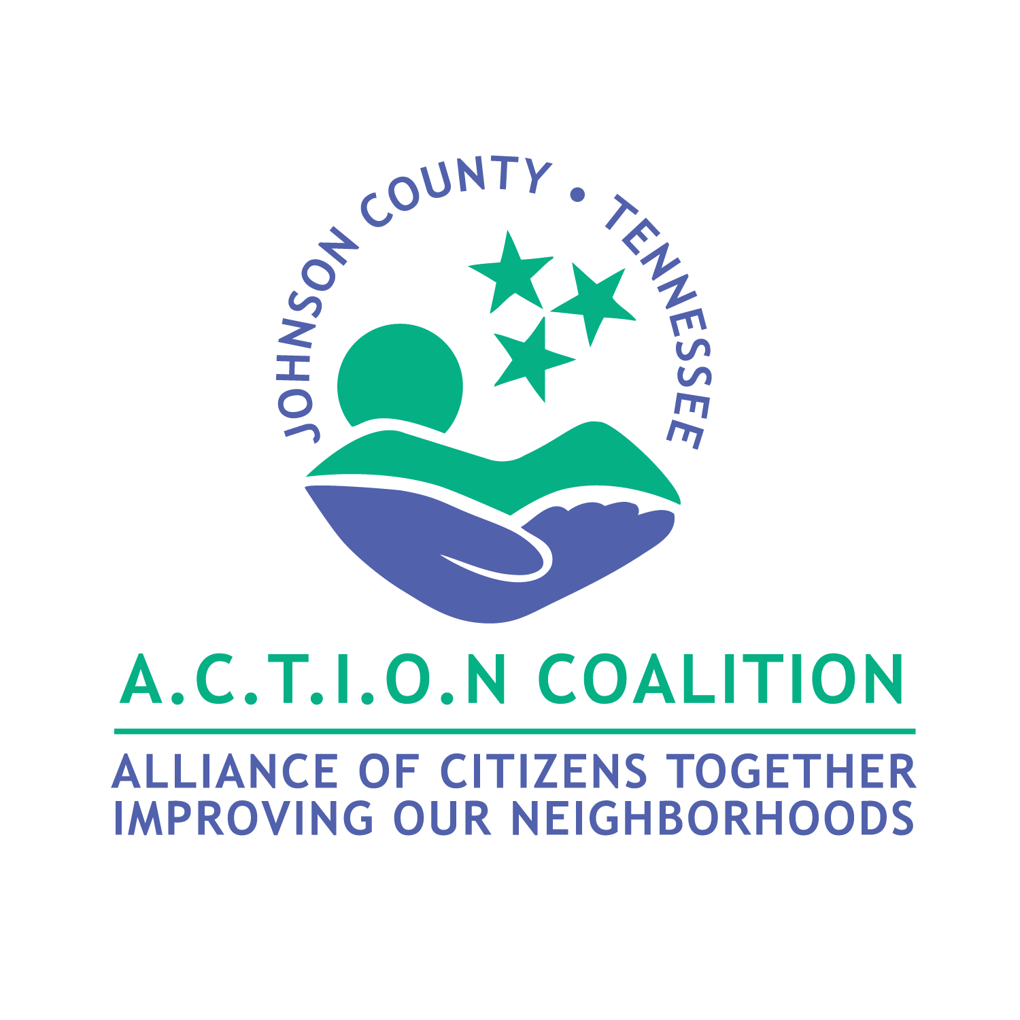

Membership Packet

Welcome

Thank you so much for your interest in the A.C.T.I.O.N Coalition. We are excited to have you as a member and we are grateful that you have made the decision to contribute to your community through coalition collaboration. Together we can effectively implement policy, practice, and procedure changes to prevent alcohol, tobacco, and other substance use in Johnson County.
Enclosed in your membership packet you will find the information you will need to better understand the efforts of the A.C.T.I.O.N Coalition. If you have any further questions, please feel free to contact our office at 423-727-0780.

Table of Contents
- Welcome Letter & Table of Contents
- A.C.T.I.O.N Coalition Membership Application
- Mission & Vision Statement
- Sector Rep Information
- Staff & Board Member Information
- Frequently Asked Questions
- Brochures & Booklets

Johnson County A.C.T.I.O.N Coalition
Membership Application Form
Name: ________________________________________________________________________
Phone: _______________________________________________________________________
Email: ________________________________________________________________________
Occupation:____________________________________________________________________
County of Residence: ____________________________________________________________
Reason for participation in coalition: ________________________________________________

Thank you so much for your interest in joining the A.C.T.I.O.N Coalition. Please take some time to answer the following questions so that we may get to know you and tailor this partnership to be mutually beneficial:

*Which sector do you belong to?
__Youth __Government
__Parent __School
__Business __Youth Serving Organization
__Law Enforcement __Religious
__Healthcare Professional __Civic Volunteer Group
__Media __Other: Specify ___________

*Which task force are you most interested in? (Check all that apply)
__Alcohol Task Force
__Tobacco Task Force
__Drug Task Force i.e., Marijuana, Heroine, Opioids

*Intended Level of Involvement/Commitment? (Check all that apply)
__Actively involved in a task force
__Attend monthly meetings
__Provide support and resources

*Are you interested in Volunteer Opportunities?
__Yes
__No

*What resources will you bring to the table? (examples…I.T. experience, ability to speak in groups, organizational skills, planning skills)__________________________________________

*I would like to become a member of the A.C.T.I.O.N Coalition. I understand that I will receive notices of upcoming meetings, events, training opportunities and news alerts. I also understand that I need to complete the Title VI training annually, provided for free, by coalition staff.

______________________________________________________________________________
Name Date
Johnson County A.C.T.I.O.N Coalition Members

Members of the Coalition will develop and implement plans to accomplish the mission of the Coalition. This team will identify, promote, and coordinate community-based programs that encourage healthy lifestyles for all Johnson County residents.

Specific Responsibilities to include but not limited to:
- Attend Coalition meetings
- Serve as a member of a task force and/or team if possible
- Assist Coalition staff in the identification, selection, and promotion of innovative healthy lifestyle activities
- Community needs assessments and identify existing resources
- Develop plans of action to carry out the mission
- Strive to coordinate programs and resources to maximize impact
- Assist in developing ways to evaluate and monitor strategies

Time Commitment:
- One-year terms (no limit on # of terms)
- Six to twelve Coalition meetings per year
- Task force/team meetings as needed

Personal Qualities:
- Commitment to improving the health of Johnson County residents
- Knowledge of the Johnson County area and its people
- Broad perspective in identifying and planning programs
- Enthusiasm
- Resourcefulness

Serving as a member of the Coalition will provide you with the opportunities to:
- Broaden your knowledge
- Gain new experiences and skills
- Increase communication skills
- Work with other community professionals

VISION STATEMENT

Uniting our community toward the VISION of a healthy, happy, drug free Johnson County

OUR MISSION

To EMPOWER through education all members of our community to make the best choices for their lives through understanding of the dangers of substance misuse.

To ENCOURAGE those in need of recovery to seek treatment.

To ENGAGE those in our recovery community as a valued asset to their families, community, and the economy of Johnson County.

To bring together community and regional stakeholders to strengthen our community.
Program Goals

Prevention
*To increase the age of first drug/alcohol use from 13 to 15.
*Reduce the frequency of binge drinking in teenagers.
*Increase the percentage of students & parents interacting.
*Provide education opportunities about effects of trauma and Adverse Childhood Experiences on substance use, suicide & mental health.
*Reduce stigma by gaining a better community-wide understanding of addiction as a disease.
*Classes for adults & students alike that will work toward a Trauma Aware Community and a significant reduction in youth vaping, alcohol, and marijuana use, to decrease the onset of substance use.
Treatment
*Increase the percentage of persons who seek treatment.
*Working with community & regional partners to make access to care & treatment more available & affordable & encourage those needing assistance by reducing those barriers.
Recovery
*Increase the percentage of community members in long-term recovery.
*Engage those in recovery to create a peer network for those struggling with Substance Use Disorder.
*Support efforts to become productive, active members of our community through education and job resources.
AARRC
The A.C.T.I.O.N Addiction Recovery Resource Center is to
help those in our community find and utilize the resources
needed for treatment and recovery options.
Information and resources can be found on website:
actioncoalition.org/aarrc
A.C.T.I.O.N Coalition Sector Representatives

Sector: Faith
Name: Andrew Norman
Organization: Johnson County Ministerial Alliance
Phone: 423-741-1962
Email: andrewnorman.fccmc@gmail.com
Position: President

Sector: Business
Name: Kim Pope
Organization: State Farm Insurance
Phone: 423-512-2179
Email: kim.pope.pocc@statefarm.com
Position: Business Owner

Sector: Civic/Volunteer
Name: Linda Moon
Organization:
Phone: 423-726-4944
Email: y2lmoon@aol.com
Position: Volunteer

Sector: Education
Name: Paula Stewart
Organization: Johnson County School System
Phone: 423-291-9861
Email: pstewart@jocoed.net
Position: Elementary School Counselor

Sector: Healthcare
Name: Sheila Cooke
Organization: Mountain City Extended Hours Health Clinic
Phone: 423-727-1160
Email: cookes@mail.etsu.edu
Position: MCEHHC Center Manager

Sector: Government
Name: Freida Gwinn
Organization: Johnson County Courthouse
Phone: 423-291-3159
Email: freidadugger72@hotmail.com
Position: Register of Deeds / Circuit Court Clerk

Sector: Mental Health
Name: Debbie Eisenhower
Organization: Frontier Health
Phone: 423-727-2100
Email: deisenho@frontierhealth.org
Position: Clinical Child & Youth Therapist

Sector: Law Enforcement
Name: Bronson Miller
Organization: Johnson County Sheriff’s Department
Phone: 423-895-1937
Email: bm@johnsoncountysd.org
Position: Jail Administration

Sector: Recovery Community
Name: Buffy Cornett
Organization:
Phone: 423-445-0087
Email: buffy.cornett@gmail.com
Position: Retail Service, NA Coordinator

Sector: Media
Name: Rick Wallace
Organization: The Tomahawk
Phone: 423-727-6121
Email: adsales@thetomahawk.com
Position: Ads Manager

Sector: Youth Serving
Name: Flo Bellamy
Organization: Mountain City Community Center
Phone: 423-727-2942
Email:
Position: Community Center Coordinator

Sector: Parent
Name: Tricia Morefield
Organization: Johnson County Sheriff’s Dept
Phone: 423-491-9654
Email: r.yan02@yahoo.com
Position: Office Administrator

A.C.T.I.O.N Coalition Board Members

Name: Andrew Norman Name: Buffy Cornett
Position: Chairperson Position: Member
Phone: 423-741-1962 Phone: 423-445-0087
Email: andrewnorman.fccmc@gmail.com Email: buffy.cornett@gmail.com

Name: Paula Stewart Name: Freida Gwinn
Position: Co-Chairperson Position: Member
Phone: 423-291-9861 Phone: 423-291-3159
Email: pstewart@jocoed.net Email: freidadugger72@hotmail.com

Name: Debbie Eisenhower Name: Linda Moon
Position: Secretary Position: Member
Phone: 423-727-2100 Phone: 423-726-4944
Email: deisenho@frontierhealth.org Email: y2lmoon@aol.com

Name: Kim Pope Name: Sheila Cooke
Position: Treasurer Position: Member
Phone: 423-512-2179 Phone: 423-727-1160
Email: kim.pope.pocc@statefarm.com Email: cookes@mail.etsu.edu

A.C.T.I.O.N Coalition Staff

Name: Trish Burchette
Position: Executive Director
Phone: 423-534-1407
Email: tburchette@actioncoalition.org

Name: Kandas Motsinger
Position: Program Coordinator
Phone: 423-440-0813
Email: kmotsinger@actioncoalition.org

Name: Maggie Hart
Position: Program Coordinator
Phone: 423-440-5101
Email: actioncoalition@outlook.com

Frequently Asked Questions

- What is the A.C.T.I.O.N Coalition?
We are a 501(c)3 non-profit organization lead by community members and staff, from 12 different sectors of the community, who are dedicated to preventing alcohol, tobacco, and drug use in Johnson County. We are an accredited member and graduate organization of the Community Anti-Drug Coalition of America, funded through the TN. Dept of Health & Human Services, Substance Abuse & Mental Health Services, HHS TDMHSAS.

- Who can join the A.C.T.I.O.N Coalition?
Any Johnson County resident interested in alcohol, tobacco or other drug prevention is encouraged and welcome to join the coalition. The coalition encourages multi-agency collaboration. Regional organization representatives & other organizations with similar goals & vision.

- How often does the A.C.T.I.O.N Coalition meet?
The membership meetings are held every other month (Odd numbered months) on the third Tuesday of the month. Our A.C.T.I.O.N Community meetings are held on the third Tuesday evening of every other month (Even numbered months). Executive Committee meetings are held on the second Tuesday of every month. All meetings are open to the public.

- Who is the fiscal agent for the A.C.T.I.O.N Coalition?
Johnson County Safe Haven

- Where is the A.C.T.I.O.N Coalition located?
138 East Main Street, Mountain City TN 37683

- Why is the coalition important to Johnson County?
We are the face of substance use prevention, treatment & recovery in our community.

- What are the benefits of a local coalition?
Coalitions can help tap the resources available in your community and help extend the reach of your own resources by making them available to new audiences. Coalitions can help you better understand critical prevention topics, help build prevention processes and provide an inside look at prevention settings.

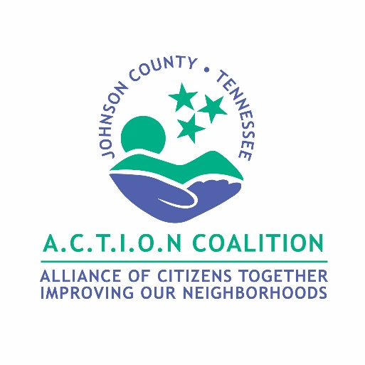
Thank You for your interest in becoming a member of A.C.T.I.O.N Coalition!

