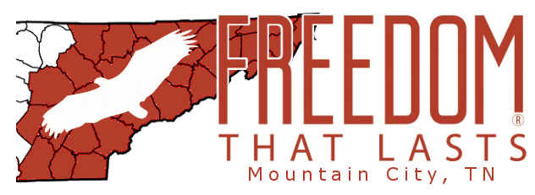 | A Ministry of Mountain City Baptist Church

Announces: Operation Love Thy Neighbor
Kick-off Date: Monday March 23, 2020
The Corona Virus is impacting everyone in one way or another. Those most affected are the elderly and shut-ins. Praying for them is a great thing, but sometimes God wants us to put “feet to our prayers.” Operation Love Thy Neighbor is a way we all can help each other!
The plan: Put together “care packages” for the elderly and shut-ins.
What’s in a care package? A care package is a box that contains non-perishable essentials:
- A roll or two of toilet paper
- A bottle of hand sanitizer
- Ramen noodles
- Canned goods
- Easy-to-make boxed foods (like mac and cheese)
- A book to read, puzzle books
- Anything you can spare as long as it is non-perishable
How big is a care package? A care package should be a single box small enough for one person (especially an elderly person) to carry by themself.
How can I help?
- You can donate items for the boxes.
- You can donate empty boxes for us to fill.
- You can e-mail us with names and contact info of people in the Mountain City, TN area that you know could use this kind of help. E-Mail: FtlMtnCity@outlook.com
When and where can I help/donate: Starting March 23rd bring boxes and donations to
Mountain City Baptist Church 936 N. Church St.
Mountain City, TN 37683
Drop-offs are on Monday, Wednesday or Friday from 5:00 – 6:00 PM (Starting March 23)
Questions? Call 423.302.0360
Or E-mail: FtlMtcCity@outlook.com

