**CONDO OFFICE – Ontario Condominium Living – There is not responsibility or liability for errors or omissions.**

**JUNE 2017**

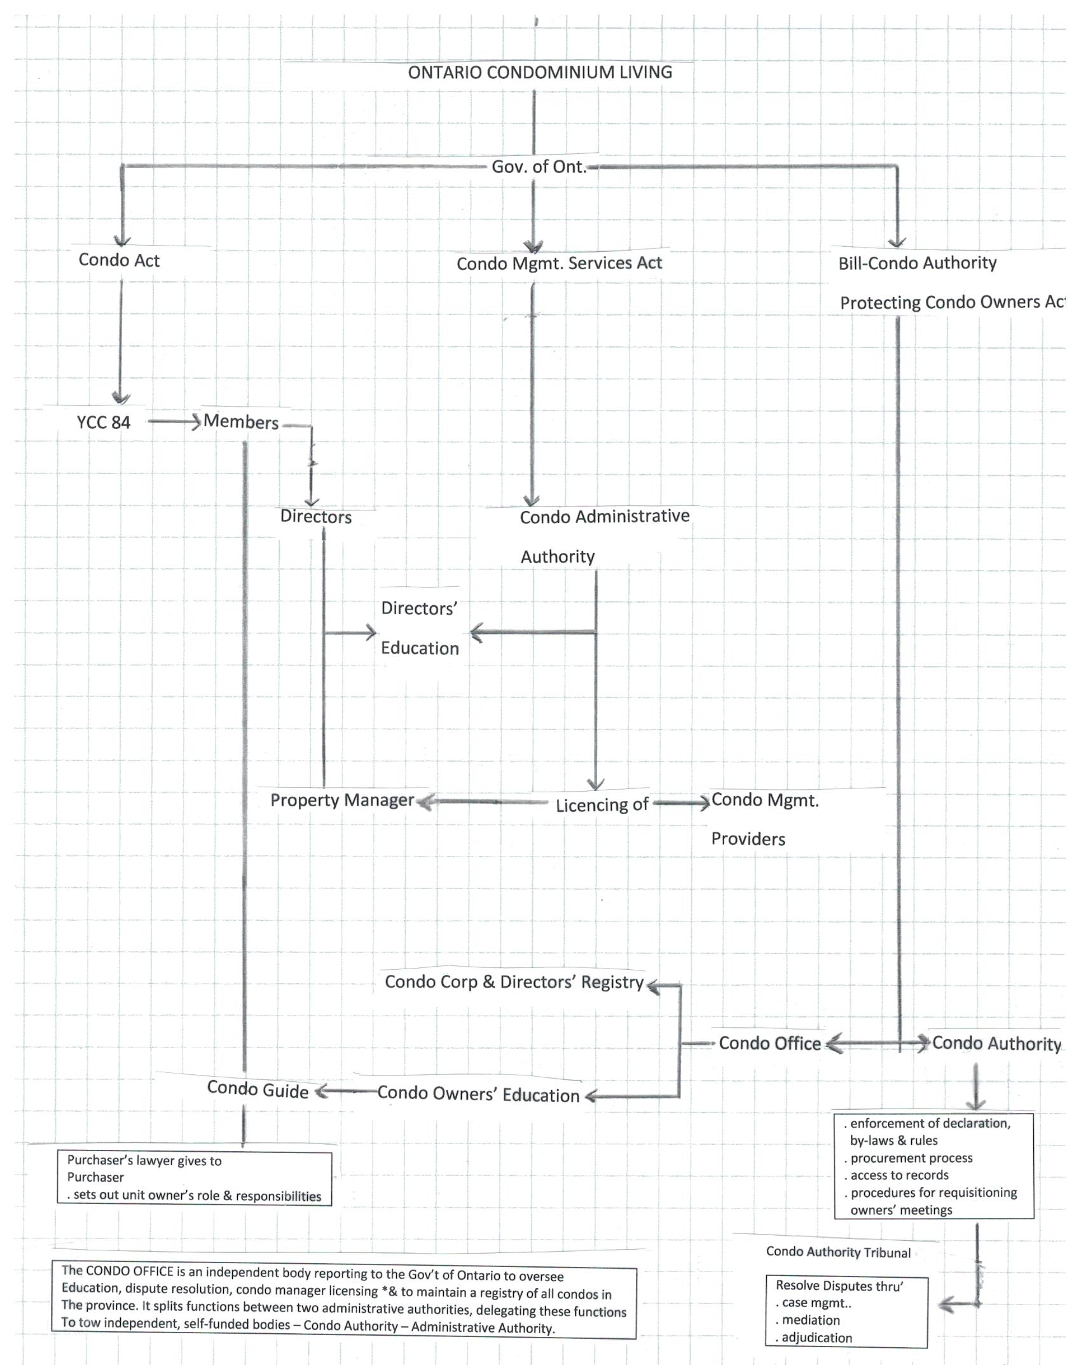

**Condo Office** 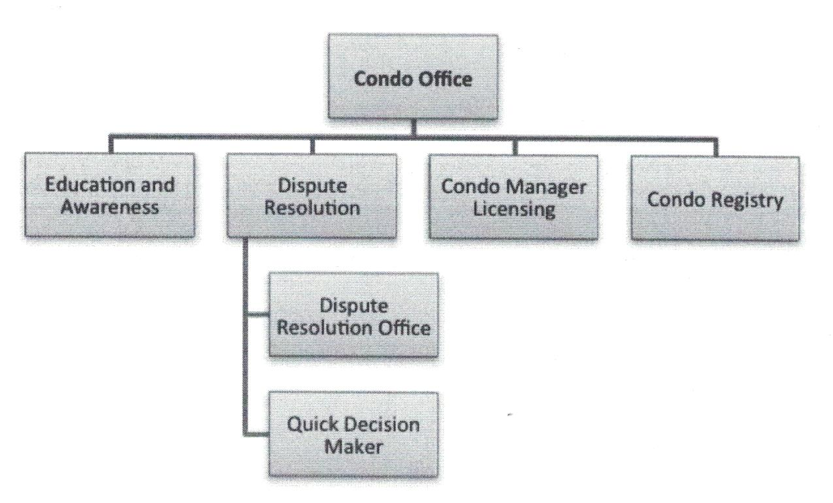

Directors must be familiar with the following:

“**Condo Office**” is an independent body reporting to the Government of Ontario to oversee education, dispute resolution, condo manager licensing and to maintain a registry of all condos in the province. It splits functions between two administrative authorities, delegating these function to two independent, self-funded bodies:

* A **Condo Authority** that is responsible for administering condo owner education, dispute resolution and a condo corporation registry. The Condo Authority has the responsibility to administer the **Condominium Authority Tribunal**, which will resolve disputes through case management, mediation and adjudication.

Key Features

1. Include online resources and self-help tools
2. Make binding decisions that would be enforceable as if they were a court order
3. Existing dispute resolution mechanisms would still apply to disputes outside the tribunal’s jurisdiction
4. The divisional court would hear appeals from tribunal findings on questions of law.

* A separate **Administrative Authority** to administer licensing of condo managers and condo management providers.

**“Condo Guide”** – The province is to publish a guide containing essential facts about the roles and responsibilities of living in a condo under the auspices of the Condo Authority.

**“Proxy”** – If a condo owner is unable to attend meetings but still wants to have a role in the decision-making process, the condo owner may complete a proxy form. This gives another person who plans to attend the meeting (i.e. proxy) the power to vote on the owner’s behalf. A proxy is not transferable. See by-law 1(6)(11).

**“Reserve Fund” -** is a required fund to ensure that there is adequate funds to pay for major repairs and replacement of the common elements and any assets of the corporation as the age. The Reserve Fund balance is to encompass the next thirty fiscal years.

**Condo Authority functions**

The Condo Authority will provide:

* affordable access to quicker, accessible and lower cost resolution of disputes primarily between corporations and owners
* self-help tools, case management and mediation to prevent easy-to-resolve disputes from being tied up in costly and time-consuming legal proceedings
* education and awareness for condo owners about their rights and responsibilities, and the basics of condo living and how it differs from other freehold ownership
* education for condo directors
* a registry of all condo corporations in Ontario, including their boards of directors and contact information
* a guide for condo buyers, setting out unit owners’ roles and responsibilities

**Condo Authority structure**

The Condo Authority will operate as an [administrative authority](https://www.ontario.ca/consumers/about-consumer-protection-ontario). It would be an independent, self-funded, not-for-profit corporation. Its employees would not be members of the Ontario Public Service.

To ensure accountability and transparency, the Condo Authority would:

* have an administrative agreement with the Minister of Government and Consumer Services
* be required to publicly disclose certain information, and
* be subject to oversight by the Auditor General

**Condo Authority funding**

The province would provide start-up funding for the Condo Authority.

After the initial start-up, the authority would set its own fees. It would charge:

* fees to users of its services
* a small fee levied on condo corporations across the province

The fee to all condo corporations is intended to help keep dispute resolution costs lower, and would cover the cost of the Condo Authority’s dispute prevention services (e.g.,condo buyer’s guide, online self-help tools).

The Condo Authority would determine and set this fee, in accordance with processes and criteria approved by the Minister of Government and Consumer Services. In line with the Stage 2 report, it is estimated that the fee will be approximately $1 per unit a month.

For example, the authority would charge a condo corporation with 100 units about $100/month.

This fee structure reflects the fact that all condo owners would have equal access to dispute resolution from the Condo Authority.

Condo corporations would collect the fee from unit owners as part of monthly common expenses. As with all monthly common expense fees, each unit’s contribution would be calculated using the proportions set out in the condo declaration.

Fees will not be collected until the Authority is in place in 2017.

**The Condo Authority Tribunal**

The amendments to the *Condominium Act* delegate to the Condo Authority the responsibility to administer the Condominium Authority Tribunal, which will resolve disputes through case management, mediation and adjudication.

Key features:

* the tribunal’s services would include online resources and self-help tools
* the tribunal would make binding decisions that would be enforceable as if they were a court order
* existing dispute resolution mechanisms would still apply to disputes outside the tribunal’s jurisdiction
* the divisional court would hear appeals from tribunal findings on questions of law

**Tribunal disputes**

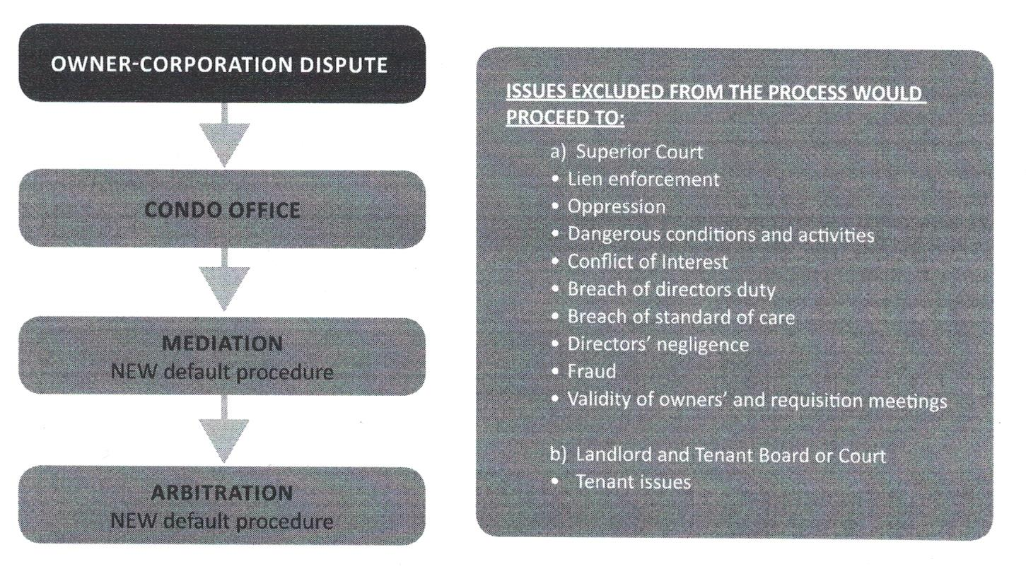

**Regulations will set out which disputes (primarily between owners and corporations) would have to be heard by the tribunal. They may include:**

* **enforcement of declarations, by-laws and condo rules**
* **procurement processes**
* **access to records**
* **procedures for requisitioning a meeting of owners**

**Certain disputes would be excluded, and would need to go through mediation and arbitration or court, such as disputes relating to:**

* **liens**
* **amalgamation and termination of condo properties**
* determination of title to real property

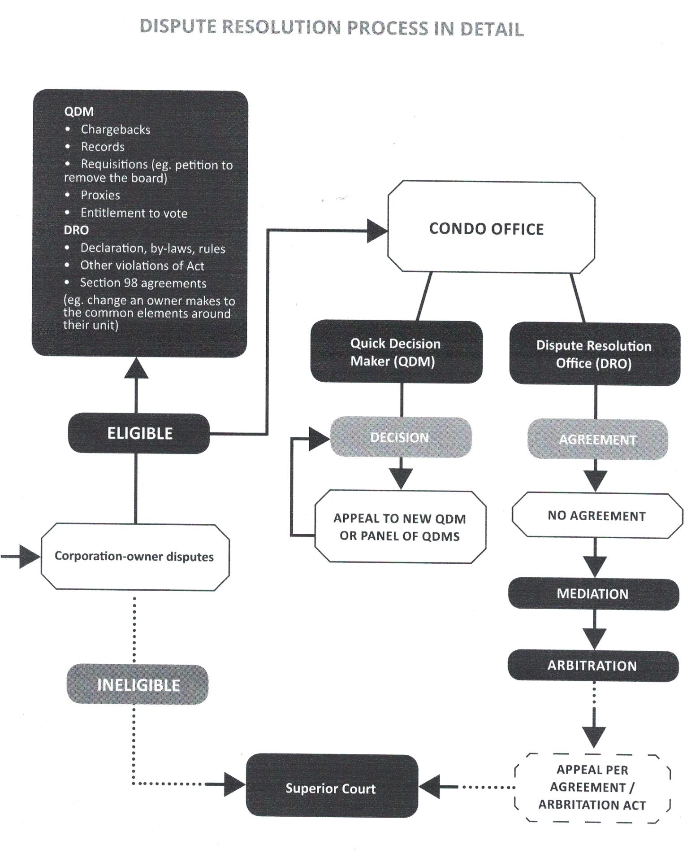

**Tribunal dispute resolution fees**

The Condo Authority will set its own budget and fees in accordance with the processes and criteria approved by the Minister of Government and Consumer Services.

It is anticipated that the cost of resolving a dispute through the tribunal would be substantially lower for owners and boards than the legal fees and other costs that are paid today. It is also expected that the tribunal would resolve disputes more quickly.

|  |
| --- |
| **I**mproved Communication with unit owners  The amendments will require boards to issue regular information on topics such as the corporation’s insurance, legal proceedings, the names and addresses for service of the corporation’s directors.  Regulations will set out how and how often boards would have to issue these updates. The act states that some of the updates would have to be sent out as “information certificates.” An information certificate would be similar to a newsletter and be sent to the owners on a regular basis or at other specific times. |

|  |
| --- |
| **YCC 84 YCC 84 YCC 84 YCC 84 YCC 84 YCC 84 YCC 84 YCC 84 YCC 84 YCC 84 YCC 84 YCC 84 YCC 84 YCC 84** |