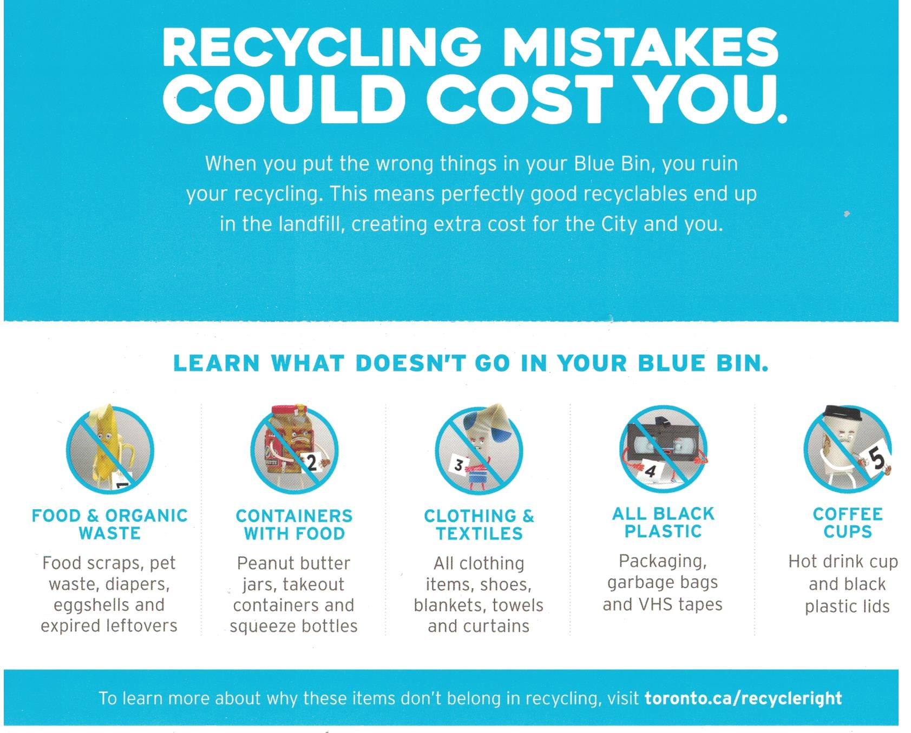

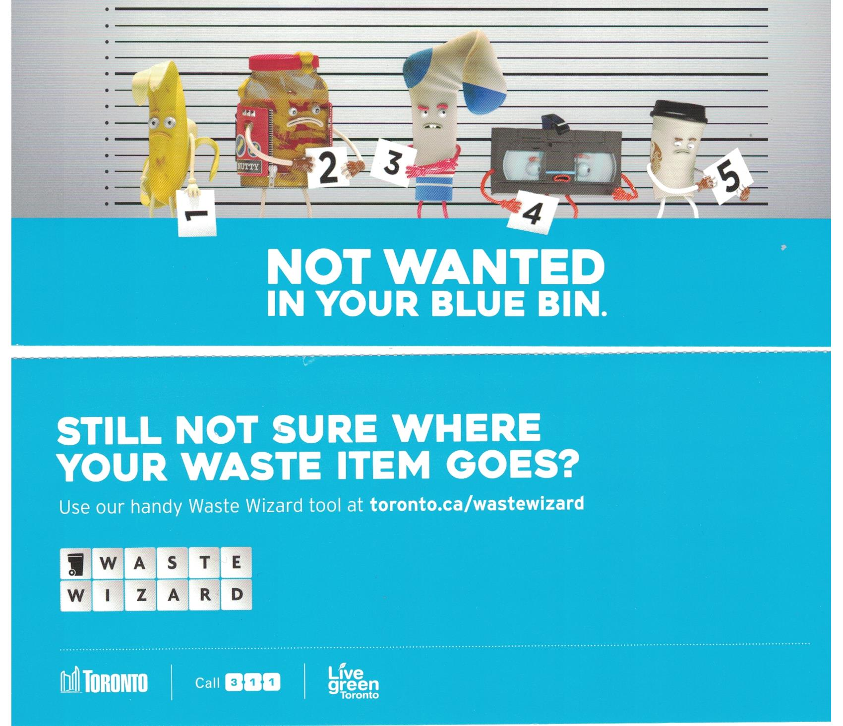

DO NOT INCLUDE

* Electronic Equipment

1. Computers
2. Computer Printers
3. Toner Cartridges
4. Batteries
5. Televisions
6. Air Conditioners
7. Construction Materials
8. Etc.

