|  |  |
| --- | --- |
| **YORK CONDOMINIUM CORPORATION NUMBER 84** | **A complete set of CONDOMINIUM CORPORATION RULES** |

**NOTICE OF RULE**

TO: The Owners

York Condominium Corporation No. 84 (the “Corporation”)

FROM: Board of Directors

DATE: September 25, 2019

RE: York Condominium Corporation No. 84

**A COMPLETE SET OF REPLALCEMENT RULES**:

Please find enclosed a copy of the Corporation’s proposed Rules, to replace the existing rules of the Corporation, in accordance with Section 58 of the Condominium Act, 1998.

**The new Rules will become effective on October 31**, 2019 unless a meeting is requisitioned in accordance with Section 46 of the Condominium Act, 1998.

Pursuant to the Condominium Act, 1998 rules may only become effective at the time determined by Section 58)7) and (8).

We enclose a copy of Sections 58 and 46 of the Condominium Act for your reference.

Owners who have leased their units are responsible to deliver these Rules to their Tenant(s).

YORK CONDOMINIUM CORPORAITON NUMBER 84

The Board of Directors

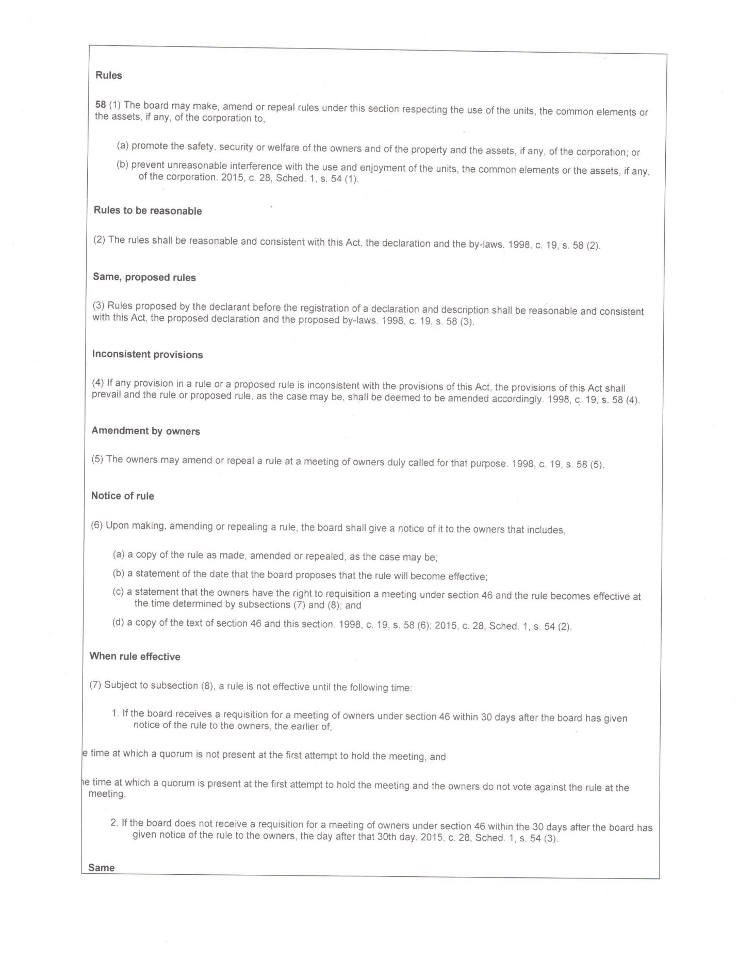

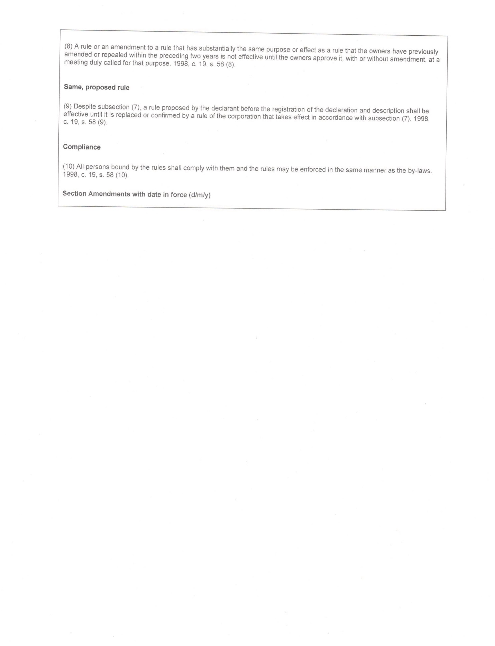

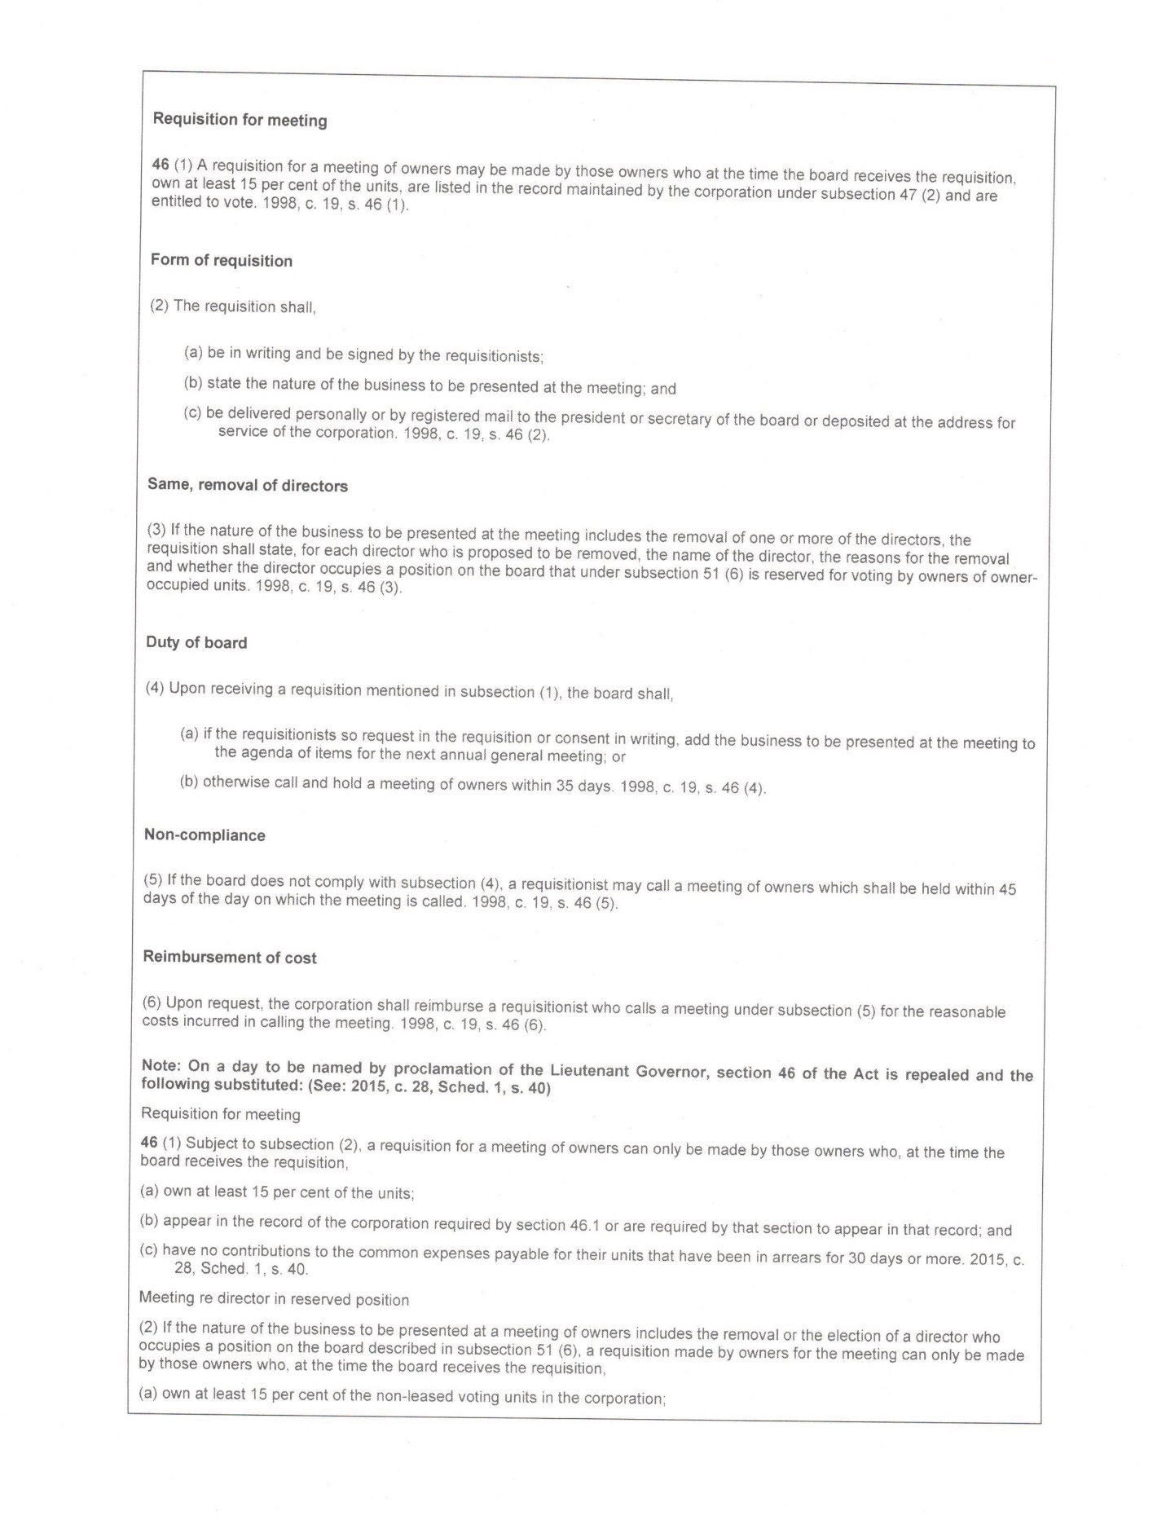

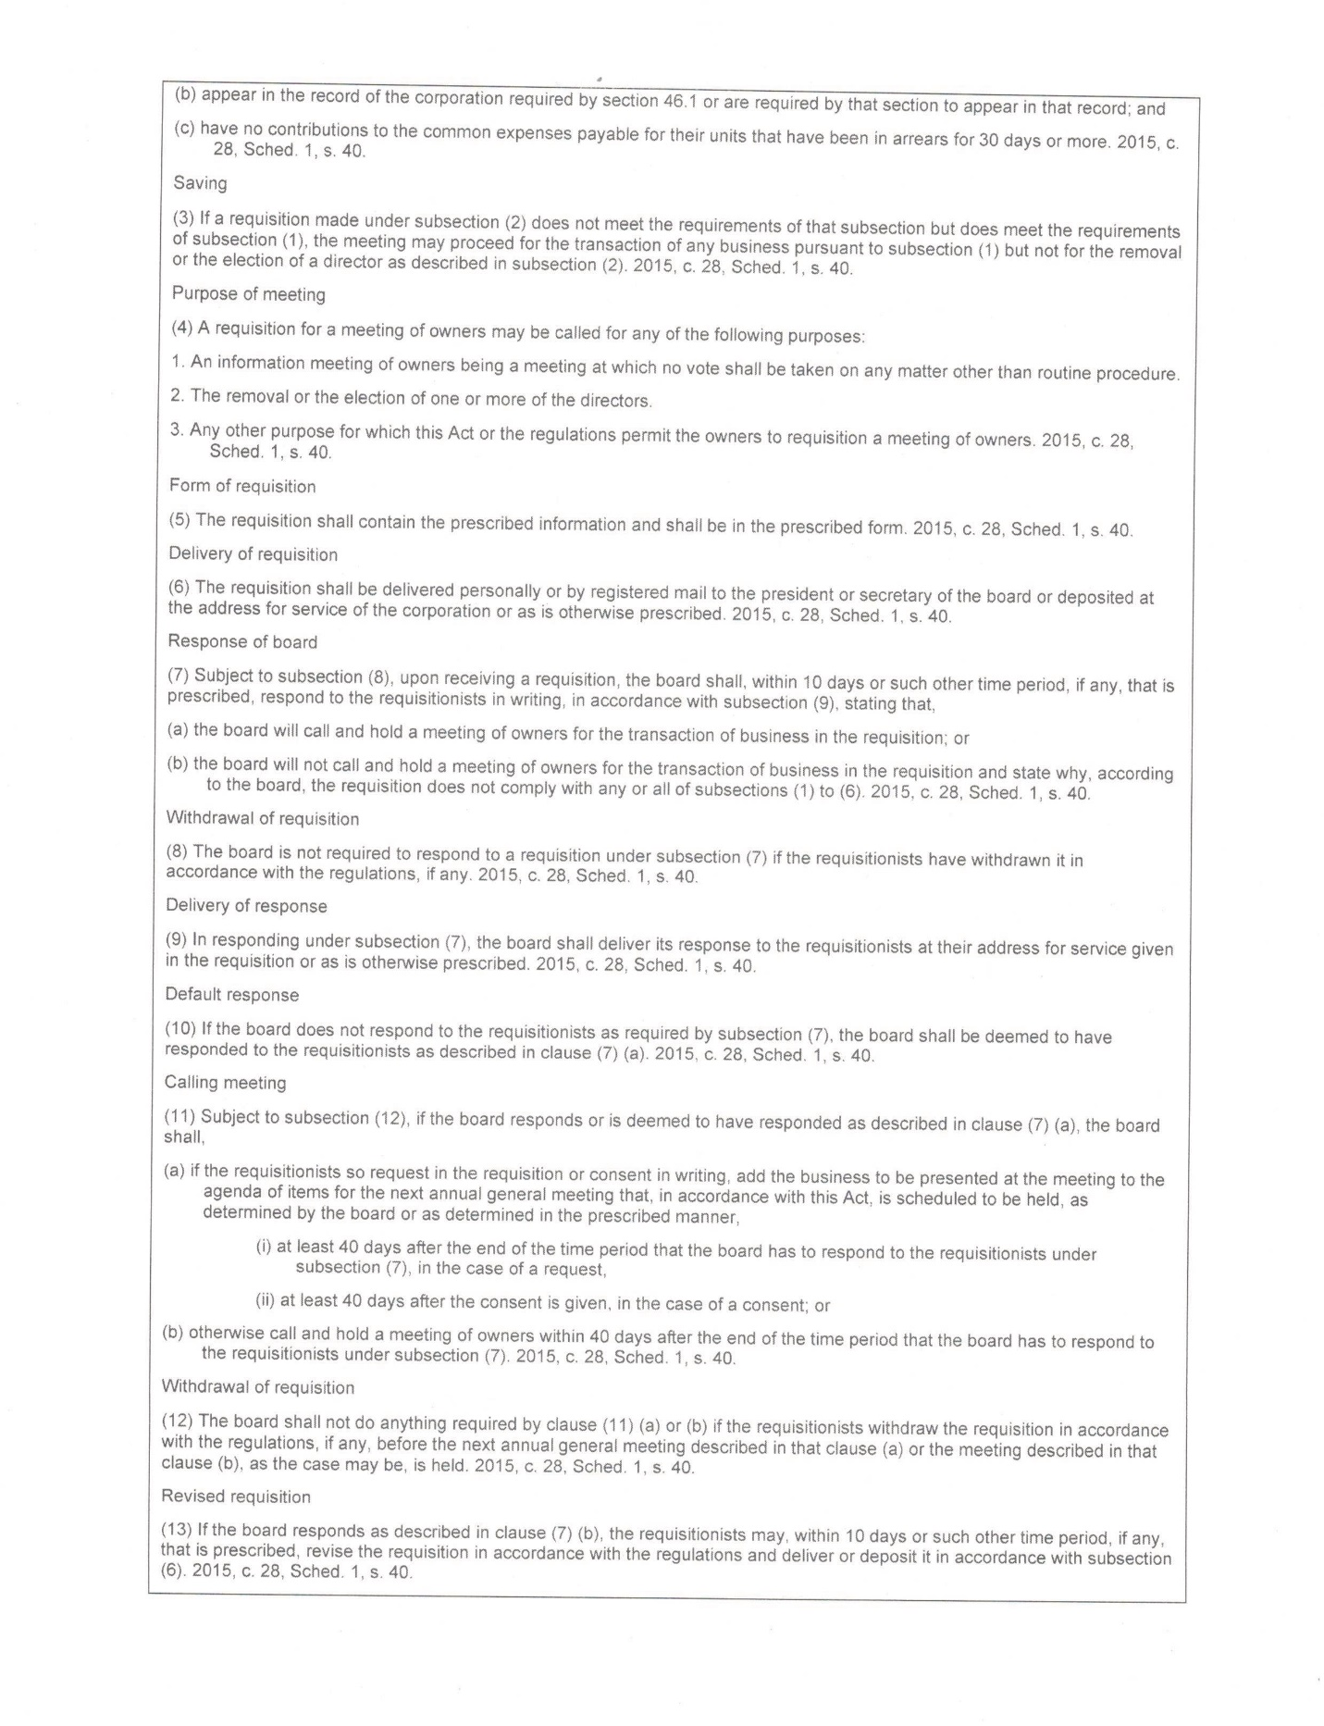

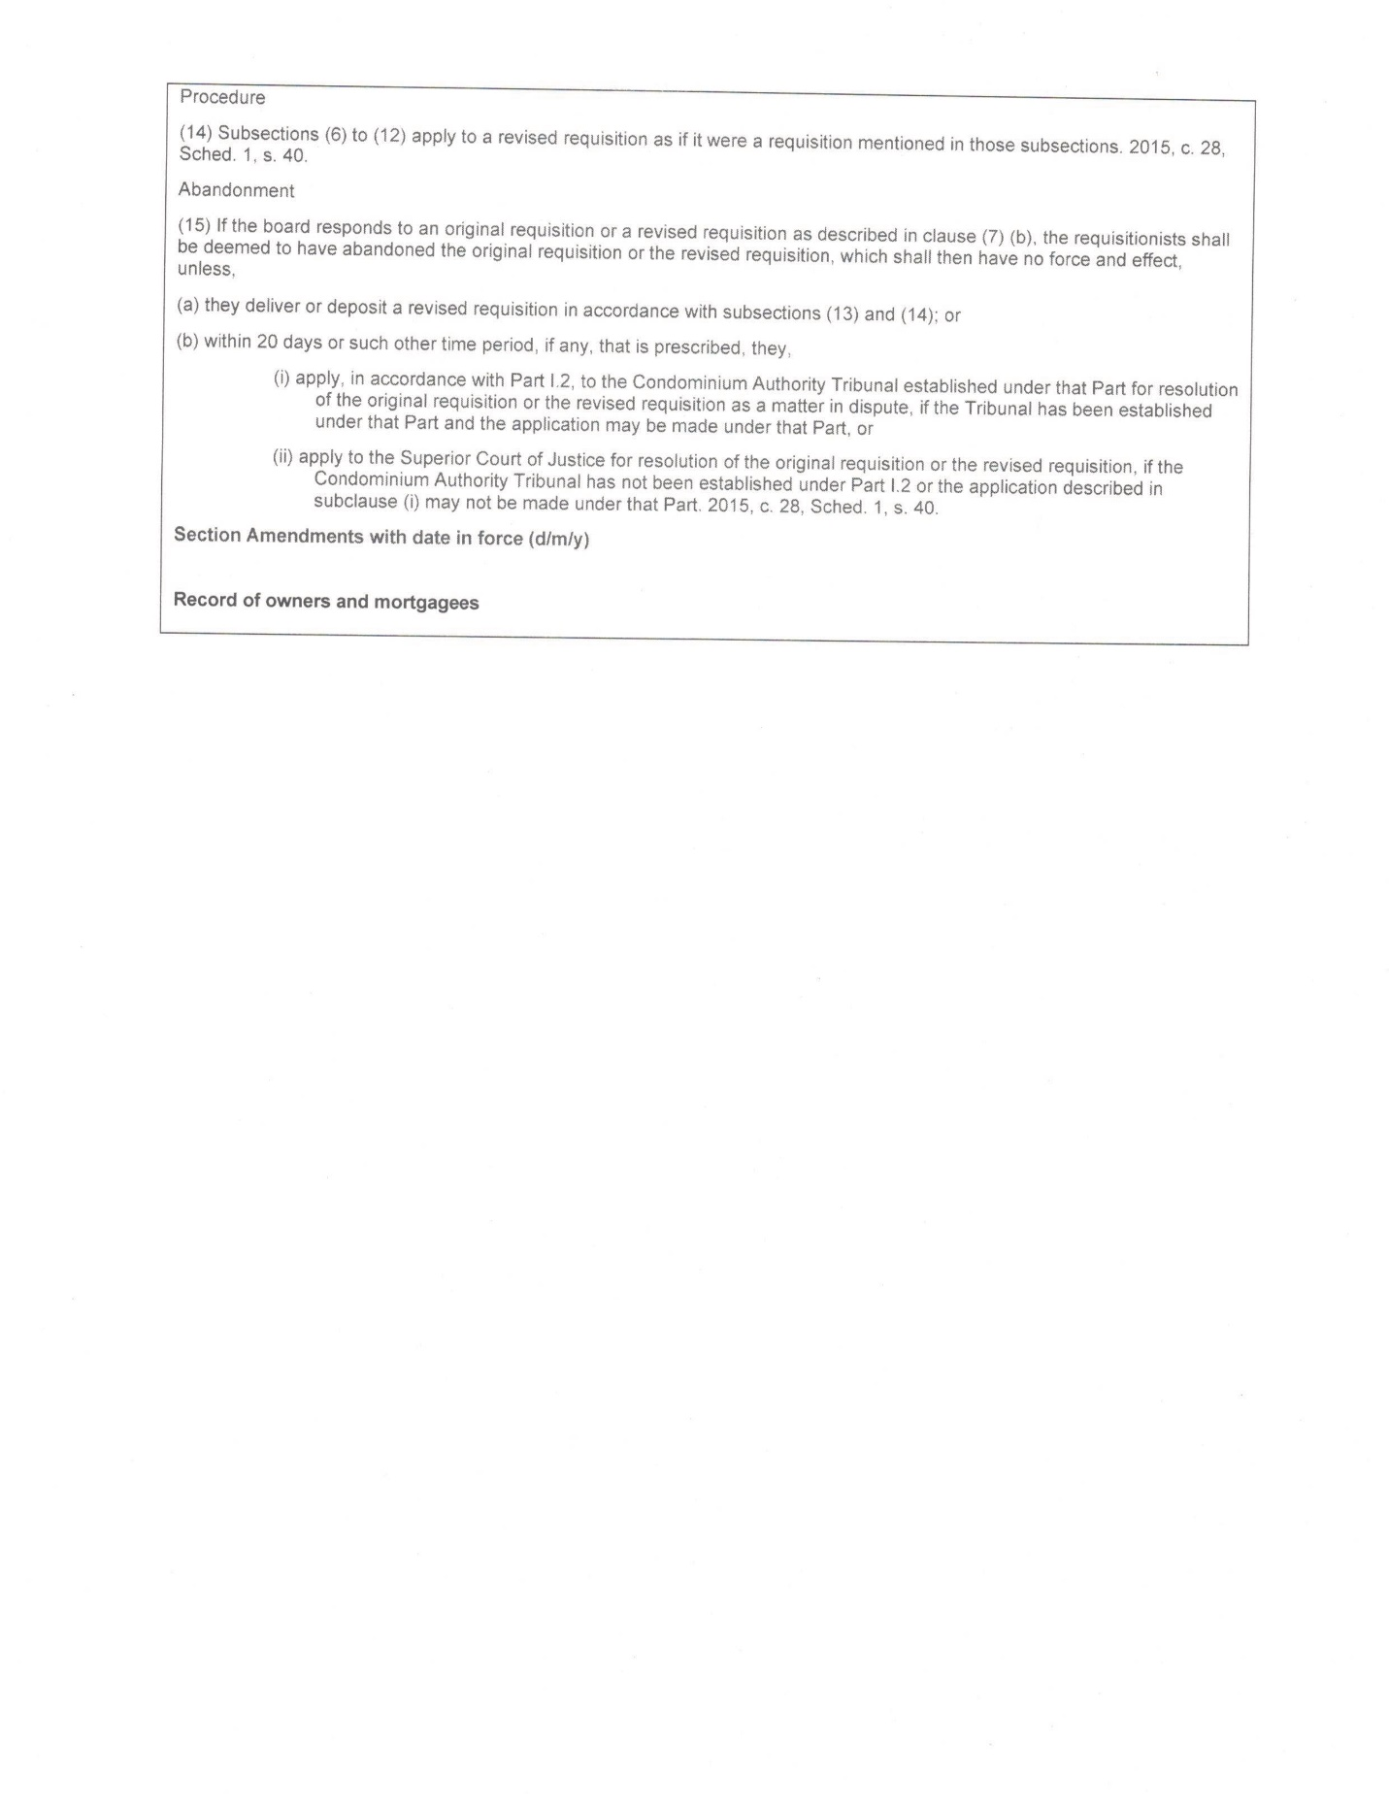

YORK CONDOMINIUM CORPORATION NO. 84  
(the “Corporation”)

RULES AND REGULATIONS (“RULES”)

TABLE OF CONTENTS

INTRODUCTION 1

1. DEFINITIONS AND INTERPRETATION 1

2. GENERAL 2

3. QUIET ENJOYMENT 4

4. UNITS AND COMMON ELEMENTS 5

5. SECURITY 9

6. SAFETY 10

7. RENOVATIONS 10

8. OWNER’S CONTRACTORS, TRADE OR SERVICE PERSONNEL 11

9. WASTE MANAGEMENT 11

10. TENANCIES 11

11. PETS/ANIMALS 12

12. AIR CONDITIONING UNITS 13

13. COMMON ELEMENT ALTERATIONS 14

14. PARKING AND MOTOR VEHICLES 19

15. CASUAL VISITOR PARKING 20

16. DOOR(S) AND WINDOW REPLACEMENT 21

17. OWNERS’ MEETINGS 25

18. CABLE COMMUNICATION’S LINE ACCESS 25

19. CHARGING AN ELECTRIC VEHICLE 25

**SCHEDULES**

The Corporation may amend or rescind Schedule items without membership approval.

A Tenant Information Form

B. Tenant’s Undertaking and Acknowledgement

C. Common Element Trees on Units’’ Front Lawns

D. Owner’s Application for Consideration

E. Resident / Member Profile

**INTRODUCTION**

The following rules (“**Rules**”) made pursuant to the *Condominium Act, 1998*, S.O. 1998, c. 19, and the regulations made thereunder, as amended, shall be observed by all present and future Owners and any other persons occupying the unit, including, without limitation, family members, household members, Residents, tenants, and by all guests, invitees, licensees, and agents. All prior existing rules are repealed.

# DEFINITIONS AND INTERPRETATION

1. “**Act**” means the *Condominium Act, 1998*, S.O. 1998, c.19 and all regulations thereunder and any amendments to said Act and regulations and any successor legislation;
2. “**Addition**” means something that is joined or connected to a structure, building on or supplementing what is already there.
3. “**Alteration**” means something that changes the structure, and can add to or subtract from what is already there.
4. “**Arbitration**” means a process whereby an independent third party (the arbitrator) hears a dispute between two or more parties and makes a determination of the rights and obligations of the parties.
5. “**Board of Directors**” or “**Board**” means the board of directors of the Corporation;
6. “**By-laws**” deal with matters of corporate governance and the management of the property.
7. “**Corporation**” means York Condominium Corporation No. 84;
8. “**Owner**” means “owner” as defined in the Act;
9. “**Condominium**” describes a system of ownership whereby a unit is owned separately by the individual who purchases it, while the common elements are owned in common by all of the unit owners. Each unit owner has an undivided interest in the common elements.
10. “**Condominium Manager**” or “**Condominium Management**” or “**Manager**” or “**Management**” means the individual or company appointed by the Corporation to manage the property and assets of the Corporation, or any agent or employee thereof;
11. “**Declaration**” provides information about the property and as required by the Act, including information regarding each unit’s boundaries as well as its share of common expenses, and a description of the exclusive use common elements, which are used exclusively by a particular unit.
12. “**Improvement**” means, in relation to a unit,

(a) any part of a unit, where the part does not constitute a standard unit or part of a standard unit, or

(b) any repair or modification to a standard unit that is done using materials that are higher in quality, as determined in accordance with current construction standards

1. “**Mediation**” means the process by which two or more parties to a dispute meet with an independent third party with a view to reach a settlement of the dispute.
2. “**Resident**” means anyone who is a resident in any unit in the Corporation, for any length of time, and includes, but is not limited to, an Owner residing in a unit, temporary guests or anyone who is permitted to reside in a residential unit for any period of time by the Owner or tenant of the unit;
3. “**Resolution of the Board of Directors**” addresses a specific decision by the Board of Directors, which is documented as a record of the Corporation.
4. “**Rules and Regulations**” address how the units and common elements are to be used by owners and residents.
5. “**Unit**” is interchangeable and synonymous with the word “townhouse”

Unless otherwise specified, the terms used herein shall have ascribed the definitions contained in the Act.

These Rules shall be read with all changes in gender and number required by the context. The headings in these Rules form no part of the Rules and have been inserted for convenience of reference only.

# GENERAL

1. Use of the common elements and units shall be subject to these Rules and any additional rules which the Board may make from time to time to promote the safety, security and welfare of the Owners, and of the property and assets of the Corporation or for the purpose of preventing unreasonable interference with the use and enjoyment of the common elements, units and assets of the Corporation.
2. Rules as deemed necessary and altered from time to time by the Corporation shall be binding on all unit owners and residents, respective family members, tenants, guests, invitees, licencees, and agents.
3. Each Owner and Resident of the Corporation shall be responsible for the acts and/or omissions of their respective family members, tenants, guests, invitees, licencees, and agents.
4. Any losses, costs or damages incurred by the Corporation (including, without limitation, legal costs) by reason of a breach of the Act, or the Declaration, By-laws and Rules or by reason of any litigation against the Corporation without obtaining a judgment against the Corporation, by any Owner and/or Resident, or by the respective family members, tenants, guests, invitees, employees or agents of the Owner and/or Resident or any of the foregoing shall be borne and paid for by such Owner of the unit and shall be deemed to be additional contributions towards the common expenses payable by such Owner and shall be recoverable as such.
5. No one shall do or permit anything to be done in a unit, or bring or keep anything therein which will in any way increase the risk of fire or the insurance premiums on the building, or on property kept therein, and no one shall do or permit anything to be done in a unit or obstruct or interfere with the rights of other Owners and/or Residents, or in any way injure or annoy them, or conflict with the regulations of the applicable municipal fire department, or with any insurance policy carried by the Corporation or conflict with any of the rules and ordinances of the applicable local board of health, or with any municipal by-law or any provincial or federal statute or regulation.
6. No one shall injure, harass, threaten, annoy, or initiate any defamatory, threatening, hateful or discriminatory statement or action, or participate in any illegal activity or harmful conduct toward any Owner, Resident, Board member, Manager, employee of the Corporation, or contractor retained by the Corporation. Harassment consists of any verbal or written statement, action, or behaviour which is intimidating, threatening, violent or which causes physical or psychological harm, fear, humiliation or embarrassment, objectively determined on a reasonable basis, including any statement, action or behaviour which a person knows or reasonably ought to know would be unwelcomed and offensive, including, without limitation, any verbal abuse, insulting comment, joke, gesture, conduct or touching or which would constitute workplace harassment or sexual harassment as set out in the *Human Rights Code*.
7. No one on the property shall act in a manner that is unmanageable, rude, disruptive, aggressive, abusive or anti-social in nature.
8. All Owners and Residents shall comply with any Workplace Violence, Harassment and Discrimination Policy, which may be passed, amended or modified from time to time by the Board.
9. No one shall use, store, or permit the prolonged storage of garbage or degradable matter, an accumulation of excessive paper or any item in any unit or on the common elements which may, in the sole and absolute discretion of the Board, overload the structure or constitute a fire, health or safety hazard (the “**Hazard**”). If an Owner and/or Resident creates a Hazard and does not rectify and/or remedy the Hazard to a standard that is approved by the Board within a reasonable time, then the Corporation shall be permitted to enter the unit and/or Exclusive Use Common Elements appurtenant to the unit upon reasonable notice (or forthwith, in the case of an emergency) and rectify and/or remedy the Hazard. In such event, the Owner shall reimburse the Corporation in full for the costs of rectifying and/or remedying the Hazard including, but not limited to, any clean-up costs and legal costs and same shall be recovered by the Corporation in the same manner as common expenses, or in any other lawful manner.
10. No one shall interfere with, hinder or impede the Board or the Manager from carrying out the Corporation’s duties and obligations under the Act, the Declaration, By-laws, or Rules of the Corporation, or any agreement to which the Corporation is a party.
11. On giving reasonable notice to an owner/resident, the Corporation or a person authorized by the Corporation may, at any reasonable time, enter a unit or a part of the common elements of which the owner has exclusive use to perform the objects and duties of the Corporation or to exercise the powers of the Corporation. Reasonable notice is determined by the circumstances of each situation.
12. The Corporation or person authorized by the corporation shall be permitted to enter the unit or part of the common elements of which the owner has exclusive use without prior notice to the owner in the event of an emergency or other event or circumstance which requires immediate entry.
13. If access is not accommodated, or emergency access is necessary, the Corporation may force entry into the unit when and where required.
14. Residents may leave an access key with a trusted neighbour to reduce the potential for having to force entry in to their unit, in which case, the resident should inform management which neighbour has a key to the unit through the form attached hereto as Schedule “E”. Repairs for forced entry are for the account of the owner. Dependent on the emergency situation, efforts will be made to obtain the key.
15. If the situation involves the common element water pipe or, the unit’s main water shut off tap/valve, access to the block’s end unit having the water pump may be necessary. Depending on the nature of this emergency and access to this block end unit, it may be necessary for immediate forced entry into the end unit. If the unit having the concern has tampered with the common water pipe or the unit’s main shut off tap/valve, repairs to the unit and to restore forced entry damage to the end unit shall be recoverable against the owner who tampered with the common water pipe or the main shut off tap/valve.
16. Residents should provide management with complete regular and complete emergency contact information through the form attached hereto as Schedule “E”.
17. Where required, residents must allow for a sufficient accessible working area for a contractor to complete the required work within a unit. Costs incurred to clear a proper working area, or other additional costs incurred by the Corporation due to obstructions to the work area shall be recoverable against the Owner and collectible in the same manner as common expenses.

# QUIET ENJOYMENT

1. No one shall create or permit the creation or continuation of any noise, odour or other nuisance which, in the opinion of the Board or the Manager, does or may disturb, annoy or interfere with the comfort or quiet enjoyment of the units or common elements by other Owners and/or Residents. No one shall obstruct or interfere with the rights of any Owner.
2. No noise (including music from an instrument or other source) or odour which is an annoyance, nuisance or disruption to other Owners or Residents shall be permitted to be transmitted from one unit to another or from the common elements to another or to the common elements. If the Board determines that any unreasonable noise or odour is being transmitted to another unit or the common elements and that such noise or odour is an annoyance or a nuisance or disruptive, then the Owner and/or Resident of such unit shall at their expense take such steps as shall be necessary to abate such noise or odour to the satisfaction of the Board. If the Owner and/or Resident of such unit fails to abate the unreasonable noise or odour, the Board may take such steps as it deems necessary to abate the noise or odour and the Owner shall be liable to the Corporation for all expenses incurred in abating the noise or odour (including legal fees).
3. No one shall permit smoke or vapour (tobacco, cannabis, or any other substance), including second-hand smoke or vapour, to unreasonably interfere with Residents in other units or the common elements. If the Board determines, in its sole and exclusive discretion, that smoke is being transmitted to another unit or the common elements, the Board may require the Owner of the unit from which the smoke emanates to take whatever reasonable steps are required to rectify the problem to the satisfaction of the Board. Without limiting the generality of the foregoing, these steps could include the Owner installing, at his/her own cost, adequate ventilation in his/her unit or the common elements, if necessary, to stop the smoke penetration, in which case, the Owner shall be required to enter into an alteration agreement with the Corporation. If the Owner of such unit fails to abate the smoke, the Board may take such steps as it deems necessary to abate the smoke and the Owner shall be liable to the Corporation for all expenses thereby incurred in abating the smoke.
4. No solicitation, canvassing or delivery of flyers is allowed on the property except for the distribution of election materials by candidates and their authorized representatives for election to the House of Commons, legislative assembly or an office in municipal government or school board, or candidates running for election to the Corporation’s Board.
5. No one shall grow, cultivate, propagate or harvest any cannabis plants on any part of the property, including, units (including, but not limited to, inside a garage), common elements and exclusive use common elements.
6. Any repairs and/or renovations to units or exclusive use common elements, which creates noise by hammering, drilling, etc., are permitted only during the hours of 8:00 a.m. to 8:00 p.m. Monday to Saturday (excluding public holidays), except in the event of an emergency, in which case the Owner or Resident must obtain approval from Management as soon as practical in the circumstances.

# UNITS AND COMMON ELEMENTS

1. Each residential unit shall be occupied and used only as a private single family residence.
2. No commercial use shall be permitted in or with respect to any unit, including, without limitation, the carrying on of a business or the operation of a business or professional office.
3. No hotel, boarding or lodging house, transient use, time-sharing or dormitory use shall be permitted with respect to any unit.
4. No immoral, improper, offensive or unlawful use shall be made of any unit, the common elements or any other part of the Corporation’s property. All federal and provincial laws and regulations, municipal by-laws and other ordinances, and all rules, regulations and codes of all quasi-governmental authorities having jurisdiction shall be strictly observed and complied with.
5. The filming of any movie for commercial purposes in any unit or on the common elements is prohibited except when authorized by written consent of the Board.
6. A yard or public sale may be held on the common elements only with the prior written consent of the Board.
7. The toilets, sinks, showers, bath tubs and other parts of the plumbing system shall be used only for purposes for which they were constructed and no sweeping, garbage, rubbish, rags, ashes or other substances shall be thrown therein. The cost of repairing damage resulting from misuse or from unusual or unreasonable use shall be borne by the owner who, or whose, tenant, family, guest, visitor, servant or agent has caused such damage.
8. Those parts of curtains, drapery, blinds, shutters or other window covering which may be visible from outside the unit through a window of the unit, shall be of a white or off-white colour. Any temporary window coverings must be properly hung and must be white or off-white in colour.
9. The inside surface of windows visible from the exterior shall remain clear and no colour or sun screen or laminate shall be applied or affixed thereto without the prior consent of the Board.
10. No laundry shall be hung or placed outside a unit or inside a unit so as to be visible from the exterior of the unit, except that clothes-trees and clothes horses are permitted on rear patios only. Clothes-trees and clothes horses must be removed when not in use.
11. All electrical appliances and equipment used in any unit shall comply with the applicable regulations in force from time to time.
12. All municipal and other zoning ordinances, laws, rules and regulations of all governmental regulatory agencies shall be strictly observed.
13. No one shall permit or cause an infestation of pests, insects, vermin or rodents to exist at any time in their unit or adjacent common elements. Owners and/or Residents shall immediately report to the Manager all incidents of pests, insects, vermin or rodents and shall fully cooperate with the Manager to provide access to each unit for the purpose of inspecting the unit to ascertain the presence of any pests, insects or vermin and conducting a spraying program or any other program to eliminate any incident of pests, insects, vermin or rodents. Residents shall prepare the unit in accordance with instructions provided by Management to facilitate the pest elimination in the unit.
14. No awnings, screens, enclosures or structures whatsoever shall be attached to the exterior wall or other common element, or over the outside of any window of an unit, or on any common elements without the prior written consent of the Board.
15. No outside painting shall be done other than by the Corporation to the exterior of the building, railings, doors, windows or any other part of the property, except with the prior written consent of the Corporation.
16. No sign, advertisement or notice shall be inscribed, painted, affixed or placed on any part of the inside or outside of the property or common elements whatsoever without the prior written consent of the Board, other than a portable sign offering a unit for sale or rent, which sign may be erected on that unit’s front lawn.
17. No television antenna, aerial, satellite dish, tower or similar structure and similar appurtenances thereto shall be erected on or fastened to any unit or to any exclusive use common element appurtenant to a unit, or any other part of the common elements except when authorized by written consent of the Board and in accordance with these Rules.
18. No one shall obstruct or permit the obstruction of any entry or passageway which is part of the common elements and any such entry or passageway shall be used only as a means of ingress or egress to and from the property and the unit or some other part of the common elements.
19. No major electrical appliances, except a stove, refrigerator, washing machine, clothes dryer, dishwasher and other common household electrical appliances shall be installed or used in any unit without the prior written consent of the Board.
20. No garburators shall be installed in any unit.
21. No permanent decorations are permitted to be affixed, placed or hanged on any unit door or door frame without the prior written consent of the Board.
22. Seasonal decorations are permitted on the common elements in front of an owner’s unit provided that they do not interfere with the safety, security and welfare of other owners.
23. No one shall harm, mutilate, destroy, alter or litter any of the common elements of the Corporation, including, but not limited to, grass, trees, shrubs, hedges, flowers, privacy screens, and landscaping on the property.
24. Prior to the first fall/winter freeze, an owner shall turn off the water faucet(s) from the inside of the unit and turn on the faucet at the outside of the unit to permit the outside faucet(s) to drain and shall remove the garden hose(s) from the exterior of the unit for winter storage.
25. The Owner shall:
    1. turn on and off the main water valve to the unit several times per year to prevent seizing;
    2. change washers in leaking taps;
    3. lubricate all hinges and locking mechanisms of doors;
    4. lubricate track and roller mechanisms in the large garage door;
    5. clean all ductwork within the unit;
    6. keep in repair all windows and screening;
    7. maintain and replace or remove worn front porch covering;
    8. maintain all steps where applicable to a height established by the Ontario Building Code;
    9. maintain all patio areas;
    10. maintain, trim, and weed all gardening associated with the unit and the patio; and
    11. water the front and back lawn grass area.
26. The Owner of a unit shall be responsible for any costs incurred to repair damage to the unit or the common elements that may have been caused by the Owner or the Resident of the Owner’s unit, or any person, thing or animal for whom or for which the Owner and/or Resident is responsible, howsoever caused.
27. No auction sales or events to which the general public is invited shall be allowed in any residential unit or on the common elements, except with the prior written consent of the Board.
28. Firecrackers or other fireworks are not permitted in any unit or on the common elements.
29. No building, structure or tent shall be erected, placed, located, kept or maintained on the common elements, and no trailer, either with or without living, sleeping or eating accommodations, shall be placed, located, kept or maintained on the common elements without the consent of the Board.
30. No one shall be entitled to post signs or notices anywhere on the property without the consent of the Board.
31. Anyone wishing to display the Canadian flag within the unit but visible from the outside, or on any exclusive use common elements appurtenant to the unit, may do so only in compliance with the Government of Canada’s flag protocol, standards and rules, and with the prior written consent of the Board. Any flag not in compliance with the said protocol, standards and rules may be removed by Management. Except as aforesaid, Owners and Residents are not permitted to fly any flag on the property.
32. Owners shall be permitted one barbeque and associated fuel only on the rear patio area. Barbeques shall not be permitted in any other areas.
33. Except as otherwise permitted in accordance with these rules, nothing shall be stored on the common elements.
34. No one shall do or permit anything to be done on the exclusive use common elements which does or may unreasonably disturb, annoy or interfere with the comfort and/or quiet enjoyment of the units and/or common elements by other Owners and/or Residents.
35. Basketball playing upon the common elements is permitted between the hours of 12:00 p.m. and 8:30 p.m., or other such times as determined by the Board.
36. At all times while a sports equipment is in use upon the common elements by children under the age of sixteen, an adult Owner or Resident must supervise the activity.
37. Portable basketball nets on stands, hockey nets, toys, bicycles, etc. are not to be left on sidewalks, roadways, driveways etc. when not in use.
38. Anything placed upon the common elements preventing the Corporation from performing grounds and building maintenance work, which could result in an insurance claim against the Corporation, or which could cause an unsafe condition, will be removed by the Corporation
39. Anything permitted to be placed upon the common elements shall be maintained in a good state of repair and erected in accordance with the manufacturer’s instructions.
40. No one shall interfere with services within the property; e.g. water sprinkler system, gas lines, telephone lines, cable system, electrical wiring, water and drainage systems, light system, sewers, manholes, grass growth, trees, shrubs, etc.
41. Front porch enclosures are not permitted.
42. Fires are not permitted on common elements inclusive of exclusive use common elements.
43. Trailers, boats, canoes, snowmobiles, toboggans, machinery or sports equipment may not be kept on common areas or exclusive use common elements.
44. Games, toys, bicycles, tricycles, wading pools when not in use may not be kept on common element areas.
45. Patio and common areas are not to be enclosed by any type of fencing to contain pets.
46. Wading pools must not be left unattended and must be emptied when not in use.
47. The Owner and/or Resident shall maintain any plants, shrubs and trees, whether in the exclusive use common elements or common elements that was planted by an Owner or Resident and not planted or maintained by the Corporation, to the satisfaction of the Corporation.
48. The Owner and/or Resident may do a reasonable amount of planting, as determined by the Board. Planting of a tree or climbing bushes is prohibited.
49. Planting is permitted along the sides of the back of the unit, not exceeding the distance of the end of the privacy screen.
50. At the end of the privacy screen the Owner, on the Owner’s side, may plant a shrub which does not go more than 18 inches beyond the privacy screen and does not exceed the height of the privacy screen. The owner may install a reasonable garden border.
51. Owners may not trim, prune nor perform any maintenance to the common element trees/shrubs.
52. The Corporation retains the right to require maintenance and/or removal of any addition, alteration, or, improvement to any common element.
53. The front lawn trees form part of the common elements, as itemized in Schedule “C” which may be updated by the Corporation from time to time without obtaining owner consultation nor approval.

# SECURITY

1. All suspicious persons on the property, or incidents of suspicious activity, or any emergency concerning any situation otherwise affecting the safety and security of the property and its Residents, must be reported immediately to the Corporation.

# SAFETY

1. No storage of any combustible or offensive goods, provisions or materials shall be kept in any unit, within any garage, or on any common element area, except for a barbecue as permitted by Rule 4.33.
2. No one shall overload existing electrical circuits in their units. No one shall alter in any way the amperage of the existing circuit breakers/fuses in any unit unless otherwise permitted in the Declaration. No one shall make any major plumbing, electrical, mechanical or structural installation or alteration without prior written consent of the Board.
3. Water shall not be left running unless in actual use.
4. The toilets, sinks, showers, bath tubs and other parts of the plumbing system shall not be used for purposes other than those for which they are constructed, and no sweepings, garbage, rubbish, rags, oils/cooking oils, diapers, chemical wash cloths, or other substances shall be thrown therein. The cost of repairing any damage (whether to the Owner’s unit, the common elements or any other unit) resulting from misuse or from unusual or unreasonable use shall be borne by the Owner of the unit in which the plumbing system was misused or used unusually or unreasonably.
5. As per applicable local regulations/laws, each Owner shall install, maintain and repair a smoke or similar fire detection device and a carbon monoxide detection device(s) in their unit, and all batteries for such devices shall be changed on a regular basis.
6. No one shall disconnect any fire alarm, smoke detector or carbon monoxide detector.
7. Washing machines, dryers and dishwashers shall not be run while no one is in the unit.
8. Lint traps in dryers must be cleaned after every use and the venting duct line cleaned annually.
9. All washing machines water connections must be with steel braid hoses.

# RENOVATIONS

1. Approval from the corporation is required. To start the process the owner is to get an application form from either the property manager or, from the web-site [www.ycc84.ca/Forms](http://www.ycc84.ca/Forms) and present this to the Corporation for consideration.
2. No one shall carry out any change, addition, alteration or improvement (i.e. renovation) to the common elements or any structural or plumbing change in a unit, unless the Owner has received the prior written consent of the Board and, where applicable, entered into an Alteration Agreement, as may be provided by the Board from time to time, unless by reason of emergency, in which case the Owner shall forthwith notify the Board of same and submit any documentation or permits as requested by the Board sufficient to ensure the protection of units and common elements from potential damage.
3. All exterior renovations are to be in general conformity with the current standards.
4. All plumbing, electrical, and gas utility work in a unit must be carried out by a licensed tradesperson.

# OWNER’S CONTRACTORS, TRADE OR SERVICE PERSONNEL

1. No contractor, trade or service personnel shall enter the property to perform any work or service in or about any unit (including common elements, or, Exclusive Use Common Elements) that may or will affect the common elements in any way unless such persons are employed by an Owner in circumstances where the intended performance of work and/or services has first been approved, in writing, by the Corporation, the Owner and the Corporation have entered into an Alteration Agreement, and proper insurance has been provided.

# WASTE MANAGEMENT

1. Garbage and blue box items are not to be on common elements. Each unit has a designated garbage room for the storage of garbage and blue box items until the designated garbage pick-up day.
2. Garbage rooms are not storage rooms for other than garbage.
3. Combustible materials are not to be stored in areas such as the garbage room and garage.
4. The Owner or Resident is responsible for disposal of all oversize items or other items not collected with ordinary garbage pickup.
5. Appliances, furniture, etc. left at the front of the property to which a resident is associated may:

(a) be returned to the appropriate unit and the owner assessed an appropriate fee for returning;

(b) be disposed of by the Corporation for which the owner will be assessed an appropriate disposal fee.

# TENANCIES

1. All tenancies for units shall be in writing.
2. No unit shall be occupied under a lease unless, prior to the tenant being permitted to occupy the unit, the Owner shall have delivered to the Corporation a completed Tenant Information Form attached hereto as Schedule A and a duly executed Tenant’s Undertaking and Acknowledgement attached hereto as Schedule B and an executed copy of the application/offer to lease and the lease itself. The foregoing documentation shall be supplied promptly and without charge to the Corporation.
3. In the event that the Owner of a unit fails to provide the foregoing documentation prior to the commencement date of the tenancy, and fails to comply with Section 83 of the Act, any person or persons intending to reside in or occupy the Owner’s unit shall be deemed a trespasser by the Corporation until and unless such person or persons and the Owner comply with the Rules and the Act.
4. Within seven (7) days of ceasing to rent a unit (or within seven (7) days of being advised that the tenant has vacated or abandoned the unit, as the case may be), the Owner shall notify the Corporation in writing that the unit is no longer rented.
5. No Owner of a unit shall allow a tenant to sublet the unit to another tenant.
6. A lease or tenancy or right to occupy shall be for an initial term of not less than twelve (12) months.
7. The Owner shall supply to Management, the Owner’s current address and telephone number during the period of occupancy by a tenant.
8. All Owners shall be responsible for any damage or additional maintenance to the common elements caused by their tenants and all costs of enforcing the Declaration, By-laws, Rules and the Act against their tenants, and any costs incurred to defend unsuccessful litigation commenced by a tenant against the Corporation, and will be assessed and charged therefor in the same manner as common expenses.
9. Upon entering into a lease of a unit, the Owner shall provide the tenant with a copy of the Corporation’s Declaration, By-laws and Rules.
10. No hotel, boarding or lodging house, transient use, time-sharing or dormitory use shall be permitted with respect to any unit.
11. No one shall advertise, list, and/or rent their unit through Airbnb, FlipKey, HomeAway, VRBO, or any similar short-term and/or vacation rental platform.
12. A lease may not be assigned by a tenant and the Owner may not consent to an assignment of lease, unless the Owner is in compliance with these Rules.
13. Where lease arrangements or rights to occupy are with a corporation, partnership or other business entity, as tenant or occupant, the Residents are to be considered along with the corporate tenant for purposes of these Rules, and a change in the Residents residing in the unit shall be treated as a tenant or occupant taking possession of the unit pursuant to a new lease or right to occupy that must be in compliance with these Rules.

# PETS/ANIMALS

1. No livestock, fowl, reptile, rodent or animal of any kind except for dogs, domestic cats, caged birds except for pigeons, tropical fish in a home aquarium and small caged animals usually considered to be pets, shall be allowed or kept in or about any unit or the common elements or any part thereof, including those parts of the common elements of which any owner has the exclusive use.
2. No animal, which is deemed by the Board, in its sole, absolute and unfettered discretion, to be a nuisance or a danger to the Owners and Residents shall be kept in any unit or permitted on the common elements. Any animal which is deemed by the Board to be a nuisance or a danger shall, within two weeks of receipt of written notice from the Board or the Property Manager, be permanently removed from the property.
3. Unless within the confines of a residential unit, all dogs and cats shall be kept or held in hand by means of a short lead, leash or chain or carried or otherwise contained and this provision shall be applicable to the whole of the common elements.
4. No breeding of animals is permitted within any unit or the common elements. No pet sitting or pet boarding is permitted in any unit.
5. Every dog and cat must wear a collar with an identification of its owner when allowed on common elements.
6. No pet will be permitted to run loose upon the common elements.
7. Any defecation on the common elements by a pet in the common elements must be cleaned up immediately by the pet owner/person having charge of the pet. Should a pet owner fail to clean up after his pet, the Board may declare such pet a nuisance animal.
8. No pet shall be permitted to damage the common elements or cause any damage to the common elements or mutilate or destroy any of the landscaping, including grass, trees, shrubs, hedges or flowers. Any costs to remedy any damage to the common elements caused by a pet, including any damage caused by cleaning, chemicals or other such materials used in the attempt to remedy damage caused by a pet, will be the responsibility of the Owner in whose unit the pet resides or where the pet is visiting, and such costs shall be collectable in the same manner as common expenses.
9. No one shall permit any animal to bark, howl or cause a noise or disturbance which disturbs the comfort or quiet enjoyment of the property by other Residents.
10. All complaints regarding pets/animals must be submitted to the Property Manager in writing and be signed. It should include details of the nature of the complaint and sufficient information to identify the violator of these Rules, if possible.
11. Each pet owner is responsible for the actions and behavior of his or her pet. The Corporation is not responsible for any damage or injury caused by any pet or any claim related thereto.
12. No feeding of wild or feral animals is permitted anywhere on the property.

# AIR CONDITIONING UNITS

1. Approval from the corporation is required. To start the process the owner is to get an application form from either the property manager or, from the website **www.ycc84.ca/Forms** and present this to the Corporation for consideration.
2. No air conditioning unit shall be installed upon the common elements without the prior written consent of the Corporation, and where permitted, in compliance with these Rules.
3. Only window type air-conditioning units using 120 volt house current, installed and operated according to these Rules, shall be erected or placed upon the common elements.
4. Where an air-conditioner has not been securely installed, or is installed in a manner not in accordance with the characteristics set forth in these Rules, the unit owner shall comply with the directives given by the Manager or the Board. If within a reasonable time the unit owner has not complied, the Manager or the Board shall effect proper installation or removal, the cost of which shall be borne by the unit owner. The unit owner is liable for any damage to the common elements caused by an air-conditioner during its installation, operation or removal.
5. The following requirements are applicable with respect to the installation of air conditioners:
   1. The unit must operate only on 120 volt house current.
   2. The unit must be of the non-drip type
   3. The exterior casing of the unit must be of a color or texture compatible with the external fabric of the townhouses.
   4. The exterior casing shall be free from rust and corrosion.
   5. The sounds produced by any unit shall not create excessive noise.
   6. Window-type air conditioners will be permitted only from April 1st to October 1st of any year.
   7. All units shall be mounted in accordance with the manufacturers’ instructions.
   8. Brackets to support air-conditioners shall not be screwed, glued, or otherwise affixed to the exterior structure.
   9. The window opening in which an air-conditioner is installed shall be enclosed only with properly installed window glass/plexiglass. No plywood, particleboard, plastic, foil or other similar type material is permitted.
   10. Compressors may only be installed in the exclusive use back patio area beside the privacy screen, and shall not to block any window area.

# COMMON ELEMENT ALTERATIONS

1. Approval from the Corporation is required. To start the process the owner is to get an application form from either the property manager or, from the web-site **www.ycc84.ca/Forms** and present this to the Corporation for consideration.
2. Prior to any addition, alteration, improvement, or installation upon the common elements, a unit owner shall be required to enter into a section 98 agreement (Indemnity Agreement) pursuant to the *Condominium Act*.
3. Specific requirements applicable to gas lines
4. Prior to installation a drawing or sketch of the proposed installation is required to show the position of the regulator / meter, entry point pipe leading into the townhouse, and venting pipes from the townhouse.
5. Future Corporation or services plans may require removal or alteration of installations. The Corporation shall not be responsible for either reimbursement to the owner, or for any restoration.
6. After the service has been installed, no one may dig without proof of a gas line location service from the gas utility, which shall be presented to the Corporation.
7. Work being done which affects common elements must be done according to any related manufacturer’s / supplier’s specifications.
8. No gas supply line may be routed through the garage.
9. During installation the Owner is liable for damages to any common element.
10. For each townhouse having gas service a gas detection meter must be installed on each level (including the basement) of the townhouse.
11. All venting channels must be as per the then provincial / municipal current codes and manufacturer’s specifications.
12. Common elements impacted by the installation shall be restored at the sole expense of the Owner.
13. Exterior gas utility item(s) shall be maintained in an appearance acceptable to the Corporation, including the use of rust retardant paints.
14. Nothing shall be hung from exterior gas elements.
15. All main gas lines are to be at a depth established by applicable provincial/municipal codes/regulations. The gas utility company is to provide underground plan(s) to the Corporation prior to commencing any work.
16. The underground gas line is to be installed along the same privacy fence as the point of entry to the townhouse. No exposed external utility line shall run along the outside of the building.
17. All venting pipes must exit the townhouse at the required specification level and no additional external pipe may be added.
18. Water taps may not be obstructed (i.e. normal use, replace washers, with a torch replace the tap unit, etc.)
19. Regulators may not be on brackets that cause the regulator / meter to stand out from the wall.
20. Holes through the building structure are to be the minimum size required. Filler for the holes is to be complementary of the area surrounding the hole. That is, matching brick or concrete. When concrete is used it is to be smoothed out to be even with the adjacent concrete.
21. Floor and ceiling joists; roof supports; and bearing wall studs may not be cut or altered without compliance with the applicable building code and prior written approval from the Corporation.
22. Every effort should be made to ensure that installation does not interfere with existing services. If interferences are unavoidable the Corporation will arrange for service relocation and the owner assumes responsibility for all related expenses.
23. All repairs and adjustments are to be completed by a certified gas contractor.
24. Except for the furnace and hot water heater vents may not serve multiple sources. Each source must have its own vent.
25. The sheet metal vent may be converted for gas use provided it complies with the appliance manufacturer’s specifications.
26. Through the back townhouse wall no more than two vent holes are permitted. Wall holes may be located at a height equal to or lower than the living room floor baseboard height and no lower than one foot form the outside ground level.
27. In other than tri-levels, holes are permitted to be located over the garage at a height not to exceed eighteen inches.
28. In tri-levels venting holes are permitted through the front wall to be located at baseboard height level on the upper most level.
29. Each venting hole is to have a cover similar to the cover over the venting hole installed by the Corporation.
30. The maximum diameter of any venting hole is not to exceed six inches.
31. The exterior regulator / meter and service entry are to be at ground level at the back of the townhouse.
32. No water tap, window, doorway or stairway may be blocked or obstructed.
33. Chimneys are not allowed.
34. Vents, windows, doorways and easy access to the water tap (use and washer replacement, tap replacement, etc.) may not be obstructed.
35. The Owner is responsible to fill in any holes not being used; for example, service discontinued so that there is an unnecessary hole in the common element wall.
36. Along the townhouse, horizontal gas lines, air lines, electrical wiring, any conduit, etc. are not permitted.
37. Air (form the compressor) and gas lines (from the regulator); etc. are to be the shortest distance to the house and enter the house at the adjacent point.
38. Specific requirements applicable to bathroom basement venting
39. All vents shall comply with applicable regulations
40. Venting must be a direct duct line to the exterior and may not join with the clothes dryer vent or any other venting line.
41. Specific requirements applicable to clothes dryer basement venting
42. The entire length of the venting duct system from a dryer may not exceed thirty-five (35) feet
43. Each ninety (90) degree bend in the duct line reduces the 35 feet length by five (5) feet and each forty-five (45) degree bend in the duct line reduces that 35 feet length by two and a half (2 1/2) feet.
44. Specific requirements applicable to patio areas and front walkways
45. Prior to installation a designer's work drawing or sketch of the proposed installation and A picture of the material to be used shall be provided to the Corporation
46. Installation work involving common elements may only be done during the months of May to October (inclusive).
47. Work being done which affects common elements must be done according to the manufacturer's and the Corporation's specifications.
48. The Board of Directors or its authorized agent may inspect work affecting common elements before, during and after installation.
49. On an ongoing basis the Owner is to provide any additional liability insurance coverage require resulting from the walkway installation.
50. Motor vehicles may not in part or in whole be parked in a manner so that any part of the vehicle rests on the walkway or patio.
51. Snow removal from enlarged patios and the walkway is the responsibility of the Owner
52. Patios at the rear of units must be from the unit's rear wall out, and cannot extend beyond the Resident's Privacy fence; that is, eight feet out from the unit's exterior wall.
53. The height of steps is to be maintained at a height in accordance with the building code.
54. The walkway is to be:
    1. adjacent to and along the entire length of the driveway. There are not to be any breaks in the walkway except, where applicable, to go around a public service or utility apparatus;
    2. not to exceed twenty four (24) inches in width;
    3. Frequently, the walkway will be lower than the adjacent grassed (garden). A back filled retaining wall may be required so that the grassed area is even with the top of the retaining wall. The height of this retaining wall may not exceed the height of a step as established within the Ontario Building Code.
    4. at the end nearest the house, maintained at a level equal to the level of the adjacent driveway and front patio.
    5. along the driveway, it is to follow the grade of the driveway and be maintained at a level equal to the level of the driveway.
    6. adjacent to and touching both the front patio and asphalt driveway; and level with the adjacent patio and driveway.
55. Specific requirements applicable to gas utility add-ons:
56. Without exclusivity add-ons include: gas stove & ventilation hood with the ventilation duct having special insulation requirements, tankless water heater, water fueled gas furnace system, gas fireplace, outside gas barbecue line connection.
57. General:
    1. The running of any system may not interfere with any resident.
    2. The Corporation may decline any application, which it feels is not in the best interest of the Corporation.
    3. During and after installation, the owner is liable for damage to any common element.
    4. Electrical requirements must satisfy specifications of all the unit manufacturer, the local municipality, the province and any other body having related jurisdiction.
    5. The Corporation may inspect the inside and outside work affecting common elements during and after installation. As required, the resident will grant access.
    6. Work being done which affects common elements must be done according to the manufacturer’s specifications and the Corporation’s by-laws and rules; and, must be completed by a professional contractor approved by the Corporation.
    7. Each job requiring work to, alteration to, or attachment to a common element (e.g.: foundation wall, etc.), must be applied for in writing (Schedule “D”), to the Corporation.
    8. After installation for any fixture to the common element (duct work, coupling, etc.) is the property of the owner. The owner is responsible for its continuing maintenance/restoration. Work to, or removal of add-ons, requires written approval from the Corporation
    9. During installation the owner is liable for damages to any common element(s) resulting from installation.
    10. After installation the owner is liable for any work required to any common element resulting from this installation.
58. Specifics (without exclusivity)
    1. Gas Stove and Ventilation Hood - a gas stove requires a special ventilation hood
       1. Stove – is to be installed by a professional contractor
       2. Ventilation Hood – because of the possible extreme heat from a gas stove there is a requirement to have installed an appropriate hood and insulated duct system.
    2. Tankless Water Heater
       1. Inside the townhouse a professional contractor may attach the unit to the common element wall.
    3. Water Fueled Gas Furnace System
       1. The system may not interfere with easy access to valves and taps.
       2. Floor joist may not be cut/notched.
    4. Gas Fireplace
       1. When located against an internal wall it will be necessary to install a duct system to the exterior
    5. Outside Gas Barbecue Line Connection
       1. The exit point from the house is to be at ground level.
       2. Outside the gas line may not run horizontally along the exterior. The barbecue is to be located adjacent to the gas line exit point from the house.

# PARKING AND MOTOR VEHICLES

1. For the purpose of these rules, the term “motor vehicle” shall be restricted to a licensed and insured vehicle and restricted to a private passenger automobile, minivan, or motorcycle as customarily understood and shall exclude any type of commercial vehicle, truck, trailer or recreational vehicle, as well as any motorhome, boat and/or snowmobile which may be limited by weight, length, and height by resolution of the Board from time to time.
2. Each Owner and/or Resident shall provide the Corporation with the license numbers of all motor vehicles driven by Residents of that particular unit through the form attached hereto as Schedule “E”. The registry of such numbers shall be used only for the conduct of the Corporation’s business.
3. Only a licensed operator shall be permitted to drive a licensed and insured motorized vehicle on common element roadways, driveways and designated parking spaces.
4. No vehicle, equipment or machinery other than a motor vehicle shall be parked in any parking space.
5. No motorized vehicle shall be driven on common element roadways, driveways and designated parking spaces at a speed in excess of twenty (20) kilometers per hour, or other such lower posted speed.
6. No parking space shall be used for storage.
7. Parking is prohibited on all portions of the property, except for an enclosed garage, on a driveway, or in a designated parking space.
8. Parked motor vehicles must not encroach on roadways, pedestrian sidewalk, or grassed areas.
9. No repairs, other than minor emergency repairs, shall be made to any motor vehicle that is parked or left standing in any parking space or upon the common elements.
10. No one shall place, leave, park or permit to be placed, left or parked in or upon the common elements or a parking space any motor vehicle that does not have current licence plates or any motor vehicle which, in the opinion of the Board or the Manager, may pose a security or safety risk, either caused by its length of unattended stay, its physical condition or its potential damage to the property.
11. Any motor vehicle and/or any other vehicle, equipment or machinery which is improperly parked and/or in breach of these Rules shall be tagged and/or towed from the property at the sole cost and expense of the owner of the vehicle, and the Corporation, its directors, officers, employees, agents and/or Management shall not be liable for any damages, costs or expenses caused to the Owner or Resident or his/her motor vehicle.

# CASUAL VISITOR PARKING

1. The visitors’ parking areas are for the exclusive use of casual visitors of the owners or the occupants of the Units and are not to be used by such owners or occupants.
2. A casual visitor is defined as a non-resident visitor without regularity, as determined by the Board.
3. Corporation permission is required for a casual visitor to park longer than three days in any month.
4. Medical Caregivers and Home Care Workers are exempt from the restrictions applicable to casual visitors.
5. The Corporation shall be entitled to impose greater restrictions on Owners or Residents found in breach of these Rules, up to and including prohibiting the use of the visitors’ parking areas by guests of a unit.

# DOOR(S) AND WINDOW REPLACEMENT

1. Approval from the corporation is required. To start the process the owner is to get an application form from either the property manager or, from the website **www.ycc84.ca/Forms** and present this to the Corporation for consideration.
2. Doors and windows shall not be installed, removed, altered, or replaced without the prior written consent of the Corporation and the submission of an application to the Corporation, in a form provided by the Corporation from time to time.
3. Specific requirements applicable to Windows
   1. Window casings are to be white or cream in colour.
   2. Windows on the same level and on the same side of the house must be done at the same time and be the same style.
   3. All windows which open are to have an exterior screen covering.
   4. Glass is to be clear glass.
   5. The window frame(s) and flashing(s) being installed must be maintenance free.
   6. The window(s) being installed may not exceed the size of the original builder installed wood window frames.
   7. Unless otherwise stated windows may slide open; or, slide open and to the inside. Windows may not open to the outside.
   8. Living Room Windows
      1. Flat Surface Windows
         1. Installations may have one section or a number equal to the number installed by the original builder. The bottom of each window may open up to twenty-four inches. Where more than one window section is being installed, each window section must be identical to the other. The remainder of the window may not open.
   9. Bedroom, Dining Room, Kitchen, and Basement Windows
      1. The window(s) is to be divided into vertical equal sections for the entire height of the window with at least one section being able to horizontally slide open for the full width of the sliding section.
   10. Side Glass Panel Beside the Front Access Door
       1. The window door frame, window “kick panel” and the door parts other than window area are to be constructed of maintenance free material.
       2. The window frame must cover from the top of the window section to the concrete step.
       3. The window frame is to be of the same material and colour as the adjacent storm door.
       4. The glass may:
          1. be the height from the extreme top of the window frame down to the concrete steps.
          2. the bottom portion covering the inside wood area below the glass section, of the house window being installed, may be a maintenance free removable “kick panel” with the remaining top portion being a single glass panel.
   11. Condition of Damaged Frames
       1. Where a frame is damaged by rot or other deterioration and the condition is such that it prevents an owner from being able to install a new window within the existing frame, the owner shall endeavour to advise the property manager of the conditions. The conditions may be inspected. The Corporation may elect to repair or replace the frame as required at the expense of the Corporation.
4. Specific requirements applicable to Doors
   1. Each application (an application form is at the end of this rule or a letter containing all required detail) must include:
      1. A picture or drawing of the door(s); and a description of the material(s) with which it is made. The amount of “glass lite” is to be indicated along with any partitioning (sectioning) of any “glass lite”. The requested colour/finish of the door is also to be indicated.
      2. The name of the proposed installer.
      3. A detailed description of all materials to be used.
   2. Installation/removal requirements
      1. Work to common elements must be completed by an installer acceptable to the Corporation.
      2. Work being done which affects common elements must be done according to the manufacturer’s specifications and this rule.
   3. In addition to the doorframe and related hardware the owner is responsible for ongoing maintenance of maintenance free and natural finish doors. As long as the owner satisfactorily maintains the appearance the Corporation will not paint these doors.
   4. The size of the replacement door may not exceed the size of the door installed by the builder of the townhouse.
   5. The basement walkout sliding door must be of the same size and design as that installed by the builder of the townhouse. That is, two sections covering the entire height of the doorway and the doorway split in the centre to form two vertical parts.
   6. The colour of the door:
      1. Basement walkout door - the frame and the edging around the door’s glass is to be maintenance free. The colour must be either white or cream matching the colour of window frames on the back of the townhouse. All maintenance free window and doorframes on the same side of the townhouse are to be the same colour.
      2. Door(s) staining and/or painting (shellac, urethane, etc.) is the responsibility of the owner.
      3. If the door is maintenance free, colour and finish are to be a colour approved by the Board. Ongoing maintenance is the owner’s responsibility.
      4. If the Board approves installation of a door to have a natural wood grain covered buy a clear finish, etc. ongoing painting.
      5. The finish/colour/style of the garage side door and the garbage room door are to be the same. The garbage room door may have a grill for ventilation not to exceed four (4) inches by ten (10) inches.
   7. Except for basement walkout sliding doors “Glass lite” means any glass, plastic, polyester, or other substances used as a fill-in to the body of the door.
   8. The plans presented to the Board must indicate the amount of, partitioning (sectioning) and location of the “glass lite” in the door.
   9. Front Townhouse Access Door: owners may choose to have no glass. When a “glass lite” section is wanted, it may not exceed thirty per cent (30%) of the door.
   10. Door from the Living Room to the Backyard: The plans presented to the board of directors must indicate the amount of, partitioning (sectioning) and location of clear glass in the door. At least thirty per cent (30%) of the door is to be clear glass.
   11. Basement Walkout door: Except for the framing the door is to be all clear glass.
   12. Storm Doors - Front Doors: Glass is to be clear from both the inside and the outside. The door and frame are to be of the same construction and colour as the adjacent storm window being installed at the same time.
   13. Storm Doors: The window area(s) may be on unit, two units, or three vertical sections and may allow for screens. The frame(s) being installed may not exceed the size of the building contractor installed wood. The frame must cover the entire exterior door wood frame.
   14. For the window at the side of the front house access door see the Rule for Window(s) Replacement.
   15. Back to Patios - Tri-levels & Townhouses backing onto 341 Military Trail
       1. The Window area(s) may be one unit, two sections or three sections and may allow for screens.
       2. Glass is to be clear from both inside and outside.
       3. The door and frame are to be constructed of maintenance free material.
       4. The colour is to be proposed by the owner and is subject to the approval of the Board of Directors or its authorized agent.
   16. Replacement of Door Frames
       1. The size of the replacement doorframe must not exceed the size of the original frame installed by the builder of the townhouse.
       2. The frame may be either a paintable wood frame or a maintenance free prefinished maintenance free frames must be approved by the board of directors.
       3. All common element finishes adjacent to or abutting the doorframe must be maintained and repaired / reinstated where affected by the installation of the doorframe. Any gaps openings between the now doorframe and adjacent common elements and finishes must be closed off and sealed.
   17. Door Viewer
       1. In accordance with the Ontario Building Code, main entrance doors to dwelling units shall be provided with a door viewer with a viewing angle of not less than 160 degrees, unless transparent glazing is provided in the door or in a sidelight.
   18. Condition of Damaged Frames
       1. The owner should endeavor to have the installer include this as part of the installation costs. When that is not possible the Corporation where a frame is damaged by rot or other deterioration and the condition is such that it prevents an owner from being able to install a new door(s) within the existing frame(s), the owner shall endeavour to advise the conditions to the property manager and the conditions may be inspected. The Corporation may elect to repair or replace the frame as required at the expense of the Corporation.

# OWNERS’ MEETINGS

1. Owner’s meetings shall not be recorded by any attendee without disclosure and provided only that no attendee objects to such recording.

# CABLE COMMUNICATION’S LINE ACCESS

1. Lines/cables access to a townhouse are to be underground until they reach the garbage room and there enter through the garbage room at a level no greater than two inches above the top level of the garbage room floor. The size of the access hole is not to exceed the diameter of the cable(s) being installed. No more than three cables may pass through a single hole. Only two holes per townhouse is permitted.

* Without exclusivity includes lines for telephone – internet – television – etc. Subject to the Corporations Declaration, By-laws and Rules, companies having easement rights will have access to the common element premises to install, upgrade, supplement, maintain and operate the physical distribution system necessary to provide service.
* Companies having an easement right will not attach anything to any common element (e.g. without exclusivity a wall, etc.). No owner may give permission to attach anything to any common element. Temporary installations which may require deviation from this standard must be approved by management.

# CHARGING AN ELECTRIC VEHICLE

1. Charging an electric vehicle requires a special dedicated electrical system.
2. An owner may install, in their unit, an electrical system improvement to accommodate charging an electric vehicle.
3. The owner:
   1. Is responsible for this improvement; and, its ongoing maintenance and service.
   2. Is to indemnify the Corporation and insure this unit improvement against any/all liability/personal injury and any/all resulting damage to any common element associated with this installation.
   3. Is to provide full details including an installation diagram to management requesting management prepare the Corporations’ Indemnity Agreement.
   4. Is to sign this completed Indemnity Agreement.
   5. Is to provide payment for registration fees and cost to register this Indemnity Agreement to the title of the townhouse.
4. The Corporation is to arrange for registration of this Indemnity Agreement to the title of the townhouse.
5. Once registration is complete the Corporation will give the owner a copy of the registered agreement with the province’s registration number thereon.
6. The owner’s receipt of this is the Corporation’s permission to proceed.
7. Management reserves the right to examine the installation at any time.
8. The owner may not connect to the Corporation’s common element electrical system.
9. The Corporation reserves the right to require maintenance and service; and removal, by the owner and at the owner’s expense.
10. In fulfilling its duties, management may require temporary disconnect or removal of the system in part or whole for which all costs are for the account of the owner.
11. The Corporation has the right to inspect all/any work completed under this rule.
12. Installation Specifications:
    1. Secure a piece of plywood to the garage wall studs. On this plywood attach the receptacle outlet box and a hook onto which the cord from the outlet box to the electric vehicle may be stored.
    2. All work must be done by a licenced electrician.
    3. A dedicated line of 200 or more amp service is required. This necessitate an amperage upgrade and new electrical panel.
    4. No part of the system may be on the outside of the garage or townhouse unit.
    5. In the garage the outlet must be between three and five feet off the garage concrete floor.
    6. In the garage the outlet box must be at least two feet from any door.
    7. Secured wrapped wire may be used.
    8. If non wrapped wire is used, from the inside of the unit to the receptacle box, inside the unit’s garage, wiring must be inside an approved conduit and that conduit secured to the receptacle box. The pass through wall hole, from inside the unit to the inside of the garage.
    9. The air space around the wire (conduit) passing through the wall from the inside of the unit to the inside of the garage must be sealed with a silicon. This hole must be air tight to prevent carbon monoxide from entering the unit. It will also prevent insects from getting into the unit.
    10. The installation must satisfy municipal, provincial and York Condominium Corporation # 84 requirements.
    11. No part of the system may be on the outside of the building.
    12. The in garage receptacle box must be:
        1. at least two feet from any door;
        2. between four and five feet up from the garage concrete floor.

SCHEDULE “A”

Tenant Information Form

Unit _____, Level _____ Municipal Address:

Landlord’s Name:

Landlord's Permanent Address:

Landlord’s Telephone:

Alternate Telephone:

Term of Lease:

Commencement Date:

Attach a copy of the application/offer to lease and the lease, or a summary of the Lease in accordance with the *Condominium Act, 1998*.

Tenant's Full Name:

Tenant’s Vehicle Plate Number:

Number of Residents: Adults _____, Children _____, Total: _____

Adults’ Full Names:

Children’s Full Names:

Pets:

Tenant’s Home Telephone:

Tenant’s Business Telephone Number:

Name of Nearest Relative/Emergency contact:

Telephone:

DATED at ________________this _____ day of________________, 20___.

Tenant’s Name:

Tenant’s Name:

SCHEDULE “B”

Tenant’s Undertaking and Acknowledgement

I/WE, ______________________________ the undersigned, as tenant(s) of Unit _____, Level _____, (the "**Unit**”), according to YorkCondominium Plan No. 84, acknowledge and agree that I/we, the members of my/our household and my/our guests from time to time, will, in using the Unit rented by me/us and the common elements, comply with the *Condominium Act 1998* and all subsequent amendments thereto (the “**Act**”), the Declaration, the By-laws, and all Rules of the Corporation during the term of my/our tenancy, and will be subject to the same duties imposed by the above as if I/we were a Unit Owner, except for the payment of common expenses unless otherwise provided by the Act.

I/We further acknowledge receipt of the Declaration, By-Laws and Rules of the Corporation.

I/We acknowledge that I am/we are subject to the provisions contained in the Act, Declaration, By-laws and Rules of the Corporation.

I/We intend to occupy the Unit with the persons named below as our principal residence and for no other purpose and I/we further acknowledge and agree that only those persons named below will be entitled to reside in the Unit, subject always to my/our right to have guests and visitors from time to time in accordance with the Rules.

I/We further acknowledge and understand that in the event that I/we or any occupant residing in the Unit contravenes the provisions of the Act, Declaration, By-Laws and Rules of the Corporation, my/our tenancy may be terminated in accordance with the provisions of the Act.

I/We intend to occupy the Unit with the following persons

Name Relationship to tenant

1.

2.

3.

4.

DATED at _______________ this _____ day of _______________, 20__.

Tenant’s Name:

Tenant’s Name:

**SCHEDULE “C”**

**Common Element Trees on Units’’ Front Lawns**

|  |  |  |  |  |  |  |  |  |  |  |  |  |  |  |  |  |  |  |  |  |  |  |  |  |  |  |  |  |  |  |  |  |  |  |  |  |  |  |  |  |  |  |
| --- | --- | --- | --- | --- | --- | --- | --- | --- | --- | --- | --- | --- | --- | --- | --- | --- | --- | --- | --- | --- | --- | --- | --- | --- | --- | --- | --- | --- | --- | --- | --- | --- | --- | --- | --- | --- | --- | --- | --- | --- | --- | --- |
| The corporation owns the following unit front lawn trees. Within this rule the corporation may update this list without following the normal amendment acceptance procedure.   |  |  |  |  |  |  |  | | --- | --- | --- | --- | --- | --- | --- | | 1 | 3 | 4 | 9 Red Maple | 10 | 15 | 18 | | 19 | 23 |  | 25 | 26 | 27 |  | | 32 | 33 | 34 |  | 38 | 42 | 45 | | 48 | 49 | 53 | 57 | 58 | 59 | 61 | | 63 | 64 | 68 | 70 | 71 | 72 | 77 | |  |  |  |  |  |  |  | |
| While on units’ front lawns the following hedges from the house to the curb belong to the corporation:   |  |  |  |  | | --- | --- | --- | --- | | 9 | 27 | 29 | 65 | |

**SCHEDULE “D”**

**Owner’s Application for Consideration**

**YORK CONDOMINIUM CORPORATION No. 84**

**Owner’s Application for Consideration**

Owner’s Information

Last Name: ____________________ First Name _______________ Unit No. ____________

Email Address: ___________________________________________________

General Description:

____ Gas Utility Install/Replace ____ Central Air-Conditioner Install/Replace

____ Door(s) Replace ____ Window(s) Replace

____ Front Walkway Along Driveway ____ Upgrade Electrical Panel

____ Venting System ____ E-Vehicle – Charging Facility

____ Window Sill Air-conditioner ____ Patio Enhancement

____ Unit Garden (& garden border)

Detailed Description & Proposed Contractor

Attachments

____ Personal Drawing ____ Professional Drawing

____ Copy of City Permit(s) ____ Indemnity Agreement

____ Insurance Certificate

Date__________________ Date __________________



**SCHEDULE “E” Resident / Member Profile**

**York Condominium Corporation No. 84**

[**ycc84@ycc84.ca**](mailto:ycc84@ycc84.ca) **www.ycc84.ca**

**resident/member profile Please complete and return to the Property Manager**

|  |  |  |  |  |
| --- | --- | --- | --- | --- |
| |  |  | | --- | --- | | Date: | ____________________ | | Unit / Townhouse No. |  |

|  |  |  |  |  |  |  |  |  |  |  |  |  |  |  |  |  |  |  |  |  |  |  |
| --- | --- | --- | --- | --- | --- | --- | --- | --- | --- | --- | --- | --- | --- | --- | --- | --- | --- | --- | --- | --- | --- | --- |
| **Member Information**   |  |  |  |  |  | | --- | --- | --- | --- | --- | | Name |  | Name |  |  |      |  |  |  |  |  |  |  |  |  |  |  |  |  |  |  |  |  | | --- | --- | --- | --- | --- | --- | --- | --- | --- | --- | --- | --- | --- | --- | --- | --- | --- | | |  |  |  |  |  |  | | --- | --- | --- | --- | --- | --- | | Home Tel. No. |  | Cell Tel No. |  | Bus/Work Tel No. |  |      |  |  |  |  |  |  | | --- | --- | --- | --- | --- | --- | | Home Tel. No. |  | Cell Tel No. |  | Bus/Work Tel No. |  |      |  |  |  |  | | --- | --- | --- | --- | | Email Address |  | Email Address |  | | |
| **Motor Vehicle Licence Numbers**   |  |  |  | | --- | --- | --- | |  |  |  | |
| **Emergency Contact**   |  |  |  |  | | --- | --- | --- | --- | | Name |  | Tel. Number |  | | Address |  | | | |

|  |  |  |  |
| --- | --- | --- | --- |
| **Mortgage**   |  |  |  | | --- | --- | --- | | Mortgagor | Mortgage No. | Tel. Number | |

|  |  |  |  |  |  |  |  |  |  |
| --- | --- | --- | --- | --- | --- | --- | --- | --- | --- |
| **Home Owners Insurance:**   |  |  |  | | --- | --- | --- | | Carrier/Insurance Co. | Policy No. | Tel No. |   **Insurance Broker/Agent**   |  |  |  |  | | --- | --- | --- | --- | | Name |  | Tel. No. |  |      |  |  | | --- | --- | | Address |  | |

* Be sure to discuss/understand the Status Certificate. Read/understand the exhibits within the Status Certificate.
* Get a copy of the Condominium Corporation’s Declaration, By-laws and Rules as attached to the Status Certificate. Read/understand these while you still have time to back out of purchase.
* Know the locations of the main water shut off (this must not be concealed behind a solid wall e.g. gyproc ceiling) within the townhouse and all other water shut off taps/valves.
* Are the required smoke and carbon monoxide detectors installed and working.
* Monthly fees must be with the Property Manager before the end of month and dated the first of the month.

Sign an Agreement to receive notices electronically and to vote electronically.

Provide Post-dated monthly fee cheques to the Property Manager for the balance of the fiscal year.