|  |  |
| --- | --- |
| **YORK CONDOMINIUM CORPORATION NUMBER 84** 331 Military Trail, Toronto, ON M1E 4E3 | **AGM Notice of Meeting**  **Monday, October 30, 2019 at 7PM**  **Highcastle School** |

**October 8, 2019** – Previously you received a Preliminary Notice of Meeting. Attached are:

1. Notice of Meeting
2. Proxy form
3. Accept the minutes of the October 2018 Annual General Meeting
4. External Audited Financial Statement.
5. Elect the External Auditor for the term ending May 31 2020.
6. Elect directors to fill director positions.
7. Proposed General Operating by-law# 19, Standard Unit by-law # 18, Mediation and Arbitration by-law # 20; and, Authorizing Electronic Voting by Members by-law # 21 for acceptance.

The Notice of Meeting and the Proxy form are in the format required by the revised Condominium Act of Ontario. These formats will have to be used in hereafter.

**Proxy voting form** – follow the instructions carefully. Errors will result in the proxy being declared spoiled and will not be counted. See website **www.ycc84.ca/Notices**.

* Enter your signature, where asked, on the right side; but, only when appropriate. When a required signature is not there that point is ignored – not counted.
* You can name more than one proxy. If the first named person, when the meeting is called to order, is not present then the proxy goes to the next named person.
* “**Please check only one of the three boxes below**”. The ticked box indicates the power you are giving the proxy. If you tick more than one box the proxy is spoiled and cannot be used/counted.

**Two directors’ positions** are expiring. In Section 1. You can enter the names of your nominees to fill these positions. BECAUSE THEY ARE ALREADY DIRECTORS; AND, THEIR TERMS ARE NOT EXPIRING DO NOT NOMINATE: PETER BAXTER, JULIA TAYLOR, JOHN CAMPBELL, HAROLD STANDARD; OR, NEIL TRAVERS.

**Electronic Voting by Members** – Attached is a copy of a proposed new by-law entitled Electronic Voting by Members. Representation at meetings is getting difficult. The new Proxy form is complicated. It is getting difficult to compete. The revised Condominium Act of Ontario appreciates its difficulties. ONLY IF THE MEMBESHIP AGREE, as a solution we will be able to do our voting electronically. Voting would then be in person, by proxy, by email, by fax; or, by telephone. To have electronic voting the Act requires the membership to first accept a by-law for that purpose. This Condominium’s proposed by-law is attached. It is hoped that we get the require 39 acceptance votes to pass this by-law. Please give it your serious consideration – acceptance will make AGM voting much easier.

**YORK CONDOMINIUM CORPORATION NUMBER 84**

**Management**

**Electronic Notices** – You are receiving this paper/hard-copy notice because you have not provided permission for notices to be sent direct to your email address. Please contact management and they will provide a copy of the required Province of Ontario Agreement form – it takes less than a minute to complete – that form is included below.

|  |  |
| --- | --- |
| **YORK CONDOMINIUM CORPORATION NUMBER 84** 331 Military Trail, Toronto, ON M1E 4E3 | **AGM Notice of Meeting**  **Wednesday, October 30, 2019 at 7PM**  **Highcastle School** |

**Instruction: -** The blank form can also be printed in full, and then filled out in hard copy. If you are filling out the form in hard copy and you need more space, you may enclose additional sheets of paper with the form.

**General Information:** Condominium Corporation’s Name: York Condominium Corporation Number 84

|  |
| --- |
| **Section 1**. Date and Time of the Meeting **Monday 2019/10/30 at 7 PM** |
| **Section 2.** Place of he meeting Highcastle School |
| **Section 3.** the nature of the business to be presented at the meeting is: 1. President’s address 2. Accept the minutes of the last Annual General Meeting (October 23, 2018) 3. External audited financial statement 4. Nominate and elect the external auditor for the fiscal year ending May 31, 2020  5. Ratify Sandy Mantini as a director for the next 2 years.  5. Nominate and elect three directors.  6. Accept the proposed **General Operating** by-law #19 as distribute (39 affirmative votes required).  7. Accept the **Standard Unit** by-law #18 as distributed (39 affirmative votes required).  8. Accept the **Mediation and Arbitration** by-law # 20 as distributed (39 affirmative votes required).  9. Accept the **Authorizing Electronic Voting by Members** by-law #21 as distributed (50% plus one of attendees affirmative votes required).  10. Close/adjourn the meeting. |
| **Section 4**. The quorum for this meeting is the owners of **19** out of 75 units in the corporation.  Only owners that are entitled to vote at the meeting and are either present at the meeting or represented by proxy can count towards quorum.  NOTE: The reference above to “units” should be read as a reference to “the common interest(s) in the corporation.” |
| **Section 5.** A by-law of the corporation authorizes methods of being present at the meeting, in addition to attending in person or by proxy.  ___X___ In person; and by, proxy |
| **Section 6.** A by-law of the corporation authorizes voting methods, in addition to voting by a show of hands, by ballot, by proxy  ___X___ No |
| **Section 7.** If you wish to be present at the meeting by proxy (for purposes of quorum) or to vote on any matters by proxy, you must use the mandatory proxy form. The form is available on the Government of Ontario website. It may also be available from you corporation. |

|  |  |  |  |  |  |  |  |  |  |  |  |  |  |  |  |  |  |  |  |  |  |  |  |  |  |  |  |  |  |
| --- | --- | --- | --- | --- | --- | --- | --- | --- | --- | --- | --- | --- | --- | --- | --- | --- | --- | --- | --- | --- | --- | --- | --- | --- | --- | --- | --- | --- | --- |
| **Section 8**. Please check all of the following that apply to the upcoming meeting:   |  |  | | --- | --- | | 8.A | ___X___ This is an annual general meeting. A copy of the corporation’s financial statements and the auditor’s report (if any) are included with this notice. | | 8.B | ___X___ This is a meeting to elect one or more directors.  The maximum number of positions on the board that are or could be the subject at the meeting, the term or remaining term of each position are:  Two (2) directors’ positions each for a three (3) year term.  Total number of positions on the board is: seven (7)  Candidates These are the names and addresses of each individual who has notified the board in writing of their intention to be a candidate by the specified date deadline   |  |  |  | | --- | --- | --- | |  | Name of Candidate | Address/Unit of Candidate | | 1. | Sandy Mantini | Unit 73 | | 2. | Julia Taylor | Unit 22 | | 3. | John Campbell | Unit 26 | | 4. | Harold Standard | Unit 71 |   A copy of any disclosure statements and information provided by the candidates is included with this notice.  **NOTE:** For information about obligations and qualifications, see s.29(1) of the Condominium Act, 1998 and s.11.6 of the Ontario Regulation 48/01 under the Condominium Act, 1998, copies of which are included with this notice. | | 8.C | This is a meeting to remove or **appoint an auditor**  This meeting will involve the removal disclosure or appointment of an auditor for the corporation. An auditor is proposed to be removed as auditor for the corporation ______ Yes ___X___ No | | 8.D | Not applicable | | 8.E | Not applicable | | 8.F | This is a meeting to discuss proposed changes to the by-laws. | | 8.G | Not applicable. | |
| **Section 9.** Additional material that was submitted by owners by the deadline specified in the preliminary notice is being included with this notice. |
| **Section 10.** Not applicable |

Note: All references in this form to “unit(s)” should be read as references to “common interest(s) in the corporation,” and all references to “unit owner(s)” should be read as references to “the owner(s) of a common interest in the corporation.

|  |
| --- |
| **Section 11.** Optional: Additional material that is not required by a by-law of the corporation is included with this notice.  1.  2.  3.  4. |

Dated this _________ day of ___October___, 2019

|  |  |
| --- | --- |
| **YORK CONDOMINIUM CORPORATION NUMBER 84**  Email ycc84@ycc84.ca | **Oct. 30, 2019**  **PROXY FORM - AGM**  **To: York Condo. Corp. No. 84**  See website www.ycc84.ca/Notices |
| Member’s Name/Proxy Giver: | Unit #: |

|  |  |  |  |  |
| --- | --- | --- | --- | --- |
|  | I/We are: The Registered Owner(s|) |  | Authorized to act on behalf of the registered owner(s) |  |

I (we) hereby appoint the proxy named on row A below; or, failing him or her, the proxy named in row B below to attend and vote on my (our) behalf at the meeting of owners to be held on **2019/10/30** and at any adjournment of the meeting.

Name of Proxy

|  |  |
| --- | --- |
|  | _______________________ Member’s Signature |
|  | _______________________ Member’s Signature |
| I/we revoke all proxies previously given: | _______________________ Member’s Signature |

**Please Check only one of the three boxes below (tick box a; or b; or c. do not tick /sign two boxes):**

|  |  |  |  |
| --- | --- | --- | --- |
| a. | The proxy is not authorized to vote on my (our) behalf with respect to any matter at the meeting, including matters of routine procedure. **Instruction for person filling out this form**: Check this box if you are appointing the proxy only to count towards quorum. If this box is checked, then the rest of the form should not be filled out. | | _______________________ Member’s Signature |
| b. | The proxy is not authorized to vote on my (our) behalf with respect to matters of routine procedure at the meeting, and no other matters, as I (we) could do if personally at the meeting. **Instruction for person filling out this form**: If this box is checked, then the rest of the form should not be filled out | | _______________________ Member’s Signature |
| c. | The proxy may nominate candidates or may vote on my (our) behalf with respect to all matters that may come before the meeting, subject to any instructions set out below, as I (we) could do if personally present at the meeting. **Instruction for person filling out this form**: If this box is checked and you do not provide instructions with respect to any part of the rest of this form, you are giving your proxy the authority to nominate any candidates or vote in any manner with respect to that part of the form, as you could do if you were personally present at the meeting. | | _______________________ Member’s Signature |
|  | Section 1: | Voting to elect candidates to vacant positions on the board that all owners may vote for. | |

**I/we instruct the proxy to nominate, if necessary, and to vote for the director candidates named below; and in the order set out below.**

|  |  |  |
| --- | --- | --- |
| **Ratify the Board’s decision for Sandy Mantini to fill a vacant director’s position for the two years remaining in a vacant position.** | | _______________________ Member’s Signature |
| Order of vote: | Candidates for the Position(s) on the Board |  |
| 1. | Julia Taylor, Unit 24 | _______________________ Member’s Signature |
| 2. | John Campbell, Unit 26 | _______________________ Member’s Signature |
| 3. | Harold Standard, Unit 71 | ______________________ Member’s Signature |

**Instruction for person filling out this form**: If you set out any names above, your proxy may only vote for the named individuals and only if, at the time of the vote, they are candidates. |If you list more names than positions available on the board of directors, your proxy will vote in the order set out above up to the number of positions that are available. The numbers in the left-hand column indicate the order in which you want the proxy to vote. These numbers indicate your priority.

|  |  |  |
| --- | --- | --- |
|  | Section 2: | Not applicable |

|  |  |  |  |
| --- | --- | --- | --- |
|  | Section 3: | Vote for specific matters. | |
| Matter |  | | |
| 1. | Accept the following nominee as the corporation’s external auditor for the fiscal year ending May 31, 20  Nabeel Ahmed, CPA, CA | |  |
| 2. | Accept the proposed General Operating by-law # 19 as distributed: | |  |
| 3. | Accept the proposed Standard Unit by-law # 18 as distributed: | |  |
| 4. | Accept the proposed Mediation and Arbitration by-law # 20 as distributed: | |  |
| 5. | Accept the proposed Authorizing Electronic Voting by-law # 21 as distributed: | |  |

Dated at Toronto, ON this _________day of October, 2019 at _______________ AM/PM.

**NOTE:** **When the member is a corporation contact the property manager for a proxy form specifically for corporation members.**

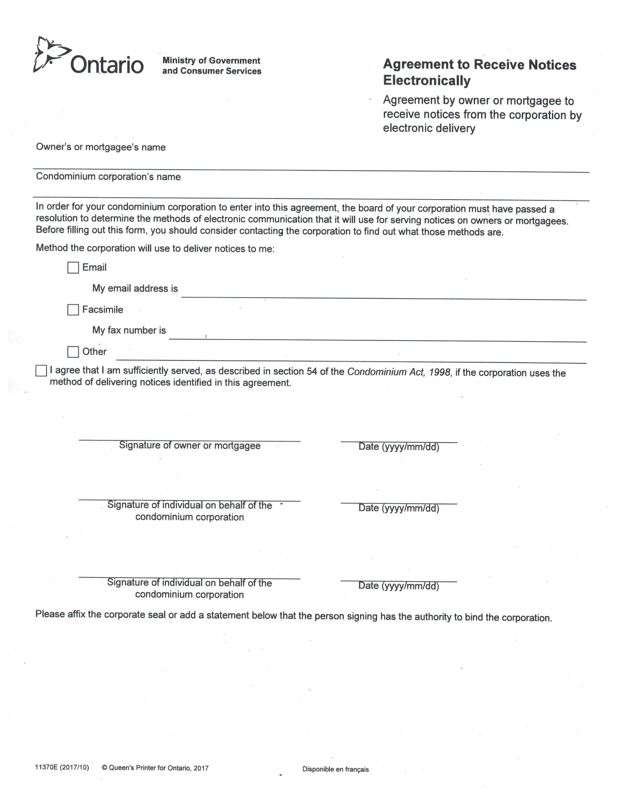

**YORK CONDOMINIUM CORPORAITON NO. 84**

**AGREEMENT TO RECEIVE NOTICES ELECTRONICALLY**

* Act s.54. Service on owner or mortgagee - Unless the At indicates otherwise, anything required to be given to an owner or a mortgagee under this Act is sufficiently served if it is given in accordance with subsection 47(7) or (8), as the case may be.
* Act s.47(7) Service on owner - A notice that is required to be given to an owner shall be,
* (a) delivered to the owner personally;
* (b) sent by prepaid mail addressed to the owner at the address for service that appears in the record;
* (c) sent by facsimile transmission, electronic mail or any other method of electronic communication if the owner agrees in writing that the party giving the notice may give the notice in this manner; or
* (d) delivered at the owner's unit or at the mail box for the unit unless,
* (i) the party giving the notice has received a written request from the owner that the notice not be given in this manner; or
* (ii) the address for service that appears in the record is not the address of the unit of the owner.
* Act s.47(8) - Service on mortgagee - A notice that is required to be given to a mortgagee shall be,
* (a) delivered to the mortgagee personally;
* (b) sent by prepaid mail addressed to the mortgagee at the address for service that appears in the record; or
* (c) sent by facsimile transmission, electronic mail or any other method of electronic communication if the mortgagee agrees in writing that the party  giving the notice ma give the notice in this manner.`

================================================================

* When there are **more than one person on the title** of the townhouse each party, if they wish, may receive separate notices. Each party must complete a separate Agreement to Receive Notices Electronically and each must have a different email address.
* When the holder of a **notarized power of attorney** wishes to receive separate notices, that attorney must complete a separate Agreement to Receive Notices Electronically. The email address must be different than that of the party giving the power of attorney.